Christ Episcopal Church in Springfield, Ohio
Service of the Word
The Last Sunday after Pentecost: Christ the King: November 21st, 2021 at 9 am

Prelude: “Good Christian Friends, Rejoice and Sing” - Gelobt Sei Gott/arr. Schelat

OPENING HYMN: “Jesus shall reign” Hymnal 544
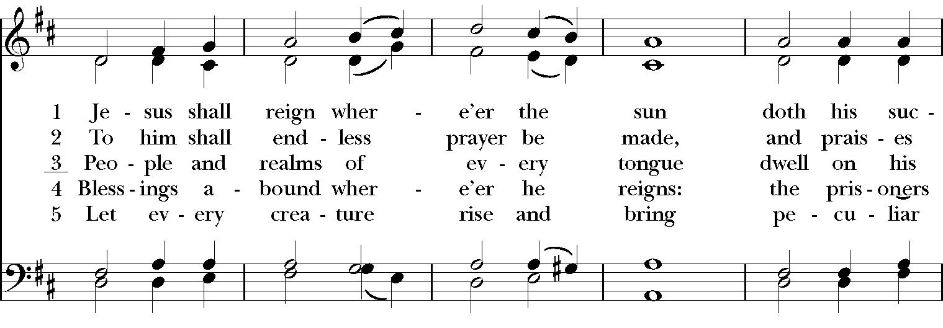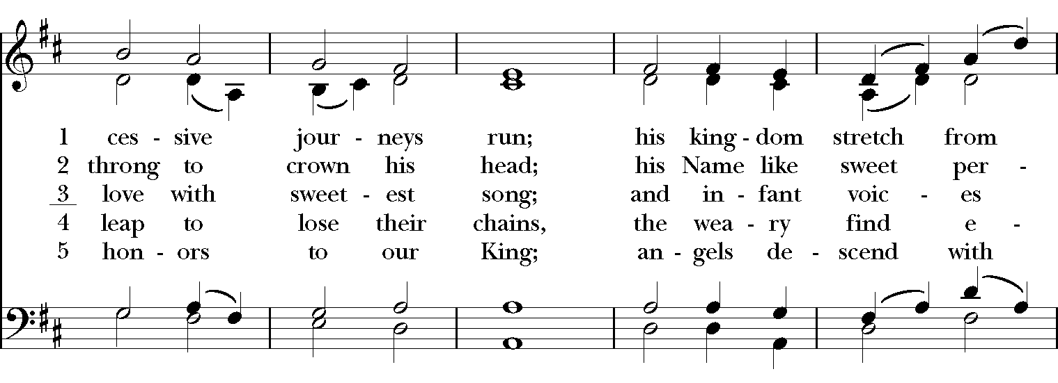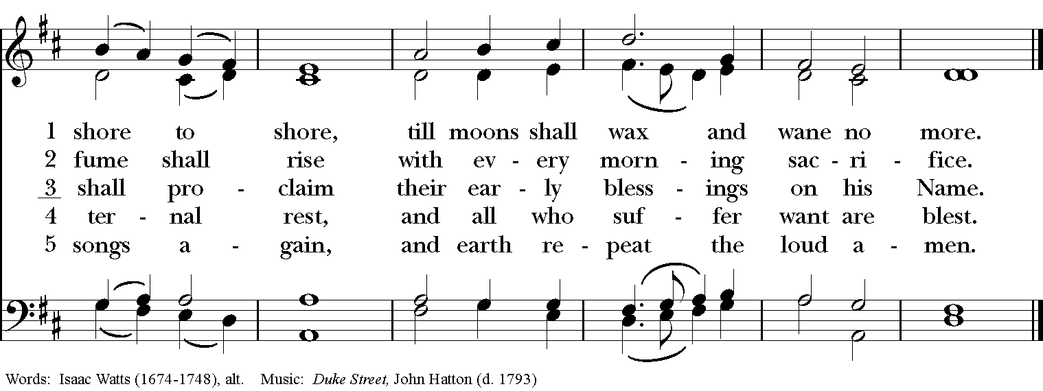

Celebrant: Blessed be God: Father, Son, and Holy Spirit.
People: And blessed be his kingdom, now and for ever. Amen.

The Collect of the Day
Celebrant: The Lord be with you.
People: And also with you.
Celebrant: Let us pray.
Almighty and everlasting God, whose will it is to restore all things in your well-beloved Son, the King of kings and Lord of lords: Mercifully grant that the peoples of the earth, divided and enslaved by sin, may be freed and brought together under his most gracious rule; who lives and reigns with you and the Holy Spirit, one God, now and for ever. Amen.

THE LESSONS

THE FIRST READING Daniel 12:1-3

As I watched,
thrones were set in place,
and an Ancient One took his throne,
his clothing was white as snow,
and the hair of his head like pure wool;
his throne was fiery flames,
and its wheels were burning fire.
A stream of fire issued
and flowed out from his presence.
A thousand thousands served him,
and ten thousand times ten thousand stood attending him.
The court sat in judgment,
and the books were opened.
As I watched in the night visions,
I saw one like a human being
coming with the clouds of heaven.
And he came to the Ancient One
and was presented before him.
To him was given dominion
and glory and kingship,
that all peoples, nations, and languages
should serve him.
His dominion is an everlasting dominion
that shall not pass away,
and his kingship is one
that shall never be destroyed.
Lector: The Word of the Lord.
People: Thanks be to God.

PSALM 93 Dominus regnavit

1 The Lord is King; he has put on splendid apparel; *
the Lord has put on his apparel and girded himself with strength.
2 He has made the whole world so sure *
that it cannot be moved;
3 Ever since the world began, your throne has been established; *
you are from everlasting.
4 The waters have lifted up, O Lord, the waters have lifted up their voice; *
the waters have lifted up their pounding waves.
5 Mightier than the sound of many waters, mightier than the breakers of the sea, *
mightier is the Lord who dwells on high.
6 Your testimonies are very sure, *
and holiness adorns your house, O Lord, for ever and for evermore.

THE SECOND LESSON Revelation 1:4b-8
Grace to you and peace from him who is and who was and who is to come, and from the seven spirits who are before his throne, and from Jesus Christ, the faithful witness, the firstborn of the dead, and the ruler of the kings of the earth.

To him who loves us and freed us from our sins by his blood, and made us to be a kingdom, priests serving his God and Father, to him be glory and dominion forever and ever. Amen.

Look! He is coming with the clouds;
every eye will see him,
even those who pierced him;
and on his account all the tribes of the earth will wail.
So it is to be. Amen.

“I am the Alpha and the Omega,” says the Lord God, who is and who was and who is to come, the Almighty.
Lector: The Word of the Lord.
People: Thanks be to God.
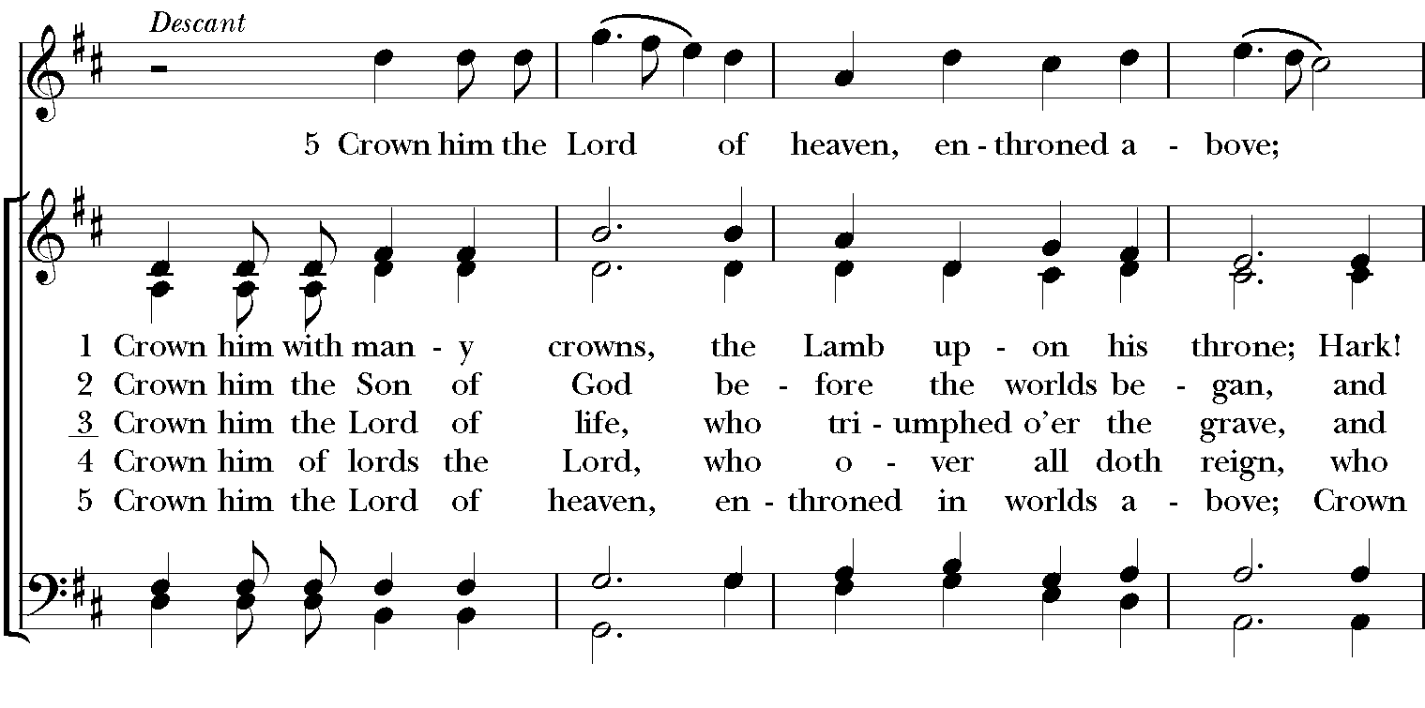
SQUENCE HYMN: “Crown Him with many crowns” Hymnal 494
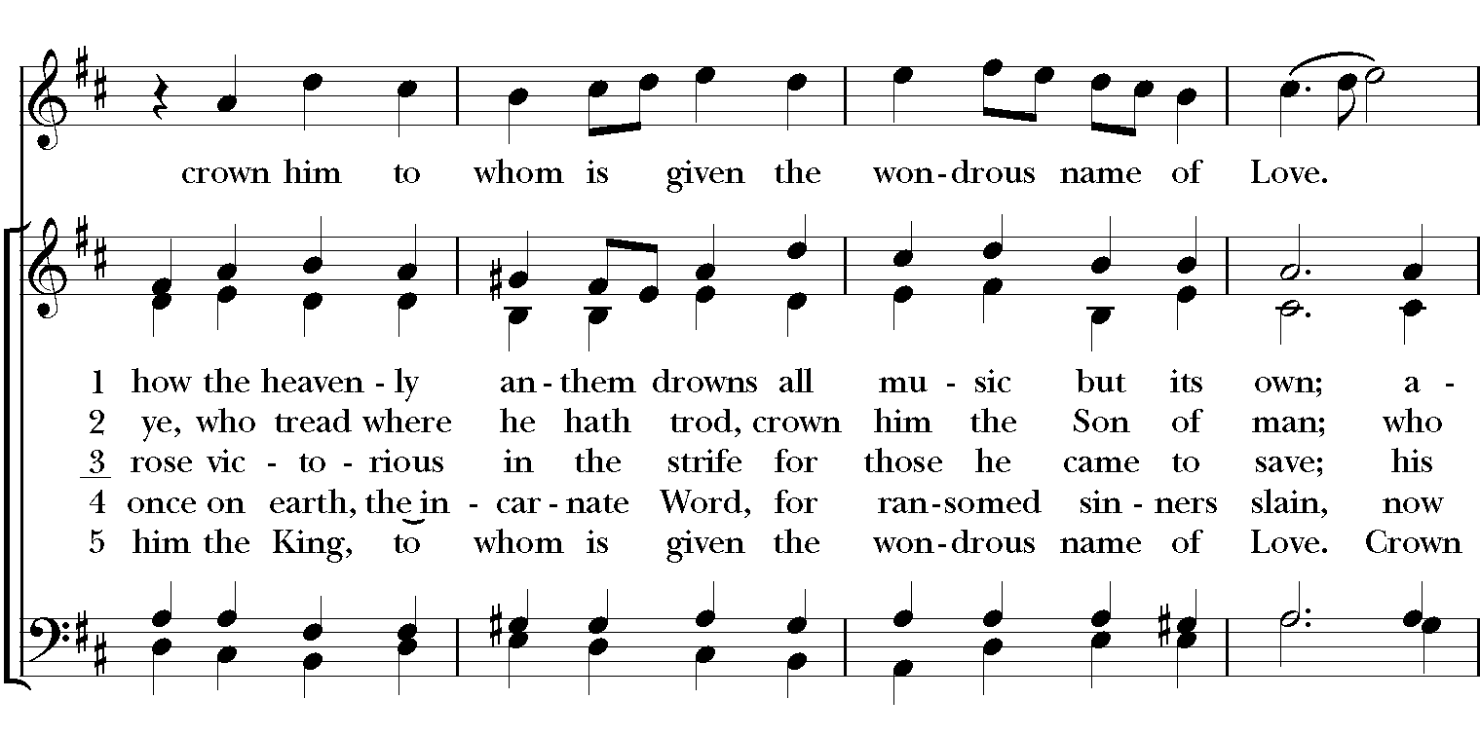
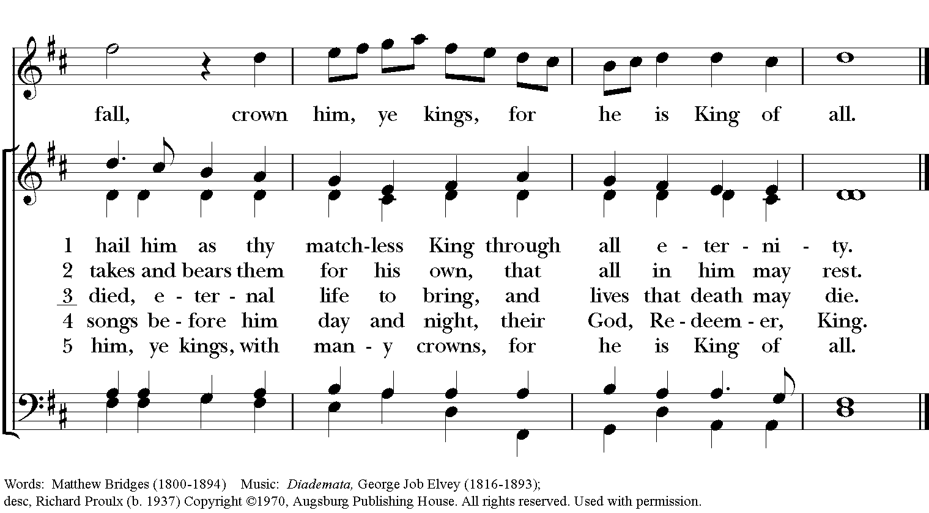
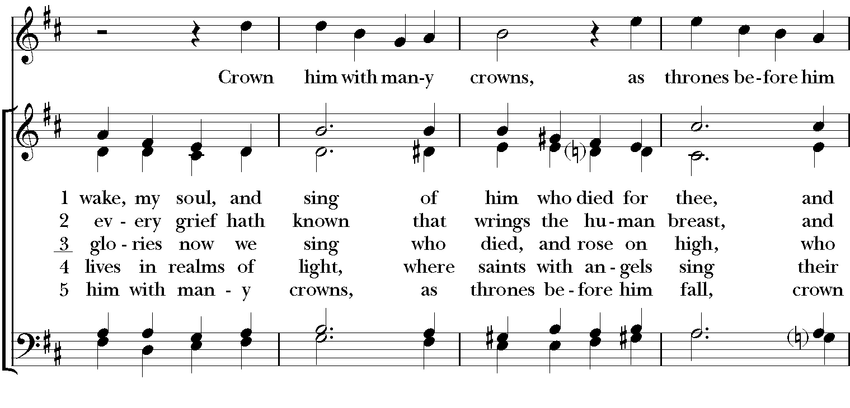

GOSPEL
Celebrant: The Holy Gospel of our Lord Jesus Christ according to John (John 18:33-37).
People: Glory to you, Lord Christ.
Pilate entered the headquarters again, summoned Jesus, and asked him, “Are you the King of the Jews?” Jesus answered, “Do you ask this on your own, or did others tell you about me?” Pilate replied, “I am not a Jew, am I? Your own nation and the chief priests have handed you over to me. What have you done?” Jesus answered, “My kingdom is not from this world. If my kingdom were from this world, my followers would be fighting to keep me from being handed over to the Jews. But as it is, my kingdom is not from here.” Pilate asked him, “So you are a king?” Jesus answered, “You say that I am a king. For this I was born, and for this I came into the world, to testify to the truth. Everyone who belongs to the truth listens to my voice.”
Celebrant: The Gospel of the Lord.
People: Praise to you, Lord Christ.

Sermon The Rev. Canon Dr. Lee Anne Reat

The Nicene Creed
We believe in one God, the Father, the Almighty,
maker of heaven and earth, of all that is, seen and unseen.
We believe in one Lord, Jesus Christ, the only Son of God,
eternally begotten of the Father, God from God,
Light from Light, true God from true God,
begotten, not made, of one Being with the Father.
Through him all things were made.
For us and for our salvation he came down from heaven,
by the power of the Holy Spirit he became incarnate from the Virgin Mary,
and was made man.
For our sake he was crucified under Pontius Pilate;
he suffered death and was buried.
On the third day he rose again in accordance with the Scriptures;
he ascended into heaven and is seated at the right hand of the Father.
He will come again in glory to judge the living and the dead, and his kingdom will have no end.
We believe in the Holy Spirit, the Lord, the giver of life,
who proceeds from the Father, and the Son.
With the Father and the Son he is worshiped and glorified,
he has spoken through the Prophets.
We believe in one holy catholic and apostolic Church.
We acknowledge one baptism for the forgiveness of sins.
We look for the resurrection of the dead, and the life of the world to come. Amen.

THE PRAYERS OF THE PEOPLE

In peace, we pray to you Lord God. Congregational responses are in bold.
Silence
Giver of every good gift, we thank you for your generosity in giving us more than we can ask or imagine.

Give grace to church leaders, especially Justin, Archbishop of Canterbury; Michael, our presiding bishop; Wayne, our provisional diocesan bishop; Lee Anne, our priest; and members of the vestry. In your time, send us the priest this church needs.
R: Giver of every good gift, grant grace.

Give wisdom to world leaders in a time of pandemic and natural disasters. Give special grace to refugees and those seeking justice.
R: Giver of every good gift, grant wisdom.

Give hope to those suffering any illness or affliction, especially Leigh, Charlene, Faye, Chris, Bonnie, Alice, Diana, James, Joy, Jane, Joni, Kim, Sarah, Traudie, Lexie, and Keith.
R: Giver of every good gift, grant hope.

Give strength to those laboring in the ministries we support as a church especially Springfield Farmer’s Market, Project Women, Children’s Defense Fund Freedom Schools, The YMCA, and Jefferson St. Oasis Garden.
R: Giver of every good gift, grant strength.

Give joy to those celebrating birthdays this week, especially Ava, Katrina, and Don, and anniversaries Bob & Dawn and Richard & Joyce.
R: Giver of every good gift, grant joy.

Grant peace and light to those who have died and comfort to those who grieve.
R: Giver of every good gift, in the midst of loss grant hope.

*THE COLLECT FOR PEACE
Grant, O God, that your holy and life-giving Spirit may so move every human heart, that barriers which divide us may crumble, suspicions disappear, and hatreds cease; that our divisions being healed, we may live in justice and peace; through Jesus Christ our Lord. Amen.

THE CONFESSION AND ABSOLUTION
Priest: Let us confess our sins against God and our neighbor.
All: Most merciful God, we confess that we have sinned against you in thought, word, and deed, by what we have done, and by what we have left undone. We have not loved you with our whole heart; we have not loved our neighbors as ourselves. We are truly sorry and we humbly repent. For the sake of your Son Jesus Christ, have mercy on us and forgive us; that we may delight in your will, and walk in your ways, to the glory of your Name. Amen.

Priest: Almighty God, have mercy on you, forgive you all your sins through our Lord Jesus Christ, strengthen you in all goodness, and by the power of the Holy Spirit keep you in eternal life. Amen.

And now, as our Savior Christ has taught us, we are bold to say:
Our Father, who art in heaven, hallowed be thy Name,
thy kingdom come, thy will be done, on earth as it is in heaven.
Give us this day our daily bread.
And forgive us our trespasses, as we forgive those who trespass against us.
And lead us not into temptation, but deliver us from evil.
For thine is the kingdom, and the power, and the glory, for ever and ever. Amen

CLOSING HYMN: “Hail to the Lord’s anointed” Hymnal 616

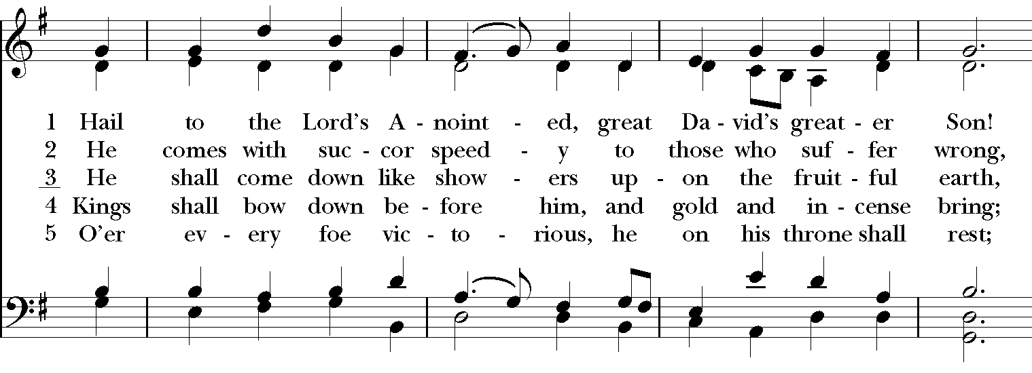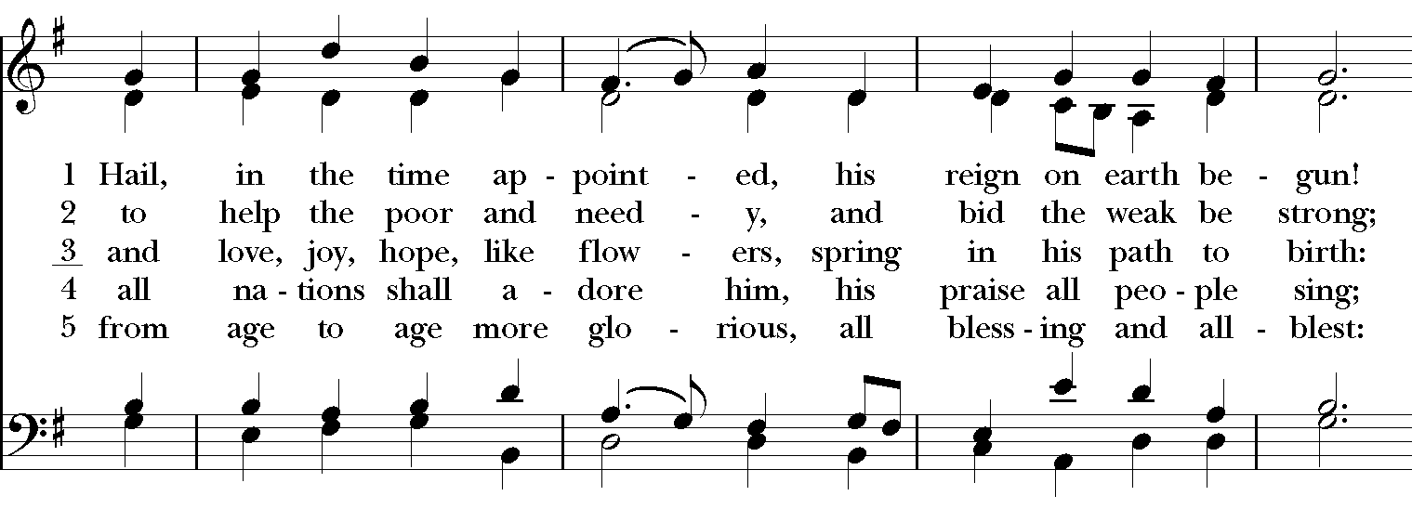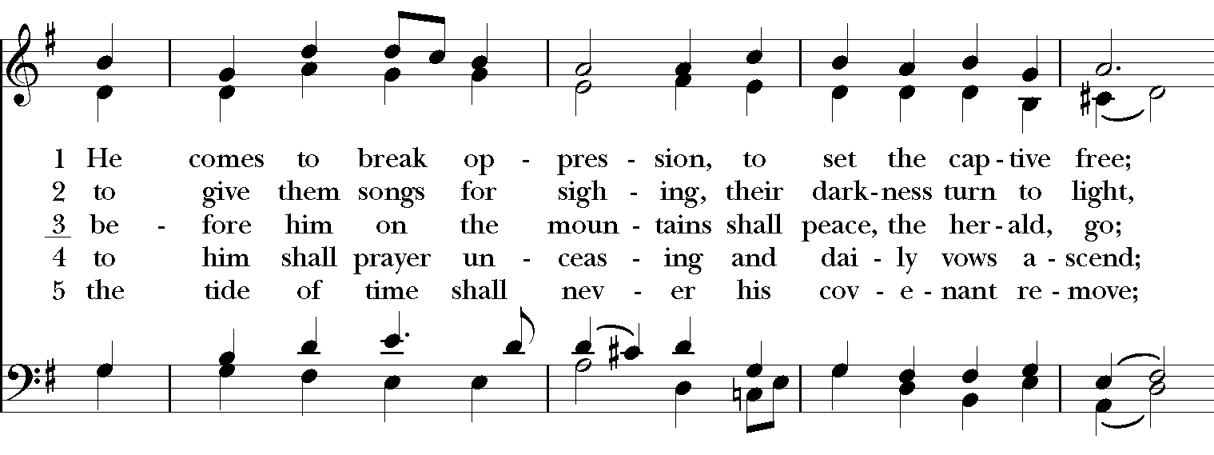
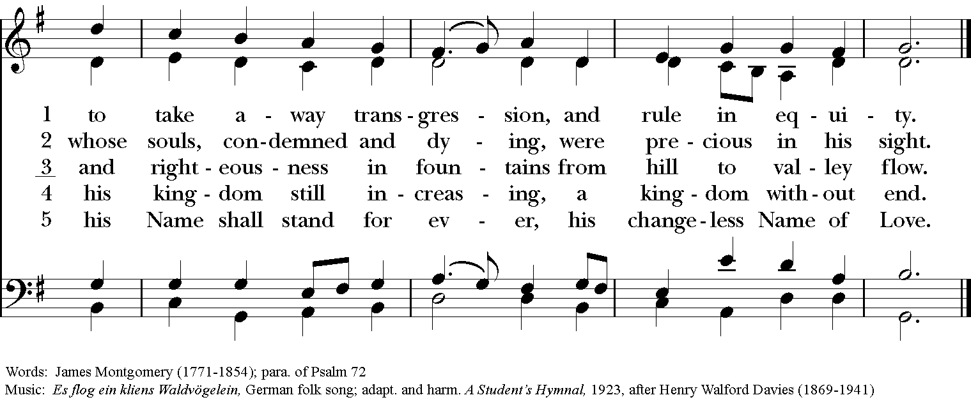

*THE BLESSING
Christ who has nourished us with himself the living bread, make you one in praise and love, and raise you up at the last day; and the blessing God Almighty, the Father, the Son, and the Holy Spirit, be among you, and remain with you always. Amen.

ANNOUNCEMENTS

*THE DISMISSAL Celebrant: Go in peace to love and serve the Lord.
People: Thanks be to God.

POSTLUDE: Gnossienne #3 - Erik Satie

Thank you for your spiritual presence with us this morning!
Although we're physically apart, we are united in prayer, worship, and holy love!
Priest-In-Charge: The Rev. Dr. Canon Lee Anne Reat
Music Director: Dr. Chris Durrenberger
Lector: Keith Doubt
Singers: Liz Wheeler, Joy Carter, Basil Fett, Chris Oldstone-Moore, and Fred Bartenstein
Technology: Steve Ide
Slideshow: Ed Hasecke
Parish Administrator and Program Coordinator: Kelly Zeller

