The
Clarion
Volume 24, Issue 8, August 2020 A Monthly Publication

“Seek Justice, Correct Oppression”
Christ Episcopal Church has invited ten local preachers to address the link between the Christian tradition and the work of social justice. The sermon series, which is part of a weekly morning prayer service, will begin this coming Sunday, August 9th, at 9:00 am. The series continues on select Sunday mornings through November 22nd.
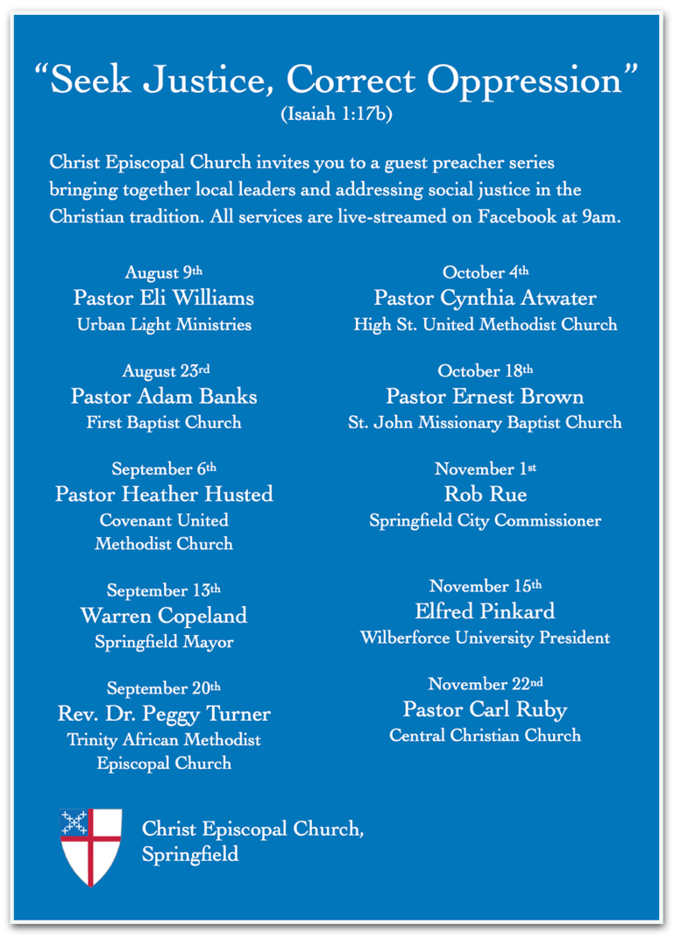
In addition to sermons by prominent local clergy, the series will include contributions from Springfield Mayor Warren Copeland, City Commissioner Rob Rue, and Wilberforce University President Elfred Pinkard. The full schedule encompasses ten Sundays over a three-month period.

The Vestry of Christ Episcopal Church supports the “Seek Justice, Correct Oppression” guest preacher series, a project that will bring local clergy and other leaders to our Morning Prayer services to share their perspectives on the Christian commitment to social justice. We see these perspectives as relevant to our baptismal commitment, which reminds us to “strive for justice and peace among all people,” and as especially valuable in times when the call to address racial inequities has become urgent. We encourage the members of Christ Church to receive these upcoming sermons, to reflect on their value for a faithful life, and to extend invitations to others who may be enriched by the series.

The Clarion

Volume 24, Issue 8
is the independently edited, local monthly newsletter of Christ Episcopal Church, 409 East High Street, Springfield, OH, 45505 and published by Christ Episcopal Church upon authority of its Senior Warden.
Office: 937/323-8651
www.ChristSpringfield.org

Christ Episcopal Church
in the Diocese of Southern Ohio
  

Christ Episcopal Church
in the Diocese of Southern Ohio
  
Bishop:
The Rt Rev Thomas E Breidenthal
Deacon:
The Rev. Rick Incorvati
Senior Warden:
Dawn Ivy
Junior Warden:
Jim Whipp
Organist:
Dr. Christopher Durrenberger
Parish Administrator/
Program Coordinator:
Kelly Zeller
Facility Manager:
Paul McAfee
Bookkeeper:
Tina Knox
Clarion Editor:
Joyce Spangler

Dear Christ Church Family,

In the next few weeks, we will begin the process of finding our interim priest and then on to finding our new rector. Please be patient with your wardens and vestry as this process unfolds.

Opening the church. We are following all the guidelines that are sent from the diocese about worshipping in our church. I ask your patience with that too. We have no control over the COVID-19 virus and how it is affecting Clark County. I will send updates weekly in the Newsnote, so you will be the first to know when we are considering opening the church and what procedures we’ll have to follow when we do open.

In the next few weeks, we will be having some outstanding ministers from neighboring churches and the community to discuss social justice and how we as Christians can help in that effort. I hope you were able to tune in to the 9 August service. If not, check out our Facebook page, and your spirits will be lifted.

I am here if you need to talk or email. We will get through this together.

Your friend in Christ,

Dawn

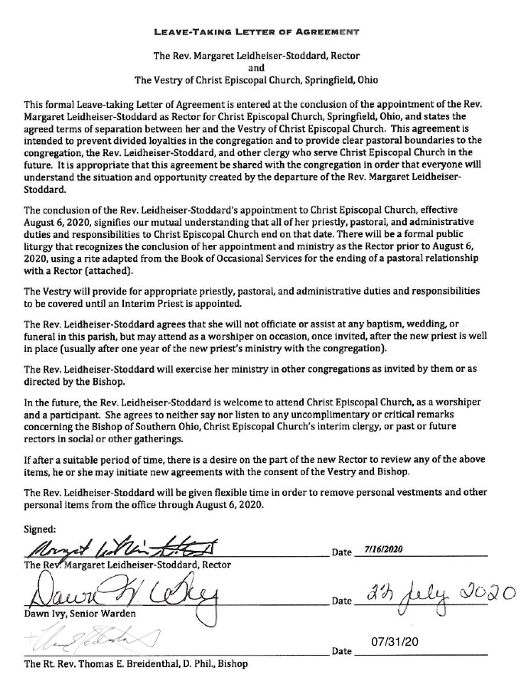

Thank you to all who came to give Rev. Maggie, Jon, and Jesse a nice send off and to wish them well!

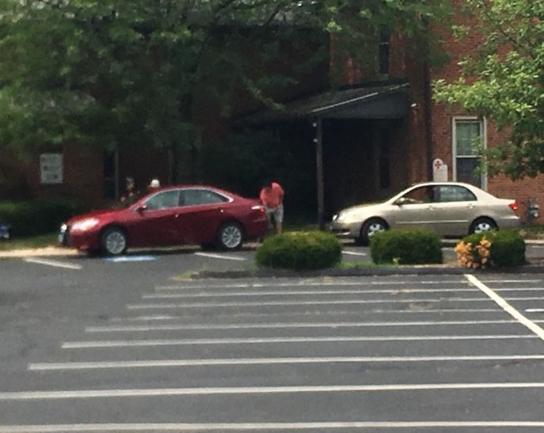

Ron & Ann deLanglade Aug. 05
Brian & Bonnie Shelburne Aug. 06
David &Kathleen Schubert Aug. 09
Keith & Carol Harbaugh Aug. 18
Fred & Joy Bartenstein Aug. 21

Christ Church on social media!
If you’re on Facebook go to Christ Episcopal Church’s Facebook page and like the page. You’ll receive information on upcoming events, learn historical facts, and view beautiful pictures. You will be in the know! If you would like to view the Facebook page and are not on Facebook you can visit Christ Church’s web page at christspringfield.org, scroll to the bottom of the home page, click on the small f and it will redirect you Christ Church’s Facebook page.

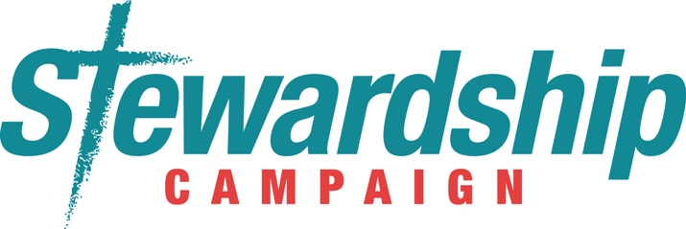

The 2021 Stewardship Campaign will kick off in August. Look for videos video links in the Newsnotes, as well as messages in the Clarion as the fall progresses!

Guiding Principles for Christ Church's Return to In-Person Worship
{adopted by Vestry on 5/7/20}

SAFELY + RESPONSIBLY + FAITHFULLY

- We, the congregation of Christ Episcopal Church, will prioritize the health and safety of the full Body of Christ over our personal preferences and desires to "get back to normal."
- We agree to be guided by the instructions issued by the Bishop’s Office in order to limit the risks in our return to in-person worship. (Rationale: see #1)
- We agree to follow applicable guidelines from the Governor's office and/or Ohio Department of Health. Note: As a religious organization, we are legally exempt from most of these guidelines; but we will not take advantage of this exemption. (Rationale: see #1)
- We will maintain 6 feet of space between all persons who do not live together. (Rationale: see #1)
- We will continue to offer as much as we can online. (Rationale: see #1)
- We will encourage folks at higher risk (65+ and/or underlying conditions) to stay home. (Rationale: see #1)
- We will not ask any staff members or volunteers to engage in high risk behaviors (i.e. any duties that may violate the parish/diocesan/state guidelines). (Rationale: see #1)

+ These guidelines will govern the first stage of our return, which begins on the date we hold our first in-person worship services (not yet known). Guidelines will be continually reevaluated by Leadership Team and Vestry.

+ Instructions from the Bishop's office will cover many specifics: communion, coffee hour, face masks, singing, etc. Our task is to discern how we will implement these specifics in the context of our parish.

Joy Bayes Aug. 01
Cathy Yeazell Aug. 02
JoEtta Cooper Aug 02
Clare Perks Aug. 04
Tom McNicol Aug. 04
Scott Dooley Aug. 04
Laura Yeazell Aug. 05
Josh Payne Aug. 09
Nick Payne Aug. 09
Dana Waggoner Aug. 11
Marilyn Howat Aug. 12
Ellie McGregor Aug. 15
Jack Ivy Aug. 21
Ted DeLong Aug. 28
Jenny Randolph Aug. 29

Church Staff
Please note that all staff are currently working from home as much as possible!
Senior Warden: Dawn Ivy
Jr. Warden: Jim Whipp
Deacon: The Rev. Rick Incorvati
Treasurer: Ken Bladh
Parish Administrator/Program Coordinator: Kelly Zeller
Organist and Choir Director: Dr. Christopher Durrenberger
Youth Teacher: Abby Glass
Nursery Attendant: Jerushia Knox
Facility Manager: Paul McAfee
Bookkeeper: Tina Knox

Your Vestry
Vestry at Large: Bonnie Bingman, Chris Oldstone-Moore, Cathy Hasecke, Denise Sharp, Brian Shelburne, Joyce Spangler, and Keith Doubt
Youth Representative: Sarah Schubert

Reminder from Outreach Team Member Deb Southward
- Just a REMINDER! Continue to $AVE PENNIES for the Warder Literacy CENTer & $AVE PULL-Tabs for Dayton Ronald McDonald House. The Warder Literacy CENTer is opening on a limited basis & there will be a growing need for their services given that kids have been out of school (some without access to computers) & will need to play catch up. The Dayton Ronald McDonald House is continuing to be a safe haven for healthcare professionals to rest & relax without exposing their families if they so choose. Not sure when they plan to transistion back to families. Rolls/baggies of pennies/pull-tabs can be dropped in the Hollenbeck House mail slot, or returned in the church building when we resume in-person worship. THANKS in advance for everyone's continual support!

Worship… Offering meaningful, relevant, and welcoming worship in the Episcopal tradition for people
of all ages.

August 2020
Date | First Lesson | Psalm | Second Lesson | Gospel
August 16 | Genesis 45:1-15 | 133 | Romans 11:1-2a 29-32 | Matthew 15:10-28
August 23 | Exodus 1:8-2:10 | 124 | Romans 12:1-8 | Matthew 16:13-20
August 30 | Exodus 3:1-15 | 105 1-6, 23-26, 45c | Romans 12:9-21 | Matthew 16:21-28

Calling in Via Telephone for
Worship Audio
These instructions will allow you to listen to the audio of our online worship services on Sunday mornings. They will not change from week to week, until we begin offering in-person worship services again. (When that happens, we'll figure out another way to share audio via phone.)

- A few minutes before 9:00 am on Sunday, call 1-312-626-6799.
- A recording will answer, saying “Welcome to Zoom!” and will ask you to enter your Meeting ID, followed by #.
Meeting ID: 88472403977#
- Next it will ask for a Participant ID—you DO NOT have one! Just press #
- Finally, it will ask you to enter the Password, followed by #.
Password: 132550#
- Now you’ll be able to hear our worship!

A special note: if you don't hear anything right away, don't panic. We may run a few minutes behind schedule due to technical issues, so just hang on and trust that we'll begin shortly.

We are hoping to add some more people to the list of lectors for our Sunday morning live stream worship services. Email Kelly Zeller (ZellerK0611@gmail.com), or Sr. Warden Dawn Ivy (dvivy0960@yahoo.com) if you're willing to help out!

Outreach…helping to provide the physical, material, social, and spiritual needs in Springfield
and beyond

The following non-profit organizations that Christ Episcopal supports through their Outreach Budget or in-kind donations will be having FUNdraisers with RUDY’s BBQ on South Limestone in Springfield over the summer through Rudy’s Giving TUESDAY program. Here is the link to Rudy’s menu www.rudyssmokehouse.com. They will receive 50% of the cost of the meal or food purchased for carry-out when you show either a printed or on-line coupon, which will be available in our weekly e-newsletter the week before:
- Tues. 8/11 Interfaith Hospitality Network - IHN (Outreach/Lori Stafford)
- Tues. 9/15 The Jefferson Street Oasis Garden
- Tues. 10/20 Habitat for Humanity (Outreach/Blue Banks “Holiday Homes”)

We are in the midst of an anxious and uncertain time in our community and in our world, yet the many ministries of Christ Church continue on in a variety of ways. Our Church staff have been faithful, flexible, and dedicated to serving this parish as best they can.
As a faithful community that seeks to embody passionate discipleship and a heart for Christian justice, we are also committed to continuing to pay all staff members at their usual levels, including those whose normal work duties have been restricted by the pandemic. And although we are currently unable to gather on site, the normal operating expenses and costs of upkeep for our historic building remain.
We invite you to support the work of the Church financially by giving in one of two ways:
- "Low-tech" giving: Mail a check made out to Christ Episcopal Church to the church office (409 East High St., Springfield OH 45505).
- "High-tech" giving: Go to the Diocesan homepage <EpiscopaliansInConnection.org> and click on Give online to your church. Select Christ Church, Springfield from the drop-down bar.

Christ Church T-Shirts Available
Christ Church members who participated in the YWCA's 21-Day Racial Justice and Social Equity Challenge were drawn to a short passage from Isaiah "Seek Justice, Correct Oppression" (1:17b), and now there's a new Christ Church T-shirts with that scripture featured prominently. If you would like one of the soft black T-shirts, contact Lori Swafford lori.swafford67@gmail.com.
Each shirt is $12.00.
