Christ Episcopal Church in Springfield, Ohio
Service of the Word
Third Sunday of Advent: December 13th, 2020 at 9 am

Prelude:

The lighting of the Advent wreath
Priest: People of God: awake! The day is coming soon when we shall see God face to face. As God’s children, we remember the ways and the works of God. We are called out of darkness to walk in the light of God’s coming. Lord, make us one as we walk with Christ today and for ever. Amen.

Opening Hymn: “Hark, a thrilling voice is sounding” Hymnal 59
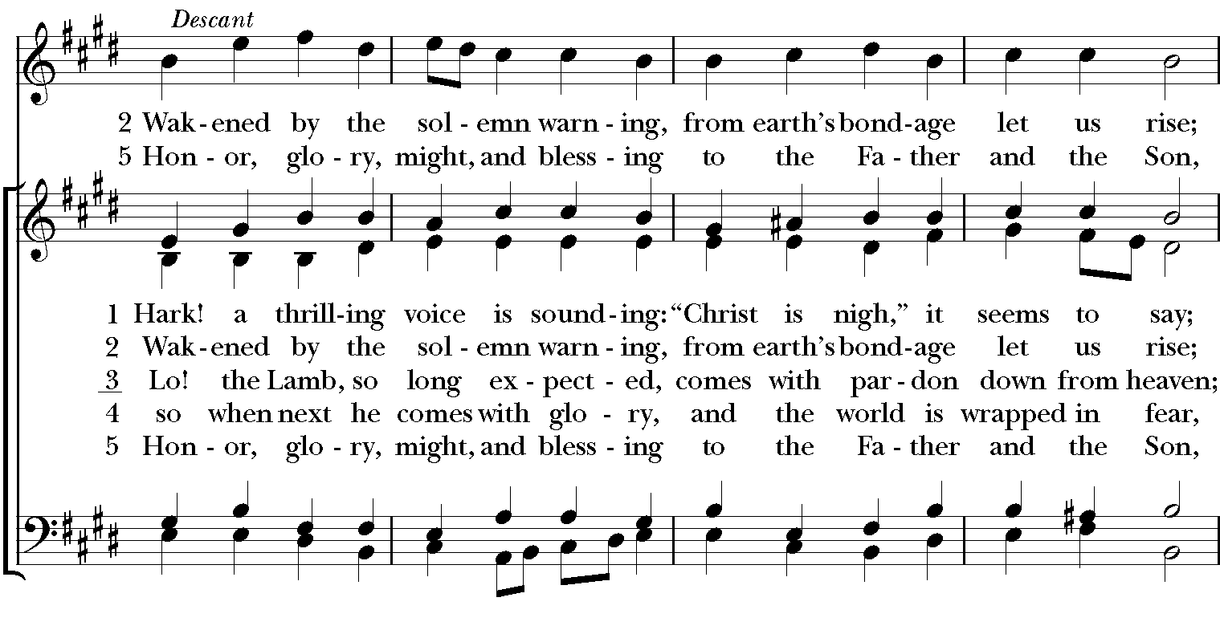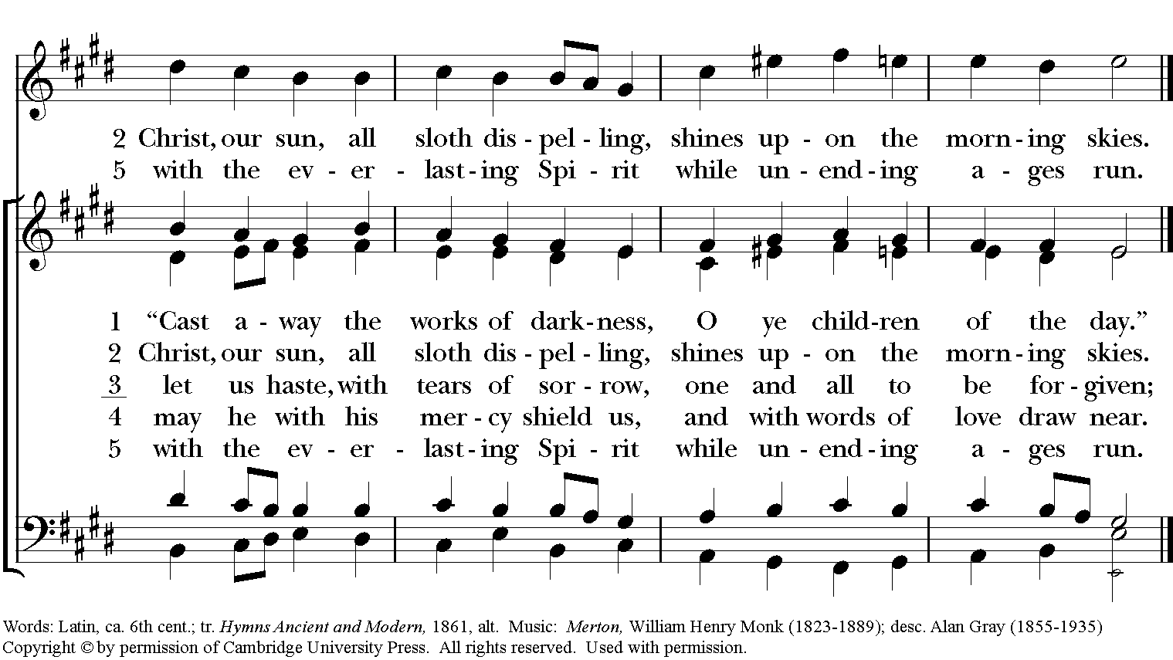

Celebrant: Blessed be God: Father, Son, and Holy Spirit.
People: And blessed be God’s kingdom, now and for ever. Amen.
Celebrant: Lord, have mercy.
People: Christ, have mercy.
Celebrant: Lord, have mercy.

The Collect of the Day
Celebrant: The Lord be with you.
People: And also with you.
Celebrant: Let us pray.
Stir up your power, O Lord, and with great might come among us; and, because we are sorely hindered by our sins, let your bountiful grace and mercy speedily help and deliver us; through Jesus Christ our Lord, to whom, with you and the Holy Spirit, be honor and glory, now and for ever. Amen.

The Lessons

The First Reading: Isaiah 61:1-4, 8-11
The spirit of the Lord God is upon me,
because the Lord has anointed me;
he has sent me to bring good news to the oppressed,
to bind up the brokenhearted,
to proclaim liberty to the captives,
and release to the prisoners;
to proclaim the year of the Lord's favor,
and the day of vengeance of our God;
to comfort all who mourn;
to provide for those who mourn in Zion—
to give them a garland instead of ashes,
the oil of gladness instead of mourning,
the mantle of praise instead of a faint spirit.
They will be called oaks of righteousness,
the planting of the Lord, to display his glory.
They shall build up the ancient ruins,
they shall raise up the former devastations;
they shall repair the ruined cities,
the devastations of many generations.
For I the Lord love justice,
I hate robbery and wrongdoing;
I will faithfully give them their recompense,
and I will make an everlasting covenant with them.
Their descendants shall be known among the nations,
and their offspring among the peoples;
all who see them shall acknowledge
that they are a people whom the Lord has blessed.
I will greatly rejoice in the LORD,
my whole being shall exult in my God;
for he has clothed me with the garments of salvation,
he has covered me with the robe of righteousness,
as a bridegroom decks himself with a garland,
and as a bride adorns herself with her jewels.
For as the earth brings forth its shoots,
and as a garden causes what is sown in it to spring up,
so the Lord God will cause righteousness and praise
to spring up before all the nations.
Reader: The Word of the Lord.
People: Thanks be to God.

Psalm 126 In convertendo

1 When the Lord restored the fortunes of Zion, *
then were we like those who dream.
2 Then was our mouth filled with laughter, *
and our tongue with shouts of joy.
3 Then they said among the nations, *
"The Lord has done great things for them."
4 The Lord has done great things for us, *
and we are glad indeed.
5 Restore our fortunes, O Lord, *
like the watercourses of the Negev.
6 Those who sowed with tears *
will reap with songs of joy.
7 Those who go out weeping, carrying the seed, *
will come again with joy, shouldering their sheaves.

Second Lesson: 1 Thessalonians 5:16-24
Rejoice always, pray without ceasing, give thanks in all circumstances; for this is the will of God in Christ Jesus for you. Do not quench the Spirit. Do not despise the words of prophets, but test everything; hold fast to what is good; abstain from every form of evil.
May the God of peace himself sanctify you entirely; and may your spirit and soul and body be kept sound and blameless at the coming of our Lord Jesus Christ. The one who calls you is faithful, and he will do this.
Reader: The Word of the Lord.
People: Thanks be to God.

Sequence Hymn: “Spirit divine, attend out prayers” Hymnal 509
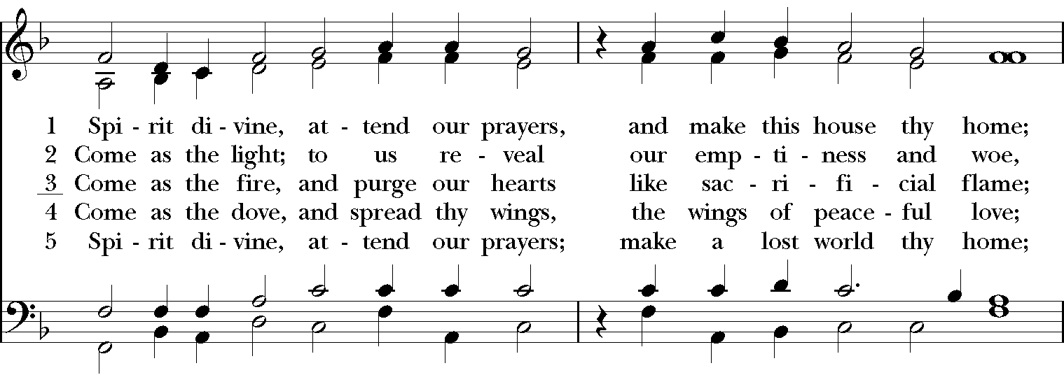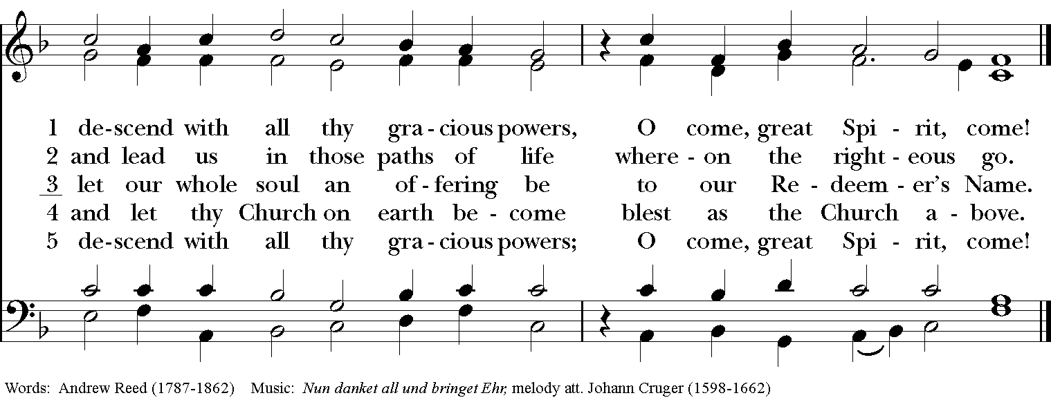
Gospel
Deacon: The Holy Gospel According to John (1:6-8, 19-28)
People: Glory to you, Lord Christ.
There was a man sent from God, whose name was John. He came as a witness to testify to the light, so that all might believe through him. He himself was not the light, but he came to testify to the light.
This is the testimony given by John when the Jews sent priests and Levites from Jerusalem to ask him, “Who are you?” He confessed and did not deny it, but confessed, “I am not the Messiah.” And they asked him, “What then? Are you Elijah?” He said, “I am not.” “Are you the prophet?” He answered, “No.” Then they said to him, “Who are you? Let us have an answer for those who sent us. What do you say about yourself?” He said, “I am the voice of one crying out in the wilderness, ‘Make straight the way of the Lord,’” as the prophet Isaiah said. Now they had been sent from the Pharisees. They asked him, “Why then are you baptizing if you are neither the Messiah, nor Elijah, nor the prophet?” John answered them, “I baptize with water. Among you stands one whom you do not know, the one who is coming after me; I am not worthy to untie the thong of his sandal.” This took place in Bethany across the Jordan where John was baptizing.
Deacon: The Gospel of the Lord.
People: Praise to you, Lord Christ.

Sermon The Rev. Canon Dr. Lee Anne Reat

The Nicene Creed
We believe in one God,
the Father, the Almighty,
the maker of heaven and earth,
of all that is, seen and unseen.
We believe in one Lord, Jesus Christ,
the only Son of God,
eternally begotten of the Father,
God from God, Light from Light,
true God from true God,
begotten, not made,
of one Being with the Father.
Through him all things were made.
For us and for our salvation
he came down from heaven:
by the power of the Holy Spirit
he became incarnate from the Virgin Mary,
and was made man.
For our sake he was crucified under Pontius Pilate;
he suffered death and was buried.
On the third day he rose again
in accordance with the Scriptures;
He ascended into heaven
and is seated on the right hand of the Father.
He will come again in glory to judge the living and the dead,
and his kingdom will have no end.
We believe in the Holy Spirit, the Lord, the giver of life,
who proceeds from the Father and the Son.
With the Father and the Son he is worshiped and glorified.
He has spoken through the Prophets.
We believe in one holy catholic and apostolic Church.
We acknowledge one baptism for the forgiveness of sins.
We look for the resurrection of the dead,
and the life of the world to come. Amen.
The Prayers of the People
In peace, we pray to you Lord God.

Silence
Let us pray. Lord Jesus Christ, you came and dwelt among us, showing us the glory of the Father. Let that glory be manifest in our churches. Give us the will to be united as You prayed we would be.
R: Lord Jesus, come and dwell within all churches.

Lord Jesus Christ, you came and dwelt among us, serving others and not seeking your own glory. Inspire church leaders, that they may be examples of willing service. Bless Justin, Archbishop of Canterbury; Michael, our Presiding Bishop; Lee Anne, our priest, and Rick, our deacon.
R: Lord Jesus, come and dwell among all church leaders

Lord Jesus Christ, you came and dwelt among us, giving us an example of true power, which lies in holiness. Direct government leaders into wise decisions that will bring forth righteousness. Give the leaders of the nation wisdom and hearts for peace.
R: Lord Jesus, come and dwell in all government leaders.

Lord Jesus Christ, you came and dwelt among us, choosing the company of the poor, the homeless, the hungry, and the sick, of widows and orphans, and of sinners. Help us to reach out in lovingkindness to those who are in any need or trouble. We pray for the ministries this church supports, especially Children’s Rescue Center/ The Ark, Christ Church Food Pantry, The Fuller Center for Housing, and Safe Harbor House.
R: Lord Jesus, come and dwell in our acts of mercy.

Lord Jesus Christ, you came and dwelt among us, taking on our flesh, and inhabiting both the pains and the joys of this life. We celebrate with those who have birthdays, especially Kathy, John, And Richard and anniversaries this week.
R: Lord Jesus, come and dwell in our moments of joy.

Lord Jesus Christ, you came and dwelt among us, taking sickness and suffering into your own hands and transforming them. Have mercy on those who suffer in body, mind, or spirit. We pray especially for Chris, Dodi, Laura, Bonnie, Alice, Diana, James, Joy, Jane, Joni, Kim, Bobby, Ruth, Sarah, Traudie, Lexie, Norm, and Keith. Give special grace and power to all those who spend this holiday working with the sick and the dying.
R: Lord Jesus, come and dwell in our dis-ease and make us whole.

Lord Jesus Christ, you came and dwelt among us, weeping at the death of those whom you loved. Comfort all those who have lost loved ones, and bless those departed.
R: Lord Jesus, come and dwell in our memories of those whom we have lost. Grant peace and light to those who have died.
*THE COLLECT FOR PEACE
Grant, O God, that your holy and life-giving Spirit may so move every human heart, that barriers which divide us may crumble, suspicions disappear, and hatreds cease; that our divisions being healed, we may live in justice and peace; through Jesus Christ our Lord. Amen.

Deacon: Let us confess our sins against God and our neighbor.
All: Most merciful God, we confess that we have sinned against you in thought, word, and deed, by what we have done, and by what we have left undone. We have not loved you with our whole heart; we have not loved our neighbors as ourselves. We are truly sorry and we humbly repent. For the sake of your Son Jesus Christ, have mercy on us and forgive us; that we may delight in your will, and walk in your ways, to the glory of your Name. Amen.

Priest: Almighty God, have mercy on you, forgive you all your sins through our Lord Jesus Christ, strengthen you in all goodness, and by the power of the Holy Spirit keep you in eternal life. Amen.

And now, as our Savior Christ has taught us, we are bold to say:
Our Father, who art in heaven, hallowed be thy Name,
thy kingdom come, thy will be done, on earth as it is in heaven.
Give us this day our daily bread.
And forgive us our trespasses, as we forgive those who trespass against us.
And lead us not into temptation, but deliver us from evil.
For thine is the kingdom, and the power, and the glory, for ever and ever. Amen.

Closing Hymn: “Hark! the glad sound!” Hymnal 71
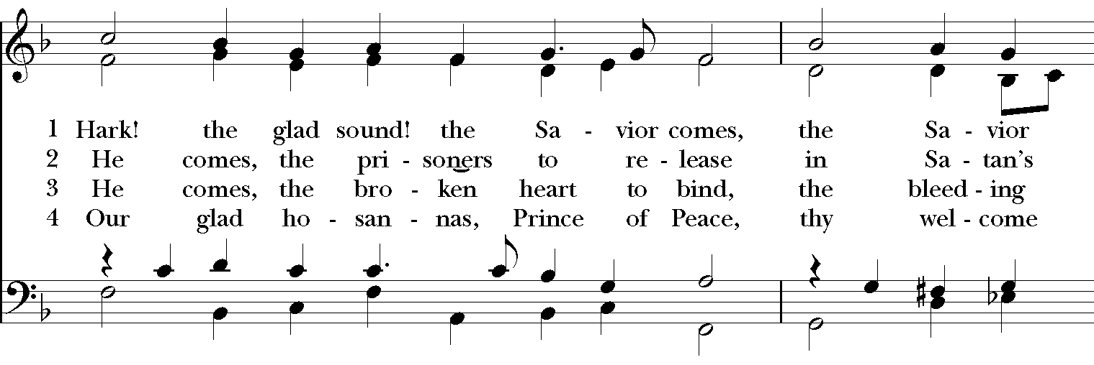
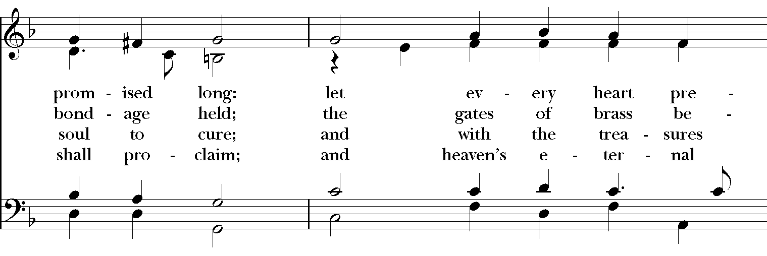

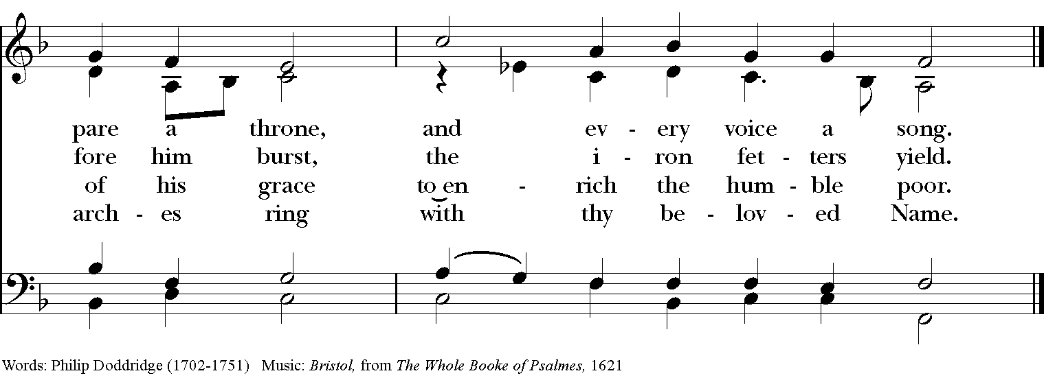

Blessing
May the Sun of Righteousness shine upon you and scatter the darkness from before your path; and the blessing of God Almighty, the Father, the Son, and the Holy Spirit, be among you, and remain with you always. Amen.”

Announcements

Dismissal
Deacon: Go in peace to love and serve the Lord.
People: Thanks be to God!
Postlude:
Thank you for your spiritual presence with us this morning!
Although we're physically apart, we are united in prayer, worship, and holy love!
Priest-In-Charge: The Rev. Dr. Canon Lee Anne Reat
Deacon: The Rev. Dr. Rick Incorvati
Music Director: Dr. Chris Durrenberger
Lector: Liz Wheeler
Acolyte: Bill Yeazell
Singers: Liz Wheeler, Joy Carter, Ed Hasecke, Fred Bartenstein
Technology: Steve Ide
Slideshow: Ed Hasecke
Parish Administrator and Program Coordinator: Kelly Zeller
Coffee Hour Host: Ron Dowling

