Third Sunday of Pentecost
June 13th, 2021 at 10:00 a.m.
The Holy Eucharist: Rite II

++++++++++++++++++++++++++++++++++++++++++

INFORMATION FOR NEWCOMERS: WELCOME TO CHRIST CHURCH!
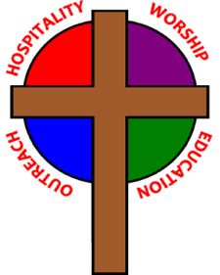
Our motto is true whether you're here for the very first time
or you've been a member for decades –
There is a place for you at God's Table!

Welcome home to Christ Church. We are so very grateful that we can worship together once again. We will need to take special care to ensure the safety of ourselves and others as we worship. Each adult must accept responsibility for his/her own actions. Here are some safety guidelines that will help keep us all safe and healthy:
- Everyone must wear a facemask over mouth and nose at all times while in church buildings, except for a few seconds during Eucharist (see below).
- Maintain a safe distance of six-feet between yourself and others not a part of your household at all times.
- Small gatherings are allowed in church buildings as long as masks are worn and safe distancing is observed.
- Singing is permitted with masks on for the safety of our worshipping community. Thank you for your cooperation.
- Use the offering plate at the entrance to the sanctuary. Plates will not be passed during worship.
- COMMUNION PROCEDURES: Communion will be in one kind only – Bread only at this time and from the center aisle, not the altar rail. When it is time to come forward for Communion, please form a single line down the center aisle, maintaining six-feet of distance from others. KEEPING YOUR MASK ON, the priest will place a Host in your hands using tongs. RETURN TO YOUR SEAT, then remove your mask momentarily to consume the Host.
THE WORD OF GOD
(*please rise as you are comfortable)
PRELUDE:

OPENING HYMN: “Hail to the Lord’s anointed” Hymnal 616
Singing is permitted with masks on for the safety of our worshipping community. Thank you for your cooperation.
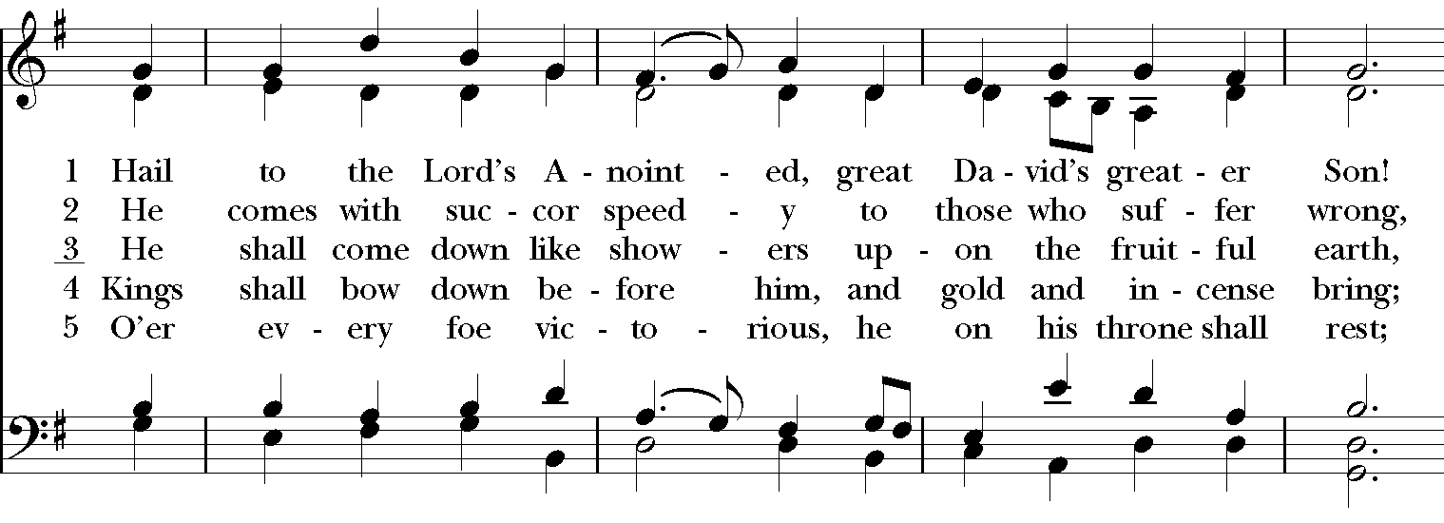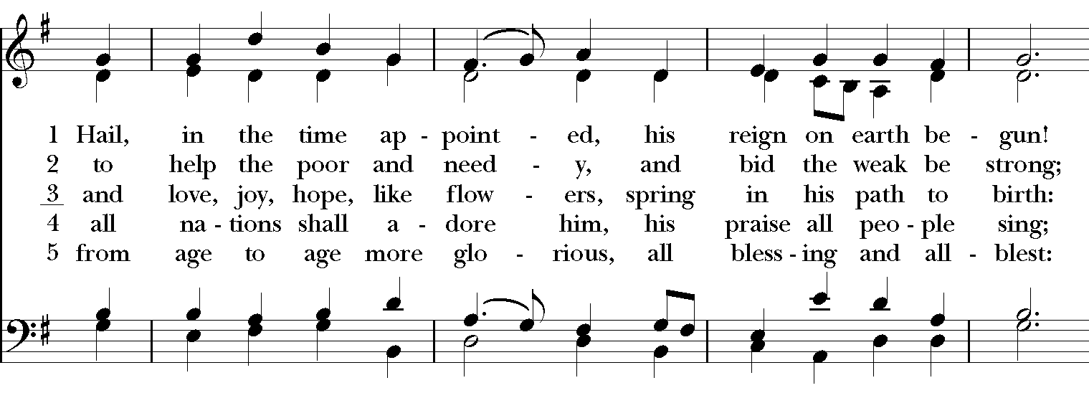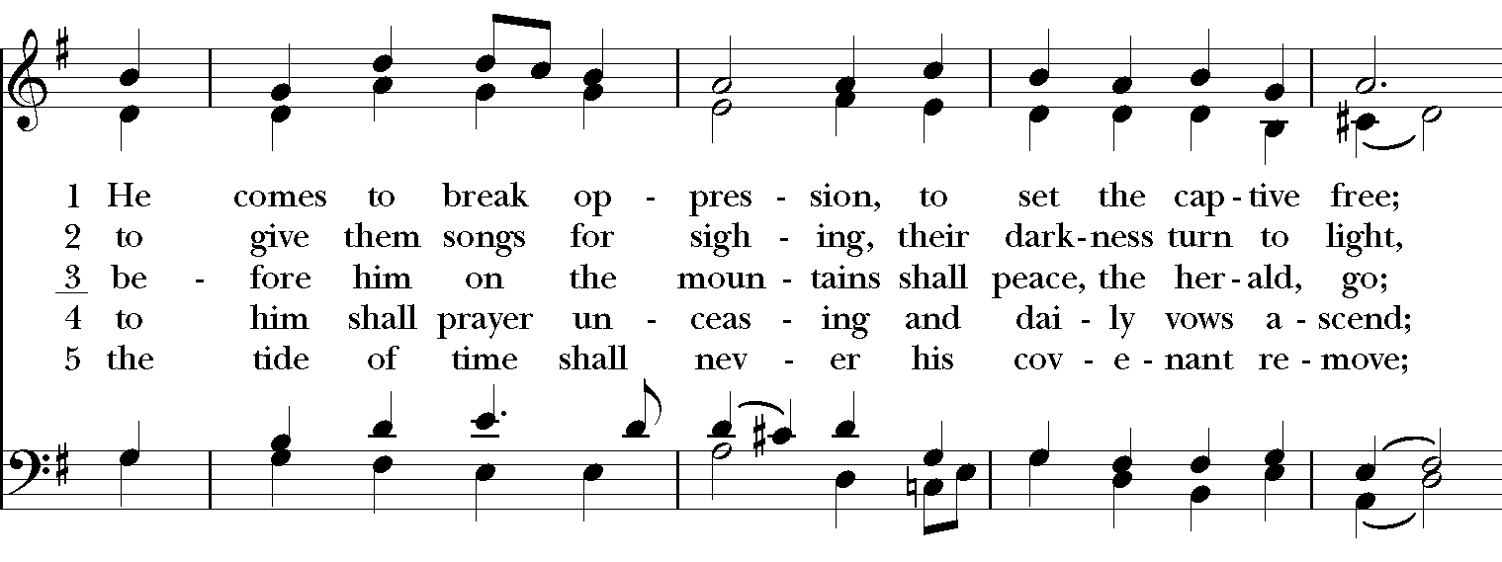
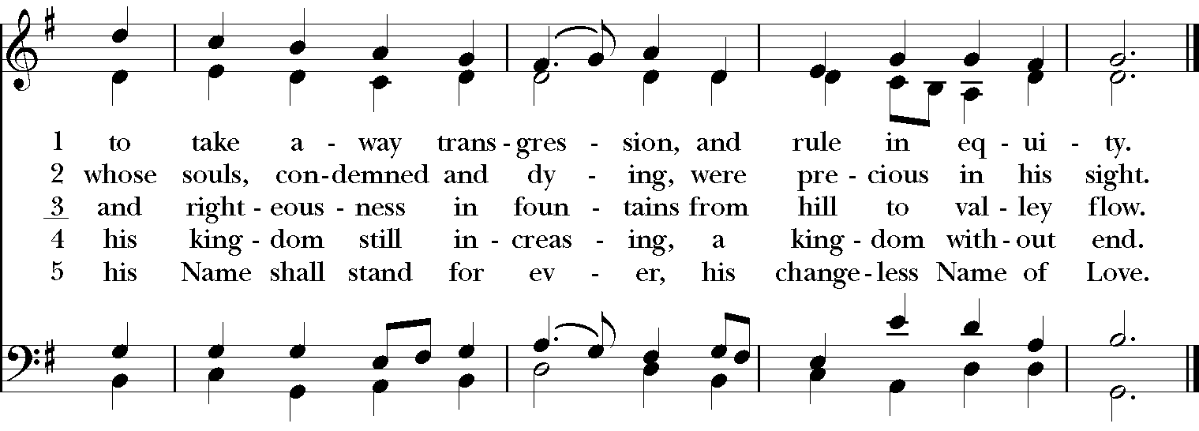

*OPENING ACCLAMATION
*OPENING ACCLAMATION
Celebrant: Blessed be God: Father, Son, and Holy Spirit.
People: And blessed be his kingdom, now and for ever. Amen.

*COLLECT FOR PURITY
Almighty God, to you all hearts are open, all desires known, and from you no secrets are hid. Cleanse the
thoughts of our hearts by the inspiration of your Holy Spirit, that we may perfectly love you, and worthily
magnify your holy Name; through Christ our Lord. Amen.

* KYRIE Lord, have mercy. Lord, have mercy. Hymnal S96
Christ, have mercy. Christ, have mercy.
Lord, have mercy. Lord, have mercy.
Lord, have mercy, have mercy.

*COLLECT OF THE DAY
Celebrant: The Lord be with you.
People: And also with you.
Celebrant: Let us pray.
Keep, O Lord, your household the Church in your steadfast faith and love, that through your grace we may proclaim your truth with boldness, and minister your justice with compassion; for the sake of our Savior Jesus Christ, who lives and reigns with you and the Holy Spirit, one God, now and for ever. Amen.

THE LESSONS

THE FIRST READING Ezekiel 17:22-24
Thus says the Lord God:
I myself will take a sprig
from the lofty top of a cedar;
I will set it out.
I will break off a tender one
from the topmost of its young twigs;
I myself will plant it
on a high and lofty mountain.
On the mountain height of Israel
I will plant it,
in order that it may produce boughs and bear fruit,
and become a noble cedar.
Under it every kind of bird will live;
in the shade of its branches will nest
winged creatures of every kind.
All the trees of the field shall know
that I am the Lord.
I bring low the high tree,
I make high the low tree;
I dry up the green tree
and make the dry tree flourish.
I the Lord have spoken;
I will accomplish it.
Lector: The Word of the Lord.
People: Thanks be to God.

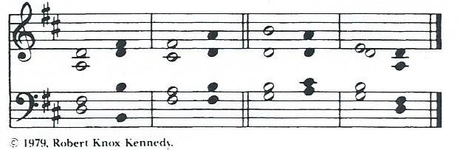

*PSALM: 92:1-4,11-14 Bonum est confiteri
1 It is a good thing to give thanks to the Lord, *
and to sing praises to your Name, O Most High;
2 To tell of your loving-kindness early in the morning *
and of your faithfulness in the night season;
3 On the psaltery, and on the lyre, *
and to the melody of the harp.
4 For you have made me glad by your acts, O Lord; *
and I shout for joy because of the works of your hands.
11 The righteous shall flourish like a palm tree, *
and shall spread abroad like a cedar of Lebanon.
12 Those who are planted in the house of the Lord *
shall flourish in the courts of our God;
13 They shall still bear fruit in old age; *
they shall be green and succulent;
14 That they may show how upright the Lord is, *
my Rock, in whom there is no fault.

THE SECOND LESSON 2 Corinthians 5:6-10,[11-13],14-17
We are always confident; even though we know that while we are at home in the body we are away from the Lord-- for we walk by faith, not by sight. Yes, we do have confidence, and we would rather be away from the body and at home with the Lord. So whether we are at home or away, we make it our aim to please him. For all of us must appear before the judgment seat of Christ, so that each may receive recompense for what has been done in the body, whether good or evil.

[Therefore, knowing the fear of the Lord, we try to persuade others; but we ourselves are well known to God, and I hope that we are also well known to your consciences. We are not commending ourselves to you again, but giving you an opportunity to boast about us, so that you may be able to answer those who boast in outward appearance and not in the heart. For if we are beside ourselves, it is for God; if we are in our right mind, it is for you.] For the love of Christ urges us on, because we are convinced that one has died for all; therefore all have died. And he died for all, so that those who live might live no longer for themselves, but for him who died and was raised for them. From now on, therefore, we regard no one from a human point of view; even though we once knew Christ from a human point of view, we know him no longer in that way. So if anyone is in Christ, there is a new creation: everything old has passed away; see, everything has become new!
Lector: The Word of the Lord.
People: Thanks be to God.

SEQUENCE HYMN: “We walk by faith, not by sight” Hymnal 209
Singing is permitted with masks on for the safety of our worshipping community. Thank you for your cooperation.
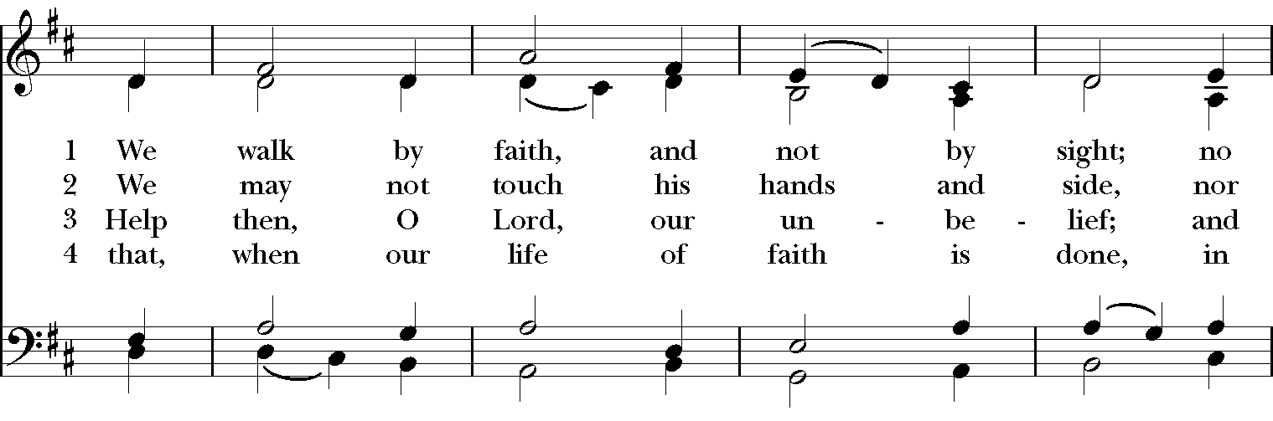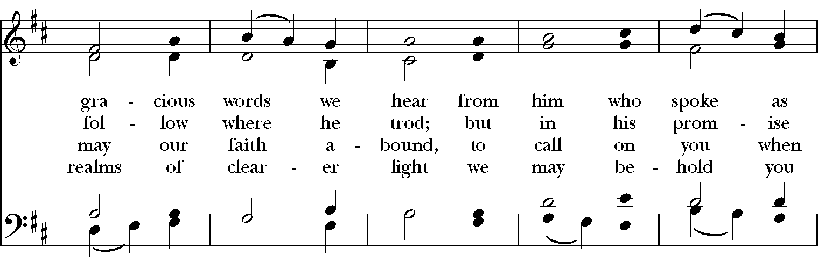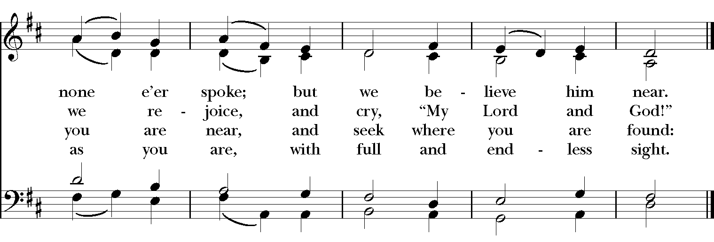
GOSPEL
Deacon: The Holy Gospel of our Lord Jesus Christ according to Mark (Mark 4:26-34).
People: Glory to you, Lord Christ.
Jesus said, “The kingdom of God is as if someone would scatter seed on the ground, and would sleep and rise night and day, and the seed would sprout and grow, he does not know how. The earth produces of itself, first the stalk, then the head, then the full grain in the head. But when the grain is ripe, at once he goes in with his sickle, because the harvest has come.”

He also said, “With what can we compare the kingdom of God, or what parable will we use for it? It is like a mustard seed, which, when sown upon the ground, is the smallest of all the seeds on earth; yet when it is sown it grows up and becomes the greatest of all shrubs, and puts forth large branches, so that the birds of the air can make nests in its shade.”

With many such parables he spoke the word to them, as they were able to hear it; he did not speak to them except in parables, but he explained everything in private to his disciples.
Deacon: The Gospel of the Lord.
People: Praise to you, Lord Christ.

Sermon The Rev. Canon Dr. Lee Anne Reat

*THE NICENE CREED
We believe in one God, the Father, the Almighty,
maker of heaven and earth, of all that is, seen and unseen.
We believe in one Lord, Jesus Christ, the only Son of God,
eternally begotten of the Father, God from God,
Light from Light, true God from true God,
begotten, not made, of one Being with the Father.
Through him all things were made.
For us and for our salvation he came down from heaven,
by the power of the Holy Spirit he became incarnate from the Virgin Mary,
and was made man.
For our sake he was crucified under Pontius Pilate;
he suffered death and was buried.
On the third day he rose again in accordance with the Scriptures;
he ascended into heaven and is seated at the right hand of the Father.
He will come again in glory to judge the living and the dead, and his kingdom will have no end.
We believe in the Holy Spirit, the Lord, the giver of life,
who proceeds from the Father, and the Son.
who with the Father and the Son is worshiped and glorified,
who has spoken through the Prophets.
We believe in one holy catholic and apostolic Church.
We acknowledge one baptism for the forgiveness of sins.
We look for the resurrection of the dead, and the life of the world to come. Amen.

THE PRAYERS OF THE PEOPLE

In peace, we pray to you Lord God. Congregational responses are in bold.

Silence

Let us pray. Founder of our faith, we ask your guidance for the Church, for its unity, and for the work it does in the world. Give grace to its leaders, especially Justin, archbishop of Canterbury; Michael, our Presiding Bishop; Ken, our Diocesan Bishop; Lee Anne, our priest; Rick, our deacon; and all the members of this parish.
R: Let your priests be clothed with righteousness; let your faithful people sing for joy.

Ruler over the nations, we pray for this country and its leaders in an unsettling time. Grant wisdom to all who serve in positions of leadership throughout the world.
R: For dominion belongs to the Lord, and he rules over the nations.

Lord of the harvest, we offer thanks for the beauty and abundance of this season. May we consider how best to tend the Earth and to share what You have given us, so that all may eat and be satisfied by your goodness. We pray for the ministries this church supports, especially Springfield Farmer’s Market, Project Woman, Children’s Defense Fund Freedom Schools, The YMCA, Jefferson St. Oasis Garden.
R: He covers the heavens with clouds, and prepares rain for the earth;
He makes grass grow upon the mountains, and green plants to serve humankind.

Giver of every good gift and we pray for those celebrating birthdays this week, especially Judy; anniversaries Kent & Rick, Steve & Denise, Dave & Bonnie, and Ross & Cathy.
R: Let the righteous be glad and rejoice before God; Let them also be merry and joyful.

Great Physician, we pray for healing and comfort for all those in need or pain, especially Leigh, Charlene, Faye, Chris, Bonnie, Alice, Diana, James, Joy, Jane, Joni, Kim, Bobby, Sarah, Traudie, Lexie, and Keith. May they remember that You are with them and those who care for them.
R: Surely you behold trouble and misery; you see it and take it into your own hand.
The helpless commit themselves to you; for you are the helper of orphans.

Just Judge, we ask your aid for all those in trouble, bringing before You prisoners and captives, refugees and the oppressed. We pray for those most vulnerable throughout the world, especially women and children.
R: Let justice roll down like waters, and righteousness like an ever-flowing stream.

Lord over life and death, we pray for all who have died, asking light and peace for them and those who mourn.
R: Precious in the sight of the Lord is the death of his servant.

*THE COLLECT FOR PEACE
Grant, O God, that your holy and life-giving Spirit may so move every human heart, that barriers which divide us may crumble, suspicions disappear, and hatreds cease; that our divisions being healed, we may live in justice and peace; through Jesus Christ our Lord. Amen.

THE CONFESSION AND ABSOLUTION
Deacon: Let us confess our sins against God and our neighbor.
All: Most merciful God, we confess that we have sinned against you in thought, word, and deed, by what we have done, and by what we have left undone. We have not loved you with our whole heart; we have not loved our neighbors as ourselves. We are truly sorry and we humbly repent. For the sake of your Son Jesus Christ, have mercy on us and forgive us; that we may delight in your will, and walk in your ways, to the glory of your Name. Amen.

Priest: Almighty God, have mercy on you, forgive you all your sins through our Lord Jesus Christ, strengthen you in all goodness, and by the power of the Holy Spirit keep you in eternal life. Amen.

*THE PEACE

ANNOUNCEMENTS
THE HOLY COMMUNION
*OFFERTORY

*THE GREAT THANKSGIVING: EUCHARISTIC PRAYER C
Celebrant The Lord be with you.
People And also with you.
Celebrant Lift up your hearts.
People We lift them to the Lord.
Celebrant Let us give thanks to the Lord our God.
People It is right to give God thanks and praise.

God of all power, Ruler of the Universe, you are worthy of glory and praise.
Glory to you for ever and ever.

At your command all things came to be: the vast expanse of interstellar space, galaxies, suns, the planets in their courses, and this fragile earth, our island home.
By your will they were created and have their being.

From the primal elements you brought forth the human race, and blessed us with memory, reason, and skill. You made us the stewards of creation. But we turned against you, and betrayed your trust; and we turned against one another.
Have mercy, Lord, for we are sinners in your sight.

Again and again, you called us to return. Through prophets and sages you revealed your righteous Law. And in the fullness of time you sent your only Son, born of a woman, to fulfill your Law, to open for us the way of freedom and peace.
By his blood, he reconciled us. By his wounds, we are healed.

And therefore we praise you, joining with the heavenly chorus, with prophets, apostles, and martyrs, and with all those in every generation who have looked to you in hope, to proclaim with them your glory, in their unending hymn:
Holy, holy, holy Lord, God of power and might, Hymnal S130
heaven and earth are full of your glory.
Hosanna in the highest. Hosanna in the highest.
Blessed is he who comes in the name of the Lord.
Hosanna in the highest. Hosanna in the highest.

And so, Father, we who have been redeemed by him, and made a new people by water and the Spirit, now bring before you these gifts. Sanctify them by your Holy Spirit to be the Body and Blood of Jesus Christ our Lord.

On the night he was betrayed he took bread, said the blessing, broke the bread, and gave it to his friends, and said, “Take, eat: This is my Body, which is given for you. Do this for the remembrance of me.”

After supper, he took the cup of wine, gave thanks, and said, “Drink this, all of you: This is my Blood of the new Covenant, which is shed for you and for many for the forgiveness of sins. Whenever you drink it, do this for the remembrance of me.”

Remembering now his work of redemption, and offering to you this sacrifice of thanksgiving,
We celebrate his death and resurrection, as we await the day of his coming.

Lord God of our Ancestors; God of Abraham and Sarah, Isaac and Rebecca, Jacob and Rachel and Leah; God and Father of our Lord Jesus Christ: Open our eyes to see your hand at work in the world about us. Deliver us from the presumption of coming to this Table for solace only, and not for strength; for pardon only, and not for renewal. Let the grace of this Holy Communion make us one body, one spirit in Christ, that we may worthily serve the world in his name.
Risen Lord, be known to us in the breaking of the Bread.

Accept these prayers and praises, Father, through Jesus Christ our great High Priest, to whom, with you and the Holy Spirit, your Church gives honor, glory, and worship, from generation to generation. Amen.

And now, as our Savior Christ has taught us, we are bold to say,
Our Father, who art in heaven, hallowed be thy name,
thy kingdom come, thy will be done, on earth as it is in heaven.
Give us this day our daily bread.
And forgive us our trespasses,
as we forgive those who trespass against us.
And lead us not into temptation, but deliver us from evil.
For thine is the kingdom, and the power, and the glory,
for ever and ever. Amen.

THE BREAKING OF THE BREAD Hymnal S155

Christ our Passover is sacrificed for us,
therefore let us keep the feast.

THE INVITATION TO COMMUNION

PRAYER AFTER COMMUNION
Eternal God, heavenly Father, you have graciously accepted us as living members
of your Son our Savior Jesus Christ, and you have fed us with spiritual food
in the Sacrament of his Body and Blood. Send us now into the world in peace,
and grant us strength and courage to love and serve you
with gladness and singleness of heart; through Christ our Lord. Amen.

*THE BLESSING
Christ who has nourished us with himself the living bread, make you one in praise and love, and raise you up at the last day; and the blessing God Almighty, the Father, the Son, and the Holy Spirit, be among you, and remain with you always. Amen.

*THE DISMISSAL Deacon: Go in peace to love and serve the Lord.
People: Thanks be to God.

CLOSING HYMN: “O day of God, draw nigh” Hymnal 601
Singing is permitted with masks on for the safety of our worshipping community. Thank you for your cooperation.
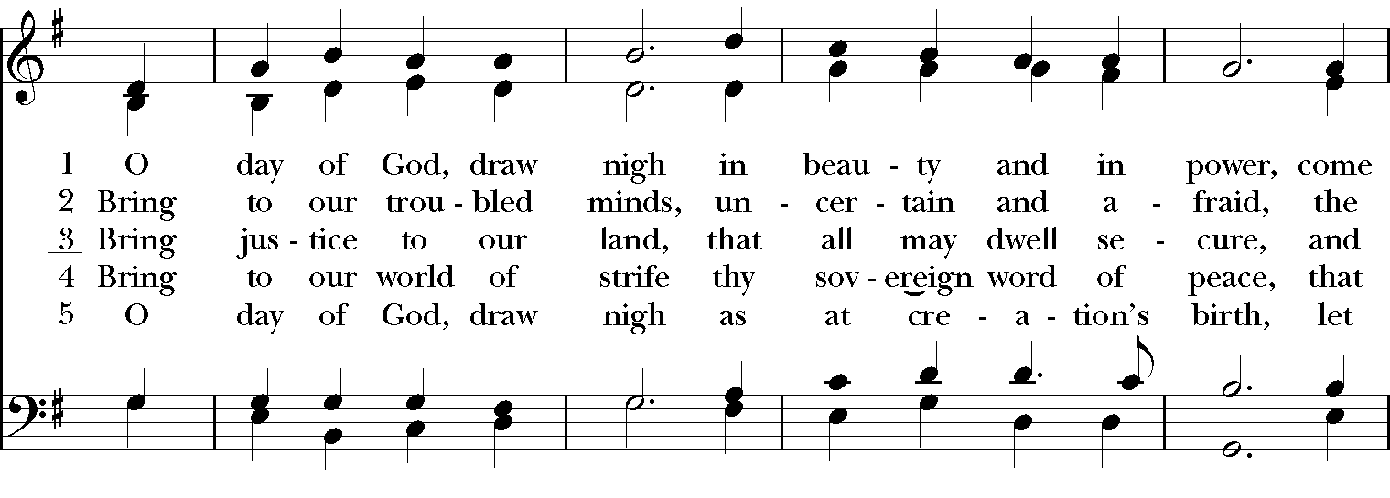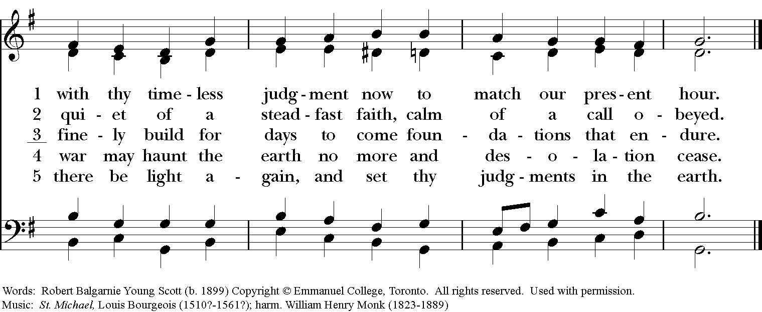

POSTLUDE:

Ministers for June 13th, 2021
Altar Guild: Joan Hurley
Lector: Anne Strothman
Ushers: Anne Strothman

General Information
Rector: The Rev. Canon Dr. Lee Anne Reat
Deacon: The Rev. Rick Incorvati
Senior Warden: Dawn Ivy
Junior Warden: Scott Yeazell
Treasurer: Ken Bladh
Vestry at Large: Bonnie Bingman, Kay Koeninger, Jimmy Ryan,
Linda Mortensen, Joyce Spangler, Denise Sharp, and Keith Doubt
Parish Administrator & Program Coordinator: Kelly Zeller
Director of Music: Dr. Christopher Durrenberger
Nursery Attendant: Jerushia Knox
Facility Manager: Paul McAfee
Bookkeeper: Tina Knox

Altar Flowers
The flowers are given today in memory of Lynn Rigsbee.

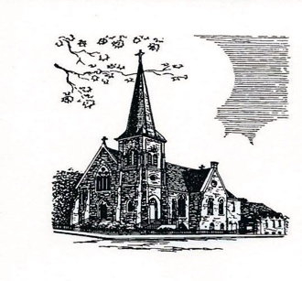

Christ Episcopal Church
409 East High Street
Springfield, Ohio 45505
937-323-8651
www.christspringfield.org

