Christ Episcopal Church in Springfield, Ohio
Service of the Word
Third Sunday of Easter: April 18th, 2021 at 9 am

PRELUDE:

OPENING HYMN: “ The strife is o’er, the battle done” Hymnal 208
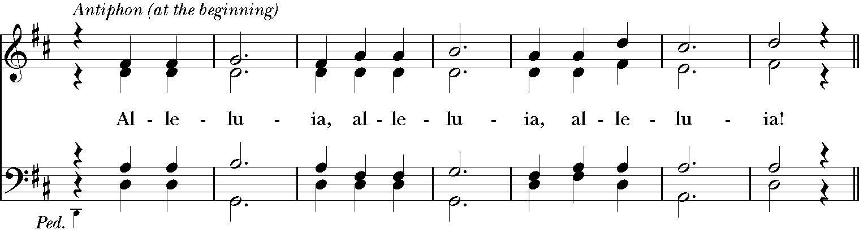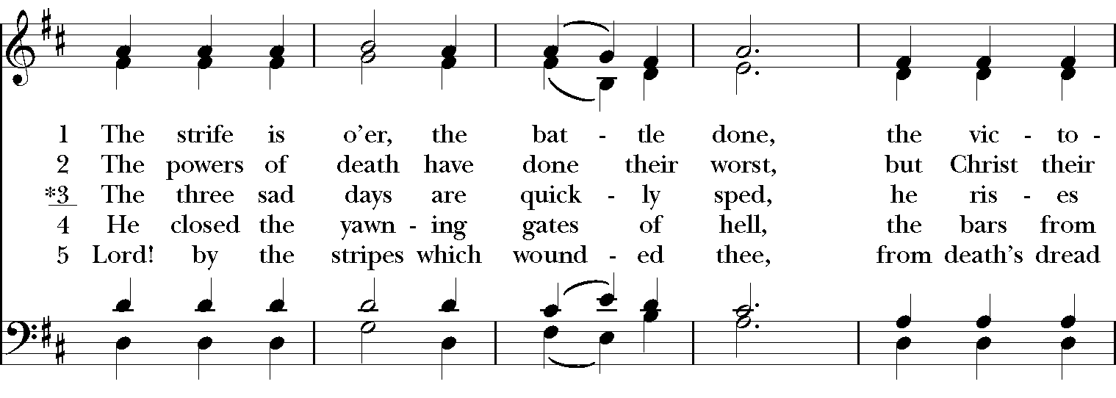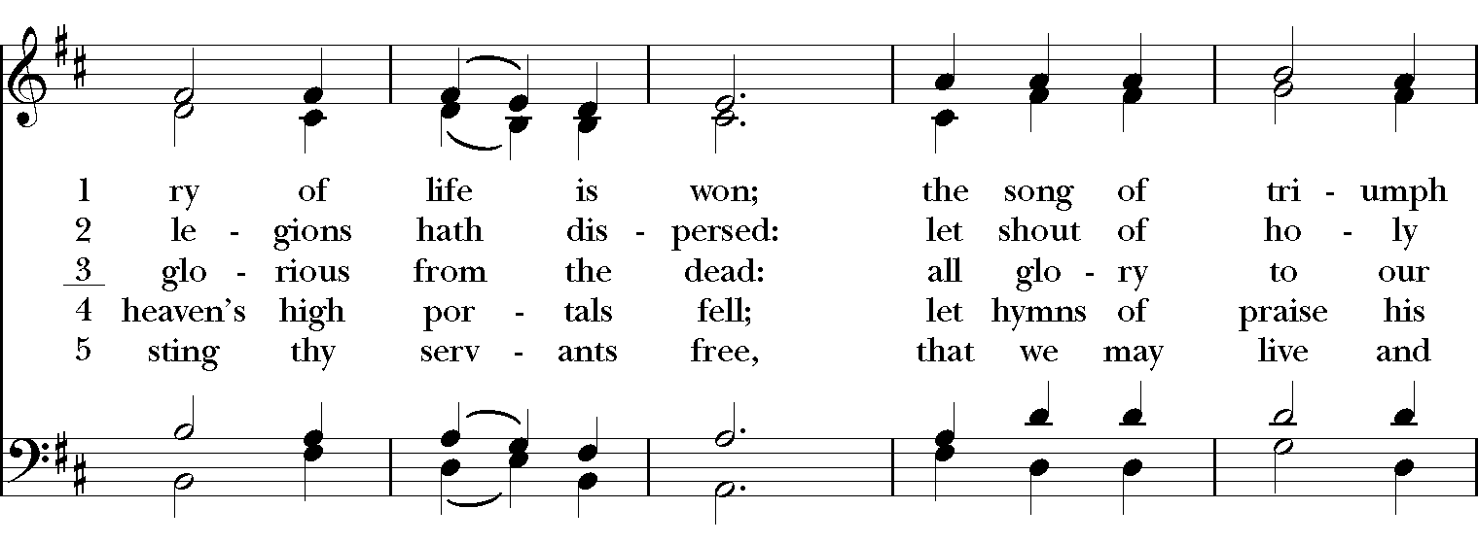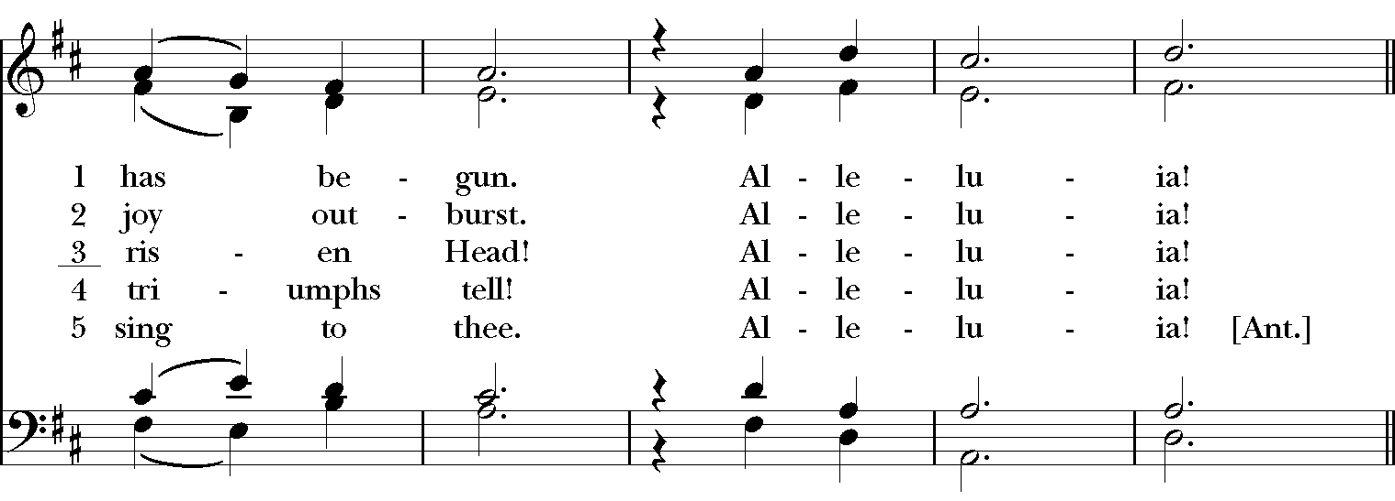
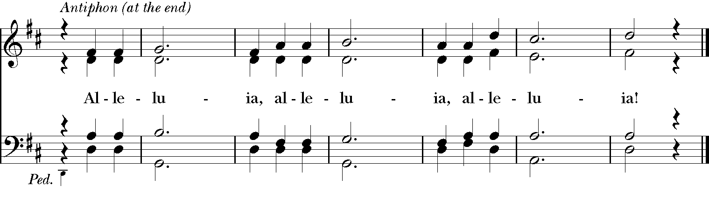
Celebrant: Alleluia! Christ has risen!
People: The Lord is risen indeed. Alleluia!

The Collect of the Day
Celebrant: The Lord be with you.
People: And also with you.
Celebrant: Let us pray.
O God, whose blessed Son made himself known to his disciples in the breaking of bread: Open the eyes of our faith, that we may behold him in all his redeeming work; who lives and reigns with you, in the unity of the Holy Spirit, one God, now and for ever. Amen.

The Lessons

THE FIRST READING Acts 3:12-19
Peter addressed the people, “You Israelites, why do you wonder at this, or why do you stare at us, as though by our own power or piety we had made him walk? The God of Abraham, the God of Isaac, and the God of Jacob, the God of our ancestors has glorified his servant Jesus, whom you handed over and rejected in the presence of Pilate, though he had decided to release him. But you rejected the Holy and Righteous One and asked to have a murderer given to you, and you killed the Author of life, whom God raised from the dead. To this we are witnesses. And by faith in his name, his name itself has made this man strong, whom you see and know; and the faith that is through Jesus has given him this perfect health in the presence of all of you.

“And now, friends, I know that you acted in ignorance, as did also your rulers. In this way God fulfilled what he had foretold through all the prophets, that his Messiah would suffer. Repent therefore, and turn to God so that your sins may be wiped out.”
Lector: The Word of the Lord.
People: Thanks be to God.

*PSALM: 4 Cum invocarem
1 Answer me when I call, O God, defender of my cause; *
you set me free when I am hard-pressed; have mercy on me and hear my prayer.
2 "You mortals, how long will you dishonor my glory; *
how long will you worship dumb idols and run after false gods?"
3 Know that the Lord does wonders for the faithful; *
when I call upon the Lord, he will hear me.
4 Tremble, then, and do not sin; *
speak to your heart in silence upon your bed.
5 Offer the appointed sacrifices *
and put your trust in the Lord.
6 Many are saying, "Oh, that we might see better times!" *
Lift up the light of your countenance upon us, O Lord.
7 You have put gladness in my heart, *
more than when grain and wine and oil increase.
8 I lie down in peace; at once I fall asleep; *
for only you, Lord, make me dwell in safety.

THE SECOND LESSON 1 John 3:1-71
See what love the Father has given us, that we should be called children of God; and that is what we are. The reason the world does not know us is that it did not know him. Beloved, we are God's children now; what we will be has not yet been revealed. What we do know is this: when he is revealed, we will be like him, for we will see him as he is. And all who have this hope in him purify themselves, just as he is pure.

Everyone who commits sin is guilty of lawlessness; sin is lawlessness. You know that he was revealed to take away sins, and in him there is no sin. No one who abides in him sins; no one who sins has either seen him or known him. Little children, let no one deceive you. Everyone who does what is right is righteous, just as he is righteous.
Lector: The Word of the Lord.
People: Thanks be to God.
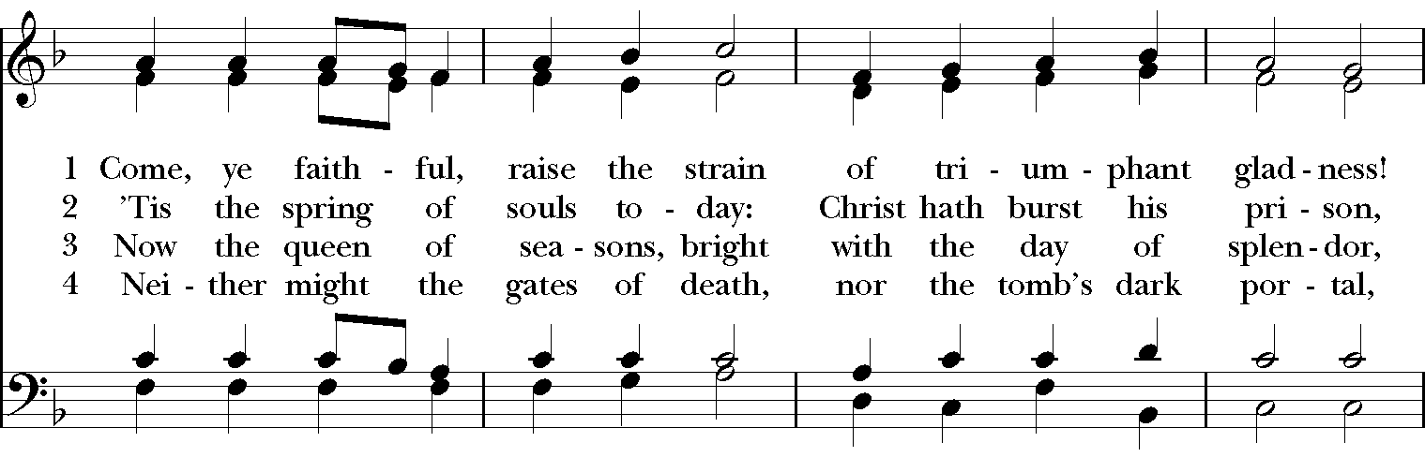
SEQUENCE HYMN: “Come ye faithful, raise the strain” Hymnal 199
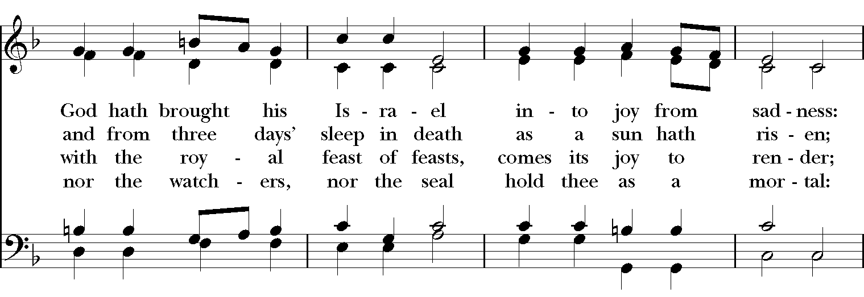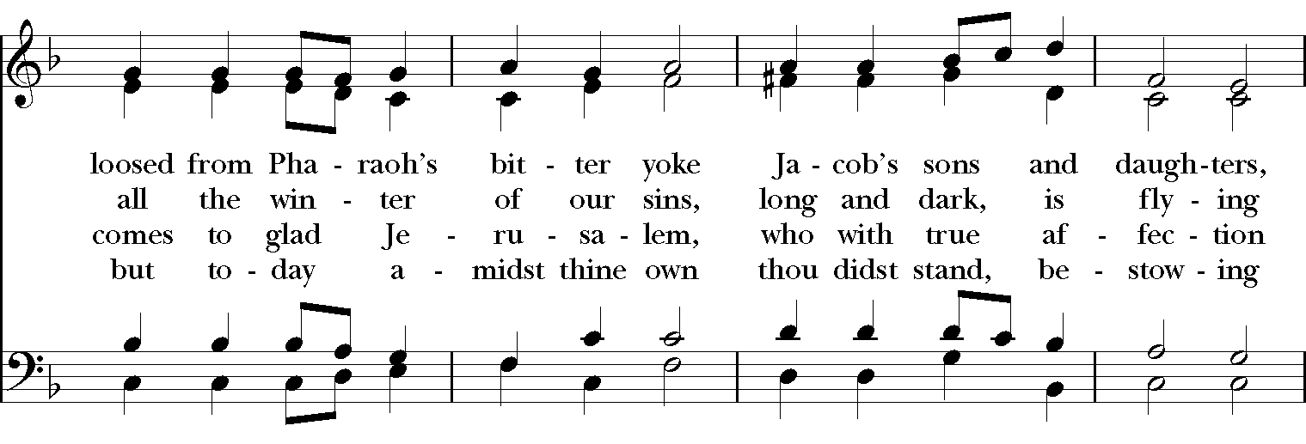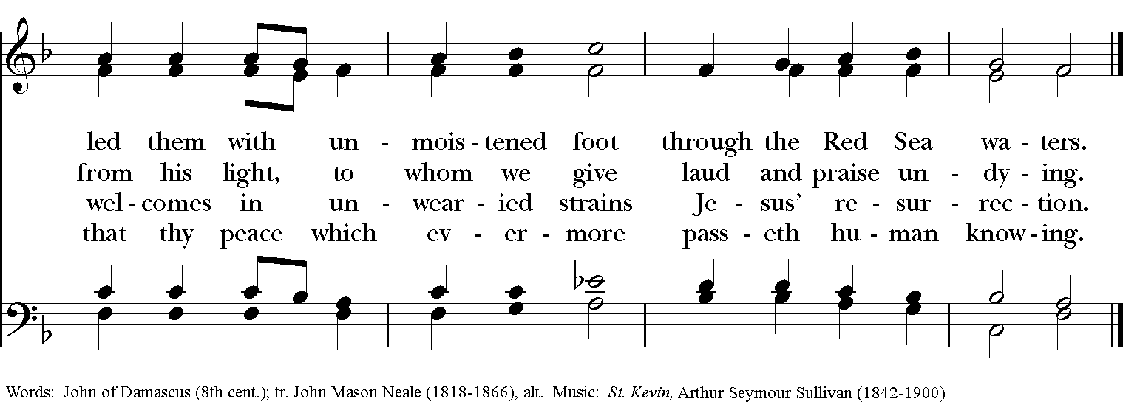

Gospel
Deacon: The Holy Gospel of our Lord Jesus Christ according to Luke (Luke 24:36b-48).
People: Glory to you, Lord Christ.
Jesus himself stood among the disciples and said to them, “Peace be with you.” They were startled and terrified, and thought that they were seeing a ghost. He said to them, “Why are you frightened, and why do doubts arise in your hearts? Look at my hands and my feet; see that it is I myself. Touch me and see; for a ghost does not have flesh and bones as you see that I have.” And when he had said this, he showed them his hands and his feet. While in their joy they were disbelieving and still wondering, he said to them, “Have you anything here to eat?” They gave him a piece of broiled fish, and he took it and ate in their presence.
Then he said to them, “These are my words that I spoke to you while I was still with you—that everything written about me in the law of Moses, the prophets, and the psalms must be fulfilled.” Then he opened their minds to understand the scriptures, and he said to them, “Thus it is written, that the Messiah is to suffer and to rise from the dead on the third day, and that repentance and forgiveness of sins is to be proclaimed in his name to all nations, beginning from Jerusalem. You are witnesses of these things.
Deacon: The Gospel of the Lord.
People: Praise to you, Lord Christ.

Sermon The Rev. Canon Lee Anne Reat

The Nicene Creed
We believe in one God, the Father, the Almighty,
maker of heaven and earth, of all that is, seen and unseen.
We believe in one Lord, Jesus Christ, the only Son of God,
eternally begotten of the Father, God from God,
Light from Light, true God from true God,
begotten, not made, of one Being with the Father.
Through him all things were made.
For us and for our salvation he came down from heaven,
by the power of the Holy Spirit he became incarnate from the Virgin Mary,
and was made man.
For our sake he was crucified under Pontius Pilate;
he suffered death and was buried.
On the third day he rose again in accordance with the Scriptures;
he ascended into heaven and is seated at the right hand of the Father.
He will come again in glory to judge the living and the dead, and his kingdom will have no end.
We believe in the Holy Spirit, the Lord, the giver of life,
who proceeds from the Father, and the Son.
who with the Father and the Son is worshiped and glorified,
who has spoken through the Prophets.
We believe in one holy catholic and apostolic Church.
We acknowledge one baptism for the forgiveness of sins.
We look for the resurrection of the dead, and the life of the world to come. Amen.

The Prayers of the People

In peace, we pray to you Lord God. Congregational responses are in bold.

Silence

Blessed are you eternal God,
to be praised and glorified forever.

Hear us as we pray for the unity of the Church.
May we all be one, that the world may come to know you.

Grant that every member of the Church may truly and humbly serve you,
that the life of Christ may be revealed in us.

We remember those who have died.
Into your hands we commend them.
We praise you for all your saints who have entered eternal glory.
May we also come to share your heavenly kingdom.

Have compassion on those who suffer from sickness, grief or trouble, especially Charlene, Laura, Faye, Chris, Bonnie, Alice, Diana, James, Joy, Jane, Joni, Kim, Bobby, Sarah, Traudie, Lexie, and Keith.
In your presence may they find strength.

Look with kindness on our homes and families, and all who celebrate birthdays this week, especially Terry, Kathleen, Wendy, Keith, Betsi, and Bonnie and for anniversaries this week, Vijay & Ann and Danny & Shannon.
Grant that your love may grow in our hearts.

Make us alive to the needs of our community, and bless the holy work of Springfield Farmer’s Market, Project Woman, Children’s Defense Fund Freedom Schools, The YMCA, and Jefferson St. Oasis Garden.
Help us to share one another’s joys and burdens.

Inspire and lead those who hold authority in the nations of the world.
Guide us and all people in the way of justice and peace.

For Justin, Archbishop of Canterbury; Michael, our Presiding Bishop; Ken, our Diocesan Bishop; Lee Anne, our priest; Rick, our deacon; and all who minister in Christ, that they may be firmly rooted in your truth and love.
Inspire us and give us courage to proclaim your Gospel of Resurrection.

*THE COLLECT FOR PEACE
Grant, O God, that your holy and life-giving Spirit may so move every human heart, that barriers which divide us may crumble, suspicions disappear, and hatreds cease; that our divisions being healed, we may live in justice and peace; through Jesus Christ our Lord. Amen.

Deacon: Let us confess our sins against God and our neighbor.
All: Most merciful God, we confess that we have sinned against you in thought, word, and deed, by what we have done, and by what we have left undone. We have not loved you with our whole heart; we have not loved our neighbors as ourselves. We are truly sorry and we humbly repent. For the sake of your Son Jesus Christ, have mercy on us and forgive us; that we may delight in your will, and walk in your ways, to the glory of your Name. Amen.

Priest: Almighty God, have mercy on you, forgive you all your sins through our Lord Jesus Christ, strengthen you in all goodness, and by the power of the Holy Spirit keep you in eternal life. Amen.

And now, as our Savior Christ has taught us, we are bold to say:
Our Father, who art in heaven, hallowed be thy Name,
thy kingdom come, thy will be done, on earth as it is in heaven.
Give us this day our daily bread.
And forgive us our trespasses, as we forgive those who trespass against us.
And lead us not into temptation, but deliver us from evil.
For thine is the kingdom, and the power, and the glory, for ever and ever. Amen

CLOSING HYMN: “O for a thousand tongues to sing” Hymnal 493
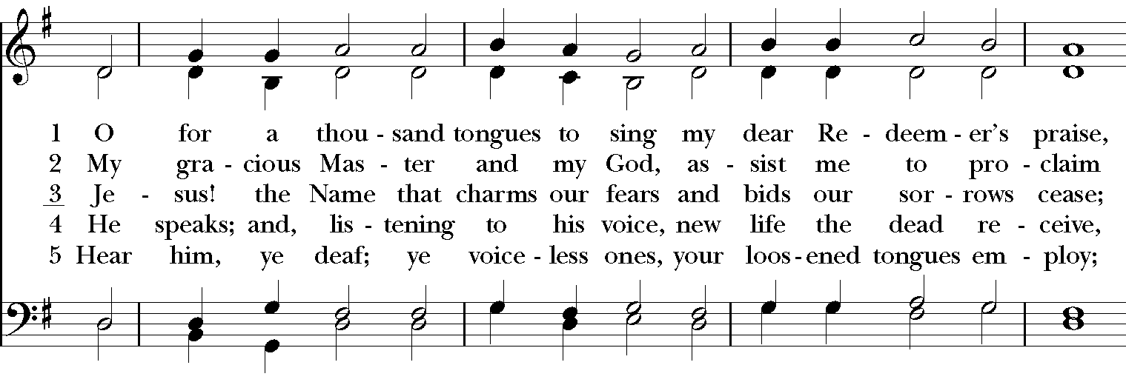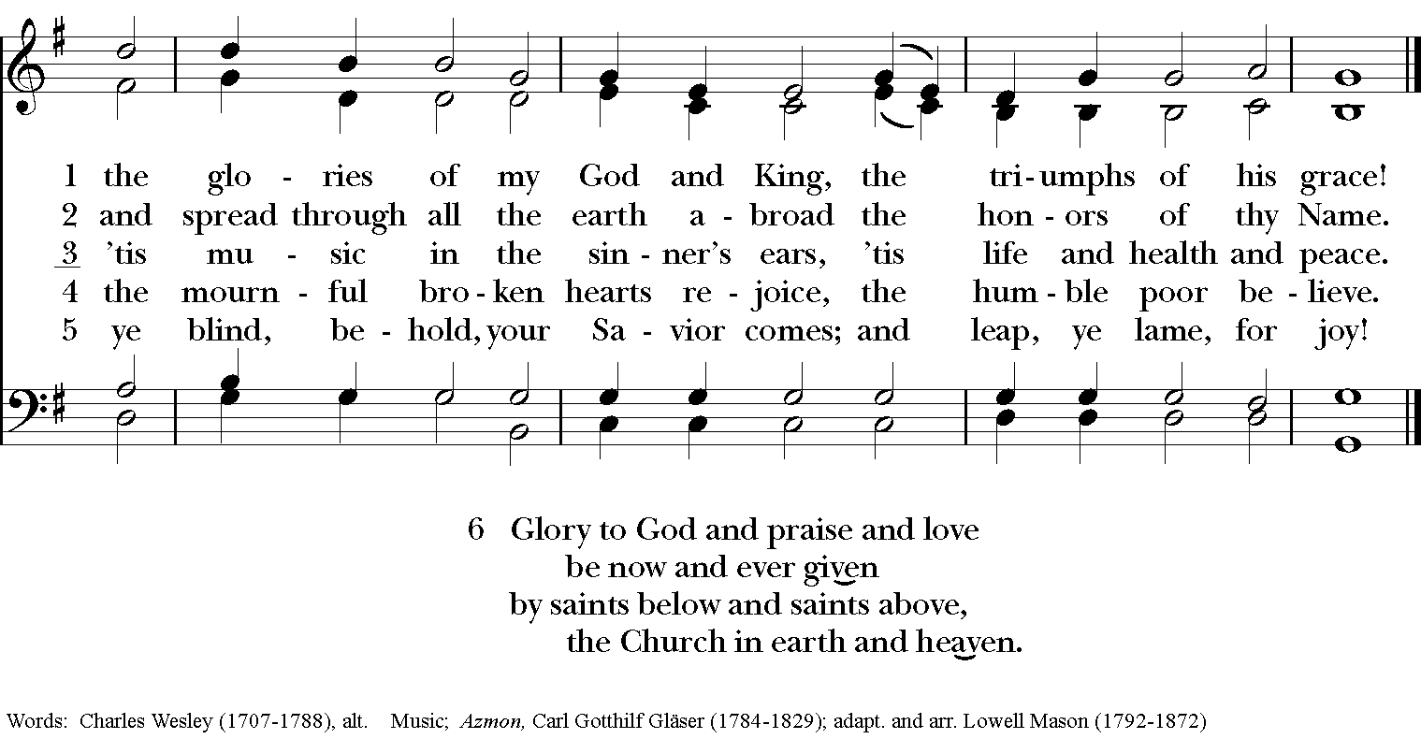
*THE BLESSING
The God of peace, who brought again from the dead our Lord Jesus Christ, the great Shepherd of the sheep, through the blood of the everlasting covenant, make you perfect in every good work to do his will, working in you that which is well-pleasing in his sight; and the blessing of God Almighty, the Father, the Son, and the Holy Spirit, be among you, and remain with you always. Amen.

*THE DISMISSAL Deacon: Go in peace to love and serve the Lord. Alleluia, alleluia!
People: Thanks be to God. Alleluia, alleluia!

POSTLUDE:

Thank you for your spiritual presence with us this morning!
Although we're physically apart, we are united in prayer, worship, and holy love!
Priest-In-Charge: The Rev. Dr. Canon Lee Anne Reat
Deacon: The Rev. Dr. Rick Incorvati
Music Director: Dr. Chris Durrenberger
Lector: Sarah Schubert
Singers: Liz Wheeler, Joy Carter, Ed Hasecke, Chris Oldstone-Moore
Technology: Steve Ide
Slideshow: Ed Hasecke
Parish Administrator and Program Coordinator: Kelly Zeller

