Christ Episcopal Church in Springfield, Ohio
Service of the Word
Fourth Sunday after Pentecost: June 20, 2021 at 9 am

PRELUDE:

OPENING HYMN: “Fight the good fight with all thy might” Hymnal 552
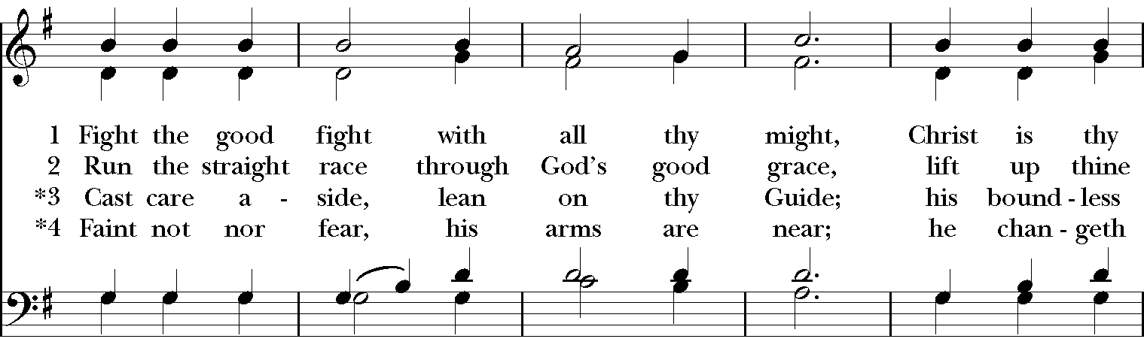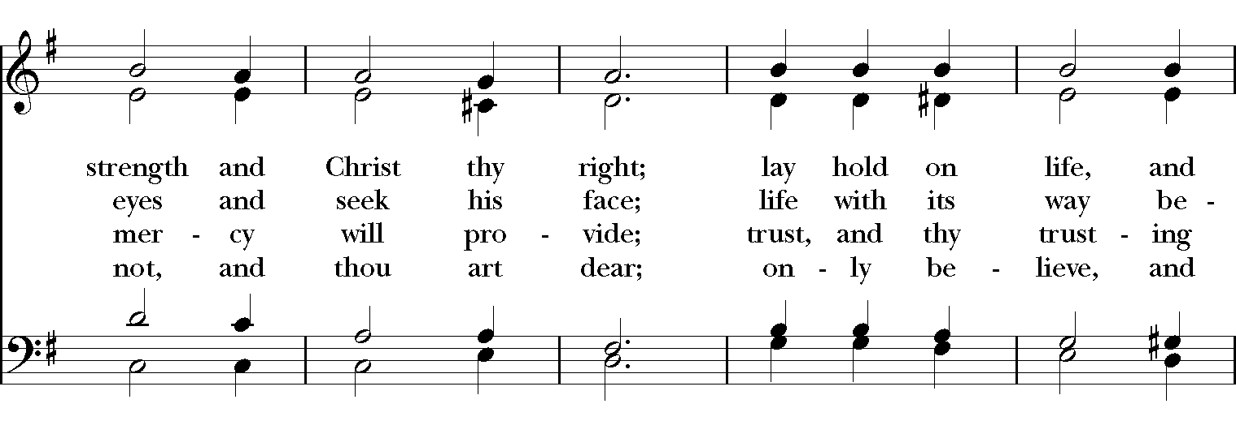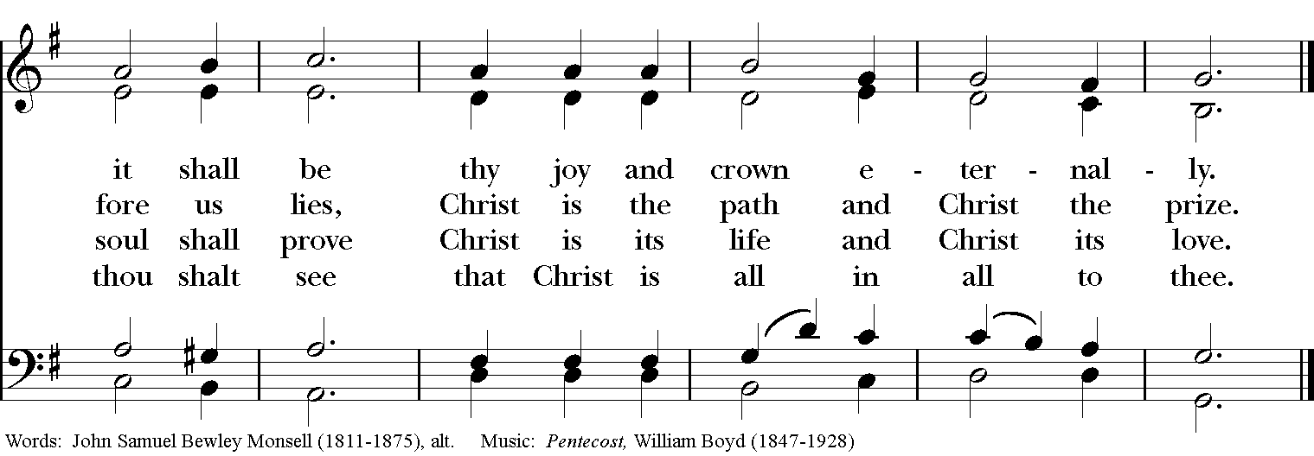

Celebrant: Blessed be God: Father, Son, and Holy Spirit.
People: And blessed be his kingdom, now and for ever. Amen.

The Collect of the Day
Celebrant: The Lord be with you.
People: And also with you.
Celebrant: Let us pray.
O Lord, make us have perpetual love and reverence for your holy Name, for you never fail to help and govern those whom you have set upon the sure foundation of your loving-kindness; through Jesus Christ our Lord, who lives and reigns with you and the Holy Spirit, one God, for ever and ever. Amen.
THE LESSONS

THE FIRST READING Job 38:1-11

The Lord answered Job out of the whirlwind:
"Who is this that darkens counsel by words without knowledge?
Gird up your loins like a man,
I will question you, and you shall declare to me.

"Where were you when I laid the foundation of the earth?
Tell me, if you have understanding.
Who determined its measurements—surely you know!
Or who stretched the line upon it?
On what were its bases sunk,
or who laid its cornerstone
when the morning stars sang together
and all the heavenly beings shouted for joy?

"Or who shut in the sea with doors
when it burst out from the womb?—
when I made the clouds its garment,
and thick darkness its swaddling band,
and prescribed bounds for it,
and set bars and doors,
and said, 'Thus far shall you come, and no farther,
and here shall your proud waves be stopped'?"
Lector: The Word of the Lord.
People: Thanks be to God.

Psalm 107:1-3, 23-32 Confitemini Domino
1 Give thanks to the Lord, for he is good, *
and his mercy endures for ever.
2 Let all those whom the Lord has redeemed proclaim *
that he redeemed them from the hand of the foe.
3 He gathered them out of the lands; *
from the east and from the west, from the north and from the south.
23 Some went down to the sea in ships *
and plied their trade in deep waters;
24 They beheld the works of the Lord *
and his wonders in the deep.
25 Then he spoke, and a stormy wind arose, *
which tossed high the waves of the sea.
26 They mounted up to the heavens and fell back to the depths; *
their hearts melted because of their peril.
27 They reeled and staggered like drunkards *
and were at their wits' end.
28 Then they cried to the Lord in their trouble, *
and he delivered them from their distress.
29 He stilled the storm to a whisper *
and quieted the waves of the sea.
30 Then were they glad because of the calm, *
and he brought them to the harbor they were bound for.
31 Let them give thanks to the Lord for his mercy *
and the wonders he does for his children.
32 Let them exalt him in the congregation of the people *
and praise him in the council of the elders.

THE SECOND LESSON 2 Corinthians 6:1-13
As we work together with Christ, we urge you also not to accept the grace of God in vain. For he says,

“At an acceptable time I have listened to you, and on a day of salvation I have helped you.”

See, now is the acceptable time; see, now is the day of salvation! We are putting no obstacle in anyone's way, so that no fault may be found with our ministry, but as servants of God we have commended ourselves in every way: through great endurance, in afflictions, hardships, calamities, beatings, imprisonments, riots, labors, sleepless nights, hunger; by purity, knowledge, patience, kindness, holiness of spirit, genuine love, truthful speech, and the power of God; with the weapons of righteousness for the right hand and for the left; in honor and dishonor, in ill repute and good repute. We are treated as impostors, and yet are true; as unknown, and yet are well known; as dying, and see-- we are alive; as punished, and yet not killed; as sorrowful, yet always rejoicing; as poor, yet making many rich; as having nothing, and yet possessing everything.

We have spoken frankly to you Corinthians; our heart is wide open to you. There is no restriction in our affections, but only in yours. In return-- I speak as to children-- open wide your hearts also.
Lector: The Word of the Lord.
People: Thanks be to God.

SEQUENCE HYMN: “Lead us, heavenly Father, lead us” Hymnal 559
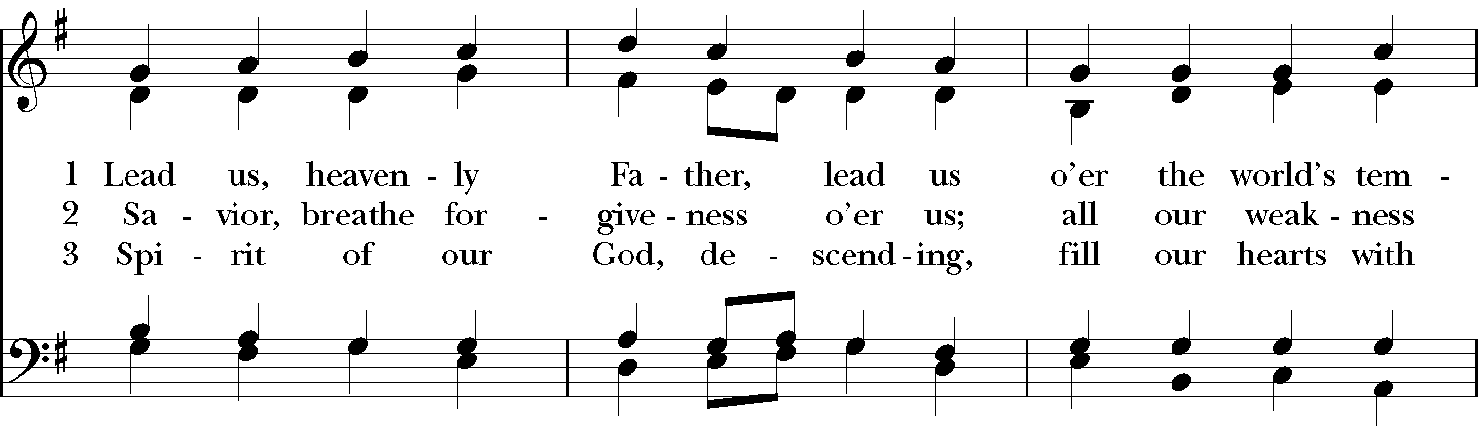

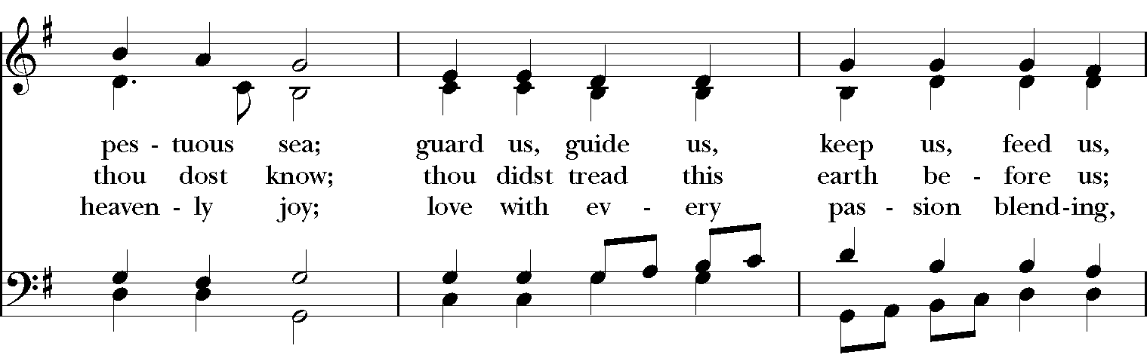

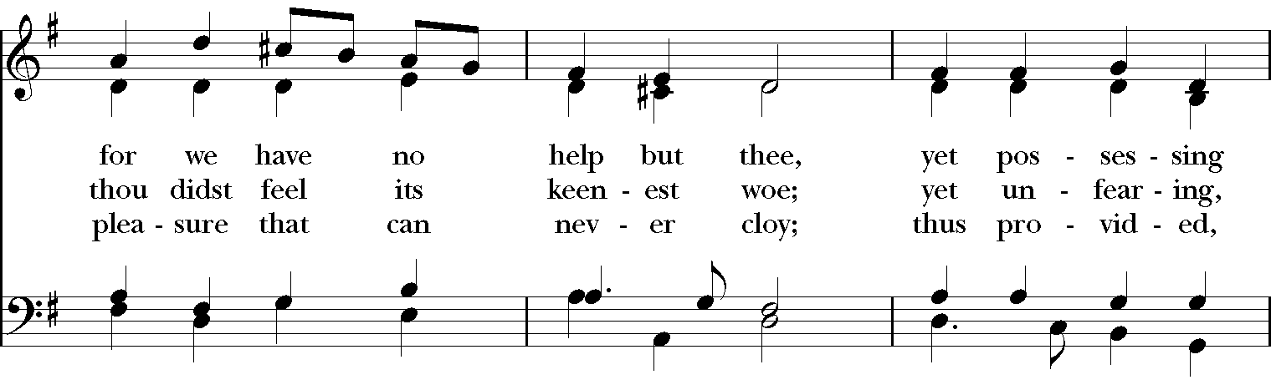

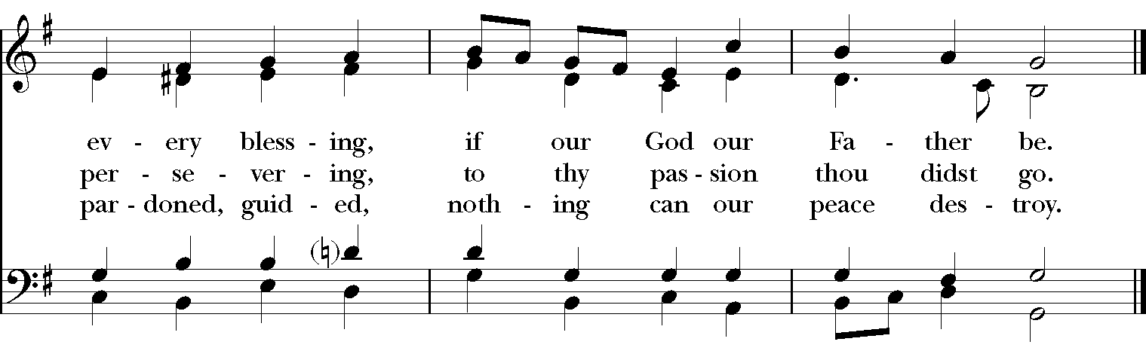

GOSPEL
Deacon: The Holy Gospel of our Lord Jesus Christ according to Mark (Mark 4:35-41).
People: Glory to you, Lord Christ
When evening had come, Jesus said to his disciples, “Let us go across to the other side.” And leaving the crowd behind, they took him with them in the boat, just as he was. Other boats were with him. A great windstorm arose, and the waves beat into the boat, so that the boat was already being swamped. But he was in the stern, asleep on the cushion; and they woke him up and said to him, “Teacher, do you not care that we are perishing?” He woke up and rebuked the wind, and said to the sea, “Peace! Be still!” Then the wind ceased, and there was a dead calm. He said to them, “Why are you afraid? Have you still no faith?” And they were filled with great awe and said to one another, “Who then is this, that even the wind and the sea obey him?”
Deacon: The Gospel of the Lord.
People: Praise to you, Lord Christ.

Sermon The Rev. Canon Dr. Lee Anne Reat

The Nicene Creed
We believe in one God, the Father, the Almighty,
maker of heaven and earth, of all that is, seen and unseen.
We believe in one Lord, Jesus Christ, the only Son of God,
eternally begotten of the Father, God from God,
Light from Light, true God from true God,
begotten, not made, of one Being with the Father.
Through him all things were made.
For us and for our salvation he came down from heaven,
by the power of the Holy Spirit he became incarnate from the Virgin Mary,
and was made man.
For our sake he was crucified under Pontius Pilate;
he suffered death and was buried.
On the third day he rose again in accordance with the Scriptures;
he ascended into heaven and is seated at the right hand of the Father.
He will come again in glory to judge the living and the dead, and his kingdom will have no end.
We believe in the Holy Spirit, the Lord, the giver of life,
who proceeds from the Father, and the Son.
who with the Father and the Son is worshiped and glorified,
who has spoken through the Prophets.
We believe in one holy catholic and apostolic Church.
We acknowledge one baptism for the forgiveness of sins.
We look for the resurrection of the dead, and the life of the world to come. Amen.

The Prayers of the People

In peace, we pray to you Lord God. Congregational responses are in bold.

Silence

Let us pray. Founder of our faith, we ask your guidance for the Church, for its unity, and for the work it does in the world. Give grace to its leaders, especially Justin, archbishop of Canterbury; Michael, our Presiding Bishop; Ken, our Diocesan Bishop; Lee Anne, our priest; Rick, our deacon; and all the members of this parish.
R: Let your priests be clothed with righteousness; let your faithful people sing for joy.

Ruler over the nations, we pray for this country and its leaders in an unsettling time. Grant wisdom to all who serve in positions of leadership throughout the world.
R: For dominion belongs to the Lord, and he rules over the nations.

Lord of the harvest, we offer thanks for the beauty and abundance of this season. May we consider how best to tend the Earth and to share what You have given us, so that all may eat and be satisfied by your goodness. We pray for the ministries this church supports, especially Rainbow Table, Springfield Promise Neighborhood, Springfield Peace Center, and Partners in Ministry in Liberia.
R: He covers the heavens with clouds, and prepares rain for the earth;
He makes grass grow upon the mountains, and green plants to serve humankind.

Giver of every good gift, we pray for those celebrating birthdays and anniversaries this week, especially Bruce, Barb, and Sharon.
R: Let the righteous be glad and rejoice before God; Let them also be merry and joyful.

Great Physician, we pray for healing and comfort for all those in need or pain, especially Leigh, Charlene, Faye, Chris, Bonnie, Alice, Diana, James, Joy, Jane, Joni, Kim, Bobby, Sarah, Traudie, Lexie, and Keith. May they remember that You are with them and those who care for them.
R: Surely you behold trouble and misery; you see it and take it into your own hand.
The helpless commit themselves to you; for you are the helper of orphans.

Just Judge, we ask your aid for all those in trouble, bringing before You prisoners and captives, refugees and the oppressed. We pray for those most vulnerable throughout the world, especially women and children.
R: Let justice roll down like waters, and righteousness like an ever-flowing stream.

Lord over life and death, we pray for all who have died, asking light and peace for them and those who mourn.
R: Precious in the sight of the Lord is the death of his servant.
*THE COLLECT FOR PEACE
Grant, O God, that your holy and life-giving Spirit may so move every human heart, that barriers which divide us may crumble, suspicions disappear, and hatreds cease; that our divisions being healed, we may live in justice and peace; through Jesus Christ our Lord. Amen.

THE CONFESSION AND ABSOLUTION
Deacon: Let us confess our sins against God and our neighbor.
All: Most merciful God, we confess that we have sinned against you in thought, word, and deed, by what we have done, and by what we have left undone. We have not loved you with our whole heart; we have not loved our neighbors as ourselves. We are truly sorry and we humbly repent. For the sake of your Son Jesus Christ, have mercy on us and forgive us; that we may delight in your will, and walk in your ways, to the glory of your Name. Amen.

Priest: Almighty God, have mercy on you, forgive you all your sins through our Lord Jesus Christ, strengthen you in all goodness, and by the power of the Holy Spirit keep you in eternal life. Amen.

And now, as our Savior Christ has taught us, we are bold to say:
Our Father, who art in heaven, hallowed be thy Name,
thy kingdom come, thy will be done, on earth as it is in heaven.
Give us this day our daily bread.
And forgive us our trespasses, as we forgive those who trespass against us.
And lead us not into temptation, but deliver us from evil.
For thine is the kingdom, and the power, and the glory, for ever and ever. Amen

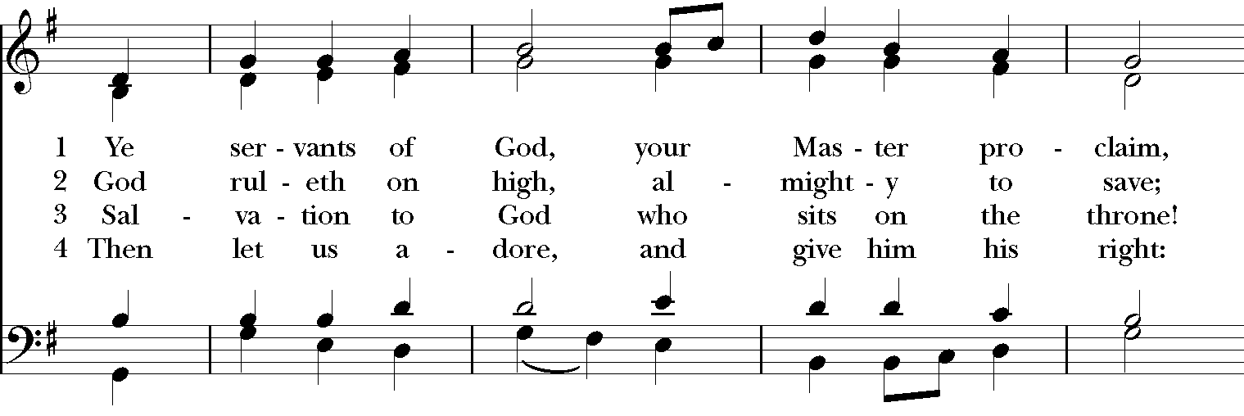
CLOSING HYMN: “Ye servants of God, your Master proclaim” Hymnal 535
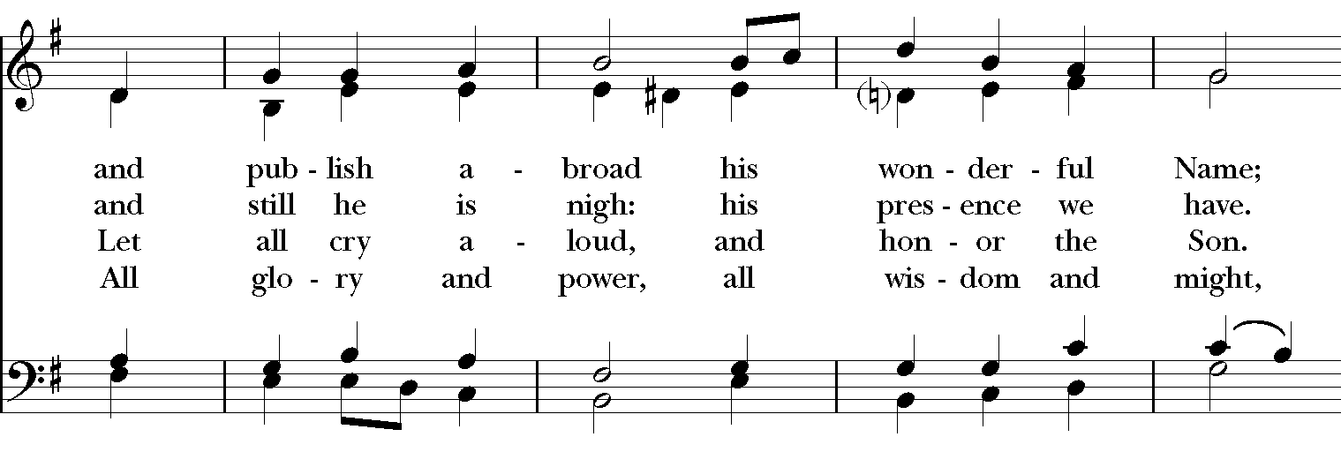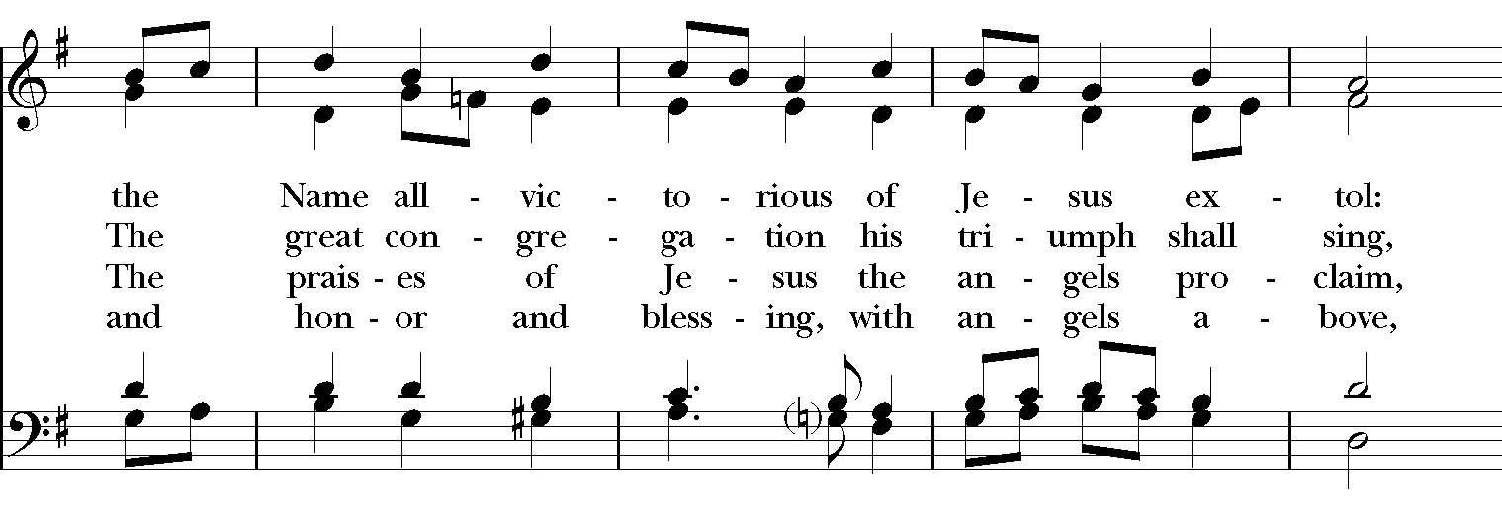
POSTLUDE:

*THE BLESSING
Christ who has nourished us with himself the living bread, make you one in praise and love, and raise you up at the last day; and the blessing God Almighty, the Father, the Son, and the Holy Spirit, be among you, and remain with you always. Amen.

*THE DISMISSAL Deacon: Go in peace to love and serve the Lord.
People: Thanks be to God.

POSTLUDE:

Thank you for your spiritual presence with us this morning!
Although we're physically apart, we are united in prayer, worship, and holy love!
Priest-In-Charge: The Rev. Dr. Canon Lee Anne Reat
Deacon: The Rev. Dr. Rick Incorvati
Music Director: Dr. Chris Durrenberger
Lector: Anne Strothman
Singers: Liz Wheeler, Joy Carter, Basil Fett, Chris Oldstone-Moore, and Fred Bartenstein
Technology: Steve Ide
Slideshow: Ed Hasecke
Parish Administrator and Program Coordinator: Kelly Zeller

