Christ Episcopal Church in Springfield, Ohio
Service of the Word
Second Sunday of Pentecost: June 6, 2021 at 9 am

PRELUDE:

OPENING HYMN: “Guide me, O though great Jehovah” Hymnal 690
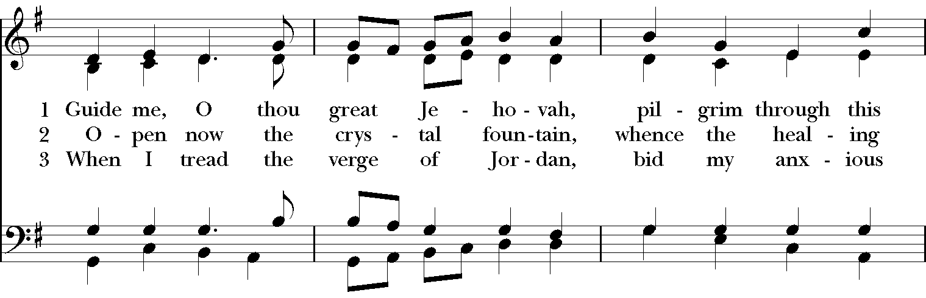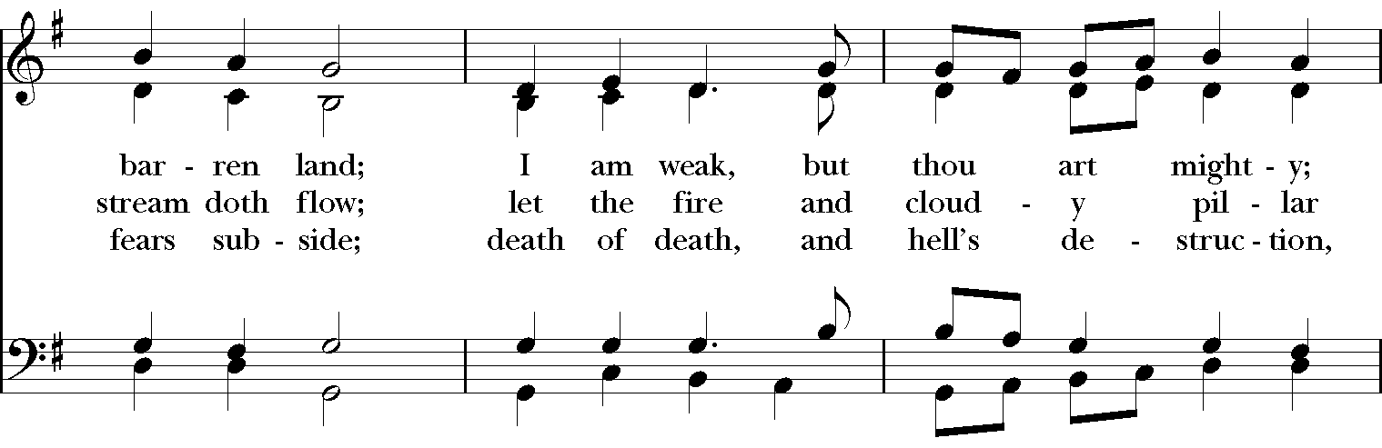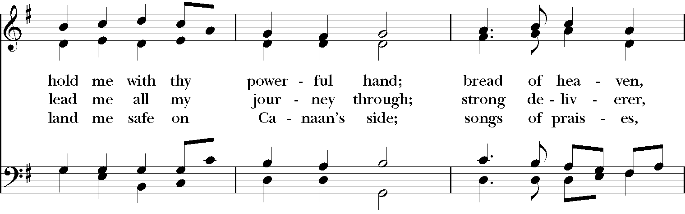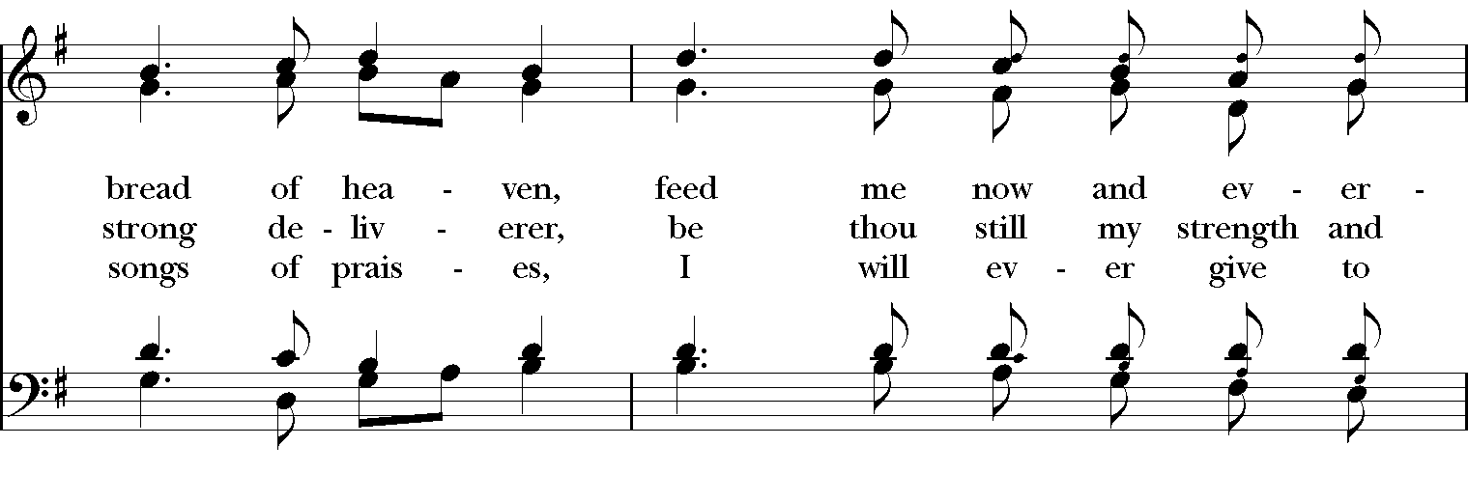

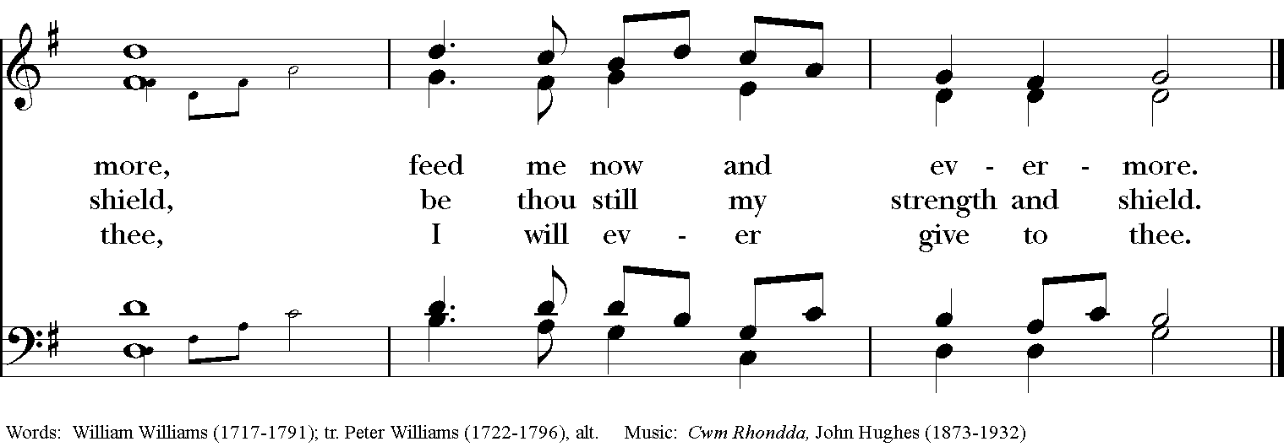

Celebrant: Blessed be God: Father, Son, and Holy Spirit.
People: And blessed be his kingdom, now and for ever. Amen.

The Collect of the Day
Celebrant: The Lord be with you.
People: And also with you.
Celebrant: Let us pray.
O God, from whom all good proceeds: Grant that by your inspiration we may think those things that are right, and by your merciful guiding may do them; through Jesus Christ our Lord, who lives and reigns with you and the Holy Spirit, one God, for ever and ever. Amen.

THE LESSONS

THE FIRST READING Genesis 3:8-15
They heard the sound of the Lord God walking in the garden at the time of the evening breeze, and the man and his wife hid themselves from the presence of the Lord God among the trees of the garden. But the Lord God called to the man, and said to him, “Where are you?” He said, “I heard the sound of you in the garden, and I was afraid, because I was naked; and I hid myself.” He said, “Who told you that you were naked? Have you eaten from the tree of which I commanded you not to eat?” The man said, “The woman whom you gave to be with me, she gave me fruit from the tree, and I ate.” Then the Lord God said to the woman, “What is this that you have done?” The woman said, “The serpent tricked me, and I ate.” The Lord God said to the serpent,
“Because you have done this,
cursed are you among all animals
and among all wild creatures;
upon your belly you shall go,
and dust you shall eat
all the days of your life.
I will put enmity between you and the woman,
and between your offspring and hers;
he will strike your head,
and you will strike his heel.”
Lector: The Word of the Lord.
People: Thanks be to God.

*PSALM:130 De profundis
1 Out of the depths have I called to you, O Lord; Lord, hear my voice; *
let your ears consider well the voice of my supplication.
2 If you, Lord, were to note what is done amiss, *
O Lord, who could stand?
3 For there is forgiveness with you; *
therefore you shall be feared.
4 I wait for the Lord; my soul waits for him; *
in his word is my hope.
5 My soul waits for the Lord, more than watchmen for the morning, *
more than watchmen for the morning.
6 O Israel, wait for the Lord, *
for with the Lord there is mercy;
7 With him there is plenteous redemption, *
and he shall redeem Israel from all their sins.

THE SECOND LESSON 2 Corinthians 4:13-5:1
Just as we have the same spirit of faith that is in accordance with scripture—“I believed, and so I spoke” —we also believe, and so we speak, because we know that the one who raised the Lord Jesus will raise us also with Jesus, and will bring us with you into his presence. Yes, everything is for your sake, so that grace, as it extends to more and more people, may increase thanksgiving, to the glory of God.

So we do not lose heart. Even though our outer nature is wasting away, our inner nature is being renewed day by day. For this slight momentary affliction is preparing us for an eternal weight of glory beyond all measure, because we look not at what can be seen but at what cannot be seen; for what can be seen is temporary, but what cannot be seen is eternal.
For we know that if the earthly tent we live in is destroyed, we have a building from God, a house not made with hands, eternal in the heavens.
Lector: The Word of the Lord.
People: Thanks be to God.

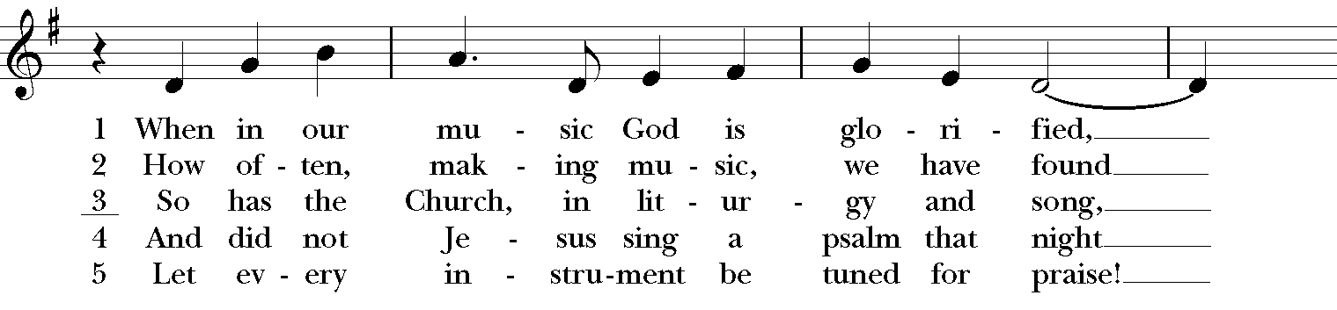
SEQUENCE HYMN: “When in our music God is glorified” Hymnal 420
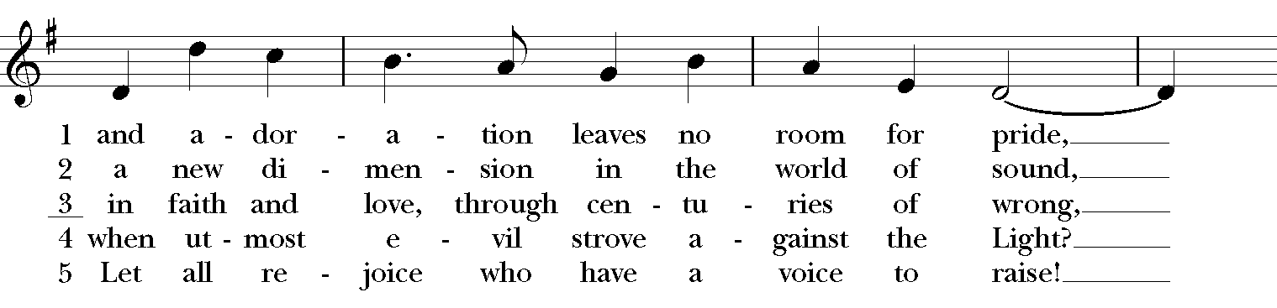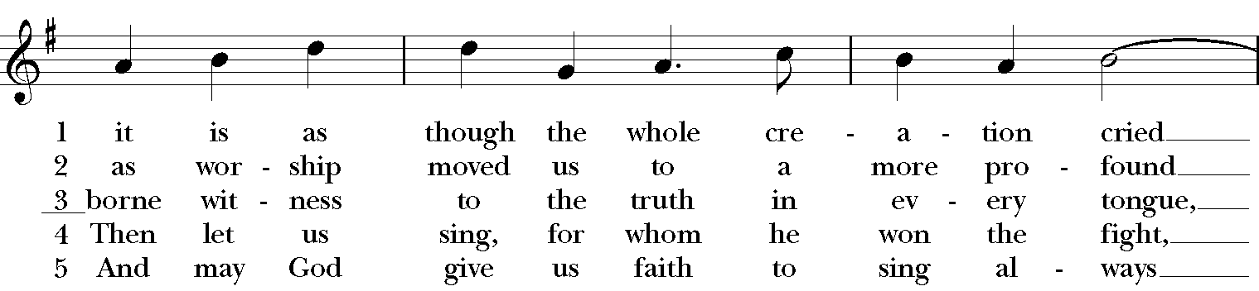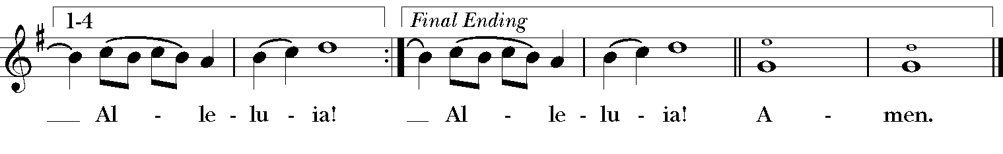
Gospel
Deacon: The Holy Gospel of our Lord Jesus Christ according to Mark (Mark 3:20-35).
People: Glory to you, Lord Christ.
The crowd came together again, so that Jesus and his disciples could not even eat. When his family heard it, they went out to restrain him, for people were saying, “He has gone out of his mind.” And the scribes who came down from Jerusalem said, “He has Beelzebul, and by the ruler of the demons he casts out demons.” And he called them to him, and spoke to them in parables, “How can Satan cast out Satan? If a kingdom is divided against itself, that kingdom cannot stand. And if a house is divided against itself, that house will not be able to stand. And if Satan has risen up against himself and is divided, he cannot stand, but his end has come. But no one can enter a strong man’s house and plunder his property without first tying up the strong man; then indeed the house can be plundered.
“Truly I tell you, people will be forgiven for their sins and whatever blasphemies they utter; but whoever blasphemes against the Holy Spirit can never have forgiveness, but is guilty of an eternal sin”— for they had said, “He has an unclean spirit.”
Then his mother and his brothers came; and standing outside, they sent to him and called him. A crowd was sitting around him; and they said to him, “Your mother and your brothers and sisters are outside, asking for you.” And he replied, “Who are my mother and my brothers?” And looking at those who sat around him, he said, “Here are my mother and my brothers! Whoever does the will of God is my brother and sister and mother.”
Deacon: The Gospel of the Lord.
People: Praise to you, Lord Christ.

Sermon The Rev. Canon Dr. Lee Anne Reat

The Nicene Creed
We believe in one God, the Father, the Almighty,
maker of heaven and earth, of all that is, seen and unseen.
We believe in one Lord, Jesus Christ, the only Son of God,
eternally begotten of the Father, God from God,
Light from Light, true God from true God,
begotten, not made, of one Being with the Father.
Through him all things were made.
For us and for our salvation he came down from heaven,
by the power of the Holy Spirit he became incarnate from the Virgin Mary,
and was made man.
For our sake he was crucified under Pontius Pilate;
he suffered death and was buried.
On the third day he rose again in accordance with the Scriptures;
he ascended into heaven and is seated at the right hand of the Father.
He will come again in glory to judge the living and the dead, and his kingdom will have no end.
We believe in the Holy Spirit, the Lord, the giver of life,
who proceeds from the Father, and the Son.
who with the Father and the Son is worshiped and glorified,
who has spoken through the Prophets.
We believe in one holy catholic and apostolic Church.
We acknowledge one baptism for the forgiveness of sins.
We look for the resurrection of the dead, and the life of the world to come. Amen.

The Prayers of the People

In peace, we pray to you Lord God. Congregational responses are in bold.

Silence

Let us pray. Founder of our faith, we ask your guidance for the Church, for its unity, and for the work it does in the world. Give grace to its leaders, especially Justin, archbishop of Canterbury; Michael, our Presiding Bishop; Ken, our Diocesan Bishop; Lee Anne, our priest; Rick, our deacon; and all the members of this parish.
R: Let your priests be clothed with righteousness; let your faithful people sing for joy.

Ruler over the nations, we pray for this country and its leaders in an unsettling time. Grant wisdom to all who serve in positions of leadership throughout the world.
R: For dominion belongs to the Lord, and he rules over the nations.

Lord of the harvest, we offer thanks for the beauty and abundance of this season. May we consider how best to tend the Earth and to share what You have given us, so that all may eat and be satisfied by your goodness. We pray for the ministries this church supports, especially Clark County Literacy Coalition, Episcopal Community Ministries, Second Harvest Food Bank, and Interfaith Hospitality Network
R: He covers the heavens with clouds, and prepares rain for the earth;
He makes grass grow upon the mountains, and green plants to serve humankind.

Giver of every good gift and we pray for those celebrating birthdays this week, especially Ron, Joyce and Sally; anniversaries Joan & Al and Will & Margaret.
R: Let the righteous be glad and rejoice before God; Let them also be merry and joyful.

Great Physician, we pray for healing and comfort for all those in need or pain, especially Charlene, Faye, Chris, Bonnie, Alice, Diana, James, Joy, Jane, Joni, Kim, Bobby, Sarah, Traudie, Lexie, and Keith. May they remember that You are with them and those who care for them.
R: Surely you behold trouble and misery; you see it and take it into your own hand.
The helpless commit themselves to you; for you are the helper of orphans.

Just Judge, we ask your aid for all those in trouble, bringing before You prisoners and captives, refugees and the oppressed. We pray for those most vulnerable throughout the world, especially women and children.
R: Let justice roll down like waters, and righteousness like an ever-flowing stream.

Lord over life and death, we pray for all who have died, asking light and peace for them and those who mourn.
R: Precious in the sight of the Lord is the death of his servant.

*THE COLLECT FOR PEACE
Grant, O God, that your holy and life-giving Spirit may so move every human heart, that barriers which divide us may crumble, suspicions disappear, and hatreds cease; that our divisions being healed, we may live in justice and peace; through Jesus Christ our Lord. Amen.

THE CONFESSION AND ABSOLUTION
Deacon: Let us confess our sins against God and our neighbor.
All: Most merciful God, we confess that we have sinned against you in thought, word, and deed, by what we have done, and by what we have left undone. We have not loved you with our whole heart; we have not loved our neighbors as ourselves. We are truly sorry and we humbly repent. For the sake of your Son Jesus Christ, have mercy on us and forgive us; that we may delight in your will, and walk in your ways, to the glory of your Name. Amen.

Priest: Almighty God, have mercy on you, forgive you all your sins through our Lord Jesus Christ, strengthen you in all goodness, and by the power of the Holy Spirit keep you in eternal life. Amen.
And now, as our Savior Christ has taught us, we are bold to say:
Our Father, who art in heaven, hallowed be thy Name,
thy kingdom come, thy will be done, on earth as it is in heaven.
Give us this day our daily bread.
And forgive us our trespasses, as we forgive those who trespass against us.
And lead us not into temptation, but deliver us from evil.
For thine is the kingdom, and the power, and the glory, for ever and ever. Amen

CLOSING HYMN: “How sweet the name of Jesus sounds” Hymnal 644 vs. 1-4
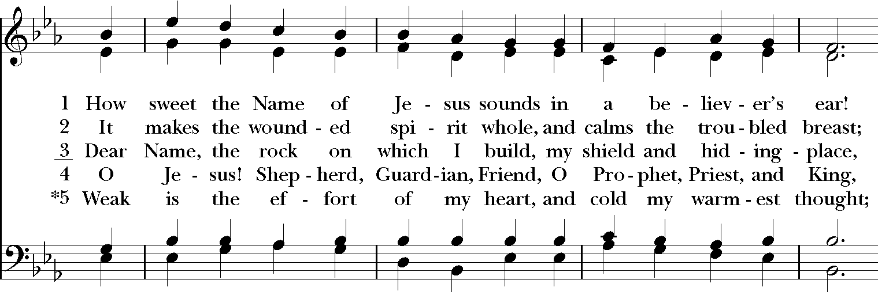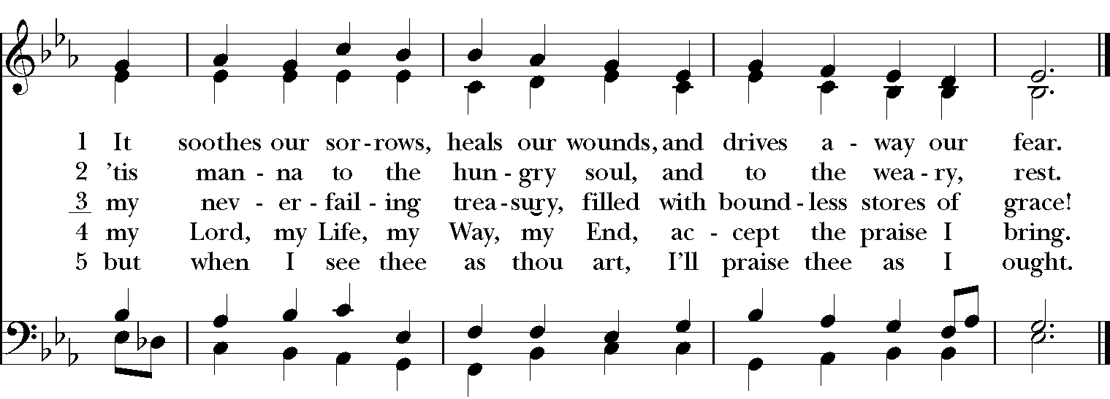

*THE BLESSING
Christ who has nourished us with himself the living bread, make you one in praise and love, and raise you up at the last day; and the blessing God Almighty, the Father, the Son, and the Holy Spirit, be among you, and remain with you always. Amen.

*THE DISMISSAL Deacon: Go in peace to love and serve the Lord.
People: Thanks be to God.

POSTLUDE:

Thank you for your spiritual presence with us this morning!
Although we're physically apart, we are united in prayer, worship, and holy love!
Priest-In-Charge: The Rev. Dr. Canon Lee Anne Reat
Deacon: The Rev. Dr. Rick Incorvati
Music Director: Dr. Chris Durrenberger
Lector: Diane Rode
Singers: Liz Wheeler, Joy Carter, Basil Fett, Chris Oldstone-Moore, and Fred Bartenstein
Technology: Steve Ide
Slideshow: Ed Hasecke
Parish Administrator and Program Coordinator: Kelly Zeller

