Christ Episcopal Church in Springfield, Ohio
Service of the Word
Trinity Sunday and Recognition of Graduates: May 30th, 2021 at 9 am

PRELUDE:

OPENING HYMN: “I bind unto myself today” Hymnal 370
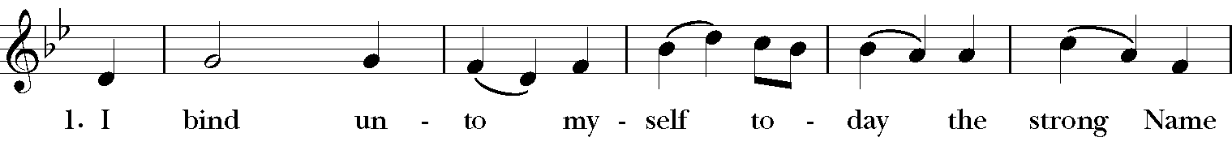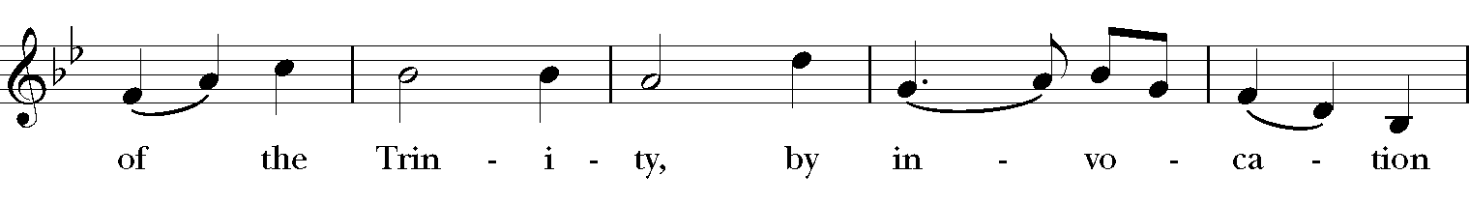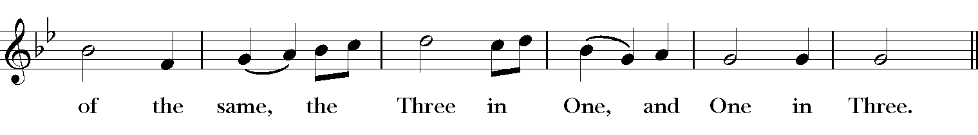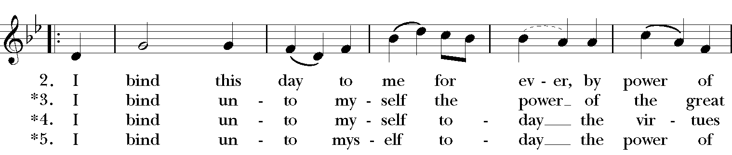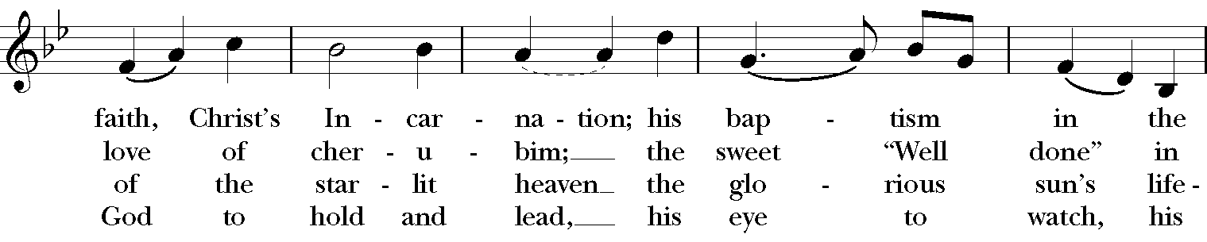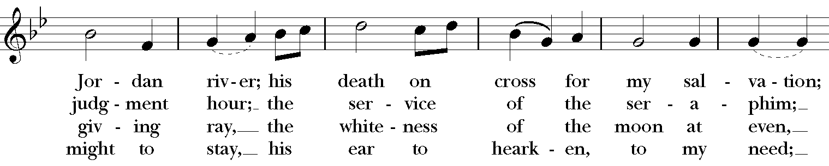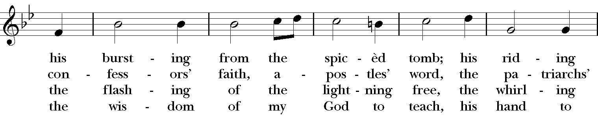

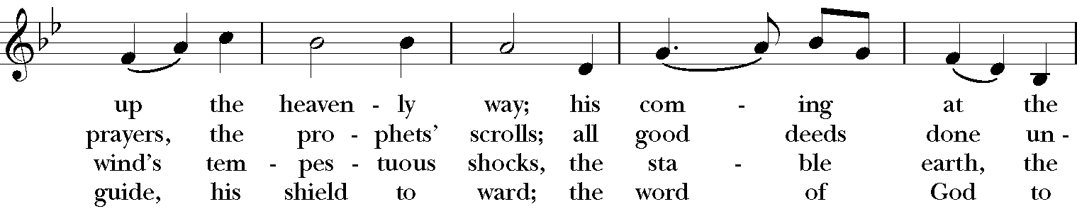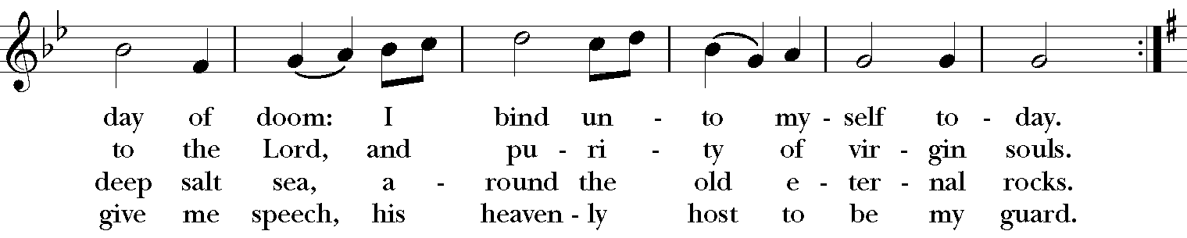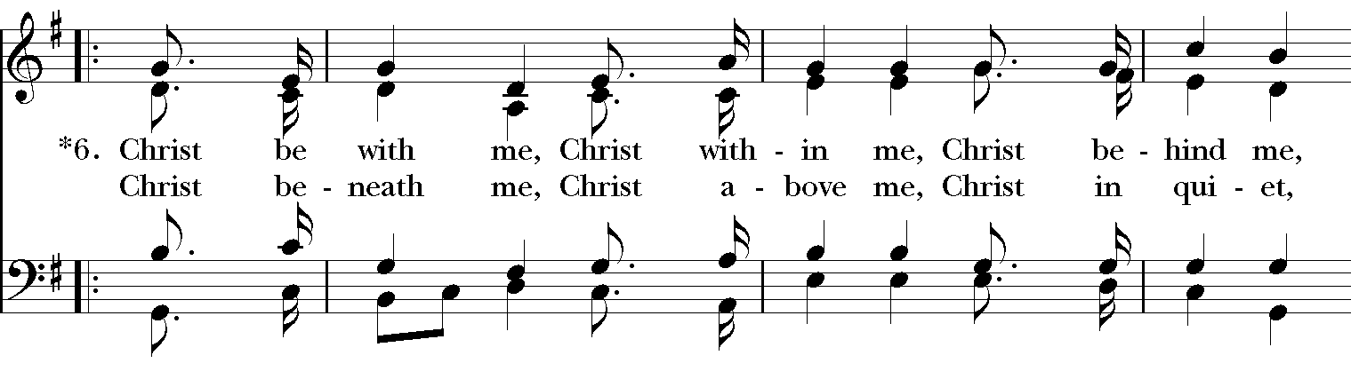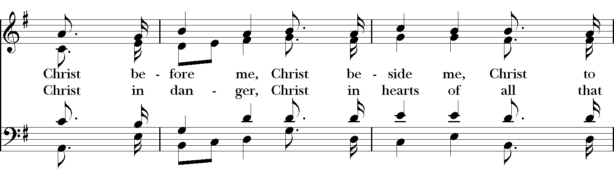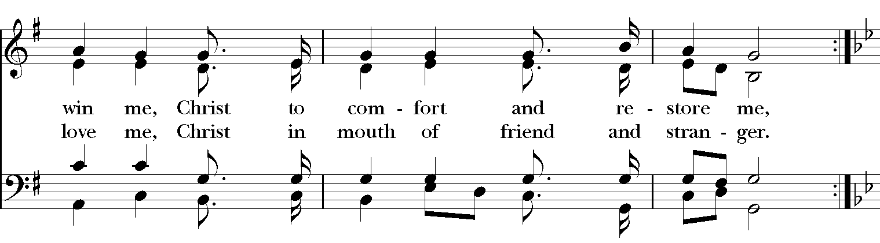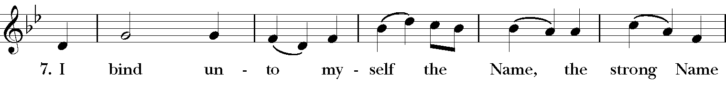
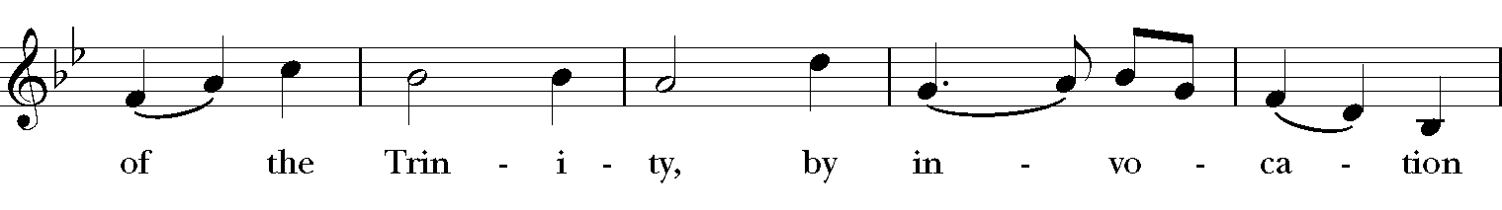
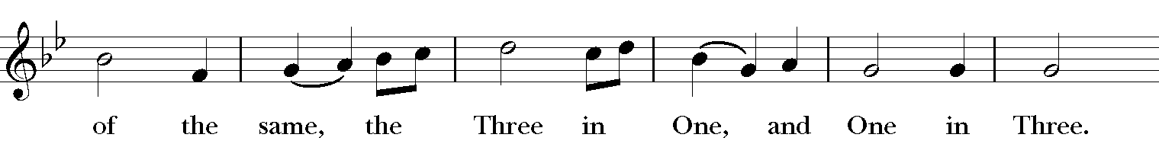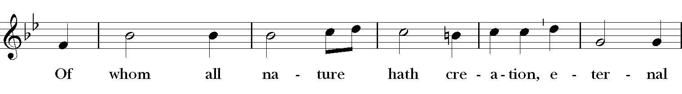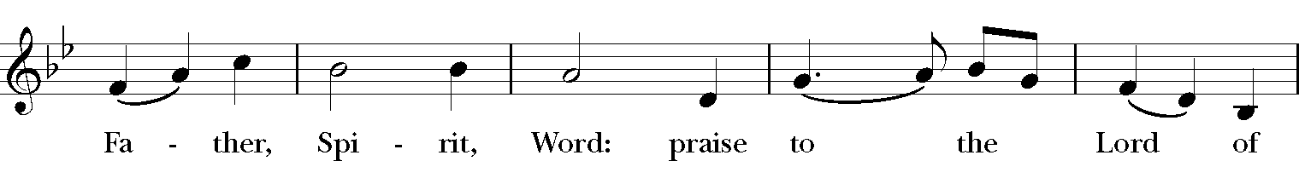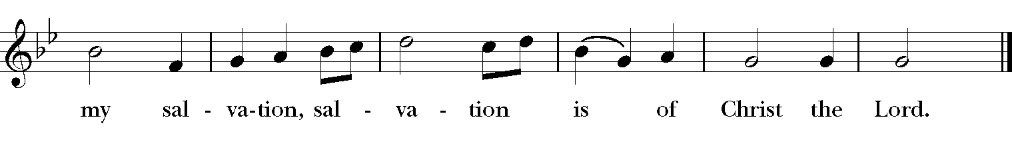
Celebrant: Blessed be God: most holy, glorious, and undivided Trinity.
People: And blessed be God’s reign, now and forever. Amen.

The Collect of the Day
Celebrant: The Lord be with you.
People: And also with you.
Celebrant: Let us pray.
Almighty and everlasting God, you have given to us your servants grace, by the confession of a true faith, to acknowledge the glory of the eternal Trinity, and in the power of your divine Majesty to worship the Unity: Keep us steadfast in this faith and worship, and bring us at last to see you in your one and eternal glory, O Father; who with the Son and the Holy Spirit live and reign, one God, for ever and ever. Amen.

The Lessons

THE FIRST READING Isaiah 6:1-8
In the year that King Uzziah died, I saw the Lord sitting on a throne, high and lofty; and the hem of his robe filled the temple. Seraphs were in attendance above him; each had six wings: with two they covered their faces, and with two they covered their feet, and with two they flew.

And one called to another and said:
“Holy, holy, holy is the Lord of hosts;
the whole earth is full of his glory.”

The pivots on the thresholds shook at the voices of those who called, and the house filled with smoke. And I said: “Woe is me! I am lost, for I am a man of unclean lips, and I live among a people of unclean lips; yet my eyes have seen the King, the Lord of hosts!”
Then one of the seraphs flew to me, holding a live coal that had been taken from the altar with a pair of tongs. The seraph touched my mouth with it and said: “Now that this has touched your lips, your guilt has departed and your sin is blotted out.” Then I heard the voice of the Lord saying, “Whom shall I send, and who will go for us?” And I said, “Here am I; send me!”
Lector: The Word of the Lord.
People: Thanks be to God.

*PSALM: 29 Afferte Domino
1 Ascribe to the Lord, you gods, *
ascribe to the Lord glory and strength.
2 Ascribe to the Lord the glory due his Name; *
worship the Lord in the beauty of holiness.
3 The voice of the Lord is upon the waters; the God of glory thunders; *
the Lord is upon the mighty waters.
4 The voice of the Lord is a powerful voice; *
the voice of the Lord is a voice of splendor.
5 The voice of the Lord breaks the cedar trees; *
the Lord breaks the cedars of Lebanon;
6 He makes Lebanon skip like a calf, *
and Mount Hermon like a young wild ox.
7 The voice of the Lord splits the flames of fire;
the voice of the Lord shakes the wilderness; *
the Lord shakes the wilderness of Kadesh.
8 The voice of the Lord makes the oak trees writhe *
and strips the forests bare.
9 And in the temple of the Lord *
all are crying, "Glory!"
10 The Lord sits enthroned above the flood; *
the Lord sits enthroned as King for evermore.
11 The Lord shall give strength to his people; *
the Lord shall give his people the blessing of peace.

THE SECOND LESSON Romans 8:12-17
So then, brothers and sisters, we are debtors, not to the flesh, to live according to the flesh-- for if you live according to the flesh, you will die; but if by the Spirit you put to death the deeds of the body, you will live. For all who are led by the Spirit of God are children of God. For you did not receive a spirit of slavery to fall back into fear, but you have received a spirit of adoption. When we cry, "Abba! Father!" it is that very Spirit bearing witness with our spirit that we are children of God, and if children, then heirs, heirs of God and joint heirs with Christ-- if, in fact, we suffer with him so that we may also be glorified with him.
Lector: The Word of the Lord.
People: Thanks be to God.

SEQUENCE HYMN: “Come, thou almighty King” Hymnal 365
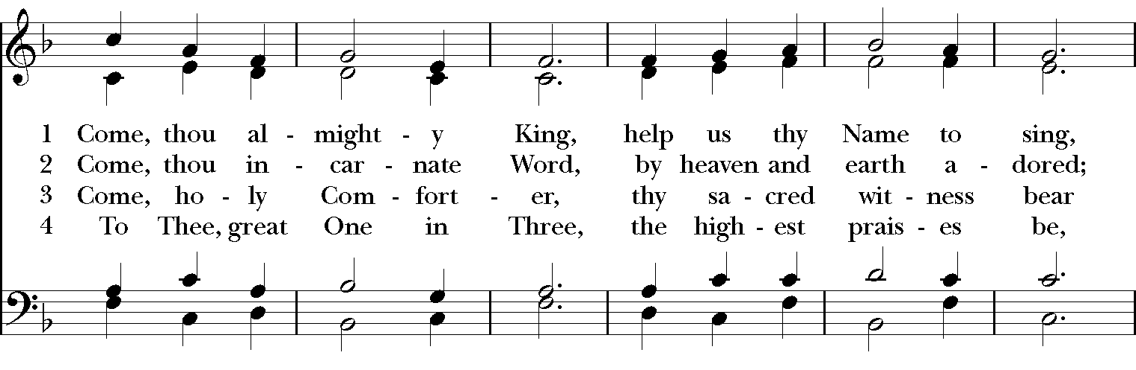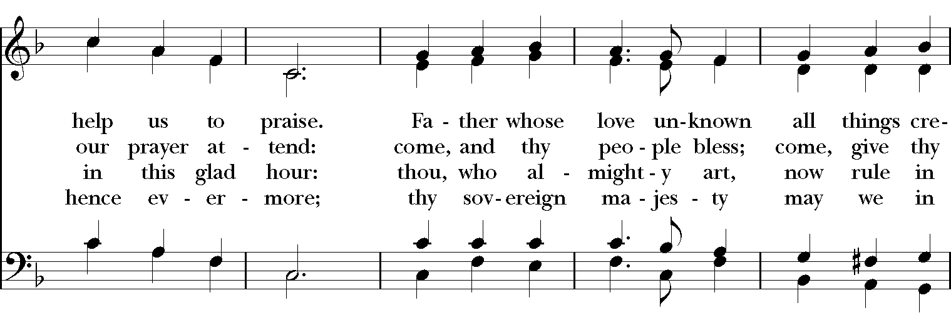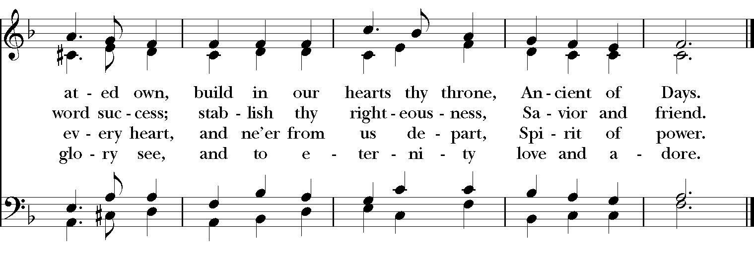
GOSPEL
Deacon: The Holy Gospel of our Lord Jesus Christ according to John (John 3:1-17).
People: Glory to you, Lord Christ.
There was a Pharisee named Nicodemus, a leader of the Jews. He came to Jesus by night and said to him, “Rabbi, we know that you are a teacher who has come from God; for no one can do these signs that you do apart from the presence of God.” Jesus answered him, “Very truly, I tell you, no one can see the kingdom of God without being born from above.” Nicodemus said to him, “How can anyone be born after having grown old? Can one enter a second time into the mother’s womb and be born?” Jesus answered, “Very truly, I tell you, no one can enter the kingdom of God without being born of water and Spirit. What is born of the flesh is flesh, and what is born of the Spirit is spirit. Do not be astonished that I said to you, ‘You must be born from above.’ The wind blows where it chooses, and you hear the sound of it, but you do not know where it comes from or where it goes. So it is with everyone who is born of the Spirit.” Nicodemus said to him, “How can these things be?” Jesus answered him, “Are you a teacher of Israel, and yet you do not understand these things?
“Very truly, I tell you, we speak of what we know and testify to what we have seen; yet you do not receive our testimony. If I have told you about earthly things and you do not believe, how can you believe if I tell you about heavenly things? No one has ascended into heaven except the one who descended from heaven, the Son of Man. And just as Moses lifted up the serpent in the wilderness, so must the Son of Man be lifted up, that whoever believes in him may have eternal life.
“For God so loved the world that he gave his only Son, so that everyone who believes in him may not perish but may have eternal life.
“Indeed, God did not send the Son into the world to condemn the world, but in order that the world might be saved through him.
Deacon: The Gospel of the Lord.
People: Praise to you, Lord Christ.

Sermon The Rev. Rick Incorvati

Introduction & Blessing of Graduates

Holy and Loving God, Source of all wisdom,
We thank you for Ben Hasecke, Katie Sharp, and Sally Boblitt.
Hear our prayer for them as they graduate and take the next steps on their life-journeys.
Direct their steps, O Lord.

For those who will now begin their careers:
help them to apply what they have learned
and to be salt and light among their fellow workers.
Direct their steps, O Lord.

For those who will receive further education:
assist them as they move to more difficult studies.
May they find new faith communities to support them in their journeys.
Direct their steps, O Lord.

We thank you for their families, teachers, mentors, and friends
who have helped them reach this milestone.
Bless all those who teach, in or out of the classroom.
Direct their steps, O Lord.

Help us each to remember
that we always have more to learn about you and your world.
Help us to use the skills we gain to serve others,
with Christ as our example.
Direct our steps, O Lord.

We ask these things in the name of God the Creator,
who gave us birth by the word of truth;
and of Jesus our Example, who increased in wisdom and in stature,
and of the Spirit of Truth, who guides us into all truth. Amen.

{The Blessing}
Before you were even formed, God knew you.
While in your Mother's womb, God named you.
At your birth, God's breath filled you with life.
Today we celebrate what you have become at this moment in time.
And so we pray,
God of our beginnings,
We thank you for the gifts of these graduates;
their excitement, their awesome wonder and curiosity,
their open speech and encouraging words.
Their contributions have blessed and challenged us,
and we have become a richer
and more diverse community because of them.
We ask this blessing upon each of them,
In the name of the Father, the Son, and the Holy Spirit. AMEN!

Ben Hasecke
Katie Sharp
Sally Boblitt

Remember Christ's promise to you, and to each one of us:
"I am with you always, to the end of the age" (Matthew 28:20)

The Nicene Creed
We believe in one God, the Father, the Almighty,
maker of heaven and earth, of all that is, seen and unseen.
We believe in one Lord, Jesus Christ, the only Son of God,
eternally begotten of the Father, God from God,
Light from Light, true God from true God,
begotten, not made, of one Being with the Father.
Through him all things were made.
For us and for our salvation he came down from heaven,
by the power of the Holy Spirit he became incarnate from the Virgin Mary,
and was made man.
For our sake he was crucified under Pontius Pilate;
he suffered death and was buried.
On the third day he rose again in accordance with the Scriptures;
he ascended into heaven and is seated at the right hand of the Father.
He will come again in glory to judge the living and the dead, and his kingdom will have no end.
We believe in the Holy Spirit, the Lord, the giver of life,
who proceeds from the Father, and the Son.
who with the Father and the Son is worshiped and glorified,
who has spoken through the Prophets.
We believe in one holy catholic and apostolic Church.
We acknowledge one baptism for the forgiveness of sins.
We look for the resurrection of the dead, and the life of the world to come. Amen.

The Prayers of the People

In peace, we pray to you Lord God. Congregational responses are in bold.

Silence

Let us pray. Founder of our faith, we ask your guidance for the Church, for its unity, and for the work it does in the world. Give grace to its leaders, especially Justin, archbishop of Canterbury; Michael, our Presiding Bishop; Ken, our Diocesan Bishop; Lee Anne, our priest; Rick, our deacon; and all the members of this parish.
R: Let your priests be clothed with righteousness; let your faithful people sing for joy.

Ruler over the nations, we pray for this country and its leaders in an unsettling time. Grant wisdom to all who serve in positions of leadership throughout the world.
R: For dominion belongs to the Lord, and he rules over the nations.

Lord of the harvest, we offer thanks for the beauty and abundance of this season. May we consider how best to tend the Earth and to share what You have given us, so that all may eat and be satisfied by your goodness. We pray for the ministries this church supports, especially Children’s Rescue Center/The Ark, Christ Church Food Pantry, The Fuller Center for Housing, and Safe Harbor House.
R: He covers the heavens with clouds, and prepares rain for the earth;
He makes grass grow upon the mountains, and green plants to serve humankind.

Giver of every good gift and we pray for those celebrating birthdays this week, especially Denny, Beth, Audra, Amil, and Mark and anniversaries Jack and Dawn Ivy.
R: Let the righteous be glad and rejoice before God; Let them also be merry and joyful.

Great Physician, we pray for healing and comfort for all those in need or pain, especially Charlene, Faye, Chris, Bonnie, Alice, Diana, James, Joy, Jane, Joni, Kim, Bobby, Sarah, Traudie, Lexie, and Keith. May they remember that You are with them and those who care for them.
R: Surely you behold trouble and misery; you see it and take it into your own hand.
The helpless commit themselves to you; for you are the helper of orphans.

Just Judge, we ask your aid for all those in trouble, bringing before You prisoners and captives, refugees and the oppressed. We pray for those most vulnerable throughout the world, especially women and children.
R: Let justice roll down like waters, and righteousness like an ever-flowing stream.

Lord over life and death, we pray for all who have died, asking light and peace for them and those who mourn.
R: Precious in the sight of the Lord is the death of his servant.

*THE COLLECT FOR PEACE
Grant, O God, that your holy and life-giving Spirit may so move every human heart, that barriers which divide us may crumble, suspicions disappear, and hatreds cease; that our divisions being healed, we may live in justice and peace; through Jesus Christ our Lord. Amen.

Deacon: Let us confess our sins against God and our neighbor.
All: Most merciful God, we confess that we have sinned against you in thought, word, and deed, by what we have done, and by what we have left undone. We have not loved you with our whole heart; we have not loved our neighbors as ourselves. We are truly sorry and we humbly repent. For the sake of your Son Jesus Christ, have mercy on us and forgive us; that we may delight in your will, and walk in your ways, to the glory of your Name. Amen.

Priest: Almighty God, have mercy on you, forgive you all your sins through our Lord Jesus Christ, strengthen you in all goodness, and by the power of the Holy Spirit keep you in eternal life. Amen.

And now, as our Savior Christ has taught us, we are bold to say:
Our Father, who art in heaven, hallowed be thy Name,
thy kingdom come, thy will be done, on earth as it is in heaven.
Give us this day our daily bread.
And forgive us our trespasses, as we forgive those who trespass against us.
And lead us not into temptation, but deliver us from evil.
For thine is the kingdom, and the power, and the glory, for ever and ever. Amen

CLOSING HYMN: “Christ is the world’s true Light” Hymnal 542

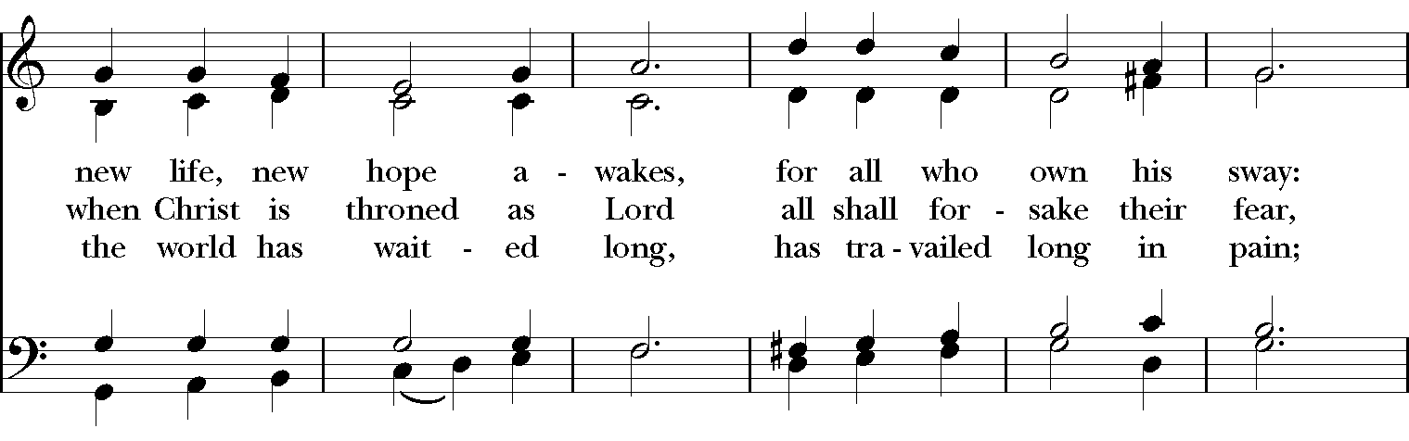
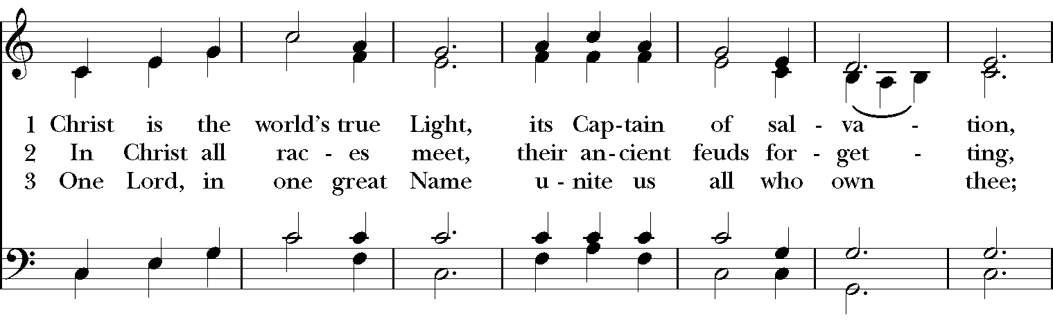

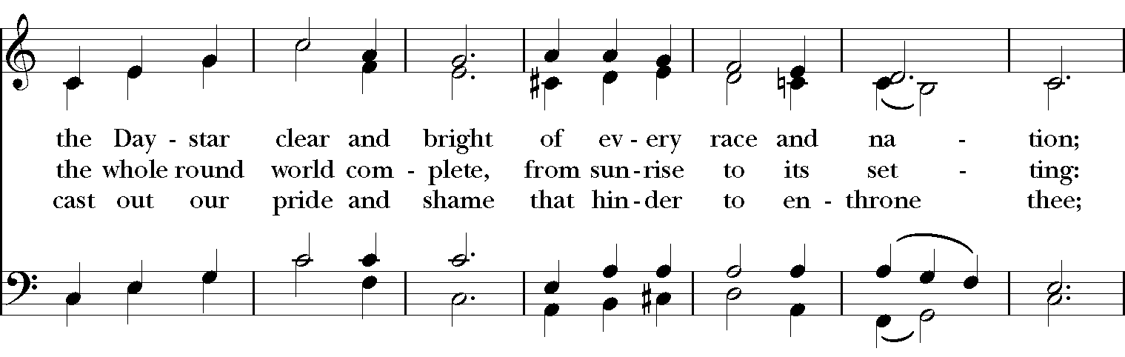

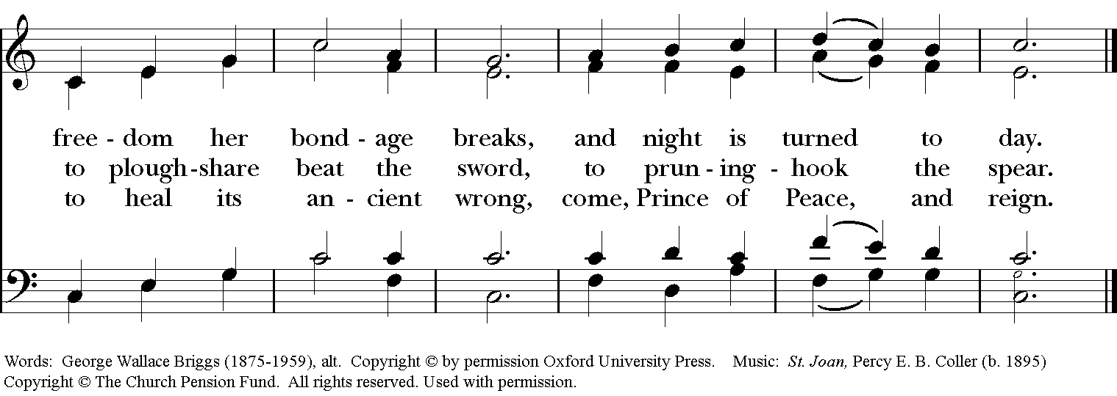

*THE BLESSING
The God of peace, who brought again from the dead our Lord Jesus Christ, the great Shepherd of the sheep, through the blood of the everlasting covenant, make you perfect in every good work to do his will, working in you that which is well-pleasing in his sight; and the blessing of God Almighty, the Father, the Son, and the Holy Spirit, be among you, and remain with you always. Amen.

ANNOUNCEMENTS

*THE DISMISSAL Deacon: Go in peace to love and serve the Lord. Alleluia, alleluia!
People: Thanks be to God. Alleluia, alleluia!

POSTLUDE:

Thank you for your spiritual presence with us this morning!
Although we're physically apart, we are united in prayer, worship, and holy love!
Priest-In-Charge: The Rev. Dr. Canon Lee Anne Reat
Deacon: The Rev. Dr. Rick Incorvati
Music Director: Dr. Chris Durrenberger
Lector: Keith Doubt
Singers: Liz Wheeler, Joy Carter, Basil Fett, Chris Oldstone-Moore, Fred Bartenstein
Technology: Steve Ide
Slideshow: Ed Hasecke
Parish Administrator and Program Coordinator: Kelly Zeller

