Christ Episcopal Church in Springfield, Ohio
Service of the Word
Eighth Sunday after Pentecost: July 18th, 2021 at 9 am

PRELUDE: “The King of Love My Shepherd Is” - St. Columbia/arr. Bisbee

OPENING HYMN: “The King of Love my Shepherd is ” Hymnal 645

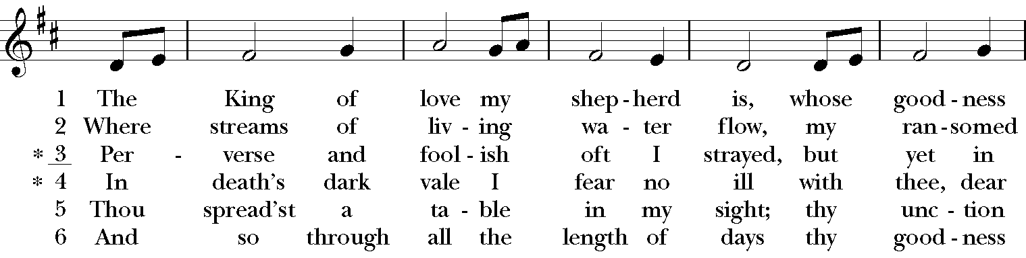

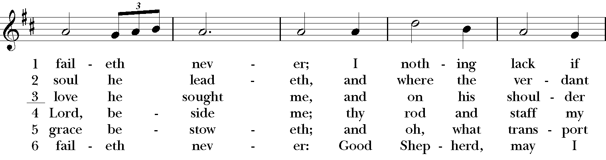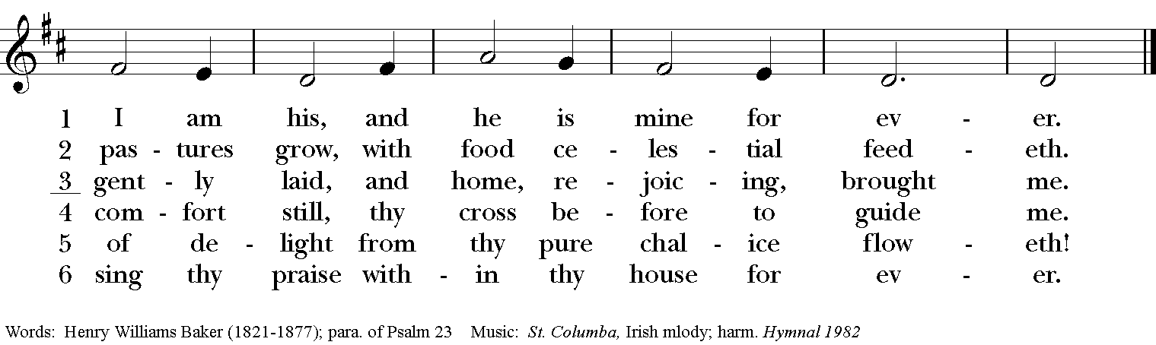

Celebrant: Blessed be God: Father, Son, and Holy Spirit.
People: And blessed be his kingdom, now and for ever. Amen.

The Collect of the Day
Celebrant: The Lord be with you.
People: And also with you.
Celebrant: Let us pray.
Almighty God, the fountain of all wisdom, you know our necessities before we ask and our ignorance in asking: Have compassion on our weakness, and mercifully give us those things which for our unworthiness we dare not, and for our blindness we cannot ask; through the worthiness of your Son Jesus Christ our Lord, who lives and reigns with you and the Holy Spirit, one God, now and for ever. Amen.
THE LESSONS

THE FIRST READING Jeremiah 23:1-6
Woe to the shepherds who destroy and scatter the sheep of my pasture! says the Lord. Therefore thus says the Lord, the God of Israel, concerning the shepherds who shepherd my people: It is you who have scattered my flock, and have driven them away, and you have not attended to them. So I will attend to you for your evil doings, says the Lord. Then I myself will gather the remnant of my flock out of all the lands where I have driven them, and I will bring them back to their fold, and they shall be fruitful and multiply. I will raise up shepherds over them who will shepherd them, and they shall not fear any longer, or be dismayed, nor shall any be missing, says the Lord.
The days are surely coming, says the Lord, when I will raise up for David a righteous Branch, and he shall reign as king and deal wisely, and shall execute justice and righteousness in the land. In his days Judah will be saved and Israel will live in safety. And this is the name by which he will be called: “The Lord is our righteousness.”
Lector: The Word of the Lord.
People: Thanks be to God.

PSALM 23 Dominus regit me

1 The Lord is my shepherd; *
I shall not be in want.
2 He makes me lie down in green pastures *
and leads me beside still waters.
3 He revives my soul *
and guides me along right pathways for his Name's sake.
4 Though I walk through the valley of the shadow of death, I shall fear no evil; *
for you are with me; your rod and your staff, they comfort me.
5 You spread a table before me in the presence of those who trouble me; *
you have anointed my head with oil, and my cup is running over.
6 Surely your goodness and mercy shall follow me all the days of my life, *
and I will dwell in the house of the Lord for ever.

THE SECOND LESSON Ephesians 2:11-22
Remember that at one time you Gentiles by birth, called “the uncircumcision” by those who are called “the circumcision” —a physical circumcision made in the flesh by human hands— remember that you were at that time without Christ, being aliens from the commonwealth of Israel, and strangers to the covenants of promise, having no hope and without God in the world. But now in Christ Jesus you who once were far off have been brought near by the blood of Christ. For he is our peace; in his flesh he has made both groups into one and has broken down the dividing wall, that is, the hostility between us. He has abolished the law with its commandments and ordinances, that he might create in himself one new humanity in place of the two, thus making peace, and might reconcile both groups to God in one body through the cross, thus putting to death that hostility through it. So he came and proclaimed peace to you who were far off and peace to those who were near; for through him both of us have access in one Spirit to the Father. So then you are no longer strangers and aliens, but you are citizens with the saints and also members of the household of God, built upon the foundation of the apostles and prophets, with Christ Jesus himself as the cornerstone. In him the whole structure is joined together and grows into a holy temple in the Lord; in whom you also are built together spiritually into a dwelling place for God.
Lector: The Word of the Lord.
People: Thanks be to God.
SEQUENCE HYMN: “The Church’s one foundation” Hymnal 525
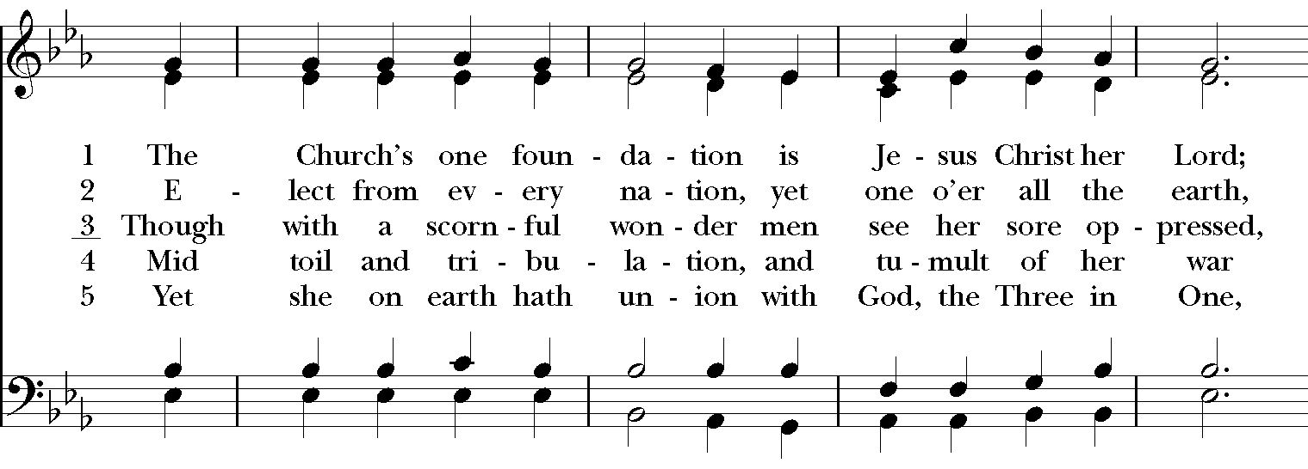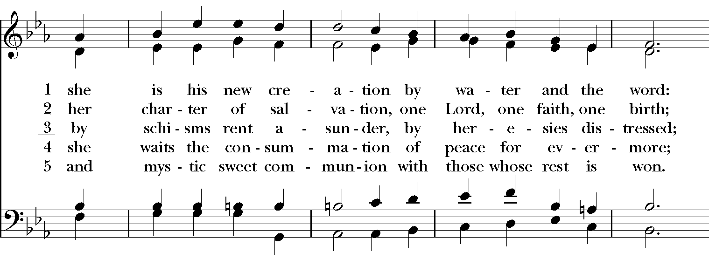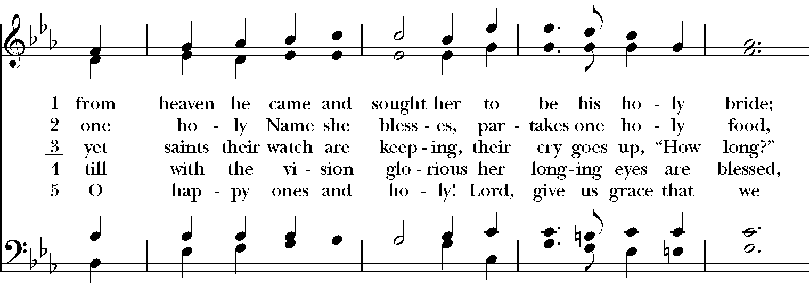
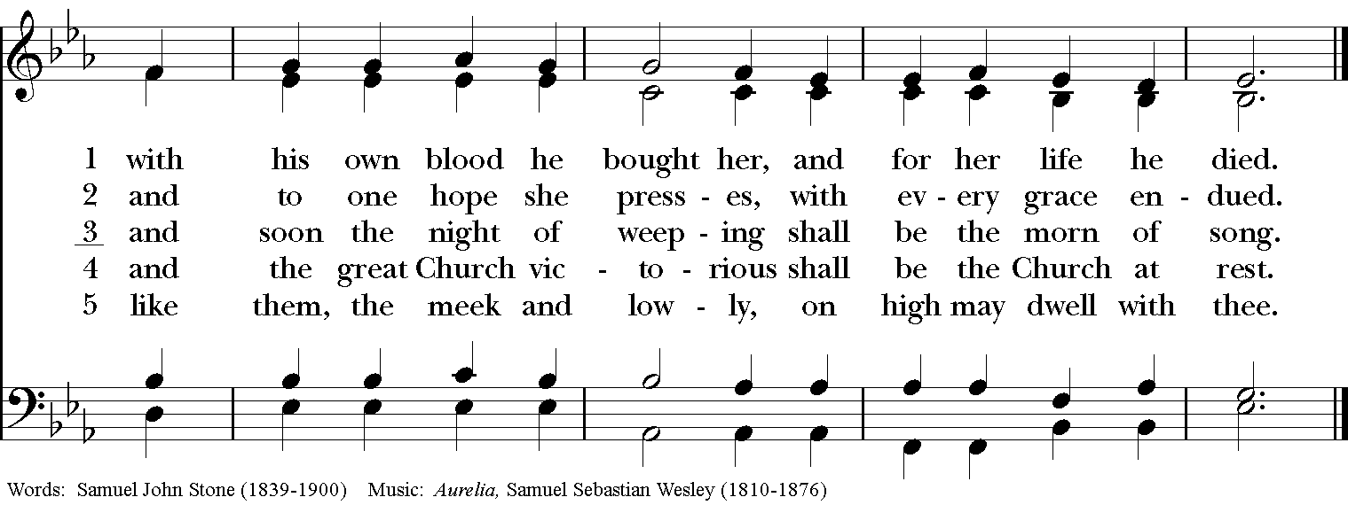

GOSPEL
Deacon: The Holy Gospel of our Lord Jesus Christ according to Mark (Mark 6:30-34, 56-56).
People: Glory to you, Lord Christ.
The apostles gathered around Jesus, and told him all that they had done and taught. He said to them, “Come away to a deserted place all by yourselves and rest a while.” For many were coming and going, and they had no leisure even to eat. And they went away in the boat to a deserted place by themselves. Now many saw them going and recognized them, and they hurried there on foot from all the towns and arrived ahead of them. As he went ashore, he saw a great crowd; and he had compassion for them, because they were like sheep without a shepherd; and he began to teach them many things.
When they had crossed over, they came to land at Gennesaret and moored the boat. When they got out of the boat, people at once recognized him, and rushed about that whole region and began to bring the sick on mats to wherever they heard he was. And wherever he went, into villages or cities or farms, they laid the sick in the marketplaces, and begged him that they might touch even the fringe of his cloak; and all who touched it were healed.
Deacon: The Gospel of the Lord.
People: Praise to you, Lord Christ.

Sermon The Rev. Canon Dr. Lee Anne Reat

The Nicene Creed
We believe in one God, the Father, the Almighty,
maker of heaven and earth, of all that is, seen and unseen.
We believe in one Lord, Jesus Christ, the only Son of God,
eternally begotten of the Father, God from God,
Light from Light, true God from true God,
begotten, not made, of one Being with the Father.
Through him all things were made.
For us and for our salvation he came down from heaven,
by the power of the Holy Spirit he became incarnate from the Virgin Mary,
and was made man.
For our sake he was crucified under Pontius Pilate;
he suffered death and was buried.
On the third day he rose again in accordance with the Scriptures;
he ascended into heaven and is seated at the right hand of the Father.
He will come again in glory to judge the living and the dead, and his kingdom will have no end.
We believe in the Holy Spirit, the Lord, the giver of life,
who proceeds from the Father, and the Son.
who with the Father and the Son is worshiped and glorified,
who has spoken through the Prophets.
We believe in one holy catholic and apostolic Church.
We acknowledge one baptism for the forgiveness of sins.
We look for the resurrection of the dead, and the life of the world to come. Amen.

THE PRAYERS OF THE PEOPLE

In peace, we pray to you Lord God. Congregational responses are in bold.

Silence

Let us pray. Founder of our faith, we ask your guidance for the Church, for its unity, and for the work it does in the world. Give grace to its leaders, especially Justin, archbishop of Canterbury; Michael, our Presiding Bishop; Ken, our Diocesan Bishop; Lee Anne, our priest; Rick, our deacon; and all the members of this parish.
R: Let your priests be clothed with righteousness; let your faithful people sing for joy.

Ruler over the nations, we pray for this country and its leaders in an unsettling time. Grant wisdom to all who serve in positions of leadership throughout the world.
R: For dominion belongs to the Lord, and he rules over the nations.

Lord of the harvest, we offer thanks for the beauty and abundance of this season. May we consider how best to tend the Earth and to share what You have given us, so that all may eat and be satisfied by your goodness. We pray for the ministries this church supports, especially Rainbow Table, Springfield Promise Neighborhood,, Springfield Peace Center, and Partners in Ministry in Liberia.
R: He covers the heavens with clouds, and prepares rain for the earth;
He makes grass grow upon the mountains, and green plants to serve humankind.

Giver of every good gift, we pray for those celebrating birthdays this week, especially Devon, James, and Steven; anniversaries Jake & Alan.
R: Let the righteous be glad and rejoice before God; Let them also be merry and joyful.

Great Physician, we pray for healing and comfort for all those in need or pain, especially Leigh, Charlene, Faye, Chris, Bonnie, Alice, Diana, James, Joy, Jane, Joni, Kim, Bobby, Sarah, Traudie, Lexie, and Keith. May they remember that You are with them and those who care for them.
R: Surely you behold trouble and misery; you see it and take it into your own hand.
The helpless commit themselves to you; for you are the helper of orphans.

Just Judge, we ask your aid for all those in trouble, bringing before You prisoners and captives, refugees and the oppressed. We pray for those most vulnerable throughout the world, especially women and children.
R: Let justice roll down like waters, and righteousness like an ever-flowing stream.

Lord over life and death, we pray for all who have died, asking light and peace for them and those who mourn.
R: Precious in the sight of the Lord is the death of his servant.

*THE COLLECT FOR PEACE
Grant, O God, that your holy and life-giving Spirit may so move every human heart, that barriers which divide us may crumble, suspicions disappear, and hatreds cease; that our divisions being healed, we may live in justice and peace; through Jesus Christ our Lord. Amen.

THE CONFESSION AND ABSOLUTION
Deacon: Let us confess our sins against God and our neighbor.
All: Most merciful God, we confess that we have sinned against you in thought, word, and deed, by what we have done, and by what we have left undone. We have not loved you with our whole heart; we have not loved our neighbors as ourselves. We are truly sorry and we humbly repent. For the sake of your Son Jesus Christ, have mercy on us and forgive us; that we may delight in your will, and walk in your ways, to the glory of your Name. Amen.

Priest: Almighty God, have mercy on you, forgive you all your sins through our Lord Jesus Christ, strengthen you in all goodness, and by the power of the Holy Spirit keep you in eternal life. Amen.

And now, as our Savior Christ has taught us, we are bold to say:
Our Father, who art in heaven, hallowed be thy Name,
thy kingdom come, thy will be done, on earth as it is in heaven.
Give us this day our daily bread.
And forgive us our trespasses, as we forgive those who trespass against us.
And lead us not into temptation, but deliver us from evil.
For thine is the kingdom, and the power, and the glory, for ever and ever. Amen

CLOSING HYMN: “O for a thousand tongues to sing” Hymnal 493
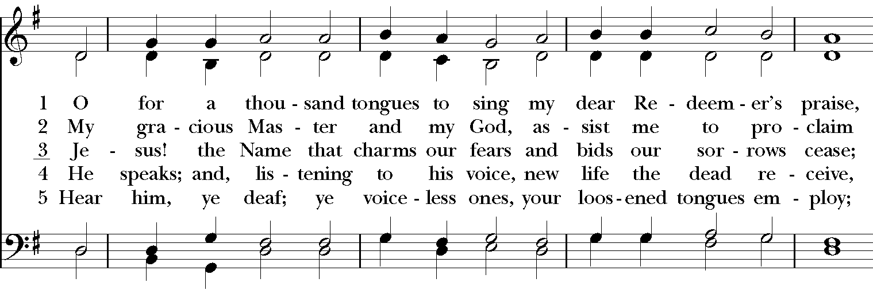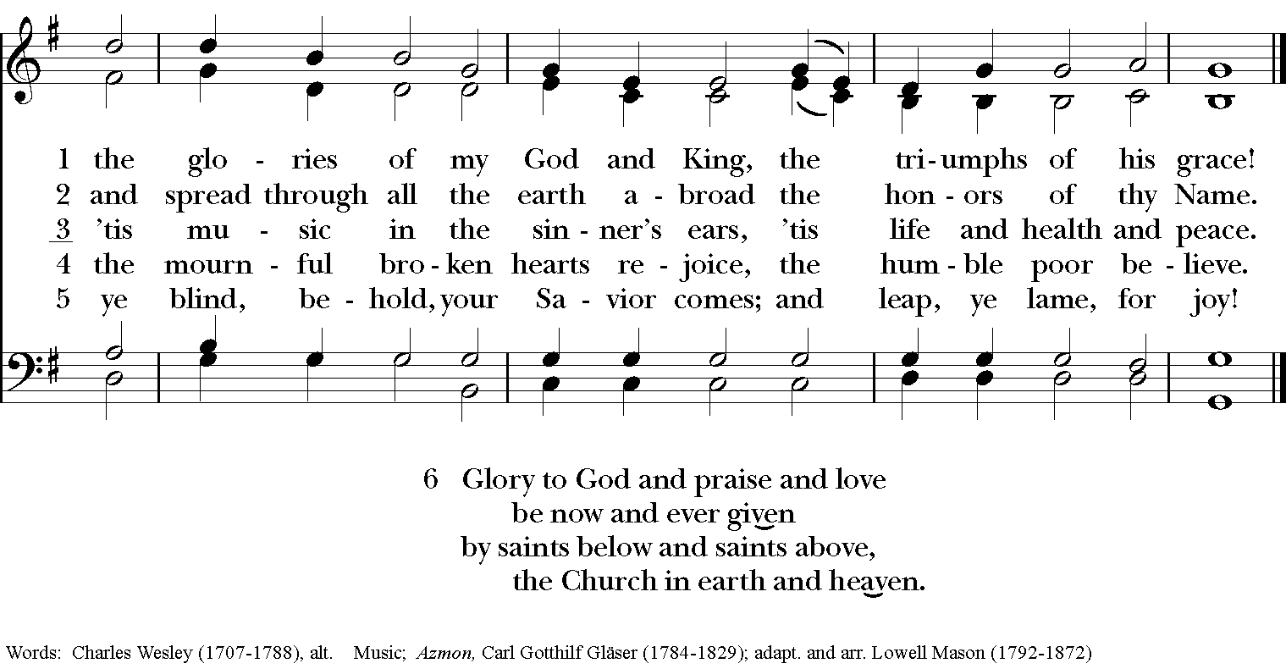
*THE BLESSING
Christ who has nourished us with himself the living bread, make you one in praise and love, and raise you up at the last day; and the blessing God Almighty, the Father, the Son, and the Holy Spirit, be among you, and remain with you always. Amen.

*THE DISMISSAL Deacon: Go in peace to love and serve the Lord.
People: Thanks be to God.

POSTLUDE: “Adagio cantabile“ from sonata in C Minor “Pathétique“ - Beethoven

Thank you for your spiritual presence with us this morning!
Although we're physically apart, we are united in prayer, worship, and holy love!
Priest-In-Charge: The Rev. Dr. Canon Lee Anne Reat
Deacon: The Rev. Dr. Rick Incorvati
Music Director: Dr. Chris Durrenberger
Lector: Anne Strothman
Singers: Liz Wheeler, Joy Carter, Basil Fett, Chris Oldstone-Moore, and Fred Bartenstein
Technology: Steve Ide
Slideshow: Ed Hasecke
Parish Administrator and Program Coordinator: Kelly Zeller

