Christ Episcopal Church in Springfield, Ohio
Service of the Word
Twelfth Sunday after Pentecost: August 15th, 2021 at 9 am

PRELUDE: “Jesu, Joy of Man’s Desiring” - Werde Munter/arr. Keene

OPENING HYMN: “Be thou my vision” Hymnal 488
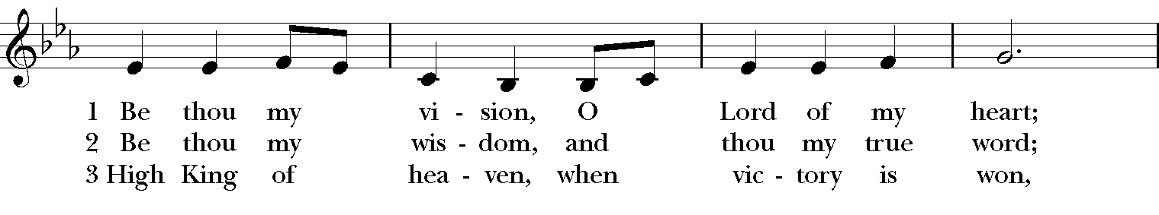

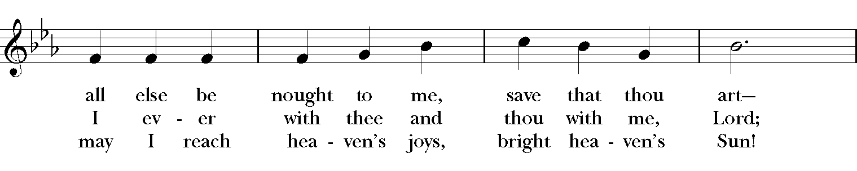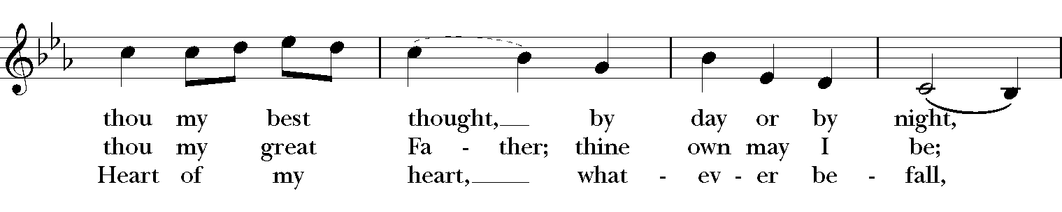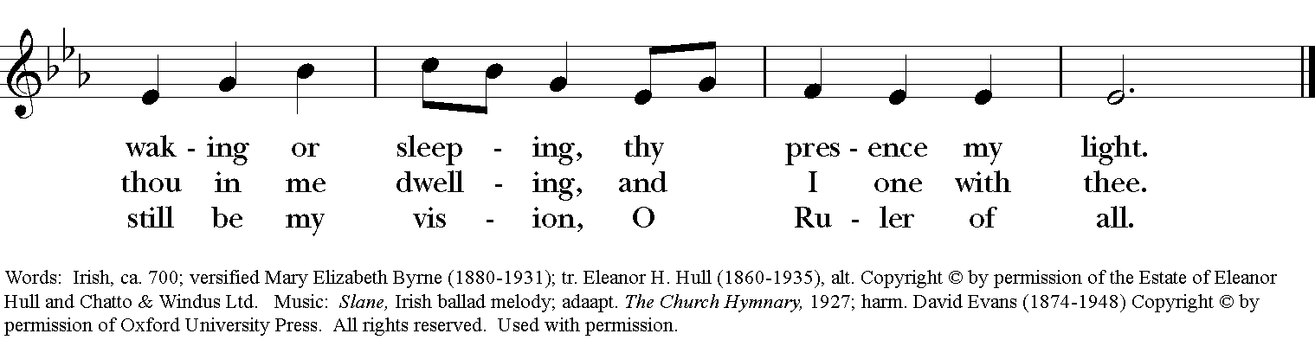

Celebrant: Blessed be God: Father, Son, and Holy Spirit.
People: And blessed be his kingdom, now and for ever. Amen.

The Collect of the Day
Celebrant: The Lord be with you.
People: And also with you.
Celebrant: Let us pray.
Almighty God, you have given your only Son to be for us a sacrifice for sin, and also an example of godly life: Give us grace to receive thankfully the fruits of his redeeming work, and to follow daily in the blessed steps of his most holy life; through Jesus Christ your Son our Lord, who lives and reigns with you and the Holy Spirit, one God, now and for ever. Amen.

THE LESSONS

THE FIRST READING Proverbs 9:1-6
Wisdom has built her house,
she has hewn her seven pillars.
She has slaughtered her animals, she has mixed her wine,
she has also set her table.
She has sent out her servant-girls, she calls
from the highest places in the town,
“You that are simple, turn in here!”
To those without sense she says,
“Come, eat of my bread
and drink of the wine I have mixed.
Lay aside immaturity, and live,
and walk in the way of insight.”
Lector: The Word of the Lord.
People: Thanks be to God.
PSALM 34:9-14 Benedicam Dominum
9 Fear the Lord, you that are his saints, *
for those who fear him lack nothing.
10 The young lions lack and suffer hunger, *
but those who seek the Lord lack nothing that is good.
11 Come, children, and listen to me; *
I will teach you the fear of the Lord.
12 Who among you loves life *
and desires long life to enjoy prosperity?
13 Keep your tongue from evil-speaking *
and your lips from lying words.
14 Turn from evil and do good; *
seek peace and pursue it.

THE SECOND LESSON Ephesians 5:15-20
Be careful then how you live, not as unwise people but as wise, making the most of the time, because the days are evil. So do not be foolish, but understand what the will of the Lord is. Do not get drunk with wine, for that is debauchery; but be filled with the Spirit, as you sing psalms and hymns and spiritual songs among yourselves, singing and making melody to the Lord in your hearts, giving thanks to God the Father at all times and for everything in the name of our Lord Jesus Christ.
Lector: The Word of the Lord.
People: Thanks be to God.
SQUENCE HYMN: “Praise to the Lord, the Almighty” Hymnal 390
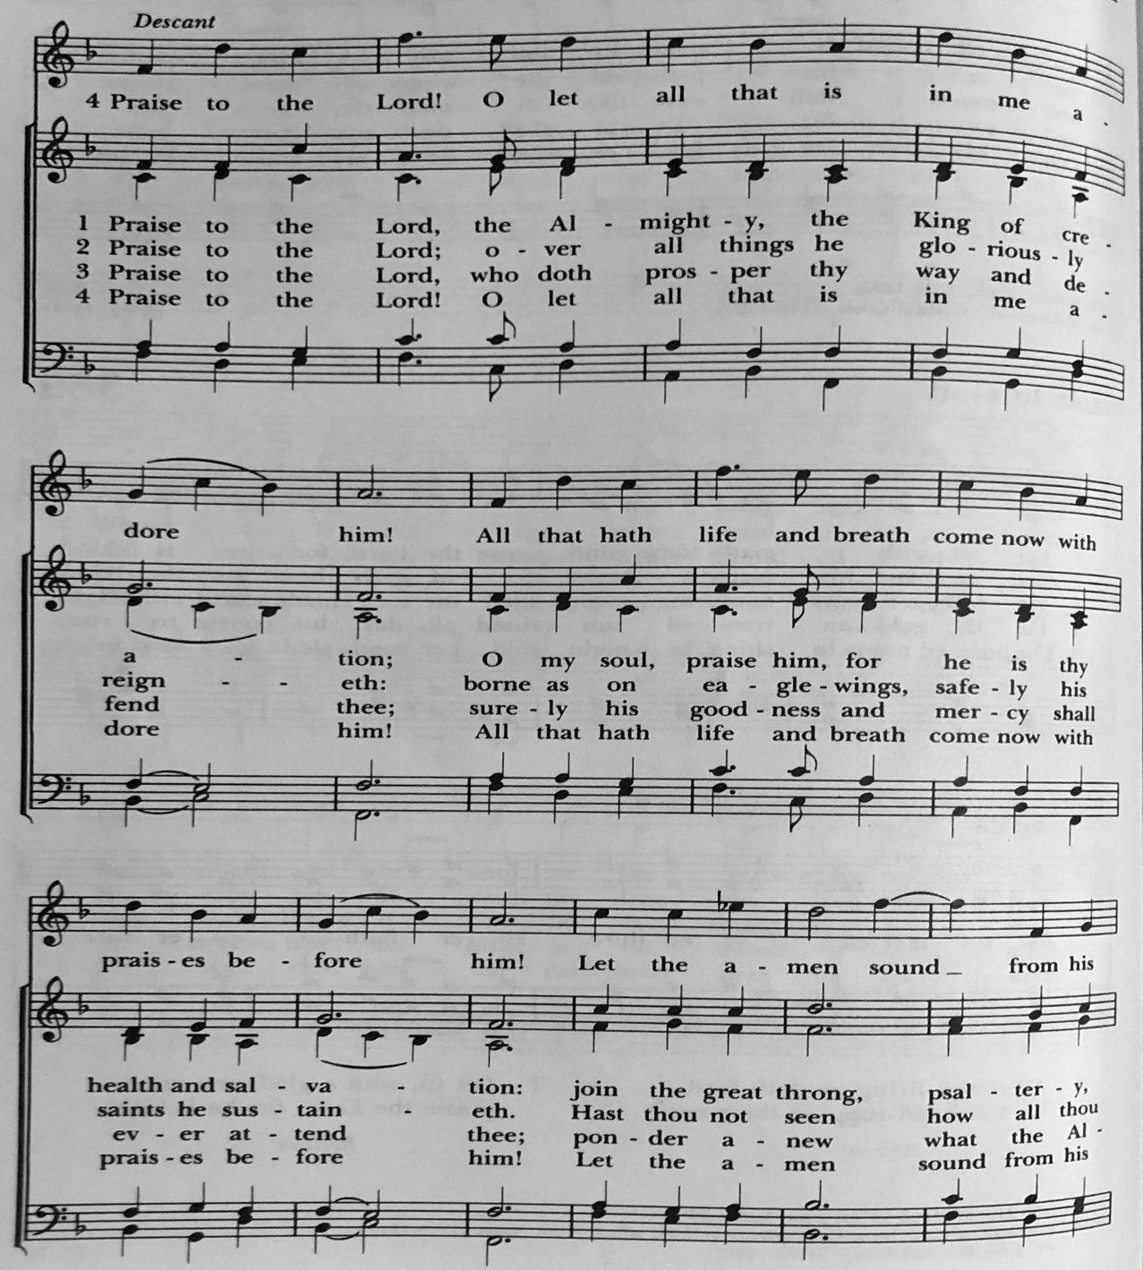

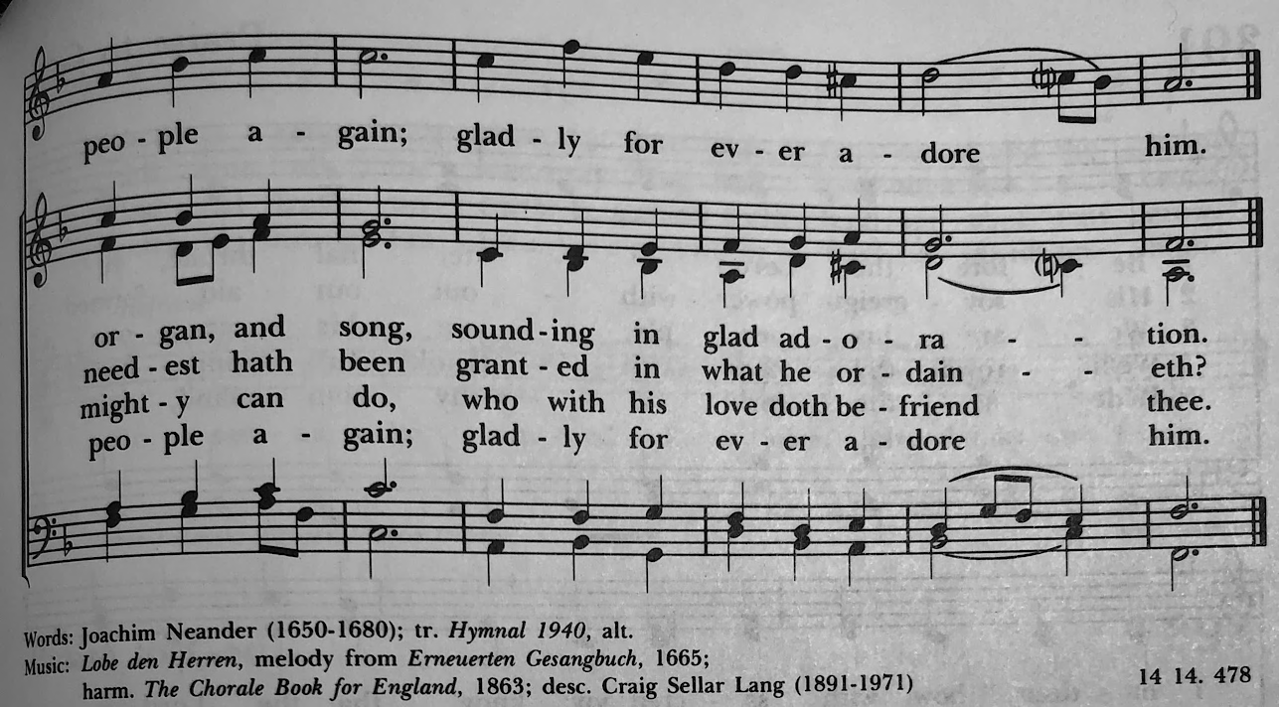

GOSPEL
Celebrant: The Holy Gospel of our Lord Jesus Christ according to John (John 6:51-58).
People: Glory to you, Lord Christ.
Jesus said, “I am the living bread that came down from heaven. Whoever eats of this bread will live forever; and the bread that I will give for the life of the world is my flesh.”
The Jews then disputed among themselves, saying, “How can this man give us his flesh to eat?” So Jesus said to them, “Very truly, I tell you, unless you eat the flesh of the Son of Man and drink his blood, you have no life in you. Those who eat my flesh and drink my blood have eternal life, and I will raise them up on the last day; for my flesh is true food and my blood is true drink. Those who eat my flesh and drink my blood abide in me, and I in them. Just as the living Father sent me, and I live because of the Father, so whoever eats me will live because of me. This is the bread that came down from heaven, not like that which your ancestors ate, and they died. But the one who eats this bread will live forever.”
Celebrant: The Gospel of the Lord.
People: Praise to you, Lord Christ.

Sermon The Rev. Canon Dr. Lee Anne Reat

The Nicene Creed
We believe in one God, the Father, the Almighty,
maker of heaven and earth, of all that is, seen and unseen.
We believe in one Lord, Jesus Christ, the only Son of God,
eternally begotten of the Father, God from God,
Light from Light, true God from true God,
begotten, not made, of one Being with the Father.
Through him all things were made.
For us and for our salvation he came down from heaven,
by the power of the Holy Spirit he became incarnate from the Virgin Mary,
and was made man.
For our sake he was crucified under Pontius Pilate;
he suffered death and was buried.
On the third day he rose again in accordance with the Scriptures;
he ascended into heaven and is seated at the right hand of the Father.
He will come again in glory to judge the living and the dead, and his kingdom will have no end.
We believe in the Holy Spirit, the Lord, the giver of life,
who proceeds from the Father, and the Son.
who with the Father and the Son is worshiped and glorified,
who has spoken through the Prophets.
We believe in one holy catholic and apostolic Church.
We acknowledge one baptism for the forgiveness of sins.
We look for the resurrection of the dead, and the life of the world to come. Amen.

THE PRAYERS OF THE PEOPLE

In peace, we pray to you Lord God. Congregational responses are in bold.

Silence

Let us pray. Founder of our faith, we ask your guidance for the Church, for its unity, and for the work it does in the world. Give grace to its leaders, especially Justin, archbishop of Canterbury; Michael, our Presiding Bishop; George, our Provisional Bishop; Lee Anne, our priest; and all the members of this parish.
R: Let your priests be clothed with righteousness; let your faithful people sing for joy.

Ruler over the nations, we pray for this country and its leaders in an unsettling time. Grant wisdom to all who serve in positions of leadership throughout the world.
R: For dominion belongs to the Lord, and he rules over the nations.

Lord of the harvest, we offer thanks for the beauty and abundance of this season. May we consider how best to tend the Earth and to share what You have given us, so that all may eat and be satisfied by your goodness. We pray for the ministries this church supports, especially Rainbow Table, Springfield Promise Neighborhood, Springfield Peace Center, Partners in Ministry in Liberia.
R: He covers the heavens with clouds, and prepares rain for the earth;
He makes grass grow upon the mountains, and green plants to serve humankind.

Giver of every good gift, we pray for those celebrating birthdays this week, especially Jack and anniversaries, Keith & Carol and Fred & Joy.
R: Let the righteous be glad and rejoice before God; Let them also be merry and joyful.
Great Physician, we pray for healing and comfort for all those in need or pain, especially Leigh, Charlene, Faye, Chris, Bonnie, Alice, Diana, James, Joy, Jane, Joni, Kim, Bobby, Sarah, Traudie, Lexie, and Keith. May they remember that You are with them and those who care for them.
R: Surely you behold trouble and misery; you see it and take it into your own hand.
The helpless commit themselves to you; for you are the helper of orphans.

Just Judge, we ask your aid for all those in trouble, bringing before You prisoners and captives, refugees and the oppressed. We pray for those most vulnerable throughout the world, especially women and children.
R: Let justice roll down like waters, and righteousness like an ever-flowing stream.

Lord over life and death, we pray for all who have died, asking light and peace for them and those who mourn.
R: Precious in the sight of the Lord is the death of his servant.

*THE COLLECT FOR PEACE
Grant, O God, that your holy and life-giving Spirit may so move every human heart, that barriers which divide us may crumble, suspicions disappear, and hatreds cease; that our divisions being healed, we may live in justice and peace; through Jesus Christ our Lord. Amen.

THE CONFESSION AND ABSOLUTION
Priest: Let us confess our sins against God and our neighbor.
All: Most merciful God, we confess that we have sinned against you in thought, word, and deed, by what we have done, and by what we have left undone. We have not loved you with our whole heart; we have not loved our neighbors as ourselves. We are truly sorry and we humbly repent. For the sake of your Son Jesus Christ, have mercy on us and forgive us; that we may delight in your will, and walk in your ways, to the glory of your Name. Amen.

Priest: Almighty God, have mercy on you, forgive you all your sins through our Lord Jesus Christ, strengthen you in all goodness, and by the power of the Holy Spirit keep you in eternal life. Amen.

And now, as our Savior Christ has taught us, we are bold to say:
Our Father, who art in heaven, hallowed be thy Name,
thy kingdom come, thy will be done, on earth as it is in heaven.
Give us this day our daily bread.
And forgive us our trespasses, as we forgive those who trespass against us.
And lead us not into temptation, but deliver us from evil.
For thine is the kingdom, and the power, and the glory, for ever and ever. Amen

CLOSING HYMN: “Come, my Way, my Truth, my Life” Hymnal 487
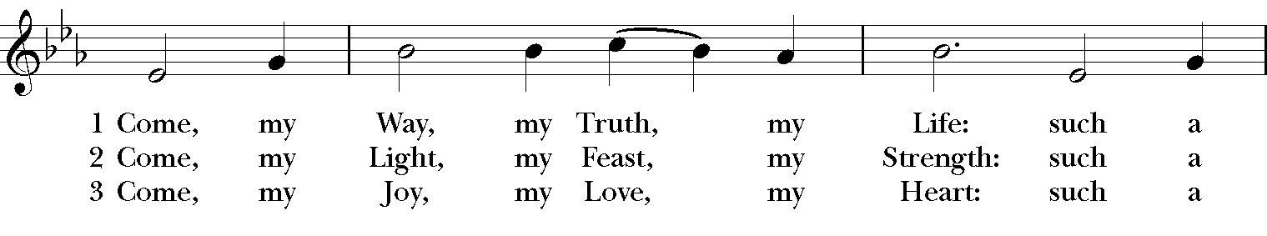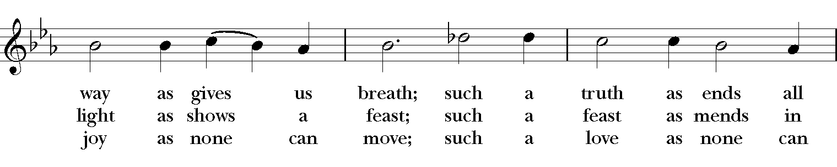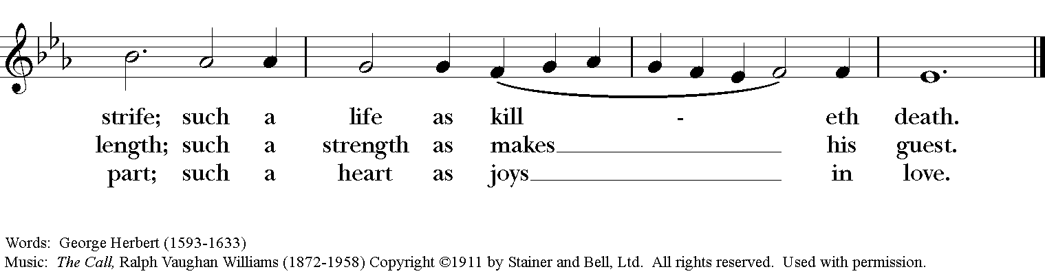

*THE BLESSING
Christ who has nourished us with himself the living bread, make you one in praise and love, and raise you up at the last day; and the blessing God Almighty, the Father, the Son, and the Holy Spirit, be among you, and remain with you always. Amen.

ANNOUNCEMENTS

*THE DISMISSAL Celebrant: Go in peace to love and serve the Lord.
People: Thanks be to God.
POSTLUDE: “Andante” from Sonata in C Major K545 - Mozart

Thank you for your spiritual presence with us this morning!
Although we're physically apart, we are united in prayer, worship, and holy love!
Priest-In-Charge: The Rev. Dr. Canon Lee Anne Reat
Music Director: Dr. Chris Durrenberger
Lector: Sarah Schubert
Singers: Liz Wheeler, Joy Carter, Basil Fett, Chris Oldstone-Moore, and Fred Bartenstein
Technology: Steve Ide
Slideshow: Ed Hasecke
Parish Administrator and Program Coordinator: Kelly Zeller

