Christ Episcopal Church in Springfield, Ohio
Service of the Word
Fourteenth Sunday after Pentecost: August 29th, 2021 at 9 am

PRELUDE: “My Jesus, I Love Thee“ - Gordon/arr. Lloyd Larson

OPENING HYMN: “Awake, my soul, and with the sun” Hymnal 11
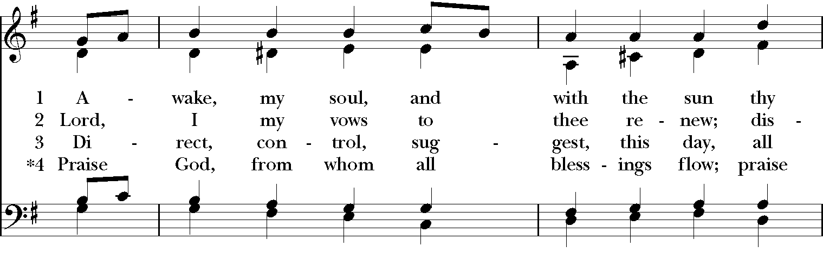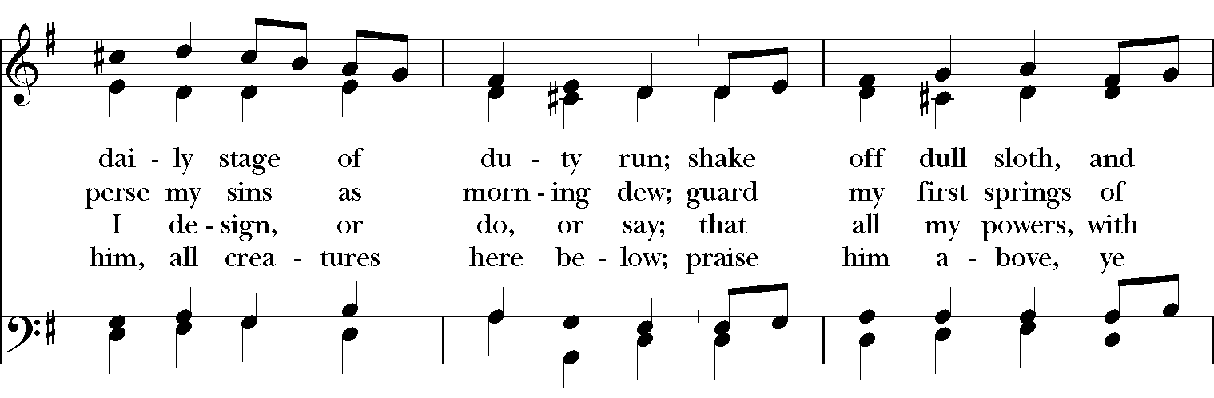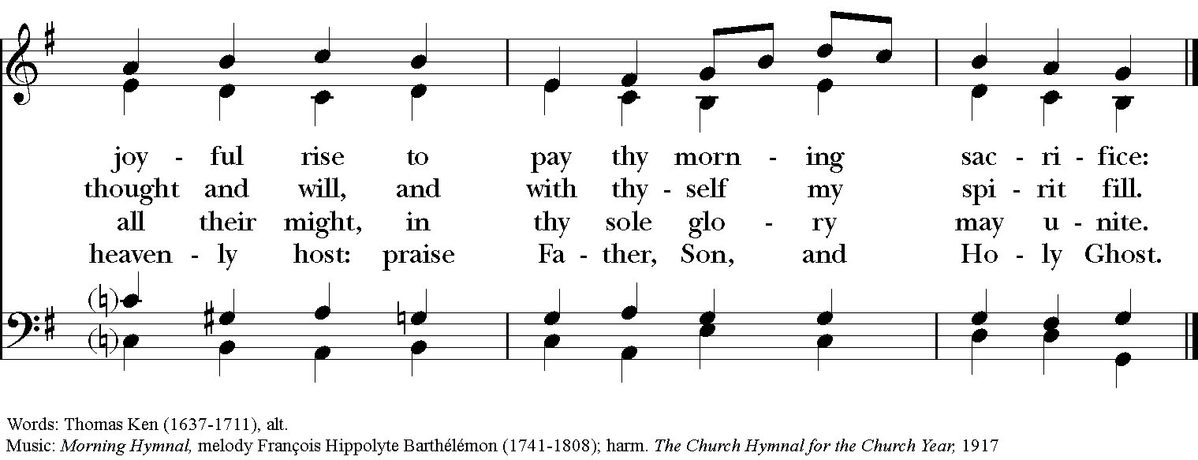

Celebrant: Blessed be God: Father, Son, and Holy Spirit.
People: And blessed be his kingdom, now and for ever. Amen.

The Collect of the Day
Celebrant: The Lord be with you.
People: And also with you.
Celebrant: Let us pray.
Lord of all power and might, the author and giver of all good things: Graft in our hearts the love of your Name; increase in us true religion; nourish us with all goodness; and bring forth in us the fruit of good works; through Jesus Christ our Lord, who lives and reigns with you and the Holy Spirit, one God for ever and ever. Amen
THE LESSONS

THE FIRST READING Deuteronomy 4:1-2, 6-9
Moses said: So now, Israel, give heed to the statutes and ordinances that I am teaching you to observe, so that you may live to enter and occupy the land that the Lord, the God of your ancestors, is giving you. You must neither add anything to what I command you nor take away anything from it, but keep the commandments of the Lord your God with which I am charging you.

You must observe them diligently, for this will show your wisdom and discernment to the peoples, who, when they hear all these statutes, will say, “Surely this great nation is a wise and discerning people!” For what other great nation has a god so near to it as the Lord our God is whenever we call to him? And what other great nation has statutes and ordinances as just as this entire law that I am setting before you today?
But take care and watch yourselves closely, so as neither to forget the things that your eyes have seen nor to let them slip from your mind all the days of your life; make them known to your children and your children’s children.
Lector: The Word of the Lord.
People: Thanks be to God

PSALM 15 Domine, quis habitabit?

1 Lord, who may dwell in your tabernacle? *
who may abide upon your holy hill?
2 Whoever leads a blameless life and does what is right, *
who speaks the truth from his heart.
3 There is no guile upon his tongue; he does no evil to his friend; *
he does not heap contempt upon his neighbor.
4 In his sight the wicked is rejected, *
but he honors those who fear the Lord.
5 He has sworn to do no wrong *
and does not take back his word.
6 He does not give his money in hope of gain, *
nor does he take a bribe against the innocent.
7 Whoever does these things *
shall never be overthrown.

THE SECOND LESSON James 1:17-27
Every generous act of giving, with every perfect gift, is from above, coming down from the Father of lights, with whom there is no variation or shadow due to change. In fulfillment of his own purpose he gave us birth by the word of truth, so that we would become a kind of first fruits of his creatures.
You must understand this, my beloved: let everyone be quick to listen, slow to speak, slow to anger; for your anger does not produce God's righteousness. Therefore rid yourselves of all sordidness and rank growth of wickedness, and welcome with meekness the implanted word that has the power to save your souls.

But be doers of the word, and not merely hearers who deceive themselves. For if any are hearers of the word and not doers, they are like those who look at themselves in a mirror; for they look at themselves and, on going away, immediately forget what they were like. But those who look into the perfect law, the law of liberty, and persevere, being not hearers who forget but doers who act-they will be blessed in their doing.

If any think they are religious, and do not bridle their tongues but deceive their hearts, their religion is worthless. Religion that is pure and undefiled before God, the Father, is this: to care for orphans and widows in their distress, and to keep oneself unstained by the world.
Lector: The Word of the Lord.
People: Thanks be to God.
SQUENCE HYMN: “Immortal, invisible, God only wise” Hymnal 423
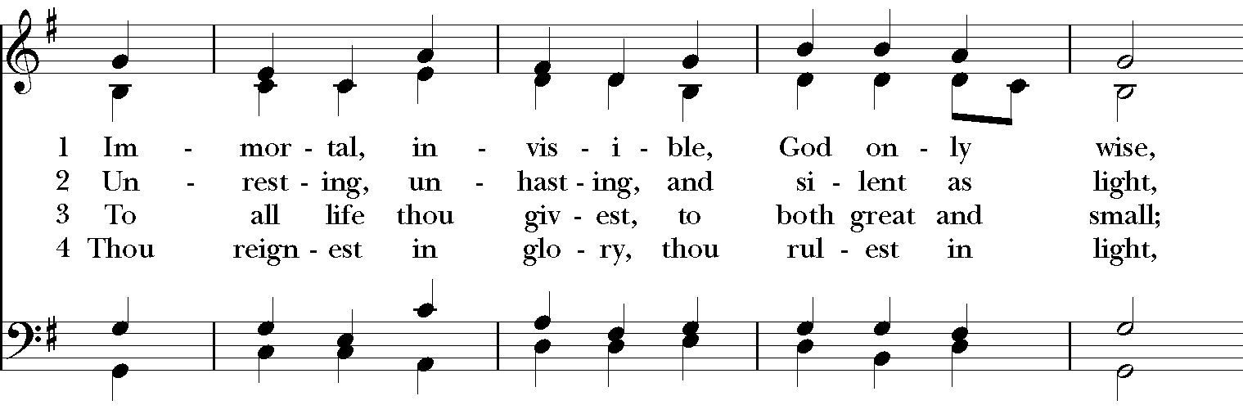
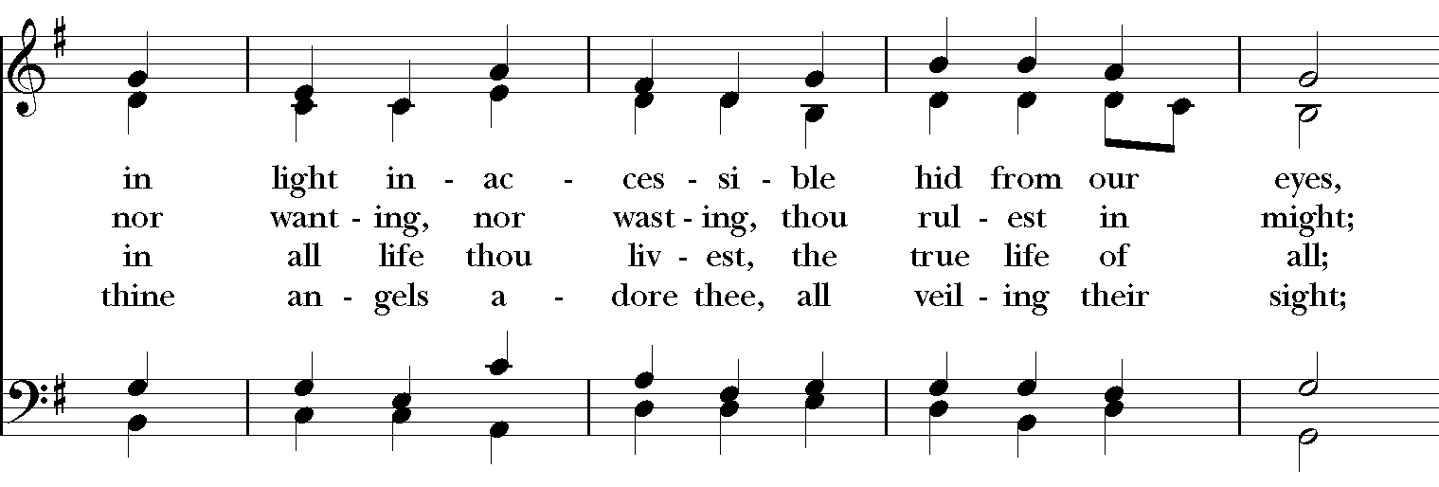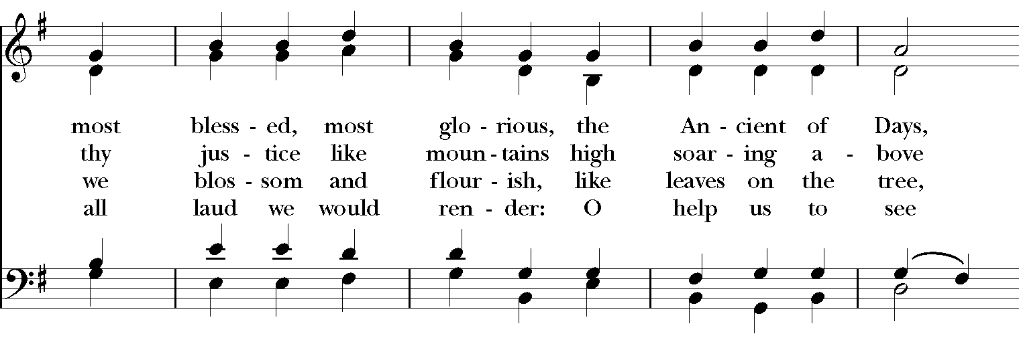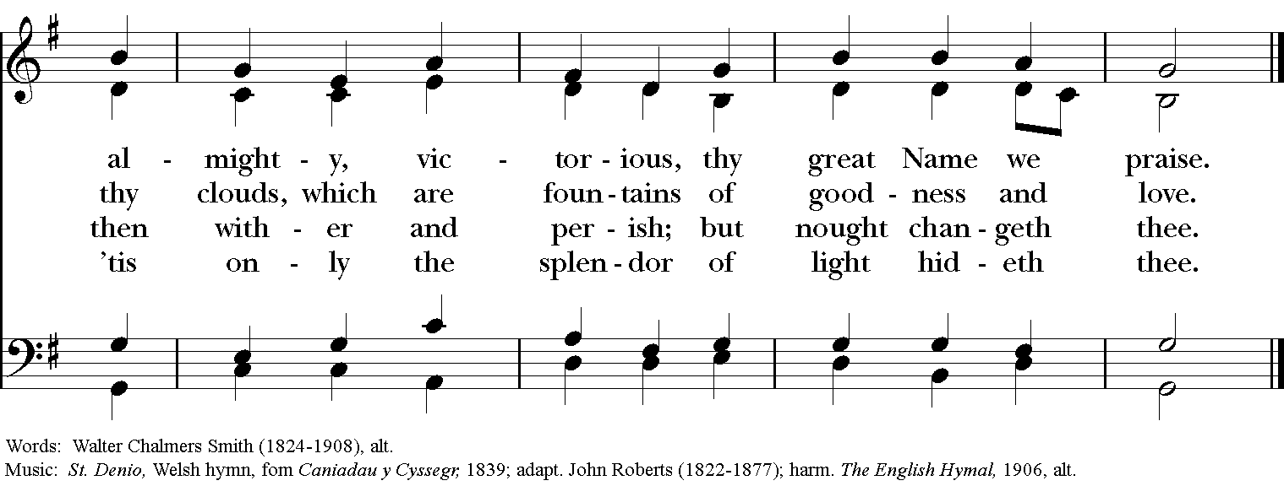
GOSPEL
Celebrant: The Holy Gospel of our Lord Jesus Christ according to Mark (Mark 7:1-8, 14-15, 21-23).
People: Glory to you, Lord Christ.
When the Pharisees and some of the scribes who had come from Jerusalem gathered around him, they noticed that some of his disciples were eating with defiled hands, that is, without washing them. (For the Pharisees, and all the Jews, do not eat unless they thoroughly wash their hands, thus observing the tradition of the elders; and they do not eat anything from the market unless they wash it; and there are also many other traditions that they observe, the washing of cups, pots, and bronze kettles.) So the Pharisees and the scribes asked him, “Why do your disciples not live according to the tradition of the elders, but eat with defiled hands?” He said to them,

“Isaiah prophesied rightly about you hypocrites, as it is written, ‘This people honors me with their lips,
but their hearts are far from me; in vain do they worship me, teaching human precepts as doctrines.’
You abandon the commandment of God and hold to human tradition.”

Then he called the crowd again and said to them, “Listen to me, all of you, and understand: there is nothing outside a person that by going in can defile, but the things that come out are what defile.” For it is from within, from the human heart, that evil intentions come: fornication, theft, murder, adultery, avarice, wickedness, deceit, licentiousness, envy, slander, pride, folly. All these evil things come from within, and they defile a person.”
Celebrant: The Gospel of the Lord.
People: Praise to you, Lord Christ.

Sermon The Rev. Canon Dr. Lee Anne Reat

The Nicene Creed
We believe in one God, the Father, the Almighty,
maker of heaven and earth, of all that is, seen and unseen.
We believe in one Lord, Jesus Christ, the only Son of God,
eternally begotten of the Father, God from God,
Light from Light, true God from true God,
begotten, not made, of one Being with the Father.
Through him all things were made.
For us and for our salvation he came down from heaven,
by the power of the Holy Spirit he became incarnate from the Virgin Mary,
and was made man.
For our sake he was crucified under Pontius Pilate;
he suffered death and was buried.
On the third day he rose again in accordance with the Scriptures;
he ascended into heaven and is seated at the right hand of the Father.
He will come again in glory to judge the living and the dead, and his kingdom will have no end.
We believe in the Holy Spirit, the Lord, the giver of life,
who proceeds from the Father, and the Son.
who with the Father and the Son is worshiped and glorified,
who has spoken through the Prophets.
We believe in one holy catholic and apostolic Church.
We acknowledge one baptism for the forgiveness of sins.
We look for the resurrection of the dead, and the life of the world to come. Amen.

THE PRAYERS OF THE PEOPLE

In peace, we pray to you Lord God. Congregational responses are in bold.

Silence

Let us pray. Founder of our faith, we ask your guidance for the Church, for its unity, and for the work it does in the world. Give grace to its leaders, especially Justin, archbishop of Canterbury; Michael, our Presiding Bishop; George, our Provisional Bishop; Lee Anne, our priest; and all the members of this parish.
R: Let your priests be clothed with righteousness; let your faithful people sing for joy.

Ruler over the nations, we pray for this country and its leaders in an unsettling time. Grant wisdom to all who serve in positions of leadership throughout the world.
R: For dominion belongs to the Lord, and he rules over the nations.

Lord of the harvest, we offer thanks for the beauty and abundance of this season. May we consider how best to tend the Earth and to share what You have given us, so that all may eat and be satisfied by your goodness. We pray for the ministries this church supports, especially Clark County Literacy Coalition, Episcopal Community Ministries, Second Harvest Food Bank, and Interfaith Hospitality Network.
R: He covers the heavens with clouds, and prepares rain for the earth;
He makes grass grow upon the mountains, and green plants to serve humankind.

Giver of every good gift, we pray for those celebrating birthdays this week, especially Jenny, Anne, Lee Anne, and Bonnie, and anniversaries D.J. and Myra Dean Banion.
R: Let the righteous be glad and rejoice before God; Let them also be merry and joyful.

Great Physician, we pray for healing and comfort for all those in need or pain, especially Leigh, Charlene, Faye, Chris, Bonnie, Alice, Diana, James, Joy, Jane, Joni, Kim, Bobby, Sarah, Traudie, Lexie, and Keith. May they remember that You are with them and those who care for them.
R: Surely you behold trouble and misery; you see it and take it into your own hand.
The helpless commit themselves to you; for you are the helper of orphans.

Just Judge, we ask your aid for all those in trouble, bringing before You prisoners and captives, refugees and the oppressed. We pray for those most vulnerable throughout the world, especially women and children.
R: Let justice roll down like waters, and righteousness like an ever-flowing stream.

Lord over life and death, we pray for all who have died, asking light and peace for them and those who mourn.
R: Precious in the sight of the Lord is the death of his servant.
*THE COLLECT FOR PEACE
Grant, O God, that your holy and life-giving Spirit may so move every human heart, that barriers which divide us may crumble, suspicions disappear, and hatreds cease; that our divisions being healed, we may live in justice and peace; through Jesus Christ our Lord. Amen.

THE CONFESSION AND ABSOLUTION
Priest: Let us confess our sins against God and our neighbor.
All: Most merciful God, we confess that we have sinned against you in thought, word, and deed, by what we have done, and by what we have left undone. We have not loved you with our whole heart; we have not loved our neighbors as ourselves. We are truly sorry and we humbly repent. For the sake of your Son Jesus Christ, have mercy on us and forgive us; that we may delight in your will, and walk in your ways, to the glory of your Name. Amen.

Priest: Almighty God, have mercy on you, forgive you all your sins through our Lord Jesus Christ, strengthen you in all goodness, and by the power of the Holy Spirit keep you in eternal life. Amen.

And now, as our Savior Christ has taught us, we are bold to say:
Our Father, who art in heaven, hallowed be thy Name,
thy kingdom come, thy will be done, on earth as it is in heaven.
Give us this day our daily bread.
And forgive us our trespasses, as we forgive those who trespass against us.
And lead us not into temptation, but deliver us from evil.
For thine is the kingdom, and the power, and the glory, for ever and ever. Amen

CLOSING HYMN: “O praise Ye the Lord” Hymnal 432 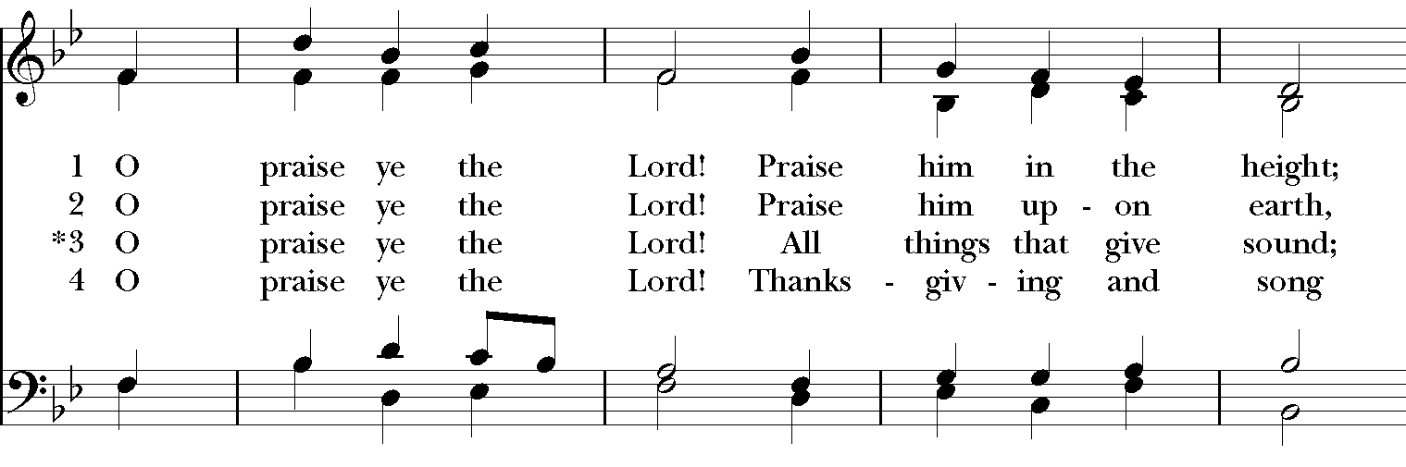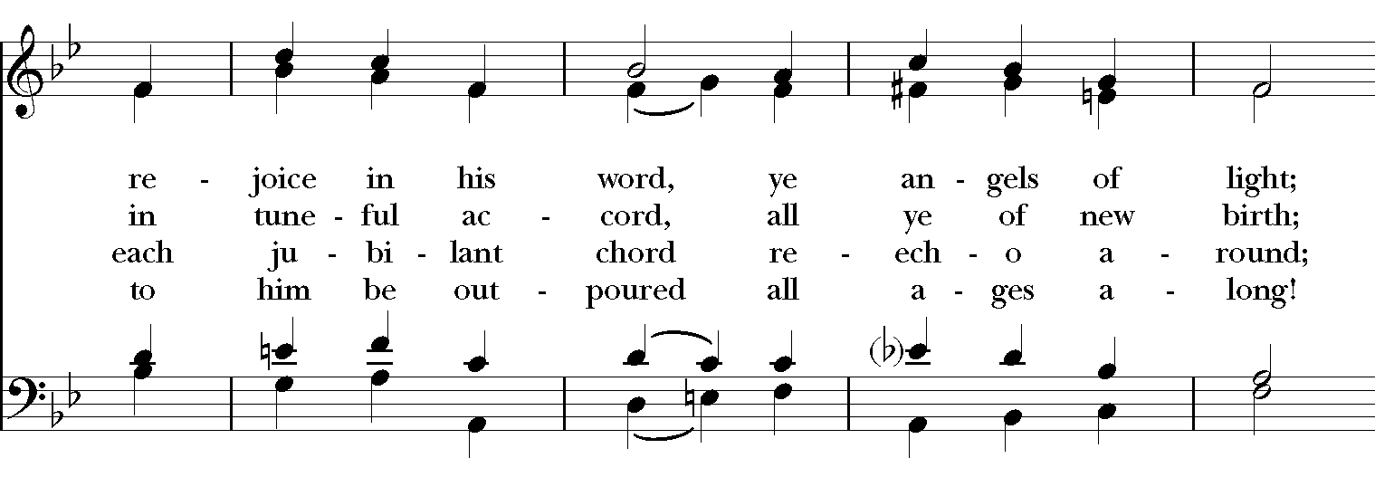

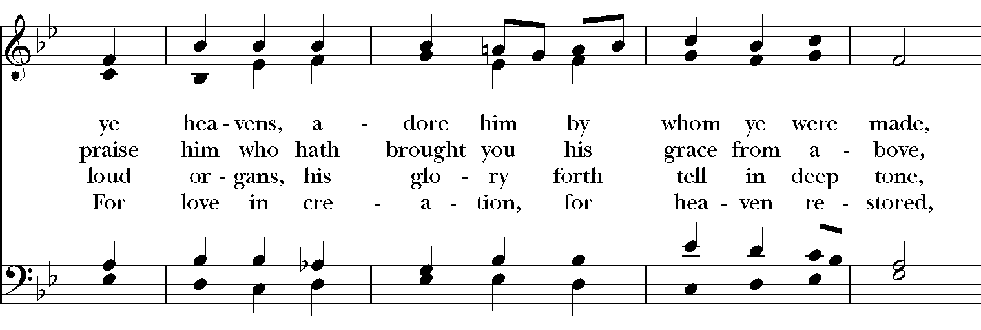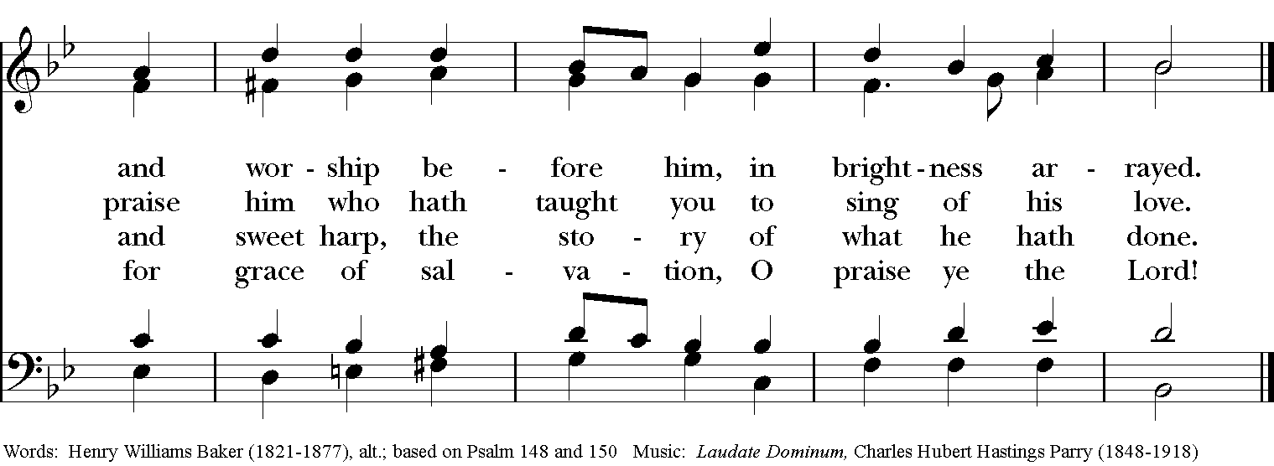

*THE BLESSING
Christ who has nourished us with himself the living bread, make you one in praise and love, and raise you up at the last day; and the blessing God Almighty, the Father, the Son, and the Holy Spirit, be among you, and remain with you always. Amen.

ANNOUNCEMENTS

*THE DISMISSAL Celebrant: Go in peace to love and serve the Lord.
People: Thanks be to God.

POSTLUDE: “Ecossaises 1 and 2” woo 83 - Beethoven

Thank you for your spiritual presence with us this morning!
Although we're physically apart, we are united in prayer, worship, and holy love!
Priest-In-Charge: The Rev. Dr. Canon Lee Anne Reat
Music Director: Dr. Chris Durrenberger
Lector: Anne Strothman
Singers: Liz Wheeler, Joy Carter, Basil Fett, Chris Oldstone-Moore, and Fred Bartenstein
Technology: Steve Ide
Slideshow: Ed Hasecke
Parish Administrator and Program Coordinator: Kelly Zeller

