Christ Episcopal Church in Springfield, Ohio
Service of the Word
Fifteenth Sunday after Pentecost: September 5th, 2021 at 9 am

PRELUDE: “The King of Love My Shepherd Is” - St. Columbia/arr. Bisbee

OPENING HYMN: “Joyful, joyful, we adore thee” Hymnal 376
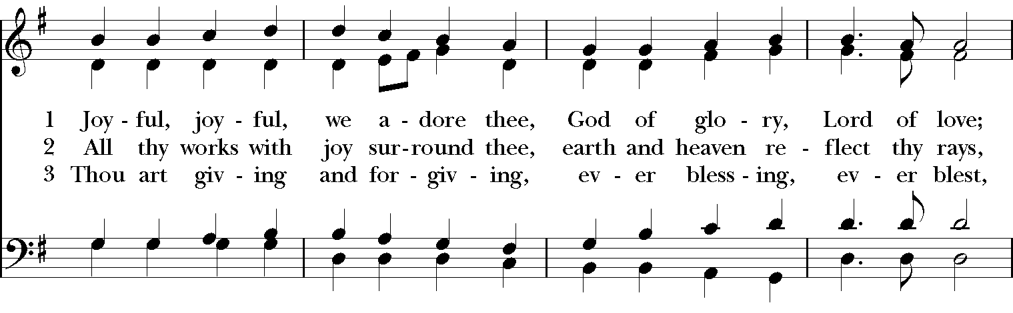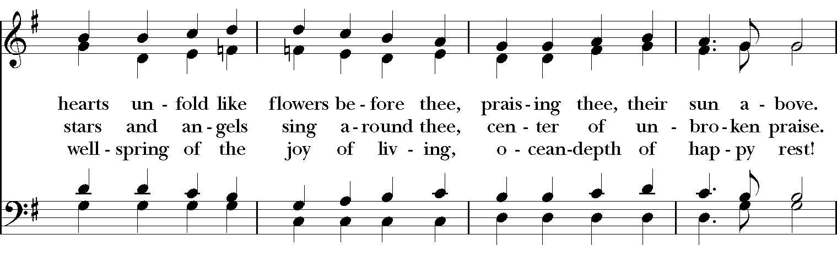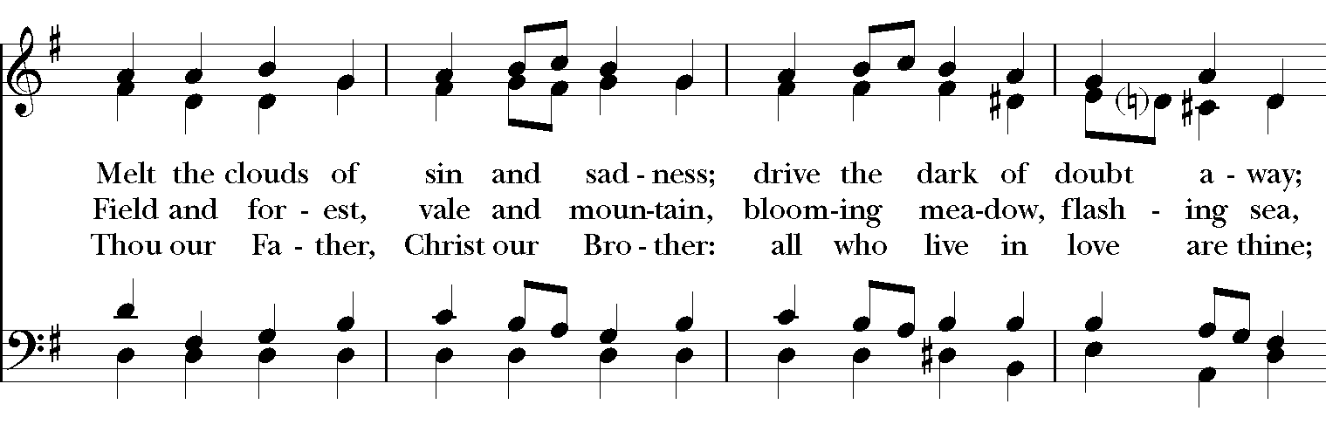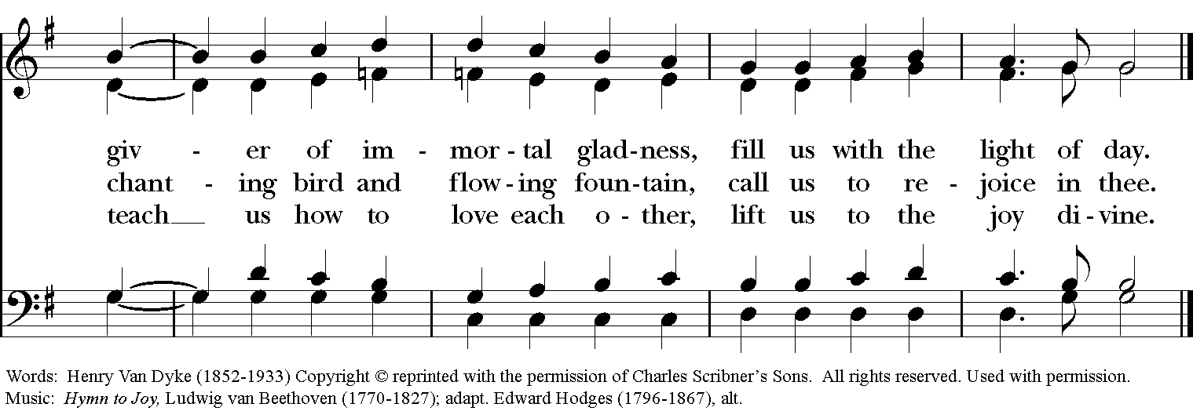

Celebrant: Blessed be God: Father, Son, and Holy Spirit.
People: And blessed be his kingdom, now and for ever. Amen.

The Collect of the Day
Celebrant: The Lord be with you.
People: And also with you.
Celebrant: Let us pray.
Grant us, O Lord, to trust in you with all our hearts; for, as you always resist the proud who confide in their own strength, so you never forsake those who make their boast of your mercy; through Jesus Christ our Lord, who lives and reigns with you and the Holy Spirit, one God, now and for ever. Amen.

THE LESSONS

THE FIRST READING Isaiah 35:4-7a
Say to those who are of a fearful heart,
‘Be strong, do not fear!
Here is your God.
He will come with vengeance,
with terrible recompense.
He will come and save you.’

Then the eyes of the blind shall be opened,
and the ears of the deaf unstopped;
then the lame shall leap like a deer,
and the tongue of the speechless sing for joy.
For waters shall break forth in the wilderness,
and streams in the desert;
the burning sand shall become a pool,
and the thirsty ground springs of water;
Lector: The Word of the Lord.
People: Thanks be to God.
PSALM 146 Lauda, anima mea
1 Hallelujah!
Praise the Lord, O my soul! *
I will praise the Lord as long as I live; I will sing praises to my God while I have my being.
2 Put not your trust in rulers, nor in any child of earth, *
for there is no help in them.
3 When they breathe their last, they return to earth, *
and in that day their thoughts perish.
4 Happy are they who have the God of Jacob for their help! *
whose hope is in the Lord their God;
5 Who made heaven and earth, the seas, and all that is in them; *
who keeps his promise for ever;
6 Who gives justice to those who are oppressed, *
and food to those who hunger.
7 The Lord sets the prisoners free; the Lord opens the eyes of the blind; *
the Lord lifts up those who are bowed down;
8 The Lord loves the righteous; the Lord cares for the stranger; *
he sustains the orphan and widow, but frustrates the way of the wicked.
9 The Lord shall reign for ever, *
your God, O Zion, throughout all generations.
Hallelujah!

THE SECOND LESSON James 2:1-10, [11-13], 14-17
My brothers and sisters, do you with your acts of favoritism really believe in our glorious Lord Jesus Christ? For if a person with gold rings and in fine clothes comes into your assembly, and if a poor person in dirty clothes also comes in, and if you take notice of the one wearing the fine clothes and say, “Have a seat here, please,” while to the one who is poor you say, “Stand there,” or, “Sit at my feet,” have you not made distinctions among yourselves, and become judges with evil thoughts? Listen, my beloved brothers and sisters.

Has not God chosen the poor in the world to be rich in faith and to be heirs of the kingdom that he has promised to those who love him? But you have dishonored the poor. Is it not the rich who oppress you? Is it not they who drag you into court? Is it not they who blaspheme the excellent name that was invoked over you?

You do well if you really fulfill the royal law according to the scripture, “You shall love your neighbor as yourself.” But if you show partiality, you commit sin and are convicted by the law as transgressors. For whoever keeps the whole law but fails in one point has become accountable for all of it.[ For the one who said, “You shall not commit adultery,” also said, “You shall not murder.” Now if you do not commit adultery but if you murder, you have become a transgressor of the law. So speak and so act as those who are to be judged by the law of liberty. For judgment will be without mercy to anyone who has shown no mercy; mercy triumphs over judgment.]

What good is it, my brothers and sisters, if you say you have faith but do not have works? Can faith save you? If a brother or sister is naked and lacks daily food, and one of you says to them, “Go in peace; keep warm and eat your fill,” and yet you do not supply their bodily needs, what is the good of that? So faith by itself, if it has no works, is dead.
Lector: The Word of the Lord.
People: Thanks be to God.
SQUENCE HYMN: “Strengthen for service ” Hymnal 312
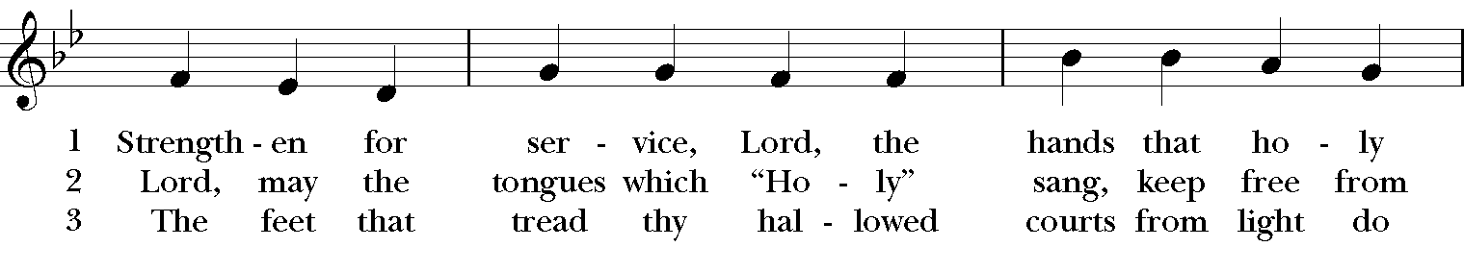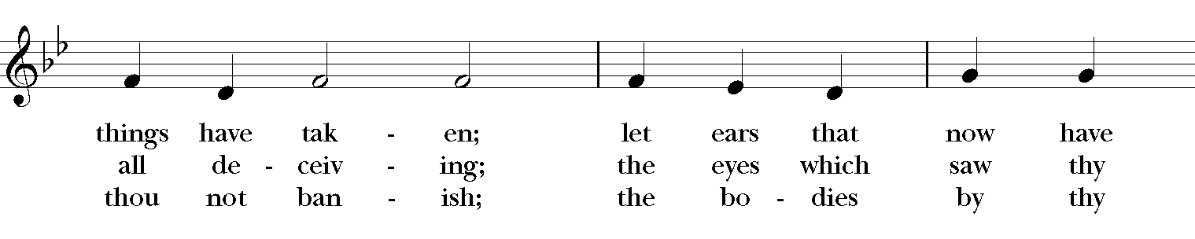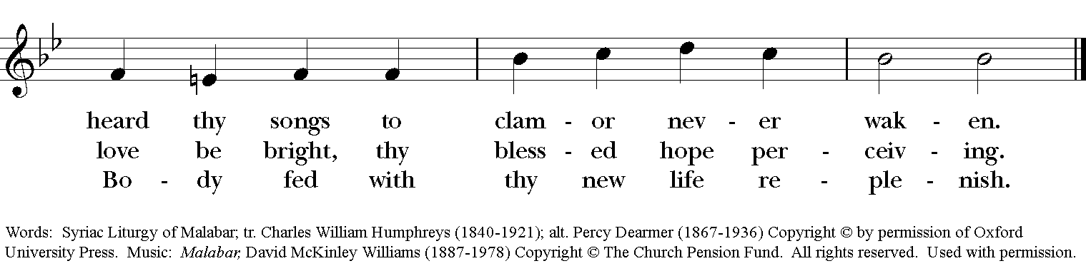
GOSPEL
Celebrant: The Holy Gospel of our Lord Jesus Christ according to Mark (Mark 7:24-37).
People: Glory to you, Lord Christ.
Jesus set out and went away to the region of Tyre. He entered a house and did not want anyone to know he was there. Yet he could not escape notice, but a woman whose little daughter had an unclean spirit immediately heard about him, and she came and bowed down at his feet. Now the woman was a Gentile, of Syrophoenician origin. She begged him to cast the demon out of her daughter. He said to her, “Let the children be fed first, for it is not fair to take the children’s food and throw it to the dogs.” But she answered him, “Sir, even the dogs under the table eat the children’s crumbs.” Then he said to her, “For saying that, you may go—the demon has left your daughter.” So she went home, found the child lying on the bed, and the demon gone.

Then he returned from the region of Tyre, and went by way of Sidon towards the Sea of Galilee, in the region of the Decapolis. They brought to him a deaf man who had an impediment in his speech; and they begged him to lay his hand on him. He took him aside in private, away from the crowd, and put his fingers into his ears, and he spat and touched his tongue. Then looking up to heaven, he sighed and said to him, “Ephphatha,” that is, “Be opened.” And immediately his ears were opened, his tongue was released, and he spoke plainly. Then Jesus ordered them to tell no one; but the more he ordered them, the more zealously they proclaimed it. They were astounded beyond measure, saying, “He has done everything well; he even makes the deaf to hear and the mute to speak.”
Celebrant: The Gospel of the Lord.
People: Praise to you, Lord Christ.

Sermon The Rev. Canon Dr. Lee Anne Reat

The Nicene Creed
We believe in one God, the Father, the Almighty,
maker of heaven and earth, of all that is, seen and unseen.
We believe in one Lord, Jesus Christ, the only Son of God,
eternally begotten of the Father, God from God,
Light from Light, true God from true God,
begotten, not made, of one Being with the Father.
Through him all things were made.
For us and for our salvation he came down from heaven,
by the power of the Holy Spirit he became incarnate from the Virgin Mary,
and was made man.
For our sake he was crucified under Pontius Pilate;
he suffered death and was buried.
On the third day he rose again in accordance with the Scriptures;
he ascended into heaven and is seated at the right hand of the Father.
He will come again in glory to judge the living and the dead, and his kingdom will have no end.
We believe in the Holy Spirit, the Lord, the giver of life,
who proceeds from the Father, and the Son.
who with the Father and the Son is worshiped and glorified,
who has spoken through the Prophets.
We believe in one holy catholic and apostolic Church.
We acknowledge one baptism for the forgiveness of sins.
We look for the resurrection of the dead, and the life of the world to come. Amen.

THE PRAYERS OF THE PEOPLE

In peace, we pray to you Lord God. Congregational responses are in bold.

Silence

Let us pray. Founder of our faith, we ask your guidance for the Church, for its unity, and for the work it does in the world. Give grace to its leaders, especially Justin, archbishop of Canterbury; Michael, our Presiding Bishop; George, our Provisional Bishop; Lee Anne, our priest; and all the members of this parish.
R: Let your priests be clothed with righteousness; let your faithful people sing for joy.

Ruler over the nations, we pray for this country and its leaders in an unsettling time. Grant wisdom to all who serve in positions of leadership throughout the world.
R: For dominion belongs to the Lord, and he rules over the nations.

Lord of the harvest, we offer thanks for the beauty and abundance of this season. May we consider how best to tend the Earth and to share what You have given us, so that all may eat and be satisfied by your goodness. We pray for the ministries this church supports, especially Springfield Farmer’s Market, Project Woman, Children’s Defense Fund Freedom Schools, The YMCA, and Jefferson St. Oasis Garden.
R: He covers the heavens with clouds, and prepares rain for the earth;
He makes grass grow upon the mountains, and green plants to serve humankind.

Giver of every good gift, we pray for those celebrating birthdays this week, especially Angus, Brian, Joy, and Jeff and anniversaries David and Rose.
R: Let the righteous be glad and rejoice before God; Let them also be merry and joyful.

Great Physician, we pray for healing and comfort for all those in need or pain, especially Leigh, Charlene, Faye, Chris, Bonnie, Alice, Diana, James, Joy, Jane, Joni, Kim, Bobby, Sarah, Traudie, Lexie, and Keith. May they remember that You are with them and those who care for them.
R: Surely you behold trouble and misery; you see it and take it into your own hand.
The helpless commit themselves to you; for you are the helper of orphans.

Just Judge, we ask your aid for all those in trouble, bringing before You prisoners and captives, refugees and the oppressed. We pray for those most vulnerable throughout the world, especially women and children.
R: Let justice roll down like waters, and righteousness like an ever-flowing stream.

Lord over life and death, we pray for all who have died, asking light and peace for them and those who mourn.
R: Precious in the sight of the Lord is the death of his servant.

*THE COLLECT FOR PEACE
Grant, O God, that your holy and life-giving Spirit may so move every human heart, that barriers which divide us may crumble, suspicions disappear, and hatreds cease; that our divisions being healed, we may live in justice and peace; through Jesus Christ our Lord. Amen.

THE CONFESSION AND ABSOLUTION
Priest: Let us confess our sins against God and our neighbor.
All: Most merciful God, we confess that we have sinned against you in thought, word, and deed, by what we have done, and by what we have left undone. We have not loved you with our whole heart; we have not loved our neighbors as ourselves. We are truly sorry and we humbly repent. For the sake of your Son Jesus Christ, have mercy on us and forgive us; that we may delight in your will, and walk in your ways, to the glory of your Name. Amen.

Priest: Almighty God, have mercy on you, forgive you all your sins through our Lord Jesus Christ, strengthen you in all goodness, and by the power of the Holy Spirit keep you in eternal life. Amen.

And now, as our Savior Christ has taught us, we are bold to say:
Our Father, who art in heaven, hallowed be thy Name,
thy kingdom come, thy will be done, on earth as it is in heaven.
Give us this day our daily bread.
And forgive us our trespasses, as we forgive those who trespass against us.
And lead us not into temptation, but deliver us from evil.
For thine is the kingdom, and the power, and the glory, for ever and ever. Amen

CLOSING HYMN: “Hail to the Lord’s Anointed” Hymnal 616
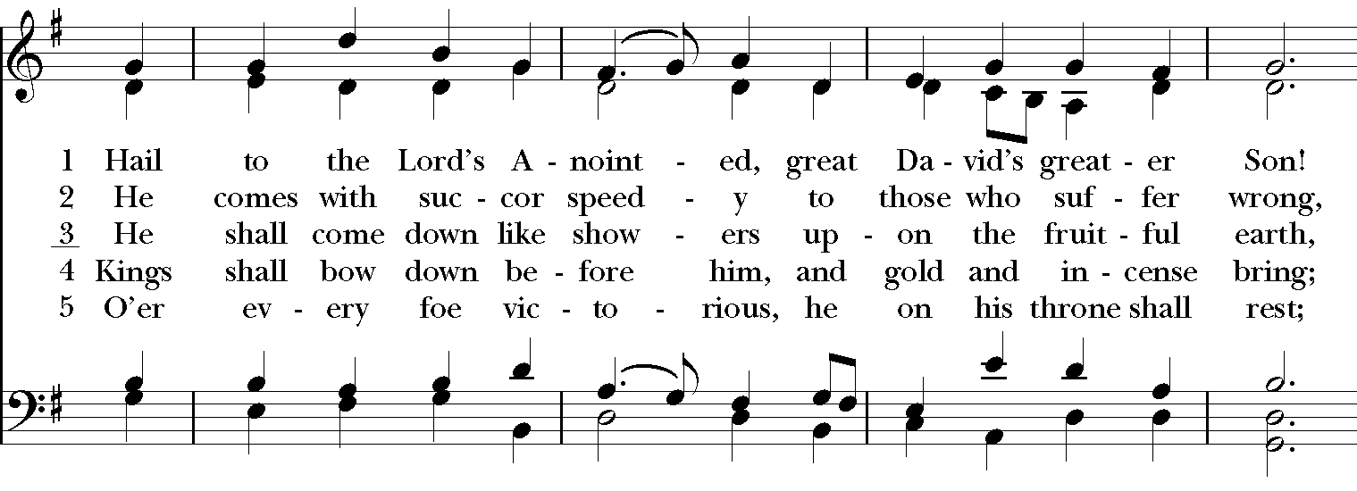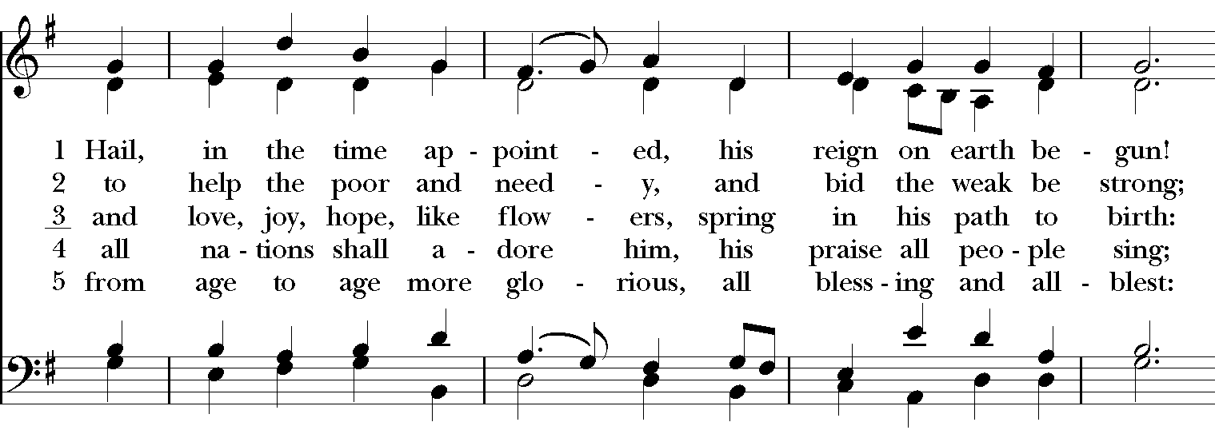c
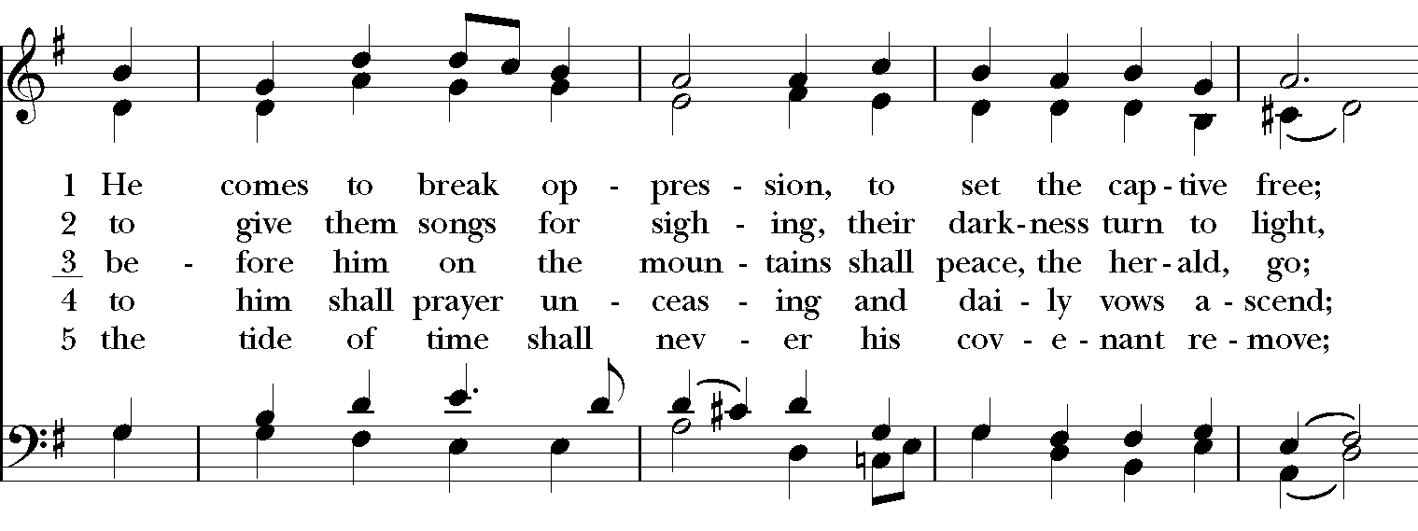

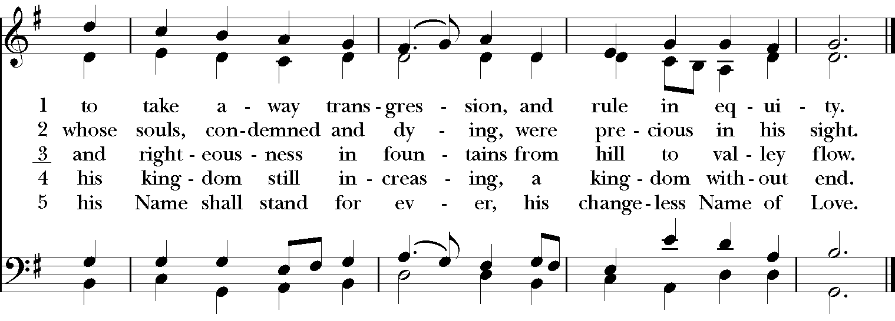

*THE BLESSING
Christ who has nourished us with himself the living bread, make you one in praise and love, and raise you up at the last day; and the blessing God Almighty, the Father, the Son, and the Holy Spirit, be among you, and remain with you always. Amen.

ANNOUNCEMENTS

*THE DISMISSAL Celebrant: Go in peace to love and serve the Lord.
People: Thanks be to God.

POSTLUDE: “Adagio cantabile“ from sonata in C Minor “Pathétique“ - Beethoven

Thank you for your spiritual presence with us this morning!
Although we're physically apart, we are united in prayer, worship, and holy love!
Priest-In-Charge: The Rev. Dr. Canon Lee Anne Reat
Music Director: Dr. Chris Durrenberger
Lector: Diane Rode
Singers: Liz Wheeler, Joy Carter, Basil Fett, Chris Oldstone-Moore, and Fred Bartenstein
Technology: Steve Ide
Slideshow: Ed Hasecke
Parish Administrator and Program Coordinator: Kelly Zeller

