Christ Episcopal Church in Springfield, Ohio
Service of the Word
Sixteenth Sunday after Pentecost: September 12th, 2021 at 9 am

PRELUDE: “Come Down, O Love Divine“ - Down Ampney/arr. Callahan

OPENING HYMN: “Come down, O Love Divine” Hymnal 516
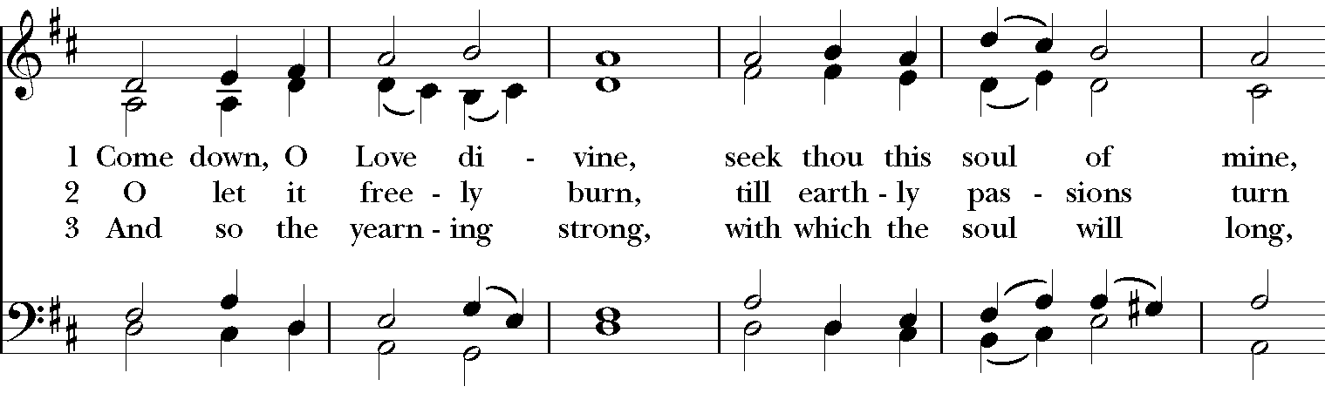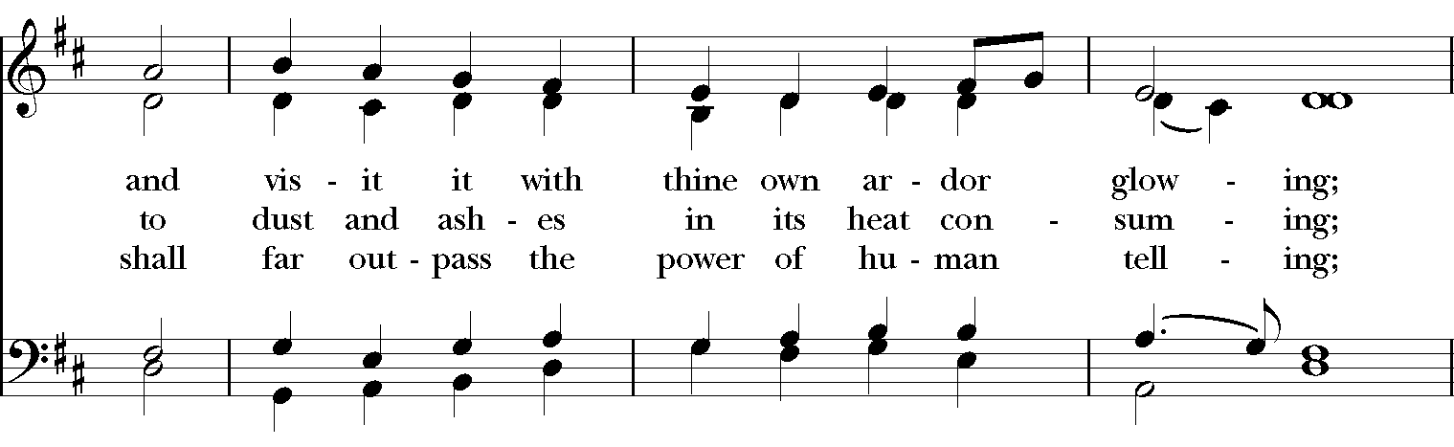
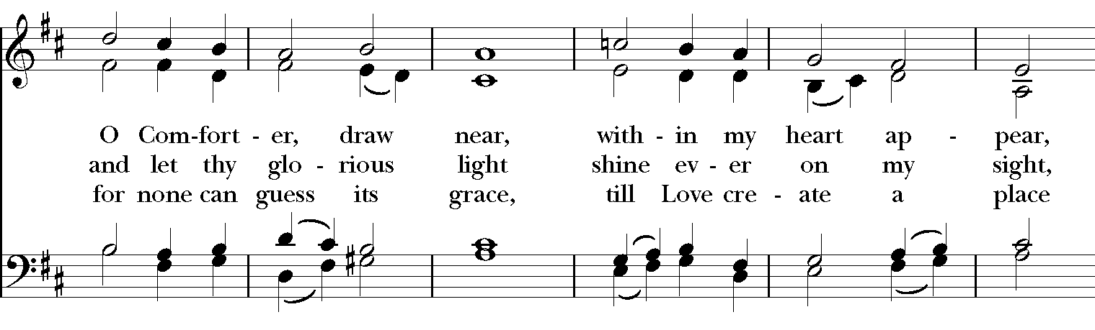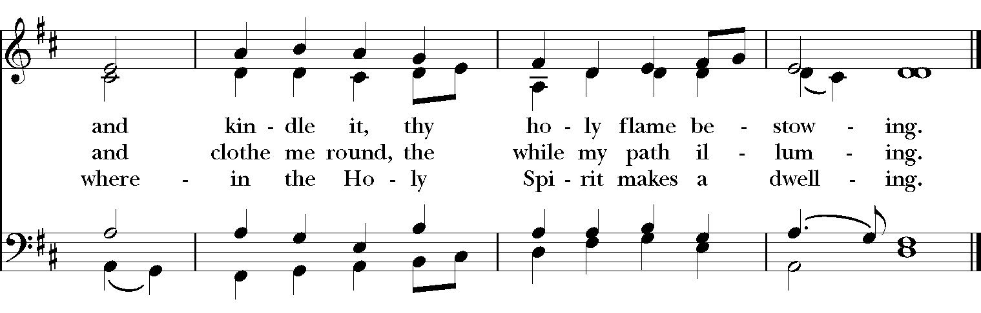

Celebrant: Blessed be God: Father, Son, and Holy Spirit.
People: And blessed be his kingdom, now and for ever. Amen.

The Collect of the Day
Celebrant: The Lord be with you.
People: And also with you.
Celebrant: Let us pray.
O God, because without you we are not able to please you, mercifully grant that your Holy Spirit may in all things direct and rule our hearts; through Jesus Christ our Lord, who lives and reigns with you and the Holy Spirit, one God, now and for ever. Amen.

THE LESSONS

THE FIRST READING Isaiah 50:4-9a
The Lord God has given me
the tongue of a teacher,
that I may know how to sustain
the weary with a word.
Morning by morning he wakens--
wakens my ear
to listen as those who are taught.
The Lord God has opened my ear,
and I was not rebellious,
I did not turn backward.
I gave my back to those who struck me,
and my cheeks to those who pulled out the beard;
I did not hide my face
from insult and spitting.
The Lord God helps me;
therefore I have not been disgraced;
therefore I have set my face like flint,
and I know that I shall not be put to shame;
he who vindicates me is near.
Who will contend with me?
Let us stand up together.
Who are my adversaries?
Let them confront me.
It is the Lord God who helps me;
who will declare me guilty?
Lector: The Word of the Lord.
People: Thanks be to God.

PSALM 116 1-8 Dilexi, quoniam

1 I love the Lord, because he has heard the voice of my supplication, *
because he has inclined his ear to me whenever I called upon him.

2 The cords of death entangled me; the grip of the grave took hold of me; *
I came to grief and sorrow.

3 Then I called upon the Name of the Lord: *
"O Lord, I pray you, save my life."

4 Gracious is the Lord and righteous; *
our God is full of compassion.

5 The Lord watches over the innocent; *
I was brought very low, and he helped me.

6 Turn again to your rest, O my soul, *
for the Lord has treated you well.

7 For you have rescued my life from death, *
my eyes from tears, and my feet from stumbling.

8 I will walk in the presence of the Lord *
in the land of the living.

THE SECOND LESSON James 3:1-12
Not many of you should become teachers, my brothers and sisters, for you know that we who teach will be judged with greater strictness. For all of us make many mistakes. Anyone who makes no mistakes in speaking is perfect, able to keep the whole body in check with a bridle. If we put bits into the mouths of horses to make them obey us, we guide their whole bodies. Or look at ships: though they are so large that it takes strong winds to drive them, yet they are guided by a very small rudder wherever the will of the pilot directs. So also the tongue is a small member, yet it boasts of great exploits.
How great a forest is set ablaze by a small fire! And the tongue is a fire. The tongue is placed among our members as a world of iniquity; it stains the whole body, sets on fire the cycle of nature, and is itself set on fire by hell. For every species of beast and bird, of reptile and sea creature, can be tamed and has been tamed by the human species, but no one can tame the tongue-- a restless evil, full of deadly poison. With it we bless the Lord and Father, and with it we curse those who are made in the likeness of God. From the same mouth come blessing and cursing. My brothers and sisters, this ought not to be so. Does a spring pour forth from the same opening both fresh and brackish water? Can a fig tree, my brothers and sisters, yield olives, or a grapevine figs? No more can salt water yield fresh.
Lector: The Word of the Lord.
People: Thanks be to God.

SQUENCE HYMN: “Lord, make us instruments of your peace ” Hymnal 593
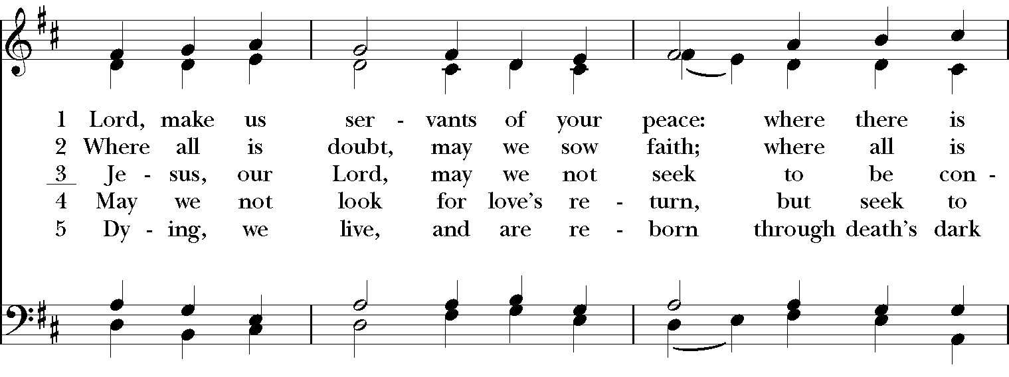

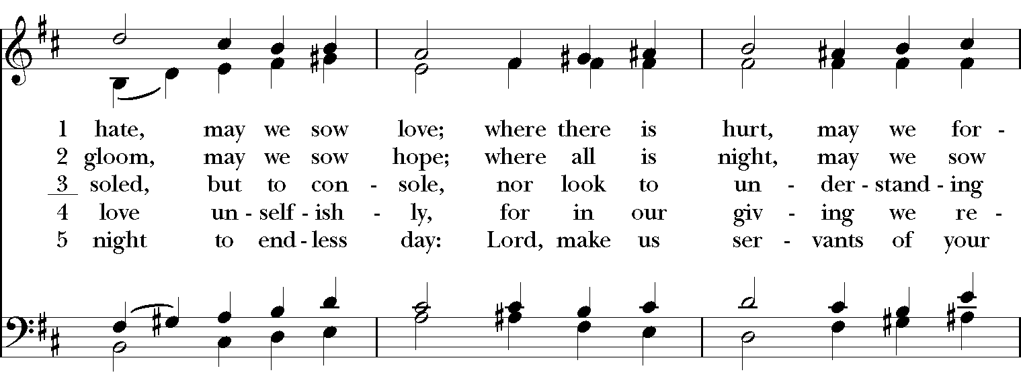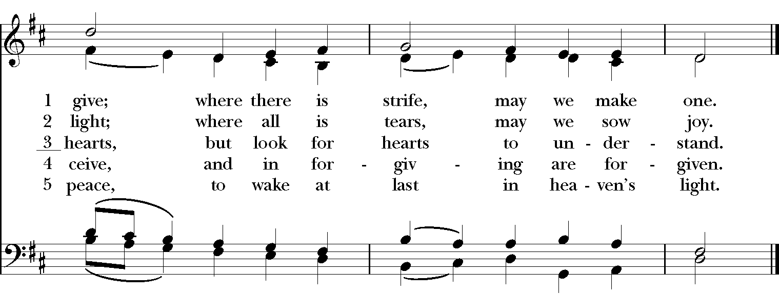
GOSPEL
Celebrant: The Holy Gospel of our Lord Jesus Christ according to Mark (Mark 8:27-38).
People: Glory to you, Lord Christ.
Jesus went on with his disciples to the villages of Caesarea Philippi; and on the way he asked his disciples, “Who do people say that I am?” And they answered him, “John the Baptist; and others, Elijah; and still others, one of the prophets.” He asked them, “But who do you say that I am?” Peter answered him, “You are the Messiah.” And he sternly ordered them not to tell anyone about him.

Then he began to teach them that the Son of Man must undergo great suffering, and be rejected by the elders, the chief priests, and the scribes, and be killed, and after three days rise again. He said all this quite openly. And Peter took him aside and began to rebuke him. But turning and looking at his disciples, he rebuked Peter and said, “Get behind me, Satan! For you are setting your mind not on divine things but on human things.”

He called the crowd with his disciples, and said to them, “If any want to become my followers, let them deny themselves and take up their cross and follow me. For those who want to save their life will lose it, and those who lose their life for my sake, and for the sake of the gospel, will save it. For what will it profit them to gain the whole world and forfeit their life? Indeed, what can they give in return for their life? Those who are ashamed of me and of my words in this adulterous and sinful generation, of them the Son of Man will also be ashamed when he comes in the glory of his Father with the holy angels.”
Celebrant: The Gospel of the Lord.
People: Praise to you, Lord Christ.

Sermon The Rev. Canon Dr. Lee Anne Reat

The Nicene Creed
We believe in one God, the Father, the Almighty,
maker of heaven and earth, of all that is, seen and unseen.
We believe in one Lord, Jesus Christ, the only Son of God,
eternally begotten of the Father, God from God,
Light from Light, true God from true God,
begotten, not made, of one Being with the Father.
Through him all things were made.
For us and for our salvation he came down from heaven,
by the power of the Holy Spirit he became incarnate from the Virgin Mary,
and was made man.
For our sake he was crucified under Pontius Pilate;
he suffered death and was buried.
On the third day he rose again in accordance with the Scriptures;
he ascended into heaven and is seated at the right hand of the Father.
He will come again in glory to judge the living and the dead, and his kingdom will have no end.
We believe in the Holy Spirit, the Lord, the giver of life,
who proceeds from the Father, and the Son.
With the Father and the Son he is worshiped and glorified,
he has spoken through the Prophets.
We believe in one holy catholic and apostolic Church.
We acknowledge one baptism for the forgiveness of sins.
We look for the resurrection of the dead, and the life of the world to come. Amen.

THE PRAYERS OF THE PEOPLE

In peace, we pray to you Lord God. Congregational responses are in bold.
Silence

Let us pray. Founder of our faith, we ask your guidance for the Church, for its unity, and for the work it does in the world. Give grace to its leaders, especially Justin, archbishop of Canterbury; Michael, our Presiding Bishop; Wayne, our Provisional Bishop; Lee Anne, our priest; and all the members of this parish.
R: Let your priests be clothed with righteousness; let your faithful people sing for joy.

Lord of the harvest, we offer thanks for the beauty and abundance of this season. May we consider how best to tend the Earth and to share what You have given us, so that all may eat and be satisfied by your goodness. We pray for the ministries this church supports, especially Rainbow Table, Springfield Promise Neighborhood, Springfield Peace Center, and Partners in Ministry in Liberia.
R: He covers the heavens with clouds, and prepares rain for the earth;
He makes grass grow upon the mountains, and green plants to serve humankind.

Giver of every good gift, we pray for those celebrating birthdays this week, especially Joe, Madison, Dawn, D.J. and anniversaries Dana & Cathy and Chris & Jennifer.
R: Let the righteous be glad and rejoice before God; Let them also be merry and joyful.

Great Physician, we pray for healing and comfort for all those in need or pain, especially Leigh, Charlene, Faye, Chris, Bonnie, Alice, Diana, James, Joy, Jane, Joni, Kim, Bobby, Sarah, Traudie, Lexie, and Keith. May they remember that You are with them and those who care for them.
R: Surely you behold trouble and misery; you see it and take it into your own hand.
The helpless commit themselves to you; for you are the helper of orphans.

Just Judge, we ask your aid for all those in trouble, bringing before You prisoners and captives, refugees and the oppressed. We pray for those most vulnerable throughout the world, especially women and children.
R: Let justice roll down like waters, and righteousness like an ever-flowing stream.

Lord over life and death, we pray for all who have died, asking light and peace for them and those who mourn.
R: Precious in the sight of the Lord is the death of his servant.

*THE COLLECT FOR PEACE
Grant, O God, that your holy and life-giving Spirit may so move every human heart, that barriers which divide us may crumble, suspicions disappear, and hatreds cease; that our divisions being healed, we may live in justice and peace; through Jesus Christ our Lord. Amen.

THE CONFESSION AND ABSOLUTION
Priest: Let us confess our sins against God and our neighbor.
All: Most merciful God, we confess that we have sinned against you in thought, word, and deed, by what we have done, and by what we have left undone. We have not loved you with our whole heart; we have not loved our neighbors as ourselves. We are truly sorry and we humbly repent. For the sake of your Son Jesus Christ, have mercy on us and forgive us; that we may delight in your will, and walk in your ways, to the glory of your Name. Amen.

Priest: Almighty God, have mercy on you, forgive you all your sins through our Lord Jesus Christ, strengthen you in all goodness, and by the power of the Holy Spirit keep you in eternal life. Amen.

And now, as our Savior Christ has taught us, we are bold to say:
Our Father, who art in heaven, hallowed be thy Name,
thy kingdom come, thy will be done, on earth as it is in heaven.
Give us this day our daily bread.
And forgive us our trespasses, as we forgive those who trespass against us.
And lead us not into temptation, but deliver us from evil.
For thine is the kingdom, and the power, and the glory, for ever and ever. Amen

CLOSING HYMN: “When I survey the wondrous cross” Hymnal 474
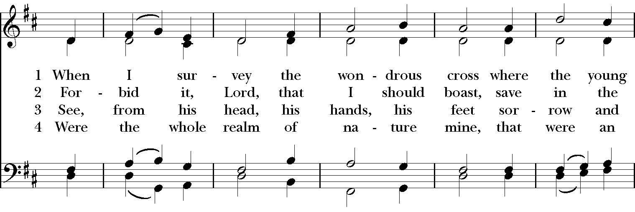

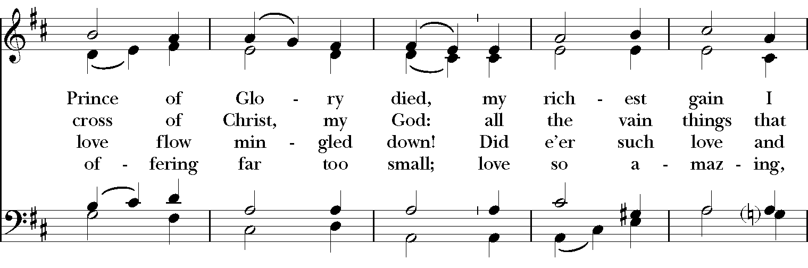

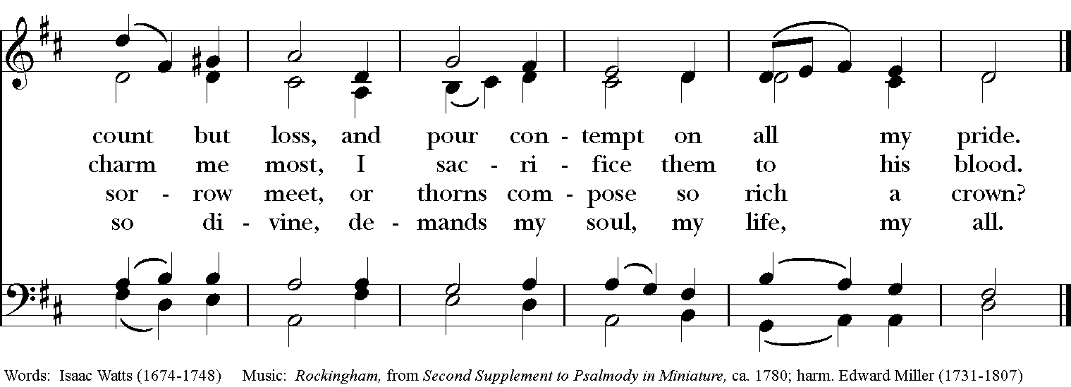

*THE BLESSING
Christ who has nourished us with himself the living bread, make you one in praise and love, and raise you up at the last day; and the blessing God Almighty, the Father, the Son, and the Holy Spirit, be among you, and remain with you always. Amen.

ANNOUNCEMENTS

*THE DISMISSAL Celebrant: Go in peace to love and serve the Lord.
People: Thanks be to God.

POSTLUDE: “Sarabande” from English Suite No. 1 in F Major - J.S. Bach

Thank you for your spiritual presence with us this morning!
Although we're physically apart, we are united in prayer, worship, and holy love!
Priest-In-Charge: The Rev. Dr. Canon Lee Anne Reat
Music Director: Dr. Chris Durrenberger
Lector: Liz Wheeler
Singers: Liz Wheeler, Joy Carter, Basil Fett, Chris Oldstone-Moore, and Fred Bartenstein
Technology: Steve Ide
Slideshow: Ed Hasecke
Parish Administrator and Program Coordinator: Kelly Zeller

