Ministers for August 13th, 2023
Eleventh Sunday after Pentecost
August 13th, 2023 at 8:00 am
The Holy Eucharist: Rite I

Lectors: Isabella Mendes and Pat Cary

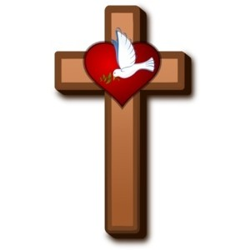
General Information
Rector: The Rev. Dr. Michelle Boomgaard
Senior Warden: Scott Yeazell
Junior Warden: Steve Sharp
Treasurer: Ken Bladh
Clerk of Vestry: Kelly Zeller
Vestry at Large: Joy Meyers, Kay Koeninger, Linda Mortensen,
Bill Hicks, Lori Swafford, and Rick Everingham
Parish Administrator & Program Coordinator: Kelly Zeller
Director of Music: Dr. Christopher Durrenberger
Facility Manager: Paul McAfee
Bookkeeper: Tina Knox

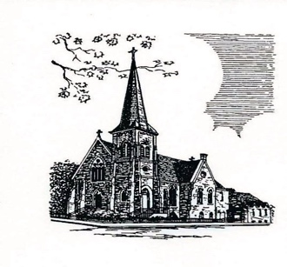

Christ Episcopal Church
409 East High Street
Springfield, Ohio 45505
937-323-8651
www.christspringfield.org

INFORMATION FOR NEWCOMERS: WELCOME TO CHRIST CHURCH!
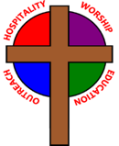
Our motto is true whether you're here for the very first time
or you've been a member for decades –

There is a place for you at God's Table!

The worship service has two main parts: the Liturgy of the Word, which includes Scripture readings and a sermon, and the Liturgy of the Table, which is also called Holy Eucharist or Communion. You will notice moments in the service when people stand, kneel, bow, and make the sign of the cross. There is no one “right” way to worship, so do what is comfortable for you at any given time in worship.

All Baptized Christians are welcome at Christ’s Table for Communion. If you do not wish to receive communion, you may come forward and request a blessing. If you wish to receive communion in your pew, please notify the ushers. And if you need a gluten-free wafer, just let Rev. Michelle know.

If you have not been baptized, or if you have questions about Holy Baptism, please talk to The Rev. Dr. Michelle Boomgaard after the service -- the people of Christ Church would love to walk with you to your baptism and beyond! Finally, if you are a visitor, please fill-out a Welcome Card on the back of the pew, so we can add you to our weekly information email the NewsNote.

The Holy Eucharist Rite I

Opening Acclamation
Celebrant: Blessed be God: Father, Son, and Holy Spirit.
People: And blessed be his kingdom, now and forever. Amen.

Collect For Purity BCP 323

Gloria BCP 324

Collect of the Day
Grant to us, Lord, we pray, the spirit to think and do always those things that are right, that we, who cannot exist without you, may by you be enabled to live according to your will; through Jesus Christ our Lord, who lives and reigns with you and the Holy Spirit, one God, for ever and ever. Amen.

The First Lesson Genesis 37: 1-4, 12-28

Psalm 105:1-6, 16-22, 45b BCP 738

The Second Lesson Romans 10:5-15

The Holy Gospel Matthew 14:22-33

The Sermon The Rev. Dr. Michelle Boomgaard

The Nicene Creed BCP 326

The Prayers of the People BCP 328
After each petition the people respond, Hear our prayer.

The Collect For The Election Of A Bishop
Almighty God, giver of every good gift: Look graciously on your Church, and so guide the minds of those who shall choose a bishop for this Diocese, that we may receive a faithful pastor, who will care for your people and equip us for our ministries; through Jesus Christ our Lord. Amen.
The Confession (bottom of page) BCP 331

The Absolution BCP 332

Peace BCP 332

Announcements

The Doxology
All things come of thee, O Lord
And of thine own have we given thee.

The Holy Communion

The Great Thanksgiving: Eucharistic Prayer I BCP 333
(after the Sanctus, stand or kneel)

The Lord’s Prayer BCP 336

The Breaking of the Bread BCP 337

The Prayer of Humble Access BCP 337

The Communion of the People BCP 337

Post-communion Prayer BCP 339

The Blessing

The Dismissal
Celebrant: Go in peace to love and serve the Lord.
People: Thanks be to God.

