Ministers for August 21st, 2022
Lector: Pat Cary
Greeter:

General Information
Supply Priest: The Rev. Eileen O’Reilly
Senior Warden: Scott Yeazell
Junior Warden: Steve Sharp
Treasurer: Ken Bladh
Vestry at Large: Joy Meyers, Kay Koeninger, Linda Mortensen,
Bill Hicks, Lori Swafford, and Keith Doubt
Parish Administrator & Program Coordinator: Kelly Zeller
Director of Music: Dr. Christopher Durrenberger
Facility Manager: Paul McAfee
Bookkeeper: Tina Knox

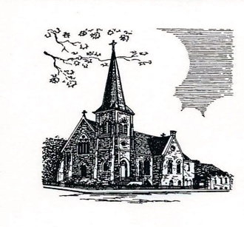

Christ Episcopal Church
409 East High Street
Springfield, Ohio 45505
937-323-8651
www.christspringfield.org

Eleventh Sunday after Pentecost
August 21st, 2022 at 8:00 a.m.
The Holy Eucharist: Rite I

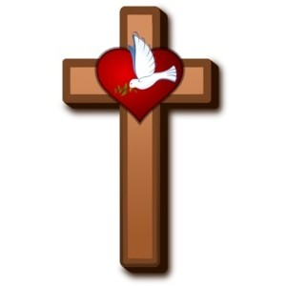

INFORMATION FOR NEWCOMERS: WELCOME TO CHRIST CHURCH!
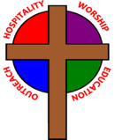
Our motto is true whether you're here for the very first time
or you've been a member for decades –
There is a place for you at God's Table!

The worship service has two main parts: the Liturgy of the Word, which includes Scripture readings and a sermon, and the Liturgy of the Table, which is also called Holy Eucharist or Communion. You will notice moments in the service when people stand, kneel, bow, and make the sign of the cross. There is no one “right” way to worship, so do what is comfortable for you at any given time in worship.

All Baptized Christians are welcome at Christ’s Table for Communion. If you do not wish to receive communion, you may come forward and request a blessing. If you wish to receive communion in your pew, please notify the ushers. And if you need a gluten-free wafer, just let Rev. Eileen know.

If you have not been baptized, or if you have questions about Holy Baptism, please talk to Rev. Eileen O’Reilly after the service -- the people of Christ Church would love to walk with you to your baptism and beyond!

The Holy Eucharist Rite I

Opening Acclamation
Celebrant: Blessed be God: Father, Son, and Holy Spirit.
People: And blessed be his kingdom, now and forever. Amen.

Collect For Purity BCP 323

Gloria BCP 324

Collect of the Day
Grant, O merciful God, that your Church, being gathered together in unity by your Holy Spirit, may show forth your power among all peoples, to the glory of your Name; through Jesus Christ our Lord, who lives and reigns with you and the Holy Spirit, one God, for ever and ever. Amen.

The First Lesson Jeremiah 1:4-10

Psalm 71:1-6 BCP 683

The Second Lesson Hebrews 12:18-29

The Holy Gospel Luke 13:10-17

The Sermon The Rev. Eileen O’Reilly

The Nicene Creed BCP 326

The Prayers of the People BCP 328
After each petition the people respond, Hear our prayer.

THE COLLECT FOR PEACE
Grant, O God, that your holy and life-giving Spirit may so move every human heart, that barriers which divide us may crumble, suspicions disappear, and hatreds cease; that our divisions being healed, we may live in justice and peace; through Jesus Christ our Lord. Amen.
The Confession (bottom of page) BCP 331

The Absolution BCP 332

Peace BCP 332

Announcements

The Doxology
All things come of thee, O Lord
And of thine own have we given thee.

The Holy Communion

The Great Thanksgiving: Eucharistic Prayer I BCP 333
(after the Sanctus, stand or kneel)

The Lord’s Prayer BCP 336

The Breaking of the Bread BCP 337

The Prayer of Humble Access BCP 337

The Communion of the People BCP 337

Post-communion Prayer BCP 339

The Blessing

The Dismissal
Celebrant: Go in peace to love and serve the Lord.
People: Thanks be to God.

