Feast of the Holy Name
January 1, 2023 at 10:00 a.m.
The Holy Eucharist: Rite II

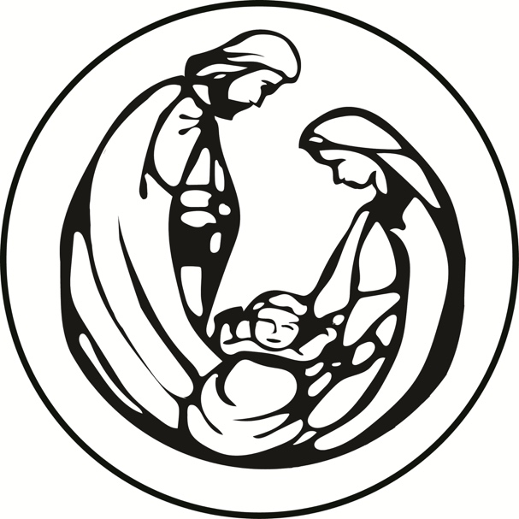

++++++++++++++++++++++++++++++++++++++++++

INFORMATION FOR NEWCOMERS: WELCOME TO CHRIST CHURCH!
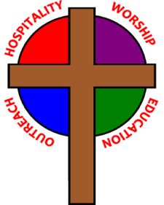
Our motto is true whether you're here for the very first time
or you've been a member for decades –
There is a place for you at God's Table!

The worship service has two main parts: the Liturgy of the Word, which includes Scripture readings and a sermon, and the Liturgy of the Table, which is also called Holy Eucharist or Communion. You will notice moments in the service when people stand, kneel, bow, and make the sign of the cross. There is no one “right” way to worship, so do what is comfortable for you at any given time in worship.

All Baptized Christians are welcome at Christ’s Table for Communion. If you do not wish to receive communion, you may come forward and request a blessing. If you wish to receive communion in your pew, please notify the ushers. And if you need a gluten-free wafer, just let Rev. Cricket know.

If you have not been baptized, or if you have questions about Holy Baptism, please talk to Rev. Cricket Park after the service -- the people of Christ Church would love to walk with you to your baptism and beyond!

When you enter a Christ Episcopal Church worship service/event, you will be entering an area where photography, video and audio recording may occur.

The Holy Eucharist Rite II

PRELUDE: “Prelude in C Minor”- Bach -Joy Meyers

OPENING HYMN: “O Come, all ye faithful” Hymnal 83 Vs. 1-3

THE LITURGY OF THE WORD

OPENING ACCLAMATION
Celebrant: Blessed be God: Father, Son, and Holy Spirit.
People: And blessed be his kingdom, now and forever. Amen.

COLLECT FOR PURITY
Almighty God, to you all hearts are open, all desires known, and from you no secrets are hid. Cleanse the
thoughts of our hearts by the inspiration of your Holy Spirit, that we may perfectly love you, and worthily
magnify your holy Name; through Christ our Lord. Amen.

GLORIA Hymnal S278
Glory to God in the highest, and peace to his people on earth.
Lord God, heavenly King, almighty God and Father,
we worship you, we give you thanks, we praise you for your glory.
Lord Jesus Christ, only Son of the Father, Lord God, Lamb of God,
you take away the sin of the world: have mercy on us;
you are seated at the right hand of the Father: receive our prayer.
For you alone are the Holy One, you alone are the Lord,
you alone are the Most High, Jesus Christ, with the Holy Spirit,
in the glory of God the Father. Amen.

THE COLLECT
Eternal Father, you gave to your incarnate Son the holy name of Jesus to be the sign of our salvation: Plant in every heart, we pray, the love of him who is the Savior of the world, our Lord Jesus Christ; who lives and reigns with you and the Holy Spirit, one God, in glory everlasting. Amen.

THE LESSONS

THE FIRST READING Numbers 6:22-27
The Lord spoke to Moses, saying: Speak to Aaron and his sons, saying, Thus you shall bless the Israelites: You shall say to them,
The Lord bless you and keep you;
the Lord make his face to shine upon you, and be gracious to you;
the Lord lift up his countenance upon you, and give you peace.
So they shall put my name on the Israelites, and I will bless them.
Lector: The Word of the Lord.
People: Thanks be to God.

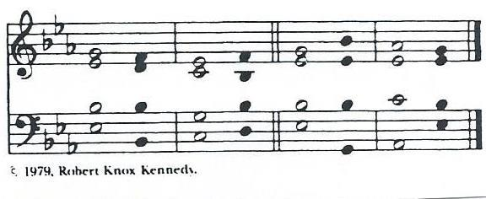
THE RESPONSE Psalm 8

1 O Lord our Governor, *
how exalted is your Name in all the world!
2 Out of the mouths of infants and children *
your majesty is praised above the heavens.
3 You have set up a stronghold against your adversaries, *
to quell the enemy and the avenger.
4 When I consider your heavens, the work of your fingers, *
the moon and the stars you have set in their courses,
5 What is man that you should be mindful of him? *
the son of man that you should seek him out?
6 You have made him but little lower than the angels; *
you adorn him with glory and honor;
7 You give him mastery over the works of your hands; *
you put all things under his feet:
8 All sheep and oxen, *
even the wild beasts of the field,
9 The birds of the air, the fish of the sea, *
and whatsoever walks in the paths of the sea.
10 O Lord our Governor, *
how exalted is your Name in all the world!

THE SECOND LESSON Galatians 4:4-7
When the fullness of time had come, God sent his Son, born of a woman, born under the law, in order to redeem those who were under the law, so that we might receive adoption as children. And because you are children, God has sent the Spirit of his Son into our hearts, crying, "Abba! Father!" So you are no longer a slave but a child, and if a child then also an heir, through God.
Lector: The Word of the Lord.
People: Thanks be to God.

SEQUENCE HYMN: “Away in a manger” Hymnal 101

GOSPEL
Celebrant: The Holy Gospel of our Lord Jesus Christ according to Luke (Luke 2:15-21).
People: Glory to you, Lord Christ.
When the angels had left them and gone into heaven, the shepherds said to one another, "Let us go now to Bethlehem and see this thing that has taken place, which the Lord has made known to us." So they went with haste and found Mary and Joseph, and the child lying in the manger. When they saw this, they made known what had been told them about this child; and all who heard it were amazed at what the shepherds told them. But Mary treasured all these words and pondered them in her heart. The shepherds returned, glorifying and praising God for all they had heard and seen, as it had been told them. After eight days had passed, it was time to circumcise the child; and he was called Jesus, the name given by the angel before he was conceived in the womb.
Celebrant: The Gospel of the Lord.
People: Praise to you, Lord Christ.

Sermon The Rev. Cricket Park

THE NICENE CREED
We believe in one God, the Father, the Almighty,
maker of heaven and earth, of all that is, seen and unseen.
We believe in one Lord, Jesus Christ, the only Son of God,
eternally begotten of the Father, God from God,
Light from Light, true God from true God,
begotten, not made, of one Being with the Father.
Through him all things were made.
For us and for our salvation he came down from heaven,
by the power of the Holy Spirit he became incarnate from the Virgin Mary,
and was made man.
For our sake he was crucified under Pontius Pilate;
he suffered death and was buried.
On the third day he rose again in accordance with the Scriptures;
he ascended into heaven and is seated at the right hand of the Father.
He will come again in glory to judge the living and the dead, and his kingdom will have no end.
We believe in the Holy Spirit, the Lord, the giver of life,
who proceeds from the Father, and the Son.
With the Father and the Son he is worshiped and glorified,
He has spoken through the Prophets.
We believe in one holy catholic and apostolic Church.
We acknowledge one baptism for the forgiveness of sins.
We look for the resurrection of the dead, and the life of the world to come. Amen

THE PRAYERS OF THE PEOPLE

In peace, we pray to you Lord God. Congregational responses are in bold.

Silence

Lord Jesus Christ, you came and dwelt among us, showing us the glory of the Father. Let that glory be manifest in our churches. Give us the will to be united as You prayed we would be.
Lord Jesus, come and dwell within all churches.

Lord Jesus Christ, you came and dwelt among us, serving others and not seeking your own glory. Inspire church leaders, that they may be examples of willing service. Bless Justin, Archbishop of Canterbury; Michael, our Presiding Bishop; Wayne, our Bishop; Cricket, our celebrant.
Lord Jesus, come and dwell among all church leaders.

Lord Jesus Christ, you came and dwelt among us, giving us an example of true power, which lies in holiness. Direct government leaders into wise decisions that will bring forth righteousness. Give the leaders of the nation wisdom and hearts for peace.
Lord Jesus, come and dwell in all government leaders.

We pray for the leadership and future of this congregation during this time of transition and discernment of our common life and ministry. Uphold us in word, in sacrament and in one another; in change and in challenge; in humility and in hope.
That we may continue the work you have given us to do.

Lord Jesus Christ, you came and dwelt among us, choosing the company of the poor, the homeless, the hungry, and the sick, of widows and orphans, and of sinners. Help us to reach out in lovingkindness to those who are in any need or trouble. We pray for the ministries this church supports, especially Rainbow Table, Springfield Promise Neighborhood, Springfield Peace Center, and Partners in Ministry in Liberia.
Lord Jesus, come and dwell in our acts of mercy.

Lord Jesus Christ, you came and dwelt among us, taking on our flesh, and inhabiting both the pains and the joys of this life. We celebrate with those who have birthdays, and anniversaries this week.
Lord Jesus, come and dwell in our moments of joy.

Lord Jesus Christ, you came and dwelt among us, taking sickness and suffering into your own hands and transforming them. Have mercy on those who suffer in body, mind, or spirit. We pray especially for Sandi Eyman, Ron deLanglade, Margaret Mattox, Joy Bartenstein, Dodi Holmes, Martha Chaney, Charlene Schreiber, Alice Kelly, Barb Kelly, Joni Pulver, and Traudie Milleck; Give special grace and power to all those who spend this holiday season working with the sick and the dying.
Lord Jesus, come and dwell in our dis-ease and make us whole.

Lord Jesus Christ, you came and dwelt among us, weeping at the death of those whom you loved. Comfort all those who have lost loved ones, and bless those departed.
Lord Jesus, come and dwell in our memories of those whom we have lost. Grant peace and light to those who have died.

Celebrant: Hasten, O Father, the coming of your kingdom; and grant that we your servants, who now live by faith, may with joy behold thy Son at his coming in glorious majesty; even Jesus Christ, our only Mediator and Advocate. Amen.

THE CONFESSION AND ABSOLUTION
Celebrant: Let us confess our sins against God and our neighbor.
All: Almighty God have mercy on you, forgive you all your sins through our Lord Jesus Christ, strengthen you in all goodness, and by the power of the Holy Spirit keep you in eternal life. Amen.

Celebrant: May Almighty God, who has redeemed us and made us his children through the resurrection of his Son our Lord, bestow upon you the riches of his blessing. Amen.

THE PEACE

ANNOUNCEMENTS

OFFERTORY: “Mary did you know” – Lowry- Soprano: Joy Meyers and Guitar” Jeff Carter

PRESENTATION OF THE GIFTS Hymnal 380, v. 3
Praise God from whom all blessings flow;
Praise God, all creatures here below;
Praise God above, ye heavenly host:
Praise Father, Son, and Holy Ghost

THE HOLY COMMUNION

THE GREAT THANKSGIVING: EUCHARISTIC PRAYER B

Celebrant The Lord be with you.
People And also with you.
Celebrant Lift up your hearts.
People We lift them to the Lord.
Celebrant Let us give thanks to the Lord our God.
People It is right to give our thanks and praise.

It is right, and a good and joyful thing, always and everywhere to give thanks to you, Father Almighty, Creator of heaven and earth. Because you sent your beloved Son to redeem us from sin and death, and to make us heirs in him of everlasting life; that when he shall come again in power and great triumph to judge the world, we may without shame or fear rejoice to behold his appearing.

Therefore we praise you, joining our voices with Angels and Archangels and with all the company of heaven, who forever sing this hymn to proclaim the glory of your Name:

Holy, holy, holy Lord, God of power and might, Hymnal S125
heaven and earth are full of your glory.
Hosanna in the highest. Hosanna in the highest.
Blessed is he who comes in the name of the Lord.
Hosanna in the highest. Hosanna in the highest.

We give thanks to you, O God, for the goodness and love which you have made known to us in creation; in the calling of Israel to be your people; in your Word spoken through the prophets; and above all in Jesus Christ, the Word made flesh. For in these last days you sent Jesus to be incarnate from the Virgin Mary, to be the Savior and Redeemer of the world. In Christ, you have delivered us from evil, and made us worthy to stand before you. In Christ, you have brought us out of error into truth, out of sin into righteousness, out of death into life.

On the night before he died for us, our Savior Jesus Christ took bread; and when he had given thanks to you, he broke it, and gave it to his disciples, and said, “Take, eat: This is my Body, which is given for you. Do this for the remembrance of me.”

After supper Jesus took the cup of wine; and when he had given thanks, he gave it to them, and said, “Drink this, all of you: This is my Blood of the new Covenant, which is shed for you and for many for the forgiveness of sins. Whenever you drink it, do this for the remembrance of me.”

Therefore, according to his command, O Father,

We remember Christ’s death,
We proclaim Christ’s resurrection,
We await Christ’s coming in glory;

And we offer our sacrifice of praise and thanksgiving to you, O Savior of all; presenting to you, from your creation, this bread and this wine.

We pray you, gracious God, to send your Holy Spirit upon these gifts that they may be the Sacrament of the Body of Christ and his Blood of the new Covenant. Unite us in the sacrifice of Jesus Christ, through whom we are acceptable to you, being sanctified by the Holy Spirit. In the fullness of time, put all things in subjection under your Christ, and bring us to that heavenly country where, with Blessed Mother Mary and all your saints, we may enter the everlasting heritage of your children; through Jesus Christ our Savior, the firstborn of all creation, the head of the Church, and the author of our salvation.

By Christ, and with Christ, and in Christ, in the unity of the Holy Spirit, all honor and glory is yours, Almighty God, now and forever. AMEN.

And now, as our Savior Christ has taught us, we are bold to say,
Our Father, who art in heaven, hallowed be thy name,
thy kingdom come, thy will be done, on earth as it is in heaven.
Give us this day our daily bread.
And forgive us our trespasses,
as we forgive those who trespass against us.
And lead us not into temptation, but deliver us from evil.
For thine is the kingdom, and the power, and the glory,
forever and ever. Amen.

THE BREAKING OF THE BREAD Hymnal S161
Lamb of God, you take away the sins of the world: have mercy on us.
Lamb of God, you take away the sins of the world: have mercy on us.
Lamb of God, you take away the sins of the world: grant us peace.

THE INVITATION TO COMMUNION

COMMUNION HYMN: “Angels, from the realms of glory ” Hymnal 93 vs. 1-2

PRAYER AFTER COMMUNION- Celebrant and people together
Eternal God, heavenly Father, you have graciously accepted us as living members of your Son our Savior Jesus Christ, and you have fed us with spiritual food in the Sacrament of his Body and Blood. Send us now into the world in peace, and grant us strength and courage to love and serve you with gladness and singleness of heart; through Christ our Lord. Amen.

THE BLESSING
The peace of God, which passes all understanding, keep your hearts and minds in the knowledge and love of God, and of his Son Jesus Christ our Lord; and the blessing of God Almighty, Father, Son and Holy Spirit, be among you, and remain with you always. Amen.

CLOSING HYMN: “Go tell it on the mountain” Hymnal 99

THE DISMISSAL Celebrant: Go in peace to love and serve the Lord.
People: Thanks be to God.

POSTLUDE: “I Wonder as I Wander” – Niles- Soprano: Joy Meyers and Guitar: Jeff Carter

Christmas Flowers 2022

In loving memory of Jim Beardsell by Anita Beardsell

In memory of Mike Fields by Sue Allender

In memory of Hank Roberts by Martha Chaney

In memory of Ben Schwartz and Dennis Sullivan by Sally Schwartz

In thanksgiving for many blessings by the Chitkara Family

In memory of Dariel Fahnestock, Russ and Audriel Mumford and Bernice Harbaugh and Keith Harbaugh by Carol Harbaugh, Larry & Linda Hupp and their families

In memory of Don and Dorothy Wiegel by Julie Wiegel Brust

In memory of Sarah Albright Healy and Clarence Albright by Joann Albright

In memory of Helen &Paul Krott, Alice & Bill T. Hicks, Bettie Hicks, John Hicks and Jed Collins; and in thanksgiving for Anita Beardsell by Bill and Gretchen Hicks

In memory of Evelyn Stinnett Reed and in thanksgiving for Don and Charlotte and Babs by Fred Reed

In loving memory of William G. Vasileff by Marj Vasileff

In memory of Bernice Schmidt, Larry and Jane Sharp by Steve and Denise Sharp

In memory of Woody and Sally Summers, Leigh Dunn, Rob Boblitt, and Ellie Fessler; and in thanksgiving for Lyndsey Bernadette and Andy Dunn by Ann Summers

Ministers for January 1st, 2023
Altar Guild: Joan Hurley
Chalice: Diane Rode
Lector: Judy Johnson
Ushers: Dan McGregor and Steve Sharp
Videographer: David Bingman
Guest musicians: Joy Meyers and Jeff Carter

General Information
Supply Priest: The Rev. Cricket Park
Senior Warden: Scott Yeazell
Junior Warden: Steve Sharp
Treasurer: Ken Bladh
Vestry at Large: Joy Meyers, Kay Koeninger, Linda Mortensen,
Bill Hicks, Lori Swafford, and Keith Doubt
Parish Administrator & Program Coordinator: Kelly Zeller
Director of Music: Dr. Christopher Durrenberger
Facility Manager: Paul McAfee
Bookkeeper: Tina Knox

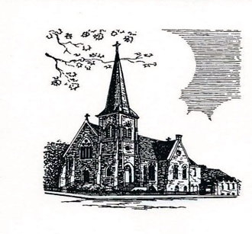

Christ Episcopal Church
409 East High Street
Springfield, Ohio 45505
937-323-8651
www.christspringfield.org

