Ministers for July 3rd, 2022
Lector: Pat Cary
Greeter: Dawn and Jack Ivy
Acolyte: Bill Yeazell

General Information
Supply Priest: Father Larry Crowell
Senior Warden: Scott Yeazell
Junior Warden: Steve Sharp
Treasurer: Ken Bladh
Vestry at Large: Joy Meyers, Kay Koeninger, Linda Mortensen,
Bill Hicks, Lori Swafford, and Keith Doubt
Parish Administrator & Program Coordinator: Kelly Zeller
Director of Music: Dr. Christopher Durrenberger
Facility Manager: Paul McAfee
Bookkeeper: Tina Knox

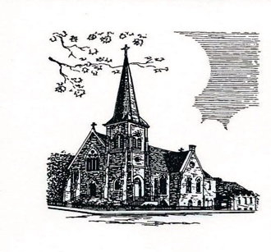

Christ Episcopal Church
409 East High Street
Springfield, Ohio 45505
937-323-8651
www.christspringfield.org

Fourth Sunday after Pentecost
July 3rd, 2022 at 8:00 a.m.
The Holy Eucharist: Rite I

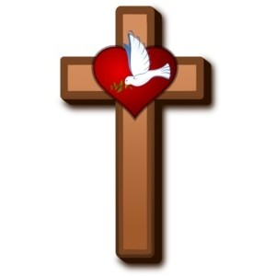

INFORMATION FOR NEWCOMERS: WELCOME TO CHRIST CHURCH!
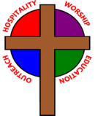
Our motto is true whether you're here for the very first time
or you've been a member for decades –
There is a place for you at God's Table!

The worship service has two main parts: the Liturgy of the Word, which includes Scripture readings and a sermon, and the Liturgy of the Table, which is also called Holy Eucharist or Communion. You will notice moments in the service when people stand, kneel, bow, and make the sign of the cross. There is no one “right” way to worship, so do what is comfortable for you at any given time in worship.

All Baptized Christians are welcome at Christ’s Table for Communion. If you do not wish to receive communion, you may come forward and request a blessing. If you wish to receive communion in your pew, please notify the ushers. And if you need a gluten-free wafer, just let Father Crowell know.

If you have not been baptized, or if you have questions about Holy Baptism, please talk to Father Larry after the service -- the people of Christ Church would love to walk with you to your baptism and beyond!

The Holy Eucharist Rite I

Opening Acclamation
Celebrant: Blessed be God: Father, Son, and Holy Spirit.
People: And blessed be his kingdom, now and forever. Amen.

Collect For Purity BCP 323

Gloria BCP 324

Collect of the Day
O God, you have taught us to keep all your commandments by loving you and our neighbor: Grant us the grace of your Holy Spirit, that we may be devoted to you with our whole heart, and united to one another with pure affection; through Jesus Christ our Lord, who lives and reigns with you and the Holy Spirit, one God, for ever and ever. Amen.

The First Lesson 2 Kings 5:1-14

Psalm 30 BCP 621

The Second Lesson Galatians 6:7-16

The Holy Gospel Luke 10:1-11, 16-20

The Sermon Father Crowell

The Nicene Creed BCP 326

The Prayers of the People BCP 328
After each petition the people respond, Hear our prayer.

Let us pray together the Collect for Independence Day
Lord God Almighty, you have made all the peoples of the earth for your glory, to serve you in freedom and in peace: Give to the people of our country a zeal for justice and the strength of forbearance, that we may use our liberty in accordance with your gracious will; through Jesus Christ our Lord, who lives and reigns with you and the Holy Spirit, one God, for ever and ever. Amen.

The Confession (bottom of page) BCP 331

The Absolution BCP 332

Peace BCP 332

Announcements

The Doxology
All things come of thee, O Lord
And of thine own have we given thee.

The Holy Communion

The Great Thanksgiving: Eucharistic Prayer I BCP 333
(after the Sanctus, stand or kneel)

The Lord’s Prayer BCP 336

The Breaking of the Bread BCP 337

The Prayer of Humble Access BCP 337

The Communion of the People BCP 337

Post-communion Prayer BCP 339

The Blessing

The Dismissal
Celebrant: Go in peace to love and serve the Lord.
People: Thanks be to God.

