The Last Sunday after Pentecost: Christ the King
November 20th, 2022 at 10:00 a.m.
The Holy Eucharist: Rite II

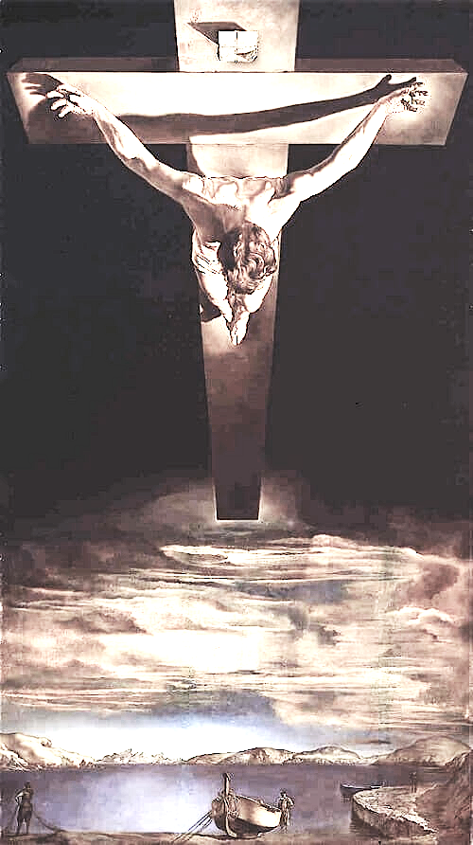

INFORMATION FOR NEWCOMERS: WELCOME TO CHRIST CHURCH!
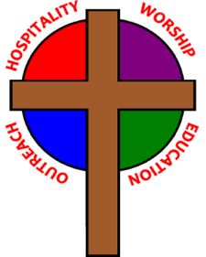
Our motto is true whether you're here for the very first time
or you've been a member for decades –
There is a place for you at God's Table!

The worship service has two main parts: the Liturgy of the Word, which includes Scripture readings and a sermon, and the Liturgy of the Table, which is also called Holy Eucharist or Communion. You will notice moments in the service when people stand, kneel, bow, and make the sign of the cross. There is no one “right” way to worship, so do what is comfortable for you at any given time in worship.

All Baptized Christians are welcome at Christ’s Table for Communion. If you do not wish to receive communion, you may come forward and request a blessing. If you wish to receive communion in your pew, please notify the ushers. And if you need a gluten-free wafer, just let Rev. Cricket know.

If you have not been baptized, or if you have questions about Holy Baptism, please talk to Rev. Cricket Park after the service -- the people of Christ Church would love to walk with you to your baptism and beyond!

When you enter a Christ Episcopal Church worship service/event, you will be entering an area where photography, video and audio recording may occur.

The Holy Eucharist Rite II

PRELUDE: "Oh, Worship the King" Hanover/arr. Callahan

OPENING HYMN: “At the name of Jesus, every knew shall bow” Hymnal 435 vs. 1-4

THE LITURGY OF THE WORD

OPENING ACCLAMATION
Celebrant: Blessed be God: Father, Son, and Holy Spirit.
People: And blessed be his kingdom, now and forever. Amen.

COLLECT FOR PURITY
Almighty God, to you all hearts are open, all desires known, and from you no secrets are hid cleanse the
thoughts of our hearts by the inspiration of your Holy Spirit, that we may perfectly love you, and worthily
magnify your holy Name; through Christ our Lord. Amen.

GLORIA Hymnal S278
Glory to God in the highest, and peace to his people on earth.
Lord God, heavenly King, almighty God and Father,
we worship you, we give you thanks, we praise you for your glory.
Lord Jesus Christ, only Son of the Father, Lord God, Lamb of God,
you take away the sin of the world: have mercy on us;
you are seated at the right hand of the Father: receive our prayer.
For you alone are the Holy One, you alone are the Lord,
you alone are the Most High, Jesus Christ, with the Holy Spirit,
in the glory of God the Father. Amen.

THE COLLECT
Almighty and everlasting God, whose will it is to restore all things in your well-beloved Son, the King of kings and Lord of lords: Mercifully grant that the peoples of the earth, divided and enslaved by sin, may be freed and brought together under his most gracious rule; who lives and reigns with you and the Holy Spirit, one God, now and forever. Amen.

THE LESSONS

THE FIRST READING Jeremiah 23:1-6
Woe to the shepherds who destroy and scatter the sheep of my pasture! says the Lord. Therefore thus says the Lord, the God of Israel, concerning the shepherds who shepherd my people: It is you who have scattered my flock, and have driven them away, and you have not attended to them. So I will attend to you for your evil doings, says the Lord. Then I myself will gather the remnant of my flock out of all the lands where I have driven them, and I will bring them back to their fold, and they shall be fruitful and multiply. I will raise up shepherds over them who will shepherd them, and they shall not fear any longer, or be dismayed, nor shall any be missing, says the Lord.

The days are surely coming, says the Lord, when I will raise up for David a righteous Branch, and he shall reign as king and deal wisely, and shall execute justice and righteousness in the land. In his days Judah will be saved and Israel will live in safety. And this is the name by which he will be called: "The Lord is our righteousness."
Lector: The Word of the Lord.
People: Thanks be to God.

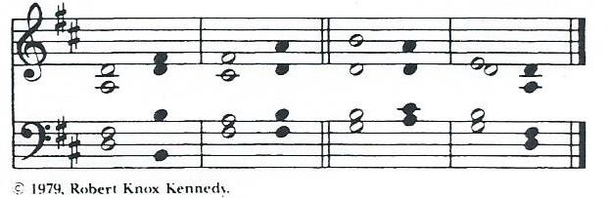

THE RESPONSE Canticle 16

1 Blessed be the Lord, the God of Israel; *
he has come to his people and set them free.
2 He has raised up for us a mighty savior, *
born of the house of his servant David.
3 Through his holy prophets he promised of old, that he would save us from our enemies, *
from the hands of all who hate us.
4 He promised to show mercy to our fathers *
and to remember his holy covenant.
5 This was the oath he swore to our father Abraham, *
to set us free from the hands of our enemies,
6 Free to worship him without fear, *
holy and righteous in his sight all the days of our life.
7 You, my child, shall be called the prophet of the Most High, *
for you will go before the Lord to prepare his way,
8 To give people knowledge of salvation *
by the forgiveness of their sins.
9 In the tender compassion of our God *
the dawn from on high shall break upon us,
10 To shine on those who dwell in darkness and the shadow of death, *
and to guide our feet into the way of peace.
11 Glory to the Father, and to the Son, and to the Holy Spirit: *
as it was in the beginning, is now, and will be forever. Amen.

THE SECOND LESSON Colossians 1:11-20
May you be made strong with all the strength that comes from his glorious power, and may you be prepared to endure everything with patience, while joyfully giving thanks to the Father, who has enabled you to share in the inheritance of the saints in the light. He has rescued us from the power of darkness and transferred us into the kingdom of his beloved Son, in whom we have redemption, the forgiveness of sins.

He is the image of the invisible God, the firstborn of all creation; for in him all things in heaven and on earth were created, things visible and invisible, whether thrones or dominions or rulers or powers-- all things have been created through him and for him. He himself is before all things, and in him all things hold together. He is the head of the body, the church; he is the beginning, the firstborn from the dead, so that he might come to have first place in everything. For in him all the fullness of God was pleased to dwell, and through him God was pleased to reconcile to himself all things, whether on earth or in heaven, by making peace through the blood of his cross.
Lector: The Word of the Lord.
People: Thanks be to God.

SEQUENCE HYMN: “Christ is made the sure foundation” Hymnal 518

GOSPEL
Celebrant: The Holy Gospel of our Lord Jesus Christ according to Luke (Luke 23:33-43).
People: Glory to you, Lord Christ.
When they came to the place that is called The Skull, they crucified Jesus there with the criminals, one on his right and one on his left. Then Jesus said, "Father, forgive them; for they do not know what they are doing." And they cast lots to divide his clothing. The people stood by, watching Jesus on the cross; but the leaders scoffed at him, saying, "He saved others; let him save himself if he is the Messiah of God, his chosen one!" The soldiers also mocked him, coming up and offering him sour wine, and saying, "If you are the King of the Jews, save yourself!" There was also an inscription over him, "This is the King of the Jews."

One of the criminals who were hanged there kept deriding him and saying, "Are you not the Messiah? Save yourself and us!" But the other rebuked him, saying, "Do you not fear God, since you are under the same sentence of condemnation? And we indeed have been condemned justly, for we are getting what we deserve for our deeds, but this man has done nothing wrong." Then he said, "Jesus, remember me when you come into your kingdom." He replied, "Truly I tell you, today you will be with me in Paradise."
Celebrant: The Gospel of the Lord.
People: Praise to you, Lord Christ.

Sermon The Rt. Rev. Wayne Smith, Bishop Provisional

Candidates For Confirmation/Reception
Alexandra Elizabeth Bickel
Gayle Winters Rich

Presentation and Examination of the Candidates

The Candidates will now be presented.
Presenter: I present these persons for Confirmation.

Bishop: Do you reaffirm your renunciation of evil?
Candidates: I do.
Bishop: Do you renew your commitment to Jesus Christ?
Candidates: I do, and with God's grace I will follow him as my Savior and Lord.

Bishop: Will you who witness these vows do all in your power to support these persons in their life in Christ?
People: We will.

Bishop: Let us join with those who are committing themselves to Christ and renew our own baptismal covenant.
The Baptismal Covenant
Bishop: Do you believe in God the Father?
People: I believe in God, the Father almighty, creator of heaven and earth.

Bishop: Do you believe in Jesus Christ, the Son of God?
People: I believe in Jesus Christ, his only Son, our Lord.
He was conceived by the power of the Holy Spirit
and born of the Virgin Mary.
He suffered under Pontius Pilate,
was crucified, died, and was buried.
He descended to the dead.
On the third day he rose again.
He ascended into heaven,
and is seated at the right hand of the Father.
He will come again to judge the living and the dead.
Bishop: Do you believe in God the Holy Spirit?
People: I believe in the Holy Spirit,
the holy catholic Church,
the communion of saints,
the forgiveness of sins,
the resurrection of the body,
and the life everlasting.

Bishop: Will you continue in the apostles' teaching and fellowship, in the breaking of bread, and in the prayers?
People: I will, with God's help.

Bishop: Will you persevere in resisting evil, and, whenever you fall into sin, repent and return to the Lord?
People: I will, with God's help.

Bishop: Will you proclaim by word and example the Good News of God in Christ?
People: I will, with God's help.

Bishop: Will you seek and serve Christ in all persons, loving your neighbor as yourself?
People: I will, with God's help.

Bishop: Will you strive for justice and peace among all people, and respect the dignity of every human being?
People: I will, with God's help.
Prayers for the Candidates
Let us now pray for these persons who have renewed their commitment to Christ.
Almighty God, we thank you that by the death and resurrection of your Son Jesus Christ you have overcome sin and brought us to yourself, and that by the sealing of your Holy Spirit you have bound us to your service. Renew in these your servants the covenant you have made with them at their Baptism. Send them forth in the power of that Spirit to perform the service you set before them; through Jesus Christ your Son our Lord, who lives and reigns with you and the Holy Spirit, one God, now and forever. Amen.
Strengthen, O Lord, your servant Alexandra with your Holy Spirit; empower her for your service; and sustain her all the days of her life. Amen.
Gayle, we recognize you as a member of the one holy catholic and apostolic Church, and we receive you into the fellowship of this Communion. God, the Father, Son, and Holy Spirit, bless, preserve, and keep you. Amen.
Almighty and everlasting God, let your fatherly hand ever be over these your servants;
let your Holy Spirit ever be with them; and so lead them in the knowledge and obedience of your Word, that they may serve you in this life, and dwell with you in the life to come; through Jesus Christ our Lord. Amen.
THE PEACE

ANNOUNCEMENTS

OFFERTORY HYMN: "The King Shall Come when Morning Dawns" - Kentucky Harmony/arr. Busarow

PRESENTATION OF THE GIFTS Hymnal 380, v. 3
Praise God from whom all blessings flow;
praise God, all creatures here below;
praise God above, ye heavenly host:
praise Father, Son, and Holy Ghost

THE HOLY COMMUNION

THE GREAT THANKSGIVING: EUCHARISTIC PRAYER A

The Lord be with you.
People And also with you.
Bishop Lift up your hearts.
People We lift them to the Lord.
Bishop Let us give thanks to the Lord our God.
People It is right to give God thanks and praise.

It is right, and a good and joyful thing, always and everywhere to give thanks to you, Father Almighty, Creator of heaven and earth. Through Jesus Christ our Lord. In fulfillment of his true promise, the Holy Spirit came down from heaven, lighting upon the disciples, to teach them and to lead them into all truth; uniting peoples of many tongues in the confession of one faith, and giving to your Church the power to serve you as a royal priesthood, and to preach the Gospel to all nations.

Therefore we praise you, joining our voices with Angels and Archangels and with all the company of heaven, who forever sing this hymn to proclaim the glory of your Name:

Holy, holy, holy Lord, God of power and might, Hymnal S130
heaven and earth are full of your glory.
Hosanna in the highest. Hosanna in the highest.
Blessed is he who comes in the name of the Lord.

Holy and gracious Father: In your infinite love you made us for yourself; and, when we had fallen into sin and become subject to evil and death, you, in your mercy, sent Jesus Christ, your only and eternal Son, to share our human nature, to live and die as one of us, to reconcile us to you, the God and Father of all.
He stretched out his arms upon the cross, and offered himself in obedience to your will, a perfect sacrifice for the whole world.

On the night he was handed over to suffering and death, our Lord Jesus Christ took bread; and when he had given thanks to you, he broke it, and gave it to his disciples, and said, “Take, eat: This is my Body, which is given for you. Do this for the remembrance of me.”

After supper he took the cup of wine; and when he had given thanks, he gave it to them, and said, “Drink this, all of you: This is my Blood of the new Covenant, which is shed for you and for many for the forgiveness of sins. Whenever you drink it, do this for the remembrance of me.”

Therefore we proclaim the mystery of faith:
Christ has died.
Christ is risen.
Christ will come again.

We celebrate the memorial of our redemption, O Father, in this sacrifice of praise and thanksgiving. Recalling his death, resurrection, and ascension, we offer you these gifts.
Sanctify them by your Holy Spirit to be for your people the Body and Blood of your Son, the holy food and drink of new and unending life in him. Sanctify us also that we may faithfully receive this holy Sacrament, and serve you in unity, constancy, and peace; and at the last day bring us with all your saints into the joy of your eternal kingdom.

All this we ask through your Son Jesus Christ. By him, and with him, and in him, in the unity of the Holy Spirit all honor and glory is yours, Almighty Father, now and forever. Amen.

And now, as our Savior Christ has taught us, we are bold to say,
Our Father, who art in heaven, hallowed be thy name,
thy kingdom come, thy will be done, on earth as it is in heaven.
Give us this day our daily bread.
And forgive us our trespasses,
as we forgive those who trespass against us.
And lead us not into temptation, but deliver us from evil.
For thine is the kingdom, and the power, and the glory,
forever and ever. Amen.

THE BREAKING OF THE BREAD Hymnal S164
Jesus, Lamb of God, have mercy on us.
Jesus, bearer of our sins, have mercy on us.
Jesus, redeemer, redeemer of the world,
Give us your peace. Give us your peace.

THE INVITATION TO COMMUNION

COMMUNION HYMN: “My song is love unknown” Hymnal 458

PRAYER AFTER COMMUNION- Celebrant and people together
Eternal God, heavenly Father, you have graciously accepted us as living members of your Son our Savior Jesus Christ, and you have fed us with spiritual food in the Sacrament of his Body and Blood. Send us now into the world in peace, and grant us strength and courage to love and serve you with gladness and singleness of heart; through Christ our Lord. Amen.

THE BLESSING
The peace of God, which passes all understanding, keep your hearts and minds in the knowledge and love of God, and of his Son Jesus Christ our Lord; and the blessing of God Almighty, Father, Son and Holy Spirit, be among you, and remain with you always. Amen.

CLOSING HYMN: “Savior, like a shepherd” Hymnal 708

THE DISMISSAL Bishop: Go in peace to love and serve the Lord.
People: Thanks be to God.

POSTLUDE: “Adagio cantabile” from Sonata in C minor op. 13 - Beethoven

Altar Flowers
The flowers today are given in thanksgiving for friends and family by Ann Chitkara.

Ministers for November 20th, 2022
Altar Guild: Joan Hurley
Chalice: Diane Rode
Lector: Fred Bartenstein
Ushers: David Bingman and Bonnie Bingman
Videographer: Ann Chitkara
Coffee Hour Host: Ann Chitkara

General Information
Bishop: The Rt. Rev. Wayne Smith, Bishop Provisional
Supply Priest: The Rev. Cricket Park
Senior Warden: Scott Yeazell
Junior Warden: Steve Sharp
Treasurer: Ken Bladh
Vestry at Large: Joy Meyers, Kay Koeninger, Linda Mortensen,
Bill Hicks, Lori Swafford, and Keith Doubt
Parish Administrator & Program Coordinator: Kelly Zeller
Director of Music: Dr. Christopher Durrenberger
Facility Manager: Paul McAfee
Bookkeeper: Tina Knox

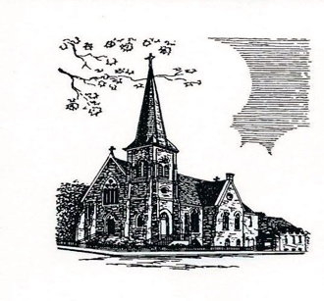

Christ Episcopal Church
409 East High Street
Springfield, Ohio 45505
937-323-8651
www.christspringfield.org

