**Thirteenth Sunday after Pentecost**

**August 27th, 2023 at 10:00 a.m.**

**The Holy Eucharist: Rite II**

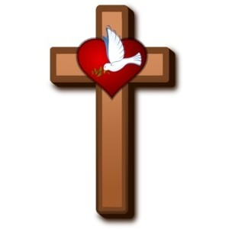

**++++++++++++++++++++++++++++++++++++++++++**

**INFORMATION FOR NEWCOMERS: WELCOME TO CHRIST CHURCH!**

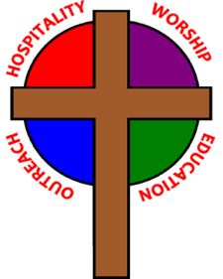

Our motto is true whether you're here for the very first time

or you've been a member for decades –

**There is a place for you at God's Table!**

The worship service has two main parts: the Liturgy of the Word, which includes Scripture readings and a sermon, and the Liturgy of the Table, which is also called Holy Eucharist or Communion. You will notice moments in the service when people stand, kneel, bow, and make the sign of the cross. There is no one “right” way to worship, so do what is comfortable for you at any given time in worship.

All Baptized Christians are welcome at Christ’s Table for Communion. If you do not wish to receive communion, you may come forward and request a blessing. If you wish to receive communion in your pew, please notify the ushers. And if you need a gluten-free wafer, just let Rev. Melody know.

If you have not been baptized, or if you have questions about Holy Baptism, please talk to The Rev. Melody Williams after the service -- the people of Christ Church would love to walk with you to your baptism and beyond!

When you enter a Christ Episcopal Church worship service/event, you will be entering an area where photography, video and audio recording may occur. Finally, if you are a visitor, please fill-out a *Welcome Card* on the back of the pew, so we can add you to our weekly information email the NewsNote.

**The Holy Eucharist Rite II**

**PRELUDE:** Improvisation on "Amazing Grace" - *New Britain*/arr. Callahan

**OPENING HYMN**: “I Come with Joy to Meet my Lord” Hymnal 304

**THE LITURGY OF THE WORD**

OPENING ACCLAMATION

Celebrant: Blessed be God: Father, Son, and Holy Spirit.

People: **And blessed be his kingdom, now and forever. Amen.**

COLLECT OF PURITY

Almighty God, to you all hearts are open, all desires known, and from you no secrets are hid cleanse the

thoughts of our hearts by the inspiration of your Holy Spirit, that we may perfectly love you, and worthily

magnify your holy Name; through Christ our Lord. **Amen.**

GLORIA HYMNAL S280

**Glory to God in the highest, and peace to his people on earth.**

**Lord God, heavenly King, almighty God and Father,**

**we worship you, we give you thanks, we praise you for your glory.**

**Lord Jesus Christ, only Son of the Father, Lord God, Lamb of God,**

**you take away the sin of the world: have mercy on us;**

**you are seated at the right hand of the Father: receive our prayer.**

**For you alone are the Holy One, you alone are the Lord,**

**you alone are the Most High, Jesus Christ, with the Holy**

**Spirit, in the glory of God the Father. Amen.**

COLLECT OF THE DAY

Celebrant:The Lord be with you.

People: **And also with you.**

Celebrant: Let us pray.

Grant, O merciful God, that your Church, being gathered together in unity by your Holy Spirit, may show forth your power among all peoples, to the glory of your Name; through Jesus Christ our Lord, who lives and reigns with you and the Holy Spirit, one God, forever and ever. ***Amen.***

Dieu de bonté, accorde à ton Église, rassemblée dans l’unité par ton Esprit saint, de faire connaître ta puissance à tous les peuples, à la gloire de ton Nom ; par Jésus Christ, notre Seigneur, qui vit et règne avec toi et le Saint-Esprit, un seul Dieu, pour les siècles des siècles. ***Amen.***

**THE LESSONS**

**THE FIRST READING Romans 12:1-8**

I appeal to you therefore, brothers and sisters, by the mercies of God, to present your bodies as a living sacrifice, holy and acceptable to God, which is your spiritual worship. Do not be conformed to this world, but be transformed by the renewing of your minds, so that you may discern what is the will of God-- what is good and acceptable and perfect.

For by the grace given to me I say to everyone among you not to think of yourself more highly than you ought to think, but to think with sober judgment, each according to the measure of faith that God has assigned. For as in one body we have many members, and not all the members have the same function, so we, who are many, are one body in Christ, and individually we are members one of another. We have gifts that differ according to the grace given to us: prophecy, in proportion to faith; ministry, in ministering; the teacher, in teaching; the exhorter, in exhortation; the giver, in generosity; the leader, in diligence; the compassionate, in cheerfulness.

Lector: The Word of the Lord.

***People:* Thanks be to God.**

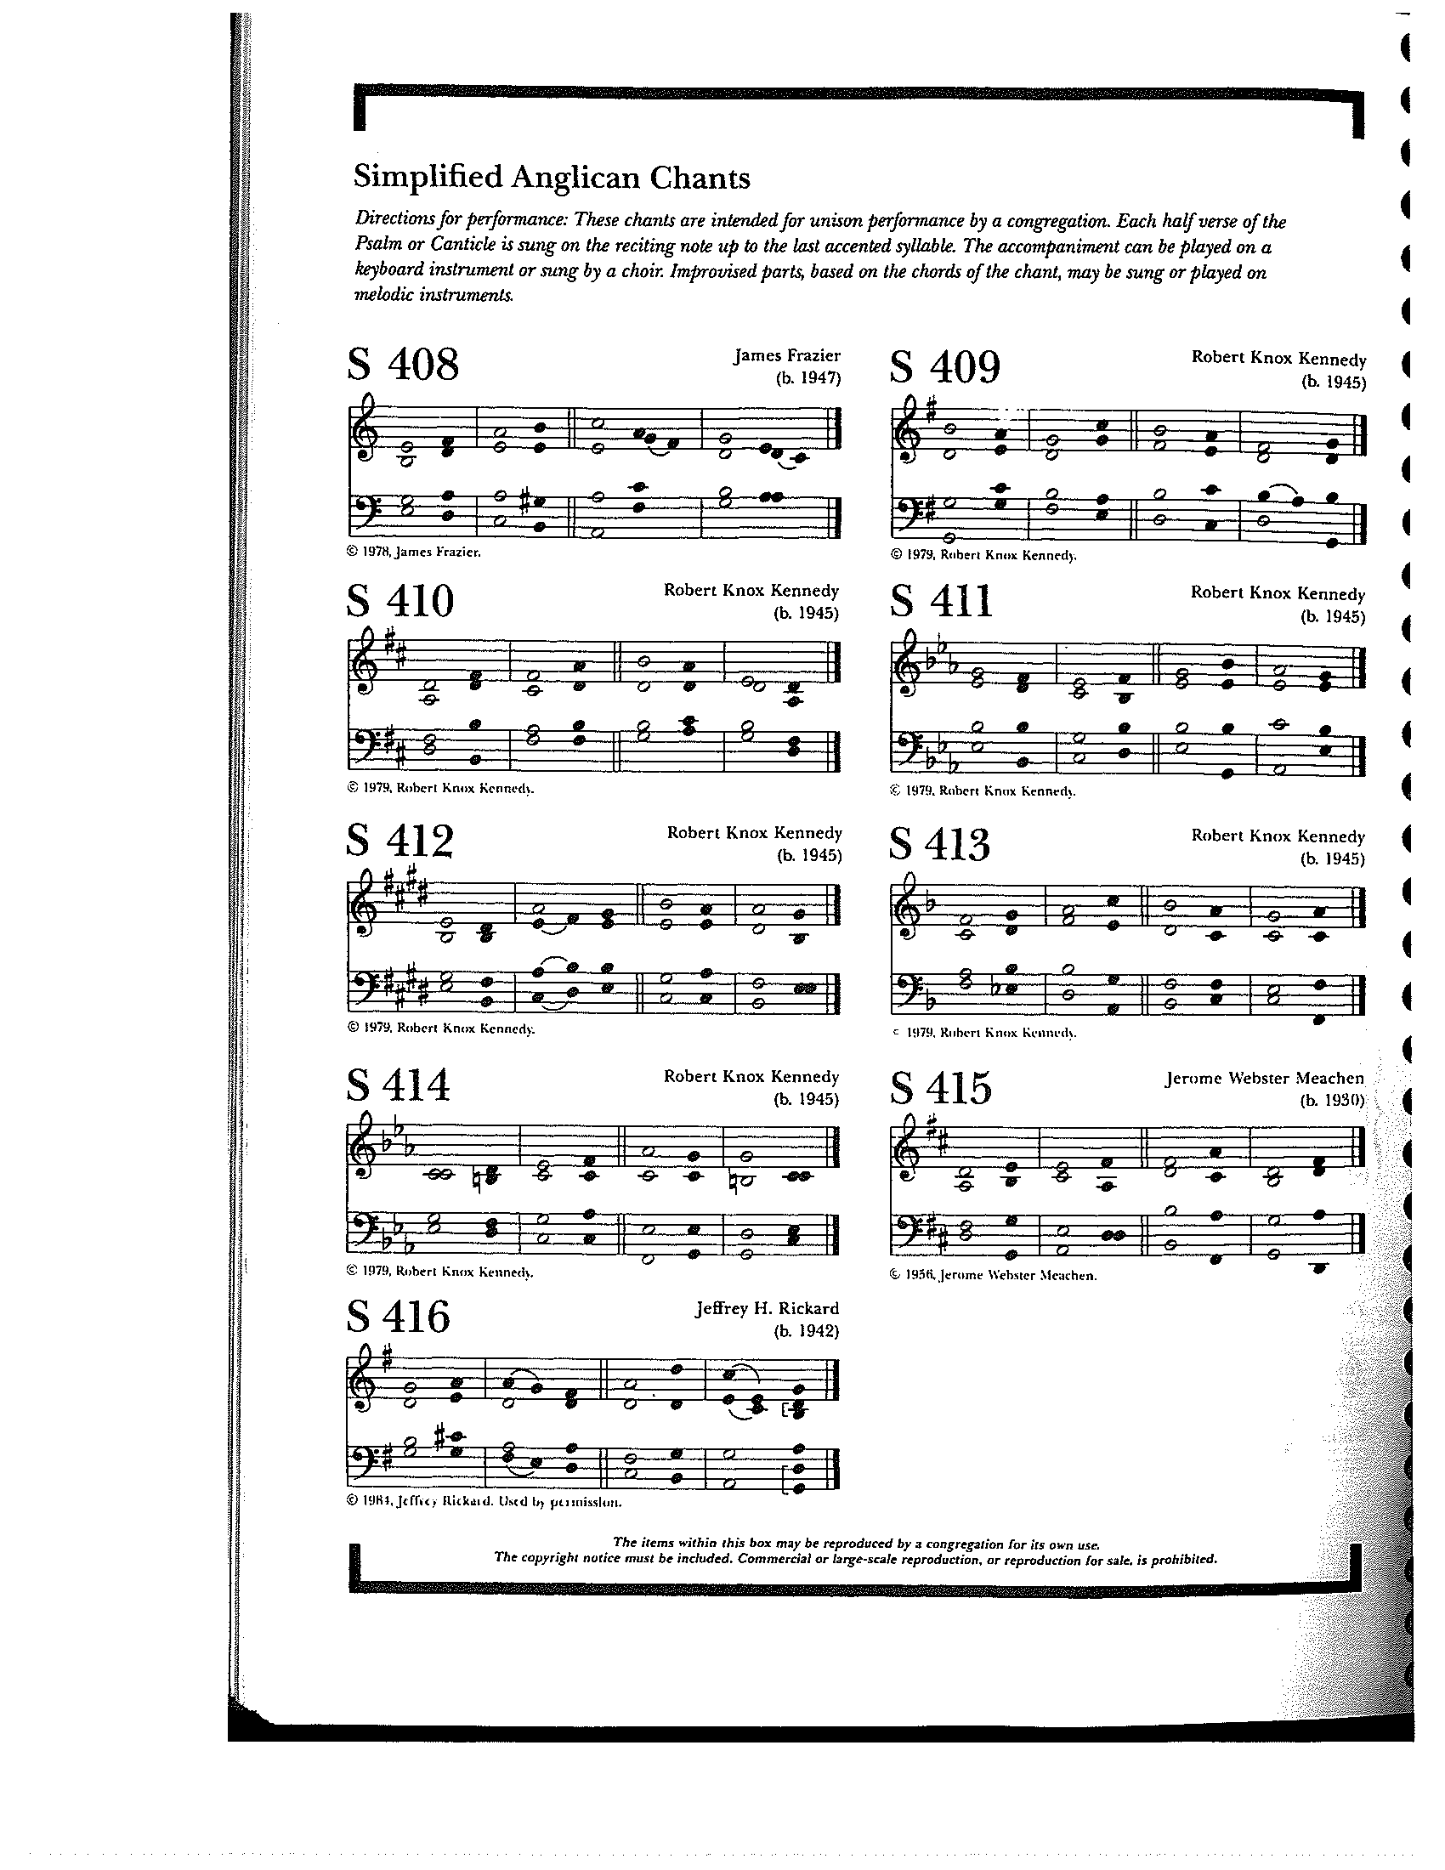

**THE RESPONSE PSALM 138**

1 I will give thanks to you, O Lord, with my whole **heart; \***before the gods I will sing your **praise.**

2 I will bow down toward your holy temple and praise your **Name, \***because of your love and **faithfulness;**

3 For you have glorified your **Name \***and your word above all **things.**

4 When I called, you answered **me; \***  
you increased my strength within **me.**

5 All the kings of the earth will praise you, O **Lord, \***  
when they have heard the words of your **mouth.**

6 They will sing of the ways of the **Lord, \***that great is the glory of the **Lord.**

7 Though the Lord be high, he cares for the **lowly; \***  
he perceives the haughty from a**far.**

8 Though I walk in the midst of trouble, you keep me **safe; \***  
you stretch forth your hand against the fury of my enemies; your right hand shall save **me.**

9 The Lord will make good his purpose for **me; \***  
O Lord, your love endures forever; do not abandon the works of your **hands.**

**THE SECOND LESSON Romans 12:1-8**

I appeal to you therefore, brothers and sisters, by the mercies of God, to present your bodies as a living sacrifice, holy and acceptable to God, which is your spiritual worship. Do not be conformed to this world, but be transformed by the renewing of your minds, so that you may discern what is the will of God-- what is good and acceptable and perfect.

For by the grace given to me I say to everyone among you not to think of yourself more highly than you ought to think, but to think with sober judgment, each according to the measure of faith that God has assigned. For as in one body we have many members, and not all the members have the same function, so we, who are many, are one body in Christ, and individually we are members one of another. We have gifts that differ according to the grace given to us: prophecy, in proportion to faith; ministry, in ministering; the teacher, in teaching; the exhorter, in exhortation; the giver, in generosity; the leader, in diligence; the compassionate, in cheerfulness.

Lector: The Word of the Lord.

People: **Thanks be to God.**

**SEQUENCE HYMN:** “God is Love, Let Heaven Adore Him” Hymnal 379

**GOSPEL**

Celebrant: The Holy Gospel of our Lord Jesus Christ according to Matthew (**Matthew 16:13-20**).

People: **Glory to you, Lord Christ.**

When Jesus came into the district of Caesarea Philippi, he asked his disciples, “Who do people say that the Son of Man is?” And they said, “Some say John the Baptist, but others Elijah, and still others Jeremiah or one of the prophets.” He said to them, “But who do you say that I am?” Simon Peter answered, “You are the Messiah, the Son of the living God.” And Jesus answered him, “Blessed are you, Simon son of Jonah! For flesh and blood has not revealed this to you, but my Father in heaven. And I tell you, you are Peter, and on this rock I will build my church, and the gates of Hades will not prevail against it. I will give you the keys of the kingdom of heaven, and whatever you bind on earth will be bound in heaven, and whatever you loose on earth will be loosed in heaven.” Then he sternly ordered the disciples not to tell anyone that he was the Messiah.

Celebrant: The Gospel of the Lord.

People: **Praise to you, Lord Christ.**

*Sermon The Rev. Melody Williams*

**THE NICENE CREED SYMBOLE DE NICÉE**

**We believe in one God, the Father, the Almighty,** Nous croyons en un seul Dieu, le Père tout-puissant,

**maker of heaven and earth, of all that is,** Créateur du ciel et de la terre,

**seen and unseen. We believe in one Lord,** De toutes les choses visibles et invisibles.

**Jesus Christ, the only Son of God,** Nous croyons en un seul Seigneur, Jésus Christ,

**eternally begotten of the Father, God from God,** Le Fils unique de Dieu,

**Light from Light, true God from true God,** Endgendré du Père avant tous les siècles,

**begotten, not made, of one Being with the Father.** Dieu né de Dieu, Lumière née de la Lumière,

**Through him all things were made.** Vrai Dieu né du vrai Dieu, Engendré, non pas crée,

**For us and for our salvation he came down** Un seul être avec le Père, Et par lui tout a été fait.

**from heaven, by the power of the Holy Spirit** Pour nous et pour notre salut,

**he became incarnate from the Virgin Mary,** Il est descendu des cieux,

**and was made man. For our sake he was** Il s’est incarné par le saint-Esprit en la Vierge Marie,

**crucified under Pontius Pilate;** Et s’est fait homme. Crucifié pour nous sous Ponce Pilate,

**he suffered death and was buried.** Il a souffert la Passion,

**On the third day he rose again in accordance** Il a été mis au tombeau,

**with the Scriptures; he ascended into heaven** Il est ressuscité le troisième jour, selon les Écritures ;

**and is seated at the right hand of the Father.** Il est monté aux cieux,

**He will come again in glory to judge the living** Il siège à la droite du Père,

**and the dead, and his kingdom will have no end.** Il reviendra dans la gloire pour juger

**We believe in the Holy Spirit, the Lord,** les vivants et les morts,

**the giver of life, who proceeds from the Father,** Et son règne n’aura pas de fin.

**and the Son. With the Father and the Son he** Nous croyons en l’Esprit saint,

**is worshiped and glorified, He has spoken** Qui est Seigneur et qui donne la vie,

**through the Prophets. We believe in one holy** Que procède du Père et du Fils,

**catholic and apostolic Church.** Avec le Père et le Fils, il reçoit même

**We acknowledge one baptism** adoration et même gloire; Il a parlé par les Prophètes.

**for the forgiveness of sins.** Nous croyons en l’Église une, sainte,

**We look for the resurrection of the dead,** catholique et apostolique.

**and the life of the world to come. Amen.** Nous reconnaissons us seul baptême pour

le pardon des péchés.

Nous attendons la résurrection des morts

Et la vie du monde à venir. Amen.

**THE PRAYERS OF THE PEOPLE**

In peace, we pray to you Lord God. (*Congregational responses are in* ***bold****)*

*Silence*

Grant, Almighty God, that all who confess your Name may be united in your truth, live together in your love, and reveal your glory in the world.

Lord, in your mercy  
**Hear our prayer.**

Give grace to church leaders, especially Justin, Archbishop of Canterbury; Michael, our presiding bishop; Wayne, our provisional diocesan bishop; Melody, our supply priest; and all who minister in Christ, that they may be firmly rooted in your truth and love.

Lord, in your mercy  
**Hear our prayer.**

Guide the people of this land, and of all the nations, in the ways of justice and peace; that we may honor one another and serve the common good. In the Ministry Cycle of Prayer, we pray for Children’s Rescue Center/The Ark, Christ Church Food Pantry, Habitat for Humanity, Safe Harbor House, and Rock of Hope.

Lord, in your mercy  
**Hear our prayer.**

Give us all a reverence for the earth as your own creation, that we may use its resources rightly in the service of others and to your honor and glory.

Lord, in your mercy  
**Hear our prayer.**

Bless all whose lives are closely linked with ours, and grant that we may serve Christ in them, and love one another as he loves us. We pray for those celebrating their birthdays this week, especially Ted DeLong, Jenny Randolph, and Anne deLanglade, and anniversaries this week.

Lord, in your mercy  
**Hear our prayer.**

Comfort and heal all those who suffer in body, mind, or spirit; especially Bill Everingham, Bill Yeazell, Don Rode, Diana DeVoe, Sandi Eyman, Margaret Mattox, Joy Bartenstein, Dodi Holmes, Martha Chaney, Charlene Schreiber, Alice Kelly, Barb Kelly, Traudie Milleck, and any others we may now name, silently or aloud, and

give them courage and hope in their troubles, and bring them the joy of your salvation.

Lord, in your mercy  
**Hear our prayer.**

We commend to your mercy all who have died, that your will for them may be fulfilled; and we pray that we may share with all your saints in your eternal kingdom.

Lord, in your mercy  
**Hear our prayer.**

THE COLLECT FOR THE ELECTION OF A BISHOP  
**Almighty God, giver of every good gift: Look graciously on your Church, and so guide the minds of those who shall choose a bishop for this Diocese, that we may receive a faithful pastor, who will care for your people and equip us for our ministries; through Jesus Christ our Lord. *Amen.***

THE CONFESSION AND ABSOLUTION

Celebrant: Let us confess our sins against God and our neighbor.

**All: God of all mercy, we confess that we have sinned against you, opposing your will in our lives. We have denied your goodness in each other, in ourselves, and in the world you have created. We repent of the evil that enslaves us, the evil we have done, and the evil done on our behalf. Forgive, restore, and strengthen us through our Savior Jesus Christ, that we may abide in your love and serve only your will. *Amen.***

Celebrant: Almighty God have mercy on you, forgive you all your sins through the grace of Jesus Christ, strengthen you in all goodness, and by the power of the Holy Spirit keep you in eternal life. ***Amen.***

THE PEACE

ANNOUNCEMENTS

**OFFERTORY HYMN:** “Amazing Grace” Hymnal 671

PRESENTATION OF THE GIFTSHymnal 380, v. 3

**Praise God from whom all blessings flow;**

**praise him, all creatures here below;**

**praise him above, ye heavenly host:**

**praise Father, Son and Holy Ghost**

**THE HOLY COMMUNION**

THE GREAT THANKSGIVING: EUCHARISTIC PRAYER 1 (from Enriching Our Worship)

Celebrant The Lord be with you.

People **And also with you.**

Celebrant Lift up your hearts.

People **We lift them to the Lord.**

Celebrant Let us give thanks to the Lord our God.

People **It is right to give our thanks and praise**.

It is truly right, and good and joyful, to give you thanks, all-holy God, source of life and fountain of mercy. You have filled us and all creation with your blessing and fed us with your constant love; you have redeemed us in Jesus Christ and knit us into one body. Through your Spirit you replenish us and call us to fullness of life.

Therefore, joining with Angels and Archangels and with the faithful of every generation, we lift our voices with all creation as we sing:

**Holy, holy, holy Lord, God of power and might, Hymnal S129**

**heaven and earth are full of your glory. Hosanna in the highest.**

**Blessed is he who comes in the name of the Lord.**

**Hosanna in the highest.**

Blessed are you, gracious God, Creator of the universe and giver of life. You formed us in your own image and called us to dwell in your infinite love. You gave the world into our care, that we might be your faithful stewards and show forth your bountiful grace. But we failed to honor your image in one another and in ourselves; we would not see your goodness in the world around us; and so we violated your creation, abused one another, and rejected your love. Yet you never ceased to care for us, and prepared the way of salvation for all people.

Through Abraham and Sarah you called us into covenant with you. You delivered us from slavery, sustained us in the wilderness, and raised up prophets to renew your promise of salvation. Then, in the fullness of time, you sent your eternal Word, made mortal flesh in Jesus. Born into the human family, and dwelling among us, he revealed your glory. Giving himself freely to death on the cross, he triumphed over evil, opening the way of freedom and life.

On the night before he died for us, Our Savior Jesus Christ took bread, and when he had given thanks to you, he broke it, and gave it to his friends, and said: “Take, eat: This is my Body which is given for you. Do this for the remembrance of me.”

As supper was ending, Jesus took the cup of wine, and when he had given thanks, he gave it to them, and said: “Drink this, all of you: This is my Blood of the new Covenant, which is poured out for you and for all for the forgiveness of sins. Whenever you drink it, do this for the remembrance of me.”

Therefore we proclaim the mystery of faith:

**Christ has died.**

**Christ is risen.**

**Christ will come again.**

Remembering his death and resurrection, we now present to you from your creation this bread and this wine. By your Holy Spirit may they be for us the Body and Blood of our Savior Jesus Christ. Grant that we who share these gifts may be filled with the Holy Spirit and live as Christ’s Body in the world. Bring us into the everlasting heritage of your daughters and sons, that with Blessed Mother Mary and all your saints, past, present, and yet to come, we may praise your Name for ever.

Through Christ and with Christ and in Christ, in the unity of the Holy Spirit, to you be honor, glory, and praise, forever and ever. Amen.

And now, as our Savior Christ has taught us, we are bold to say,

**Our Father, who art in heaven, Notre Père, qui es aux cieux,**

**hallowed be thy name, Que ton nom soit sanctifé;**

**thy kingdom come, thy will be done, Que ton règne vienne ; que ta volonté soit faite**

**on earth as it is in heaven. Sur la terre comme au ciel.**

**Give us this day our daily bread. Donne-nous aujourd’hui notre pain de ce jour.**

**And forgive us our trespasses, Pardonne-nous nos offenses,**

**as we forgive those who trespass against us. Comme nous pardonnons aussi À ceux qui nous ont offensés.**

**And lead us not into temptation, Et nous laisse pas entrer en tentation,**

**but deliver us from evil. Mais délivre-nous du mal.**

**For thine is the kingdom, Car c’est à toi qu’appartiennent le règne,**

**and the power, and the glory, La puissance et la gloire,**

**forever and ever. Amen. Pour les siècles des siècles. Amen.**

THE BREAKING OF THE BREAD Hymnal S155

**Alleluia, alleluia, alleluia.**

**Christ our Passover is sacrificed for us; therefore let us keep the feast.**

**Alleluia, alleluia, alleluia.**

THE INVITATION TO COMMUNION

**COMMUNION HYMN:** “Blessed Assurance”



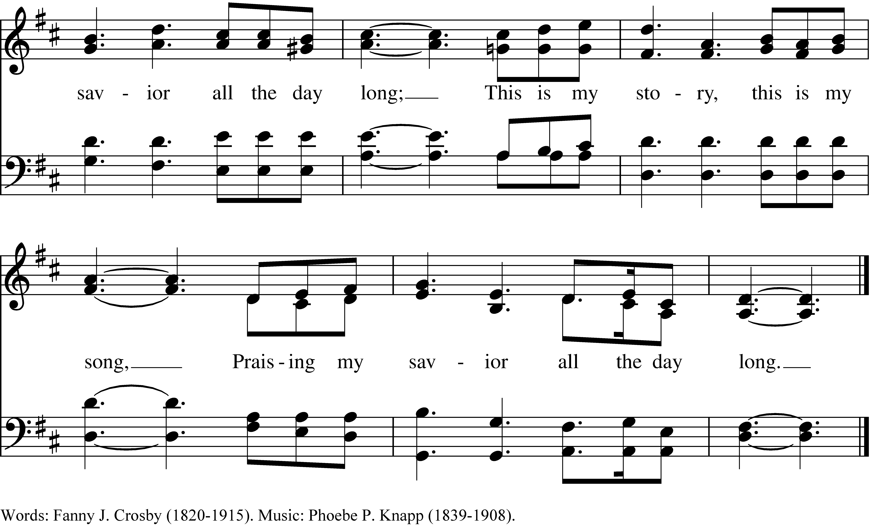

PRAYER AFTER COMMUNION- Celebrant and people together

**Eternal God, heavenly Father, you have graciously accepted us as living members of your Son our Savior Jesus Christ, and you have fed us with spiritual food  in the Sacrament of his Body and Blood. Send us now into the world in peace, and grant us strength and courage to love and serve you with gladness and singleness of heart; through Christ our Lord. Amen.**

THE BLESSING

The peace of God, which passes all understanding, keep your hearts and minds in the knowledge and love of God, and of his Son Jesus Christ our Lord; and the blessing of God Almighty, Father, Son and Holy Spirit, be among you, and remain with you always. ***Amen.***

**CLOSING HYMN:** “Glorious Things of thee are Spoken” Hymnal 522

THE DISMISSAL Celebrant: Go in peace to love and serve the Lord.

People: **Thanks be to God.**

**POSTLUDE:** Sonatina in C Major Op. 36#3 - Clementi

**Altar Flowers**

The flowers today are given in memory of Ben Schwartz by Sally Schwartz and family.

**++++++++++++++++++++**

**Announcements from Christ Church**

**Pastoral emergencies**

If you need to reach Rev. Michelle for a pastoral emergency, the number is (937) 505-0141. For

non-emergencies, you can call the office at (937) 323-8651 or email Rev. Michelle at [mboomgaard@christspringfield.org](mailto:mboomgaard@christspringfield.org).

**Wednesday Service of Holy Eucharist~**

### The Rev. Dr. Michelle Boomgaard is on vacation. There will not be a Wednesday Service of Holy Eucharist this week, but there will be an online Wednesday Noonday Prayer Service by Judy Johnson.

**Food Pantry**

**The September’s Drive-thru Food Pantry will be on September 20th, 2023, starting at 10 am**. *Please consider join us!* Volunteers are needed to help unload food, pack food and help with customer service at approximately 8:15 am. Please contact either Brian Shelburne at [bshelburne@wittenberg.edu](mailto:bshelburne@wittenberg.edu), Kelly Zeller at [zellerk0611@gmail.com](mailto:zellerk0611@gmail.com), or Anne Randolph at [annejrand@aol.com](mailto:annejrand@aol.com) to volunteer.

**Upcoming Food September Pantry opportunities:**

**September 6th, 2023***-* the first food **pick-up** at approximately **8:00 am**

September 13th, 2023 -the second food **pick-up** at approximately**8:00 am**

September 14th, 2023 - grocery bagging day - start time at **9:00 am**

September 20th, 2023 – Food Pantry Day! start time at **8:15 am**

**Celebrating our Past, Envisioning our Future~ September 17th & 24th**

Whether you’ve been coming here one week, or ever since you were baptized as an infant – we need your input as we celebrate our past and envision our future. Please join us for BOTH Sundays for a **combined service at 9:30 am.** Then, we will meet in the Parish Hall for fellowship and fun as we celebrate all that God continues to do here at Christ Episcopal Church!

**+++++++++++++++++++++++++++**

**Ministers for August 27th, 2023**

**Altar Guild:** Joan Hurley

**Chalice:** Brian Shelburne

**Lector:** Fred Bartenstein

**Ushers:** Steve Sharp and Rick Everingham

**Videographer:** Ann Chitkara

**General Information**

**Supply Priest:** The Rev. Melody Williams

**Senior Warden**: Scott Yeazell

**Junior Warden**: Steve Sharp

**Treasurer**: Ken Bladh

**Clerk of Vestry:** Kelly Zeller

**Vestry at Large**: Joy Meyers, Kay Koeninger, Linda Mortensen,

Bill Hicks, Lori Swafford, and Rick Everingham

**Parish Administrator & Program Coordinator**: Kelly Zeller

**Director of Music**: Dr. Christopher Durrenberger

**Facility Manager**: Paul McAfee

**Bookkeeper:** Tina Knox

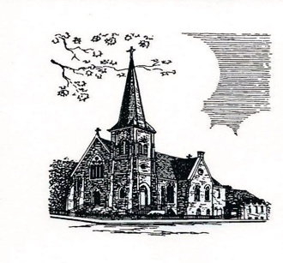

**Christ Episcopal Church**

**409 East High Street**

**Springfield, Ohio 45505**

**937-323-8651**

**www.christspringfield.org**