Fourth Sunday of Easter
April 30th, 2023 at 10:00 a.m.
The Holy Eucharist: Rite II

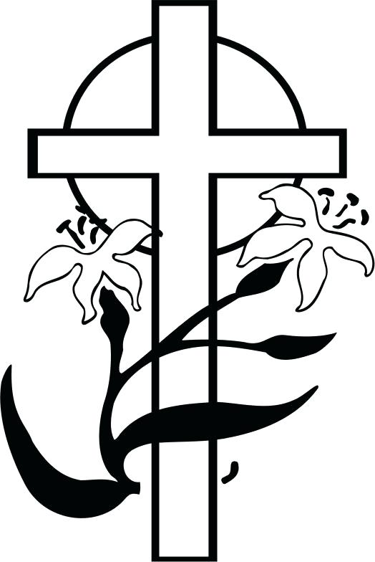

++++++++++++++++++++++++++++++++++++++++++

INFORMATION FOR NEWCOMERS: WELCOME TO CHRIST CHURCH!
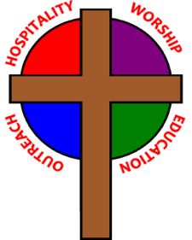
Our motto is true whether you're here for the very first time
or you've been a member for decades –

There is a place for you at God's Table!

The worship service has two main parts: the Liturgy of the Word, which includes Scripture readings and a sermon, and the Liturgy of the Table, which is also called Holy Eucharist or Communion. You will notice moments in the service when people stand, kneel, bow, and make the sign of the cross. There is no one “right” way to worship, so do what is comfortable for you at any given time in worship.

All Baptized Christians are welcome at Christ’s Table for Communion. If you do not wish to receive communion, you may come forward and request a blessing. If you wish to receive communion in your pew, please notify the ushers. And if you need a gluten-free wafer, just let Rev. Michelle know.

If you have not been baptized, or if you have questions about Holy Baptism, please talk to The Rev. Dr. Michelle Boomgaard after the service -- the people of Christ Church would love to walk with you to your baptism and beyond!

When you enter a Christ Episcopal Church worship service/event, you will be entering an area where photography, video and audio recording may occur. Finally, if you are a visitor, please fill-out a Welcome Card on the back of the pew, so we can add you to our weekly information email the NewsNote.
The Holy Eucharist Rite II

PRELUDE: "Sarabande" from English Suite #1 - J.S. Bach

OPENING HYMN: “Sing, ye faithful, sing with gladness” Hymnal 492

THE LITURGY OF THE WORD

OPENING ACCLAMATION
Celebrant: Alleluia! Christ has risen!
People: The Lord is risen indeed. Alleluia!

COLLECT FOR PURITY
Almighty God, to you all hearts are open, all desires known, and from you no secrets are hid. Cleanse the
thoughts of our hearts by the inspiration of your Holy Spirit, that we may perfectly love you, and worthily
magnify your holy Name; through Christ our Lord. Amen.

GLORIA Hymnal S278
Glory to God in the highest, and peace to his people on earth.
Lord God, heavenly King, almighty God and Father,
we worship you, we give you thanks, we praise you for your glory.
Lord Jesus Christ, only Son of the Father, Lord God, Lamb of God,
you take away the sin of the world: have mercy on us;
you are seated at the right hand of the Father: receive our prayer.
For you alone are the Holy One, you alone are the Lord,
you alone are the Most High, Jesus Christ, with the Holy Spirit,
in the glory of God the Father. Amen.

COLLECT OF THE DAY
Celebrant: The Lord be with you.
People: And also with you.
Celebrant: Let us pray. O God, whose Son Jesus is the good shepherd of your people: Grant that when we hear his voice we may know him who calls us each by name, and follow where he leads; who, with you and the Holy Spirit, lives and reigns, one God, forever and ever. Amen.

THE LESSONS

THE FIRST READING Acts 2:42-47
Those who had been baptized devoted themselves to the apostles' teaching and fellowship, to the breaking of bread and the prayers.

Awe came upon everyone, because many wonders and signs were being done by the apostles. All who believed were together and had all things in common; they would sell their possessions and goods and distribute the proceeds to all, as any had need. Day by day, as they spent much time together in the temple, they broke bread at home and ate their food with glad and generous hearts, praising God and having the goodwill of all the people. And day by day the Lord added to their number those who were being saved.
Lector: The Word of the Lord.
People: Thanks be to God.

THE RESPONSE PSALM 23

1 The Lord is my shepherd; *
I shall not be in want.
2 He makes me lie down in green pastures *
and leads me beside still waters.
3 He revives my soul *
and guides me along right pathways for his Name's sake.
4 Though I walk through the valley of the shadow of death, I shall fear no evil; *
for you are with me; your rod and your staff, they comfort me.
5 You spread a table before me in the presence of those who trouble me; *
you have anointed my head with oil, and my cup is running over.
6 Surely your goodness and mercy shall follow me all the days of my life, *
and I will dwell in the house of the Lord forever.

THE SECOND LESSON 1 Peter 2:19-25
It is a credit to you if, being aware of God, you endure pain while suffering unjustly. If you endure when you are beaten for doing wrong, what credit is that? But if you endure when you do right and suffer for it, you have God's approval. For to this you have been called, because Christ also suffered for you, leaving you an example, so that you should follow in his steps.

“He committed no sin,
and no deceit was found in his mouth.”

When he was abused, he did not return abuse; when he suffered, he did not threaten; but he entrusted himself to the one who judges justly. He himself bore our sins in his body on the cross, so that, free from sins, we might live for righteousness; by his wounds you have been healed. For you were going astray like sheep, but now you have returned to the shepherd and guardian of your souls.
Lector: The Word of the Lord.
People: Thanks be to God.

SQUENCE HYMN: “I come with joy to meet my Lord” Hymnal 304

GOSPEL
Celebrant: The Holy Gospel of our Lord Jesus Christ according to John (John 10:1-10).
People: Glory to you, Lord Christ.
Jesus said, “Very truly, I tell you, anyone who does not enter the sheepfold by the gate but climbs in by another way is a thief and a bandit. The one who enters by the gate is the shepherd of the sheep. The gatekeeper opens the gate for him, and the sheep hear his voice. He calls his own sheep by name and leads them out. When he has brought out all his own, he goes ahead of them, and the sheep follow him because they know his voice. They will not follow a stranger, but they will run from him because they do not know the voice of strangers.” Jesus used this figure of speech with them, but they did not understand what he was saying to them.

So again Jesus said to them, “Very truly, I tell you, I am the gate for the sheep. All who came before me are thieves and bandits; but the sheep did not listen to them. I am the gate. Whoever enters by me will be saved, and will come in and go out and find pasture. The thief comes only to steal and kill and destroy. I came that they may have life, and have it abundantly.”
Celebrant: The Gospel of the Lord.
People: Praise to you, Lord Christ.
Sermon The Rev. Dr. Michelle Boomgaard

THE NICENE CREED
We believe in one God, the Father, the Almighty,
maker of heaven and earth, of all that is, seen and unseen.
We believe in one Lord, Jesus Christ, the only Son of God,
eternally begotten of the Father, God from God,
Light from Light, true God from true God,
begotten, not made, of one Being with the Father.
Through him all things were made.
For us and for our salvation he came down from heaven,
by the power of the Holy Spirit he became incarnate from the Virgin Mary,
and was made man.
For our sake he was crucified under Pontius Pilate;
he suffered death and was buried.
On the third day he rose again in accordance with the Scriptures;
he ascended into heaven and is seated at the right hand of the Father.
He will come again in glory to judge the living and the dead, and his kingdom will have no end.
We believe in the Holy Spirit, the Lord, the giver of life,
who proceeds from the Father, and the Son.
With the Father and the Son he is worshiped and glorified,
He has spoken through the Prophets.
We believe in one holy catholic and apostolic Church.
We acknowledge one baptism for the forgiveness of sins.
We look for the resurrection of the dead, and the life of the world to come. Amen.

THE PRAYERS OF THE PEOPLE

In peace, we pray to you Lord God. (Congregational responses are in bold)

Silence

Blessed are you eternal God,
to be praised and glorified forever.

Hear us as we pray for the unity of the Church.
May we all be one, that the world may come to know you.

Grant that every member of the Church may truly and humbly serve you,
that the life of Christ may be revealed in us.

We remember those who have died.
Into your hands we commend them.
We praise you for all your saints who have entered eternal glory.
May we also come to share your heavenly kingdom.

Have compassion on those who suffer from sickness, grief or trouble, especially Diana DeVoe, Sandi Eyman, Ron deLanglade, Margaret Mattox, Joy Bartenstein, Dodi Holmes, Martha Chaney, Charlene Schreiber, Alice Kelly, Barb Kelly, Joni Pulver, and Traudie Milleck.
In your presence may they find strength.
Look with kindness on our homes and families, and all who celebrate birthdays especially Peg Curtain and anniversaries this week.
Grant that your love may grow in our hearts.

Make us alive to the needs of our community, and bless the holy work of Rainbow Table, Springfield Promise Neighborhood, Springfield Peace Center, Partners in Mistry in Liberia, and Living Waters.
Help us to share one another’s joys and burdens.

Inspire and lead those who hold authority in the nations of the world.
Guide us and all people in the way of justice and peace.

For Justin, Archbishop of Canterbury; Michael, our Presiding Bishop; Wayne, our Bishop; Michelle, our Rector; and all who minister in Christ, that they may be firmly rooted in your truth and love.
Inspire us and give us courage to proclaim your Gospel of Resurrection.

THE COLLECT FOR PEACE
Grant, O God, that your holy and life-giving Spirit may so move every human heart, that barriers which divide us may crumble, suspicions disappear, and hatreds cease; that our divisions being healed, we may live in justice and peace; through Jesus Christ our Lord. Amen.

THE CONFESSION AND ABSOLUTION
Celebrant: Let us confess our sins against God and our neighbor.
All: Most merciful God, we confess that we have sinned against you in thought, word, and deed, by what we have done, and by what we have left undone. We have not loved you with our whole heart; we have not loved our neighbors as ourselves. We are truly sorry and we humbly repent. For the sake of your Son Jesus Christ, have mercy on us and forgive us; that we may delight in your will, and walk in your ways, to the glory of your Name. Amen.

Celebrant: Almighty God have mercy on you, forgive you all your sins through our Lord Jesus Christ, strengthen you in all goodness, and by the power of the Holy Spirit keep you in eternal life. Amen.

THE PEACE

ANNOUNCEMENTS

OFFERTORY: "Lord of the Dance" - Carter

PRESENTATION OF THE GIFTS Hymnal 380, v. 3
Praise God from whom all blessings flow;
praise him, all creatures here below;
praise him above, ye heavenly host:
praise Father, Son and Holy Ghost

THE HOLY COMMUNION
THE GREAT THANKSGIVING: EUCHARISTIC PRAYER B
Celebrant: The Lord be with you.
People: And also with you.
Celebrant: Lift up your hearts.
People: We lift them to the Lord.
Celebrant: Let us give thanks to the Lord our God.
People: It is right to give our thanks and praise.
It is right, and a good and joyful thing, always and everywhere to give thanks to you, Almighty God, Creator of heaven and earth. But chiefly are we bound to praise you for the glorious resurrection of your Son Jesus Christ our Lord; for he is the true Paschal Lamb, who was sacrificed for us, and has taken away the sin of the world. By his death he has destroyed death, and by his rising to life again he has won for us everlasting life.

Therefore we praise you, joining our voices with Angels and Archangels and with all the company of heaven, who forever sing this hymn to proclaim the glory of your Name:

Holy, holy, holy Lord, God of power and might, Hymnal S125
heaven and earth are full of your glory.
Hosanna in the highest. Hosanna in the highest.
Blessed is he who comes in the name of the Lord.
Hosanna in the highest. Hosanna in the highest.

We give thanks to you, O God, for the goodness and love which you have made known to us in creation; in the calling of Israel to be your people; in your Word spoken through the prophets; and above all in Jesus Christ, the Word made flesh. For in these last days you sent Jesus to be incarnate from the Virgin Mary, to be the Savior and Redeemer of the world. In Christ, you have delivered us from evil, and made us worthy to stand before you. In Christ, you have brought us out of error into truth, out of sin into righteousness, out of death into life.

On the night before he died for us, our Savior Jesus Christ took bread; and when he had given thanks to you, he broke it, and gave it to his disciples, and said, “Take, eat: This is my Body, which is given for you. Do this for the remembrance of me.”

After supper Jesus took the cup of wine; and when he had given thanks, he gave it to them, and said, “Drink this, all of you: This is my Blood of the new Covenant, which is shed for you and for many for the forgiveness of sins. Whenever you drink it, do this for the remembrance of me.”

Therefore, according to his command, O Father,
We remember Christ’s death,
We proclaim Christ’s resurrection,
We await Christ’s coming in glory;

And we offer our sacrifice of praise and thanksgiving to you, O Lord of all; presenting to you, from your creation, this bread and this wine.

We pray you, gracious God, to send your Holy Spirit upon these gifts that they may be the Sacrament of the Body of Christ and his Blood of the new Covenant. Unite us in the sacrifice of Jesus Christ, through whom we are acceptable to you, being sanctified by the Holy Spirit. In the fullness of time, put all things in subjection under your Christ, and bring us to that heavenly country where, with Blessed Mother Mary and all your saints, we may enter the everlasting heritage of your children; through Jesus Christ our Savior, the firstborn of all creation, the head of the Church, and the author of our salvation.

By him, and with him, and in him, in the unity of the Holy Spirit all honor and glory is yours, Almighty Father, now and forever. Amen.
And now, as our Savior Christ has taught us, we are bold to say,
Our Father, who art in heaven, hallowed be thy name,
thy kingdom come, thy will be done, on earth as it is in heaven.
Give us this day our daily bread.
And forgive us our trespasses,
as we forgive those who trespass against us.
And lead us not into temptation, but deliver us from evil.
For thine is the kingdom, and the power, and the glory,
forever and ever. Amen.

THE BREAKING OF THE BREAD Hymnal S155

Alleluia, alleluia, alleluia.
Christ our Passover is sacrificed for us;
therefore let us keep the feast.
Alleluia, alleluia, alleluia.

THE INVITATION TO COMMUNION

COMMUNION HYMN: “The King of love my shepherd is” Hymnal 645 vs. 1, 2, 5, & 6

PRAYER AFTER COMMUNION- Celebrant and people together
Eternal God, heavenly Father, you have graciously accepted us as living members of your Son our Savior Jesus Christ, and you have fed us with spiritual food in the Sacrament of his Body and Blood. Send us now into the world in peace, and grant us strength and courage to love and serve you with gladness and singleness of heart; through Christ our Lord. Amen.

THE BLESSING
The God of peace, who brought again from the dead our Lord Jesus Christ, the great Shepherd of the sheep, through the blood of the everlasting covenant, make you perfect in every good work to do his will, working in you that which is well-pleasing in his sight; and the blessing of God Almighty, the Father, the Son, and the Holy Spirit, be among you, and remain with you always. Amen.

CLOSING HYMN: “Savior, like a shepherd lead us” Hymnal 708

THE DISMISSAL Celebrant: Go in peace to love and serve the Lord. Alleluia, alleluia!
People: Thanks be to God. Alleluia, alleluia!

POSTLUDE: "With High Delight" - arr. Burkhardt

Altar Flowers
In thanksgiving for The Rev. Dr. Michelle Boomgaard by the congregation.

Ministers for April 30th 2023
Altar Guild: Cathy Yeazell and Gretchen Hicks
Chalice Bearer: Diane Rode
Lector: Judy Johnson
Ushers: Bonnie Bingman and David Bingman
Videographer: Scott Yeazell
Coffee Hour: Anita Beardsell and Rick Everingham

General Information
The Rector: The Rev. Dr. Michelle Boomgaard
Senior Warden: Scott Yeazell
Junior Warden: Steve Sharp
Treasurer: Ken Bladh
Vestry at Large: Joy Meyers, Kay Koeninger, Linda Mortensen,
Bill Hicks, Lori Swafford, and Rick Everingham
Parish Administrator & Program Coordinator: Kelly Zeller
Director of Music: Dr. Christopher Durrenberger
Facility Manager: Paul McAfee
Bookkeeper: Tina Knox

If you need to reach Rev. Michelle for a pastoral emergency, the number is (937) 505-0141.

For non-emergencies, you can call the office at (937) 323-8651 or email Rev. Michelle at mboomgaard@christspringfield.org.

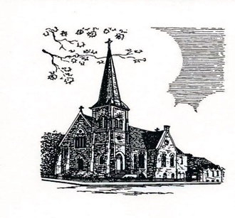

Christ Episcopal Church
409 East High Street
Springfield, Ohio 45505
937-323-8651
www.christspringfield.org

