The Sixth Sunday of Easter
May 5th, 2024 at 10:00 a.m.
The Holy Eucharist: Rite II

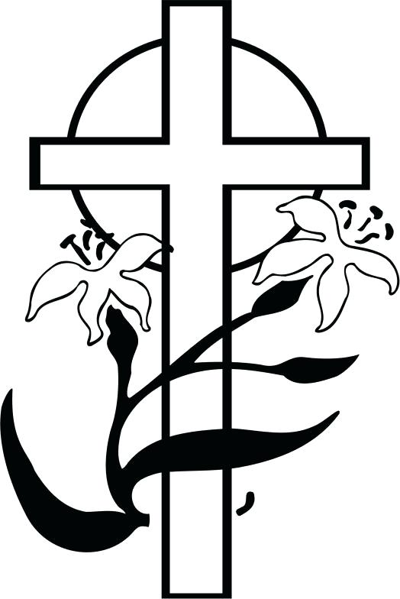

++++++++++++++++++++++++++++++++++++++++++

INFORMATION FOR NEWCOMERS: WELCOME TO CHRIST CHURCH!
Our motto is true whether you're here for the very first time
or you've been a member for decades –
There is a place for you at God's Table!

The worship service has two main parts: the Liturgy of the Word, which includes Scripture readings and a sermon, and the Liturgy of the Table, which is also called Holy Eucharist or Communion. You will notice moments in the service when people stand, kneel, bow, and make the sign of the cross. There is no one “right” way to worship, so do what is comfortable for you at any given time in worship.

All Baptized Christians are welcome at Christ’s Table for Communion. If you do not wish to receive communion, you may come forward and request a blessing. If you wish to receive communion in your pew, please notify the ushers. And if you need a gluten-free wafer, just let Rev. Michelle know.

If you have not been baptized, or if you have questions about Holy Baptism, please talk to The Rev. Dr. Michelle Boomgaard after the service -- the people of Christ Church would love to walk with you to your baptism and beyond!

When you enter a Christ Episcopal Church worship service/event, you will be entering an area where photography, video and audio recording may occur. Finally, if you are a visitor, please fill-out a Welcome Card on the back of the pew, so we can add you to our weekly information email the NewsNote.
The Holy Eucharist Rite II

PRELUDE:

OPENING HYMN: “Now the Green Blade Riseth” Hymnal 204

THE LITURGY OF THE WORD

OPENING ACCLAMATION
Celebrant: Alleluia! Christ has risen!
People: The Lord is risen indeed. Alleluia!

COLLECT FOR PURITY
Almighty God, to you all hearts are open, all desires known, and from you no secrets are hid. Cleanse the
thoughts of our hearts by the inspiration of your Holy Spirit, that we may perfectly love you, and worthily
magnify your holy Name; through Christ our Lord. Amen.

GLORIA Hymnal S278
Glory to God in the highest, and peace to his people on earth.
Lord God, heavenly King, almighty God and Father,
we worship you, we give you thanks, we praise you for your glory.
Lord Jesus Christ, only Son of the Father, Lord God, Lamb of God,
you take away the sin of the world: have mercy on us;
you are seated at the right hand of the Father: receive our prayer.
For you alone are the Holy One, you alone are the Lord,
you alone are the Most High, Jesus Christ, with the Holy Spirit,
in the glory of God the Father. Amen.

COLLECT OF THE DAY
Celebrant: The Lord be with you.
People: And also with you.
Celebrant: Let us pray.
O God, you have prepared for those who love you such good things as surpass our understanding: Pour into our hearts such love towards you, that we, loving you in all things and above all things, may obtain your promises, which exceed all that we can desire; through Jesus Christ our Lord, who lives and reigns with you and the Holy Spirit, one God, for ever and ever. Amen.

Ô Dieu, tu as préparé pour ceux et celles qui t’aiment des biens qui dépassent notre compréhension : répands dans nos cœurs un tel amour pour toi afin que nous, qui t’aimons en toutes choses et par-dessus tout, nous puissions obtenir tes promesses, qui surpassent tout ce que nous pouvons désirer ; par Jésus Christ, notre Seigneur, qui vit et règne avec toi et le Saint-Esprit, un seul Dieu, pour les siècles des siècles. Amen.

THE LESSONS
THE FIRST READING Acts 10:44-48
While Peter was still speaking, the Holy Spirit fell upon all who heard the word. The circumcised believers who had come with Peter were astounded that the gift of the Holy Spirit had been poured out even on the Gentiles, for they heard them speaking in tongues and extolling God. Then Peter said, "Can anyone withhold the water for baptizing these people who have received the Holy Spirit just as we have?" So he ordered them to be baptized in the name of Jesus Christ. Then they invited him to stay for several days.
Lector: The Word of the Lord.
People: Thanks be to God

THE RESPONSE PSALM 98

1 Sing to the Lord a new song, *
for he has done marvelous things.
2 With his right hand and his holy arm *
has he won for himself the victory.
3 The Lord has made known his victory; *
his righteousness has he openly shown in the sight of the nations.
4 He remembers his mercy and faithfulness to the house of Israel, *
and all the ends of the earth have seen the victory of our God.
5 Shout with joy to the Lord, all you lands; *
lift up your voice, rejoice, and sing.
6 Sing to the Lord with the harp, *
with the harp and the voice of song.
7 With trumpets and the sound of the horn *
shout with joy before the King, the Lord.
8 Let the sea make a noise and all that is in it, *
the lands and those who dwell therein.
9 Let the rivers clap their hands, *
and let the hills ring out with joy before the Lord, when he comes to judge the earth.
10 In righteousness shall he judge the world *
and the peoples with equity.

THE SECOND LESSON 1 John 5:1-6
Everyone who believes that Jesus is the Christ has been born of God, and everyone who loves the parent loves the child. By this we know that we love the children of God, when we love God and obey his commandments. For the love of God is this, that we obey his commandments. And his commandments are not burdensome, for whatever is born of God conquers the world. And this is the victory that conquers the world, our faith. Who is it that conquers the world but the one who believes that Jesus is the Son of God?

This is the one who came by water and blood, Jesus Christ, not with the water only but with the water and the blood. And the Spirit is the one that testifies, for the Spirit is the truth.
Lector: The Word of the Lord.
People: Thanks be to God.
GOSPEL ACCLAMATION: “Alleluia, Alleluia” Hymnal 178, v.1
GOSPEL
Celebrant: The Holy Gospel of our Lord Jesus Christ according to John (John 15:9-17).
People: Glory to you, Lord Christ.
Jesus said to his disciples, “As the Father has loved me, so I have loved you; abide in my love. If you keep my commandments, you will abide in my love, just as I have kept my Father’s commandments and abide in his love. I have said these things to you so that my joy may be in you, and that your joy may be complete.

“This is my commandment, that you love one another as I have loved you. No one has greater love than this, to lay down one’s life for one’s friends. You are my friends if you do what I command you. I do not call you servants any longer, because the servant does not know what the master is doing; but I have called you friends, because I have made known to you everything that I have heard from my Father. You did not choose me but I chose you. And I appointed you to go and bear fruit, fruit that will last, so that the Father will give you whatever you ask him in my name. I am giving you these commands so that you may love one another.”
Celebrant: The Gospel of the Lord.
People: Praise to you, Lord Christ.

Sermon The Rev. Dr. Michelle Boomgaard

THE NICENE CREED SYMBOLE DE NICÉE
We believe in one God, the Father, the Almighty, Nous croyons en un seul Dieu, le Père tout-puissant,
maker of heaven and earth, of all that is, Créateur du ciel et de la terre,
seen and unseen. We believe in one Lord, De toutes les choses visibles et invisibles.
Jesus Christ, the only Son of God, Nous croyons en un seul Seigneur, Jésus Christ,
eternally begotten of the Father, God from God, Le Fils unique de Dieu,
Light from Light, true God from true God, Endgendré du Père avant tous les siècles,
begotten, not made, of one Being with the Father. Dieu né de Dieu, Lumière née de la Lumière,
Through him all things were made. Vrai Dieu né du vrai Dieu, Engendré, non pas crée,
For us and for our salvation he came down Un seul être avec le Père, Et par lui tout a été fait.
from heaven, by the power of the Holy Spirit Pour nous et pour notre salut,
he became incarnate from the Virgin Mary, Il est descendu des cieux,
and was made man. For our sake he was Il s’est incarné par le saint-Esprit en la Vierge Marie,
crucified under Pontius Pilate; Et s’est fait homme. Crucifié pour nous sous Ponce Pilate,
he suffered death and was buried. Il a souffert la Passion,
On the third day he rose again in accordance Il a été mis au tombeau,
with the Scriptures; he ascended into heaven Il est ressuscité le troisième jour, selon les Écritures ;
and is seated at the right hand of the Father. Il est monté aux cieux,
He will come again in glory to judge the living Il siège à la droite du Père,
and the dead, and his kingdom will have no end. Il reviendra dans la gloire pour juger
We believe in the Holy Spirit, the Lord, les vivants et les morts,
the giver of life, who proceeds from the Father, Et son règne n’aura pas de fin.
and the Son. With the Father and the Son he Nous croyons en l’Esprit saint,
is worshiped and glorified, He has spoken Qui est Seigneur et qui donne la vie,
through the Prophets. We believe in one holy Que procède du Père et du Fils,
catholic and apostolic Church. Avec le Père et le Fils, il reçoit même
We acknowledge one baptism adoration et même gloire; Il a parlé par les Prophètes.
for the forgiveness of sins. Nous croyons en l’Église une, sainte,
We look for the resurrection of the dead, catholique et apostolique.
and the life of the world to come. Amen. Nous reconnaissons us seul baptême pour
le pardon des péchés. Nous attendons la résurrection des morts
Et la vie du monde à venir. Amen.
THE PRAYERS OF THE PEOPLE

In peace, we pray to you Lord God. Congregational responses are in bold.

Blessed are you eternal God,
to be praised and glorified forever.

Hear us as we pray for the unity of the Church.
May we all be one, that the world may come to know you.

Grant that every member of the Church may truly and humbly serve you,
that the life of Christ may be revealed in us

We remember those who have died.
Into your hands we commend them.
We praise you for all your saints who have entered eternal glory.
May we also come to share your heavenly kingdom.

Have compassion on those who suffer from sickness, grief or trouble, especially Mary Allardyce, Marj Vasileff, Pat, Marilyn Howat, Jeanie Everingham, Bonnie Bingman, Anita Beardsell, Don Rode, Diana DeVoe, Sandi Eyman, Margaret Mattox, Joy Bartenstein, Dodi Holmes, Martha Chaney, Charlene Schreiber, Alice Kelly, Barb Kelly, and Traudie Milleck.
In your presence may they find strength.

Look with kindness on our homes and families, and all who celebrate birthdays especially, Peg Curtin and anniversaries this week.
Grant that your love may grow in our hearts.

Make us alive to the needs of our community, and bless the holy work of for this city, for every city and community, and for those who live in them, especially Springfield Farmer’s Market, Project Woman, Children’s Defense Fund Freedom Schools, The YMCA, and Jefferson St. Oasis Garden. In the Northwest Region cycle of prayer, we pray for St. Marks, Dayton; St. George’s, Washington Township; St. Mary’s Waynesville, and Christ Church, Springfield.
Help us to share one another’s joys and burdens.

Inspire and lead those who hold authority in the nations of the world.
Guide us and all people in the way of justice and peace.

For Justin, Archbishop of Canterbury; Michael, our Presiding Bishop; Kristin, our Bishop, and Michelle, our rector; and all who minister in Christ, that they may be firmly rooted in your truth and love.
Inspire us and give us courage to proclaim your Gospel of Resurrection

The celebrant adds a concluding collect.

THE PEACE

ANNOUNCEMENTS

OFFERTORY:

PRESENTATION OF THE GIFTS Hymnal 380, v. 3
Praise God from whom all blessings flow;
praise him, all creatures here below;
praise him above, ye heavenly host:
praise Father, Son and Holy Ghost

THE HOLY COMMUNION

THE GREAT THANKSGIVING: EUCHARISTIC PRAYER C
Celebrant The Lord be with you.
People And also with you.
Celebrant Lift up your hearts.
People We lift them to the Lord.
Celebrant Let us give thanks to the Lord our God.
People It is right to give God thanks and praise.
God of all power, Ruler of the Universe, you are worthy of glory and praise.
Glory to you for ever and ever.

At your command all things came to be: the vast expanse of interstellar space, galaxies, suns, the planets in their courses, and this fragile earth, our island home.
By your will they were created and have their being.

From the primal elements you brought forth the human race, and blessed us with memory, reason, and skill. You made us the stewards of creation. But we turned against you, and betrayed your trust; and we turned against one another.
Have mercy, Lord, for we are sinners in your sight.

Again and again, you called us to return. Through prophets and sages you revealed your righteous Law. And in the fullness of time you sent your only Son, born of a woman, to fulfill your Law, to open for us the way of freedom and peace.
By his blood, he reconciled us. By his wounds, we are healed.

And therefore we praise you, joining with the heavenly chorus, with prophets, apostles, and martyrs, and with all those in every generation who have looked to you in hope, to proclaim with them your glory, in their unending hymn:

Holy, holy, holy Lord, God of power and might, Hymnal S125
heaven and earth are full of your glory.
Hosanna in the highest. Hosanna in the highest.
Blessed is he who comes in the name of the Lord.
Hosanna in the highest. Hosanna in the highest.

And so, Father, we who have been redeemed by him, and made a new people by water and the Spirit, now bring before you these gifts. Sanctify them by your Holy Spirit to be the Body and Blood of Jesus Christ our Lord.

On the night he was betrayed he took bread, said the blessing, broke the bread, and gave it to his friends, and said, “Take, eat: This is my Body, which is given for you. Do this for the remembrance of me.”

After supper, he took the cup of wine, gave thanks, and said, “Drink this, all of you: This is my Blood of the new Covenant, which is shed for you and for many for the forgiveness of sins. Whenever you drink it, do this for the remembrance of me.”

Remembering now his work of redemption, and offering to you this sacrifice of thanksgiving,
We celebrate his death and resurrection, as we await the day of his coming.

Lord God of our Ancestors; God of Abraham and Sarah, Isaac and Rebecca, Jacob and Rachel and Leah; God and Father of our Lord Jesus Christ: Open our eyes to see your hand at work in the world about us. Deliver us from the presumption of coming to this Table for solace only, and not for strength; for pardon only, and not for renewal. Let the grace of this Holy Communion make us one body, one spirit in Christ, that we may worthily serve the world in his name.
Risen Lord, be known to us in the breaking of the Bread.

Accept these prayers and praises, Father, through Jesus Christ our great High Priest, to whom, with you and the Holy Spirit, your Church gives honor, glory, and worship, from generation to generation. Amen.

And now, as our Savior Christ has taught us, we are bold to say,
Our Father, who art in heaven, Notre Père, qui es aux cieux,
hallowed be thy name, Que ton nom soit sanctifé;
thy kingdom come, thy will be done, Que ton règne vienne ; que ta volonté soit faite
on earth as it is in heaven. Sur la terre comme au ciel.
Give us this day our daily bread. Donne-nous aujourd’hui notre pain de ce jour.
And forgive us our trespasses, Pardonne-nous nos offenses,
as we forgive those who trespass against us. Comme nous pardonnons aussi À ceux qui nous ont offensés.
And lead us not into temptation, Et nous laisse pas entrer en tentation,
but deliver us from evil. Mais délivre-nous du mal.
For thine is the kingdom, Car c’est à toi qu’appartiennent le règne,
and the power, and the glory, La puissance et la gloire,
forever and ever. Amen. Pour les siècles des siècles. Amen.

THE BREAKING OF THE BREAD Hymnal S155
Alleluia, alleluia, alleluia.
Christ our Passover is sacrificed for us;
therefore let us keep the feast.
Alleluia, alleluia, alleluia.

THE INVITATION TO COMMUNION

COMMUNION HYMN: “One bread, one body”
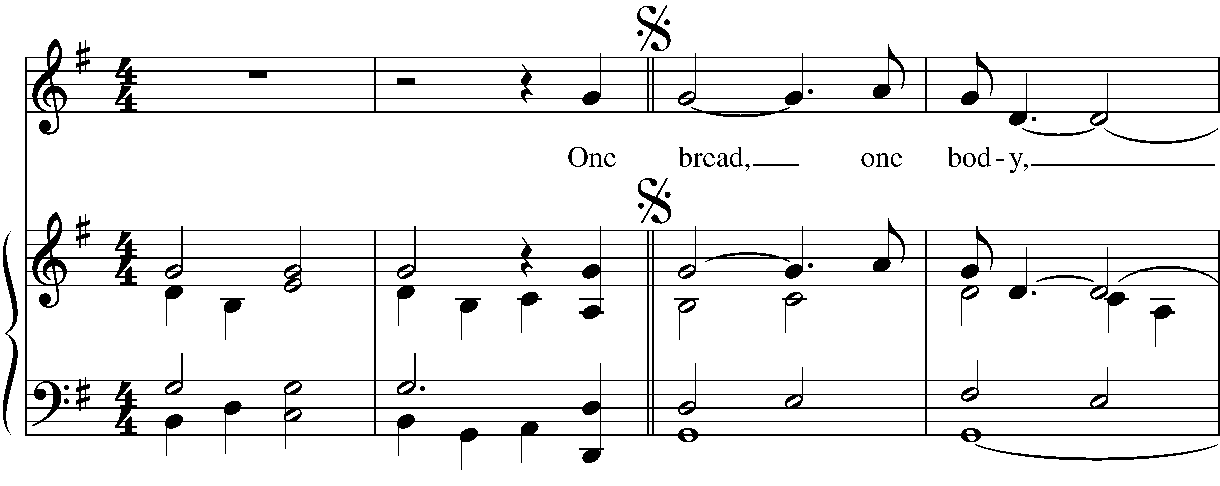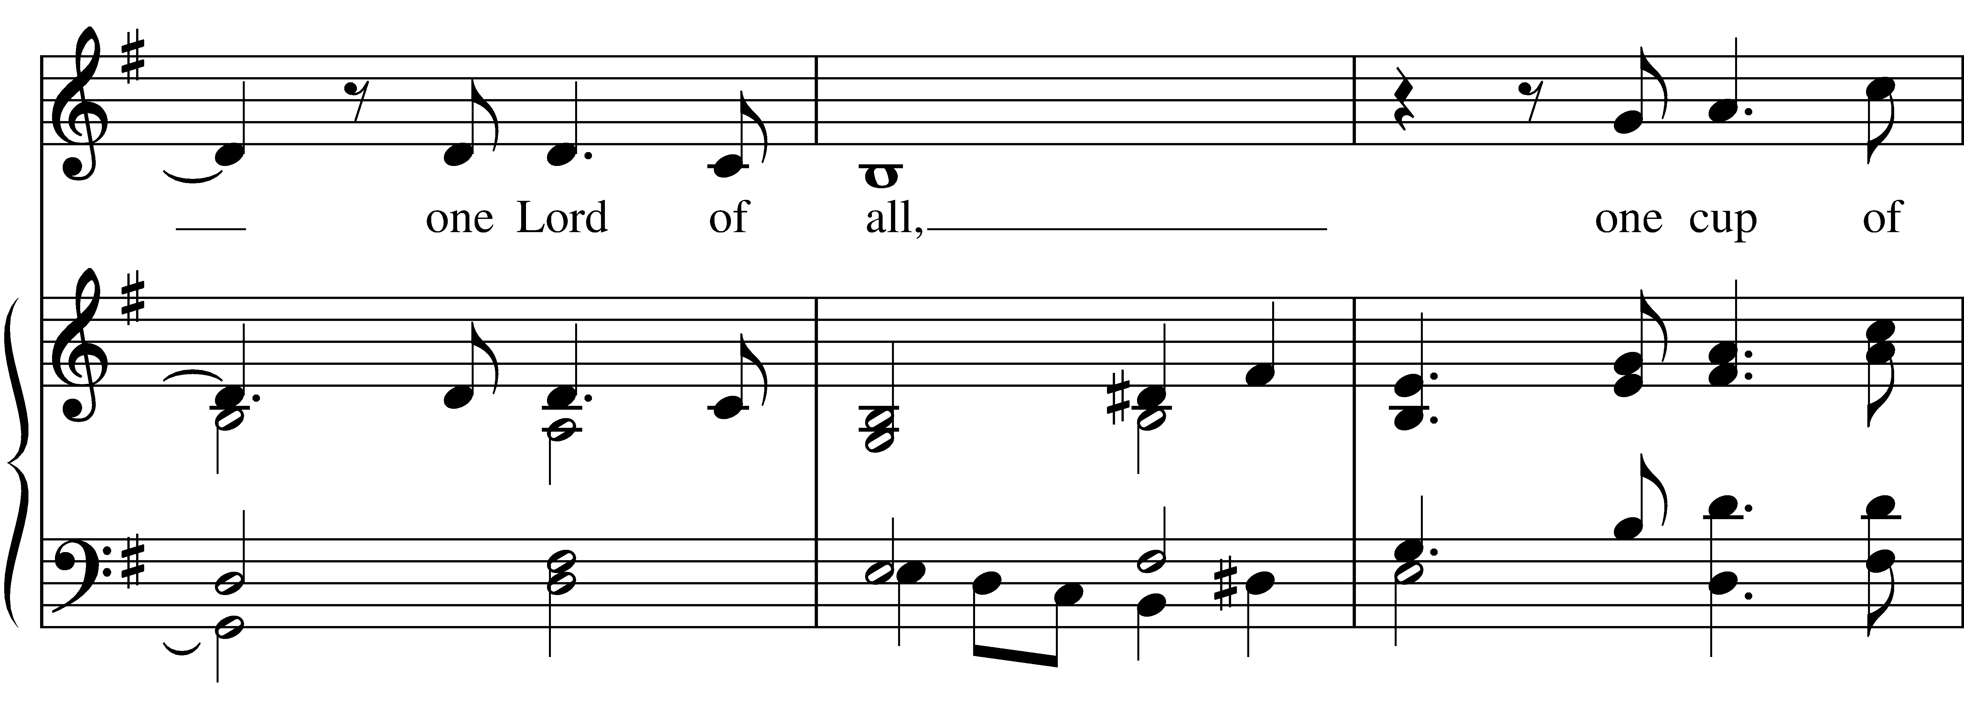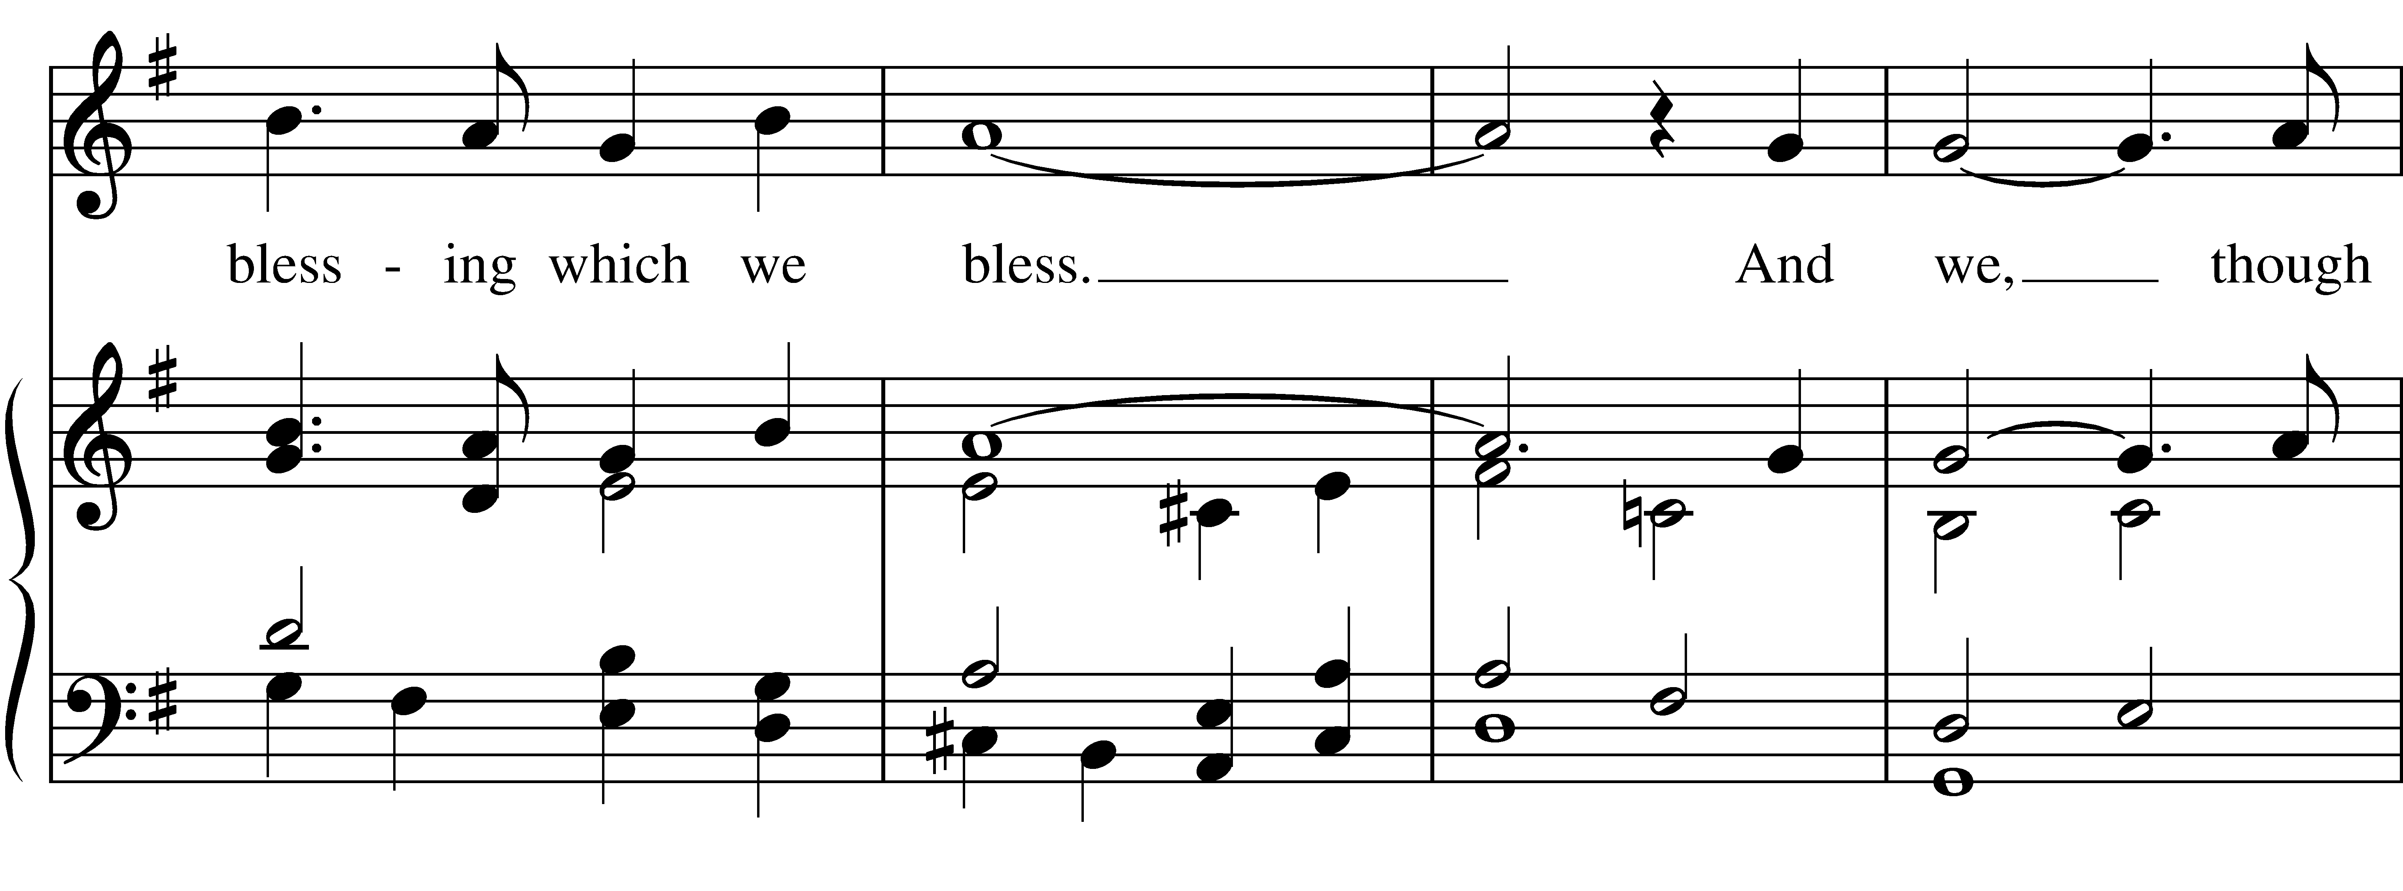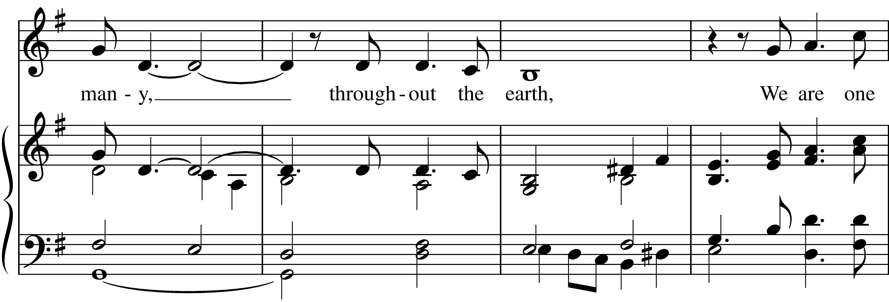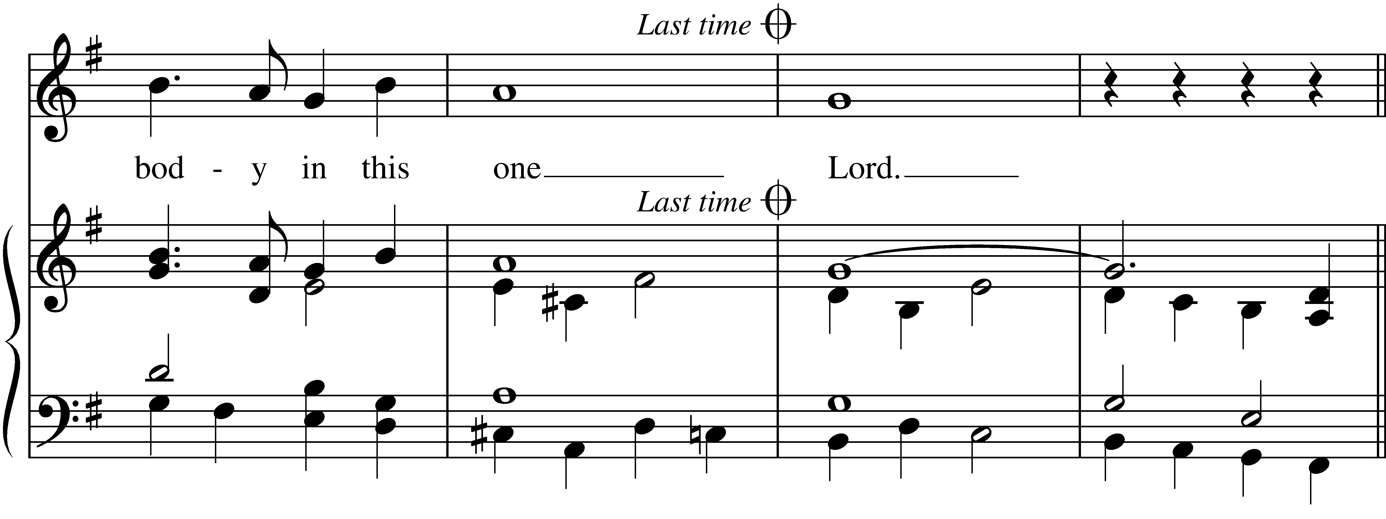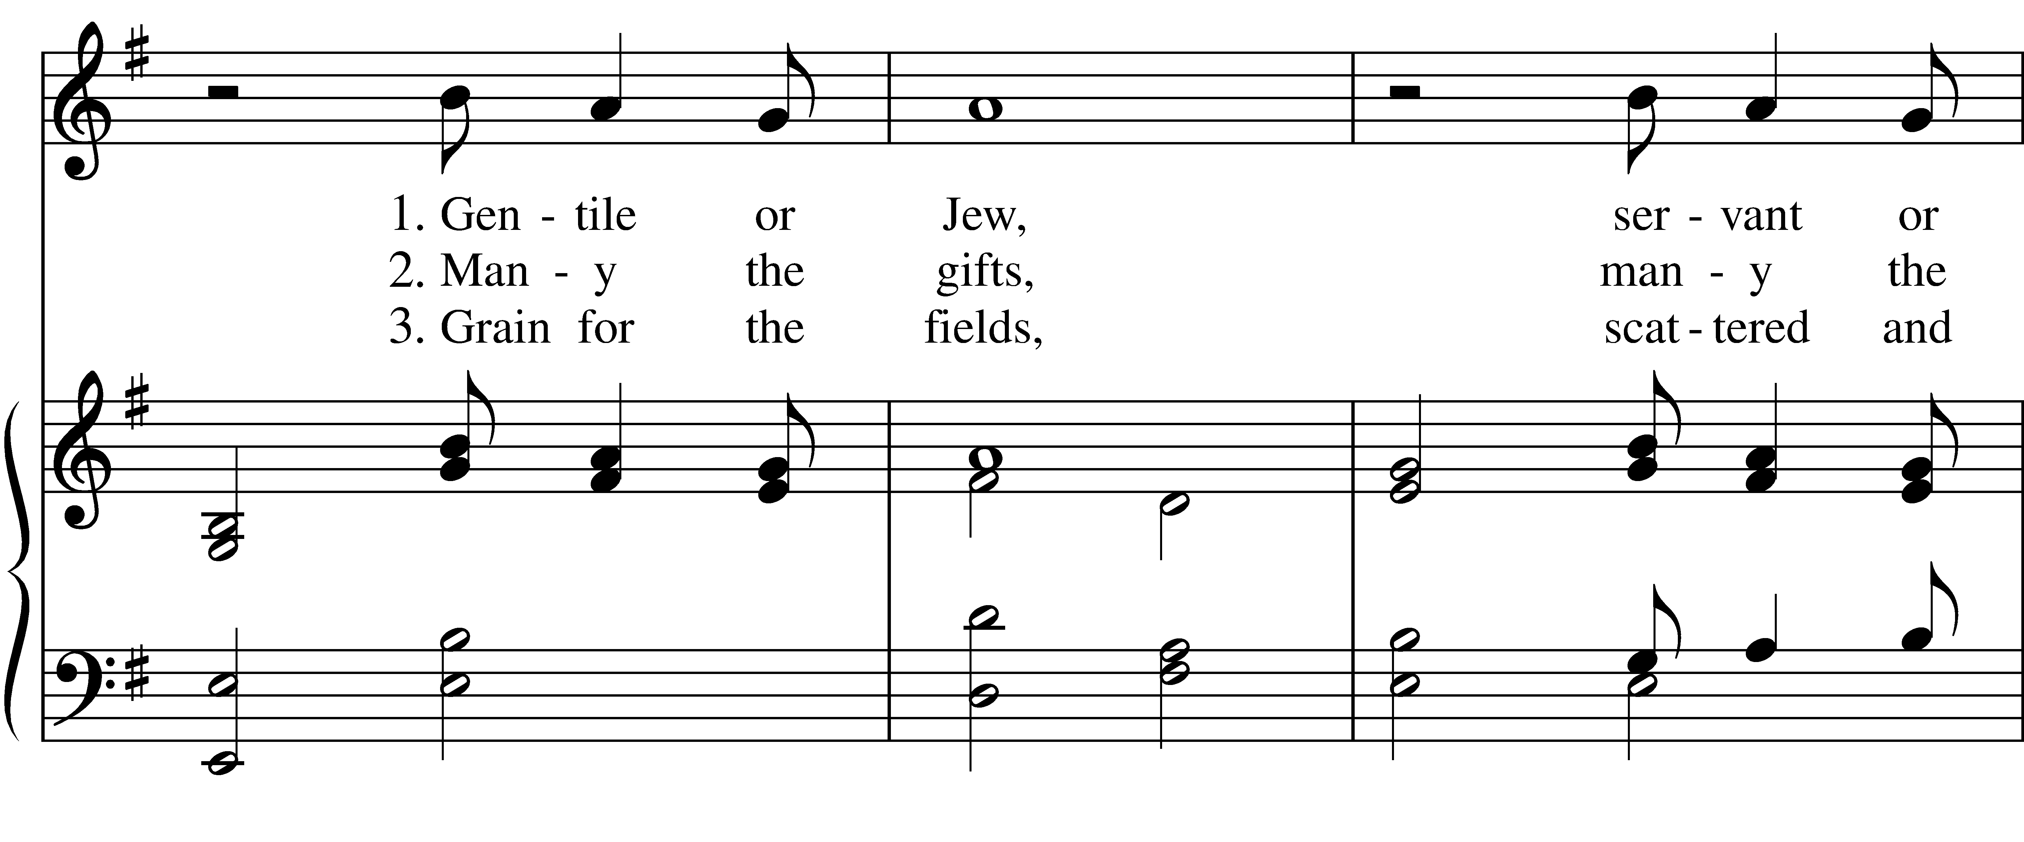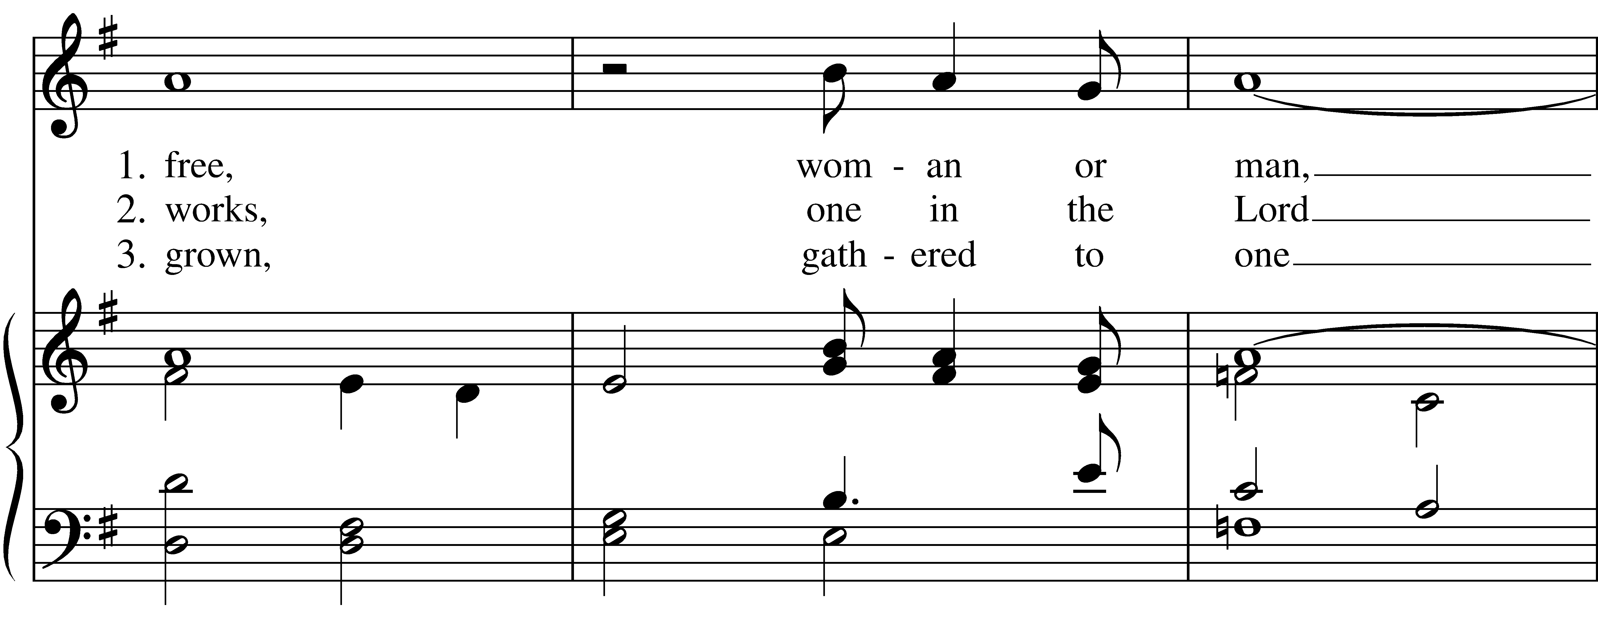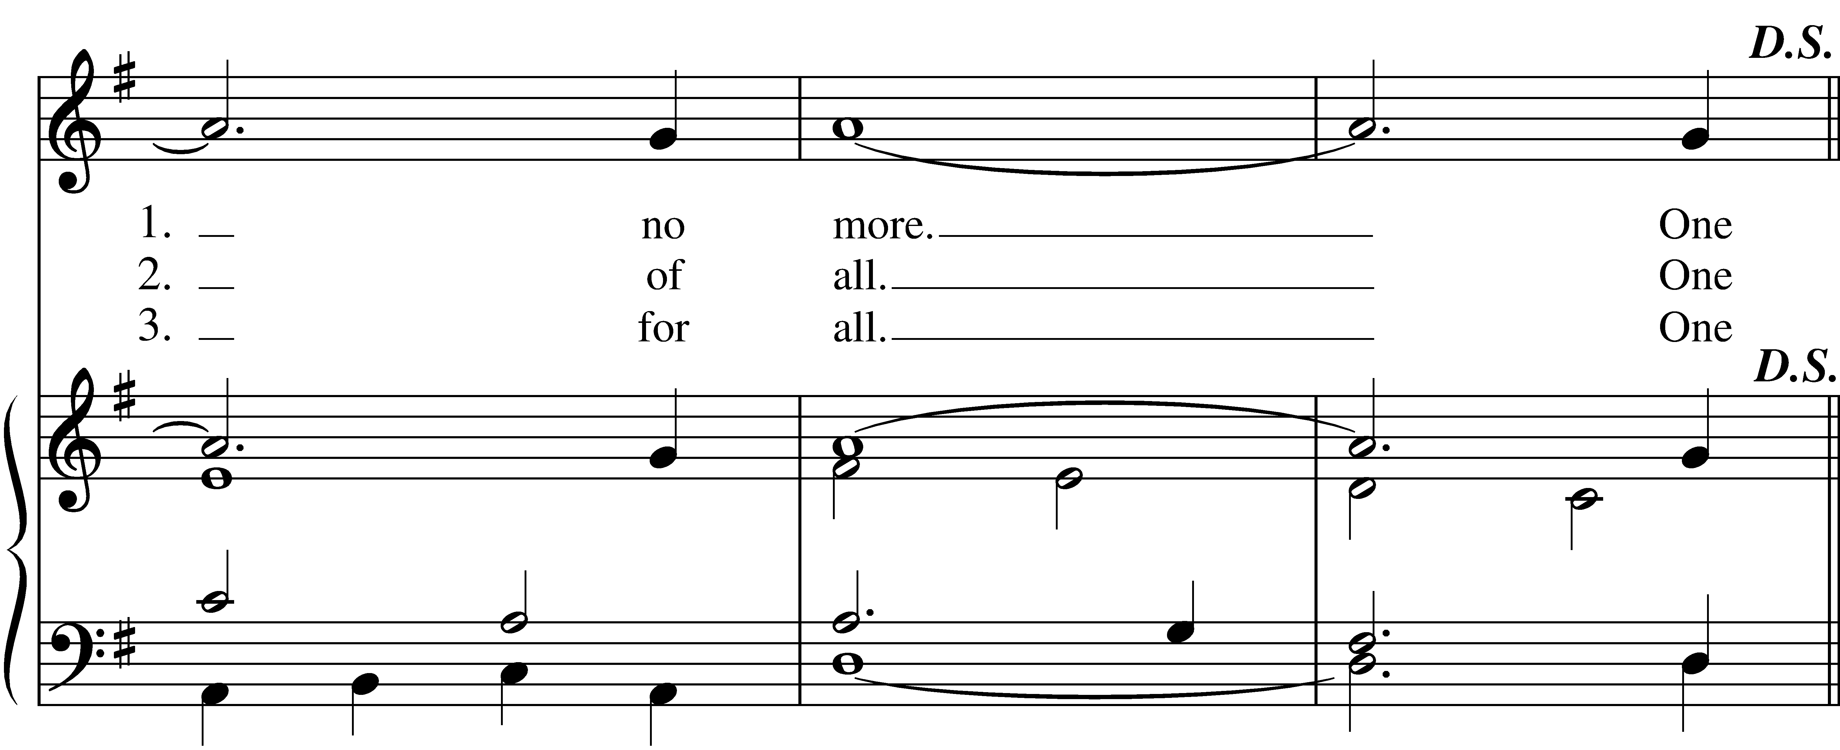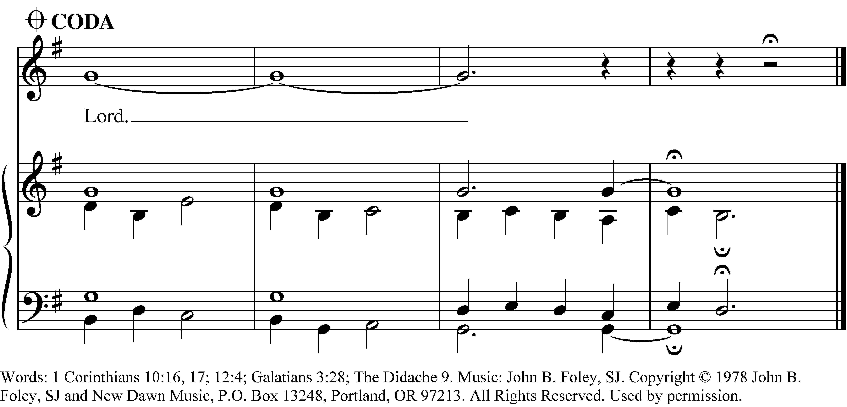
PRAYER AFTER COMMUNION- Celebrant and people together
Eternal God, heavenly Father, you have graciously accepted us as living members of your Son our Savior Jesus Christ, and you have fed us with spiritual food in the Sacrament of his Body and Blood. Send us now into the world in peace, and grant us strength and courage to love and serve you with gladness and singleness of heart; through Christ our Lord. Amen.

THE BLESSING
The God of peace, who brought again from the dead our Lord Jesus Christ, the great Shepherd of the sheep, through the blood of the everlasting covenant, make you perfect in every good work to do his will, working in you that which is well-pleasing in his sight; and the blessing of God Almighty, the Father, the Son, and the Holy Spirit, be among you, and remain with you always. Amen.

CLOSING HYMN: “O Jesus, crowned with all renown” Hymnal 292

THE DISMISSAL Celebrant: Go in peace to love and serve the Lord. Alleluia, alleluia!
People: Thanks be to God. Alleluia, alleluia!

POSTLUDE:

Altar Flowers
In thanksgiving of friends and family by Dan and Judy McGregor.

Announcements from Christ Church

Pastoral emergencies

If you need to reach Rev. Michelle for a pastoral emergency, the number is (937) 505-0141. For

non-emergencies, you can call the office at (937) 323-8651 or email Rev. Michelle at mboomgaard@christspringfield.org.

May’s Adult Forum
All Things New after the 10 am service in the Parish Hall!

May 5: Care Portal Next Steps
Come hear more about how Care Portal works, including what some of our parishioners learned during
CarePortal training, as we discuss how Christ Church will more fully use this tool to support local families
in need.

May 12: Women and the Lectionary?
In honor of Mother’s Day, Rev. Michelle will lead a discussion on the Women’s Lectionary for the Whole Church, a new resource developed by the Rev. Dr. Wil Gafney, and currently in use at a number of Episcopal parishes across the country.

May 19: Nurturing our youngest members
A special conversation with parents and grandparents of children at Christ Church. Childcare will be provided.

Bible Study
Bring Your Own Bible Study will be held on Wednesdays from 4 to 5 pm in Hollenbeck House. Join us for fellowship, insight, and maybe a little inspiration as we study the book of Genesis together. Feel free to bring your favorite Bible translation to read and discuss.

Christ Church Food Pantry
The May Drive-thru Food Pantry will be on May 15th, 2024. Volunteers are needed to help unload food, pack food, and help with customer service at approximately 8:15 am. Please contact either Brian Shelburne at bshelburne@wittenberg.edu, Kelly Zeller at zellerk0611@gmail.com, or Anne Randolph at annejrand@aol.com to volunteer.

Upcoming Food Pantry opportunities:
May 8th, 2024 - the second food pick-up at approximately 8:00 am
May 9th, 2024 - grocery bagging day - start time at 9:00 am
May 15th, 2024 – Food Pantry Day! start time at 8:15 am

Baptism
The next opportunity for Holy Baptism at Christ Church will be the Feast of Pentecost on Sunday, May 19th. Baptism is available during the 10 am service. If you or someone in your family is considering baptism (or if you want to know more), please contact Rev. Michelle for pre-baptismal counseling and planning at mboomgaard@christspringfield.org or call the Church Office (937-323-8651).

Christ Church has an option for online giving through the church’s website.
- Go to christspringfield.org or use the QR code
- Go to the tab in the upper right-hand corner marked “Online Giving”
- Click on the online giving link in blue
- Fill in the amount you would like to give
- Next, use the drop box Pledged Giving for a Pledge or Miscellaneous Giving for other giving
- If you choose Miscellaneous Giving, there is another memo drop box for the type of giving-choose one
- Fill out the rest of the form
- Press Continue
- On the next page, press continue
- Then enter your billing information
- Thank you!- If you have questions or concerns, please contact Kelly Zeller at zellerk0611@gmail.com.

Ministers for May 5th, 2024
Altar Guild: Joan Hurley
Chalice: Linda Mortensen
Lector: Marjory Wentworth
Ushers: Dan McGregor, Angus Randolph, and Brian Drew
Videographer: Kelly Zeller
Coffee Hour Host: Alex and Chris Bickel

General Information
Rector: The Rev. Dr. Michelle Boomgaard
Senior Warden: Scott Yeazell
Junior Warden: Steve Sharp
Treasurer: Ken Bladh
Clerk of Vestry: Kelly Zeller
Vestry at Large: Joy Meyers, Marjory Wentworth, Anne Strothman,
Bill Hicks, Lori Swafford, and Rick Everingham
Parish Administrator & Program Coordinator: Kelly Zeller
Director of Music: Dr. Christopher Durrenberger
Facility Manager: Paul McAfee
Bookkeeper: Tina Knox

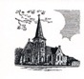

Christ Episcopal Church
409 East High Street
Springfield, Ohio 45505
937-323-8651
www.christspringfield.org

