**Fourteenth Sunday after Pentecost**

**September 3rd, 2023 at 10:00 a.m.**

**The Holy Eucharist: Rite II**

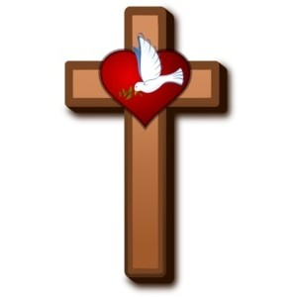

**++++++++++++++++++++++++++++++++++++++++++**

**INFORMATION FOR NEWCOMERS: WELCOME TO CHRIST CHURCH!**



Our motto is true whether you're here for the very first time

or you've been a member for decades –

**There is a place for you at God's Table!**

The worship service has two main parts: the Liturgy of the Word, which includes Scripture readings and a sermon, and the Liturgy of the Table, which is also called Holy Eucharist or Communion. You will notice moments in the service when people stand, kneel, bow, and make the sign of the cross. There is no one “right” way to worship, so do what is comfortable for you at any given time in worship.

All Baptized Christians are welcome at Christ’s Table for Communion. If you do not wish to receive communion, you may come forward and request a blessing. If you wish to receive communion in your pew, please notify the ushers. And if you need a gluten-free wafer, just let Rev. Melody know.

If you have not been baptized, or if you have questions about Holy Baptism, please talk to The Rev. Melody Williams after the service -- the people of Christ Church would love to walk with you to your baptism and beyond!

When you enter a Christ Episcopal Church worship service/event, you will be entering an area where photography, video and audio recording may occur. Finally, if you are a visitor, please fill-out a *Welcome Card* on the back of the pew, so we can add you to our weekly information email the NewsNote.

**The Holy Eucharist Rite II**

**PRELUDE:** "What Wondrous Love Is This" - arr. Callahan

**OPENING HYMN**: “New Every Morning is the Love” Hymnal 10 vs. 1, 2, &6

**THE LITURGY OF THE WORD**

OPENING ACCLAMATION

Celebrant: Blessed be God: Father, Son, and Holy Spirit.

People: **And blessed be his kingdom, now and forever. Amen.**

COLLECT OF PURITY

Almighty God, to you all hearts are open, all desires known, and from you no secrets are hid cleanse the

thoughts of our hearts by the inspiration of your Holy Spirit, that we may perfectly love you, and worthily

magnify your holy Name; through Christ our Lord. **Amen.**

GLORIA HYMNAL S280

**Glory to God in the highest, and peace to his people on earth.**

**Lord God, heavenly King, almighty God and Father,**

**we worship you, we give you thanks, we praise you for your glory.**

**Lord Jesus Christ, only Son of the Father, Lord God, Lamb of God,**

**you take away the sin of the world: have mercy on us;**

**you are seated at the right hand of the Father: receive our prayer.**

**For you alone are the Holy One, you alone are the Lord,**

**you alone are the Most High, Jesus Christ, with the Holy**

**Spirit, in the glory of God the Father. Amen.**

COLLECT OF THE DAY

Celebrant:The Lord be with you.

People: **And also with you.**

Celebrant: Let us pray.

Lord of all power and might, the author and giver of all good things: Graft in our hearts the love of your Name; increase in us true religion; nourish us with all goodness; and bring forth in us the fruit of good works; through Jesus Christ our Lord, who lives and reigns with you and the Holy Spirit, one God forever and ever. ***Amen.***

Seigneur de puissance et de gloire, toi qui crées et prodigues tout bien : greffe dans nos cœurs l’amour de ton Nom ; fais grandir en nous la vraie religion ; nourris-nous de toute bonté ; et manifeste en nous le fruit des œuvres bonnes ; par Jésus Christ, notre Seigneur, qui vit et règne avec toi et le Saint-Esprit, un seul Dieu, pour les siècles des siècles. ***Amen.***

**THE LESSONS**

**THE FIRST READING Exodus 3:1-15**

Moses was keeping the flock of his father-in-law Jethro, the priest of Midian; he led his flock beyond the wilderness, and came to Horeb, the mountain of God. There the angel of the Lord appeared to him in a flame of fire out of a bush; he looked, and the bush was blazing, yet it was not consumed. Then Moses said, “I must turn aside and look at this great sight, and see why the bush is not burned up.” When the Lord saw that he had turned aside to see, God called to him out of the bush, “Moses, Moses!” And he said, “Here I am.” Then he said, “Come no closer! Remove the sandals from your feet, for the place on which you are standing is holy ground.” He said further, “I am the God of your father, the God of Abraham, the God of Isaac, and the God of Jacob.” And Moses hid his face, for he was afraid to look at God.

Then the Lord said, “I have observed the misery of my people who are in Egypt; I have heard their cry on account of their taskmasters. Indeed, I know their sufferings, and I have come down to deliver them from the Egyptians, and to bring them up out of that land to a good and broad land, a land flowing with milk and honey, to the country of the Canaanites, the Hittites, the Amorites, the Perizzites, the Hivites, and the Jebusites. The cry of the Israelites has now come to me; I have also seen how the Egyptians oppress them. So come, I will send you to Pharaoh to bring my people, the Israelites, out of Egypt.”

But Moses said to God, “Who am I that I should go to Pharaoh, and bring the Israelites out of Egypt?” He said, “I will be with you; and this shall be the sign for you that it is I who sent you: when you have brought the people out of Egypt, you shall worship God on this mountain.” But Moses said to God, “If I come to the Israelites and say to them, ‘The God of your ancestors has sent me to you,’ and they ask me, ‘What is his name?’ what shall I say to them?” God said to Moses, “I am who I am.” He said further, “Thus you shall say to the Israelites, ‘I am has sent me to you.’“ God also said to Moses, “Thus you shall say to the Israelites, ‘The Lord, the God of your ancestors, the God of Abraham, the God of Isaac, and the God of Jacob, has sent me to you’:

This is my name forever,   
and this my title for all generations.

Lector: The Word of the Lord.

***People:* Thanks be to God.**

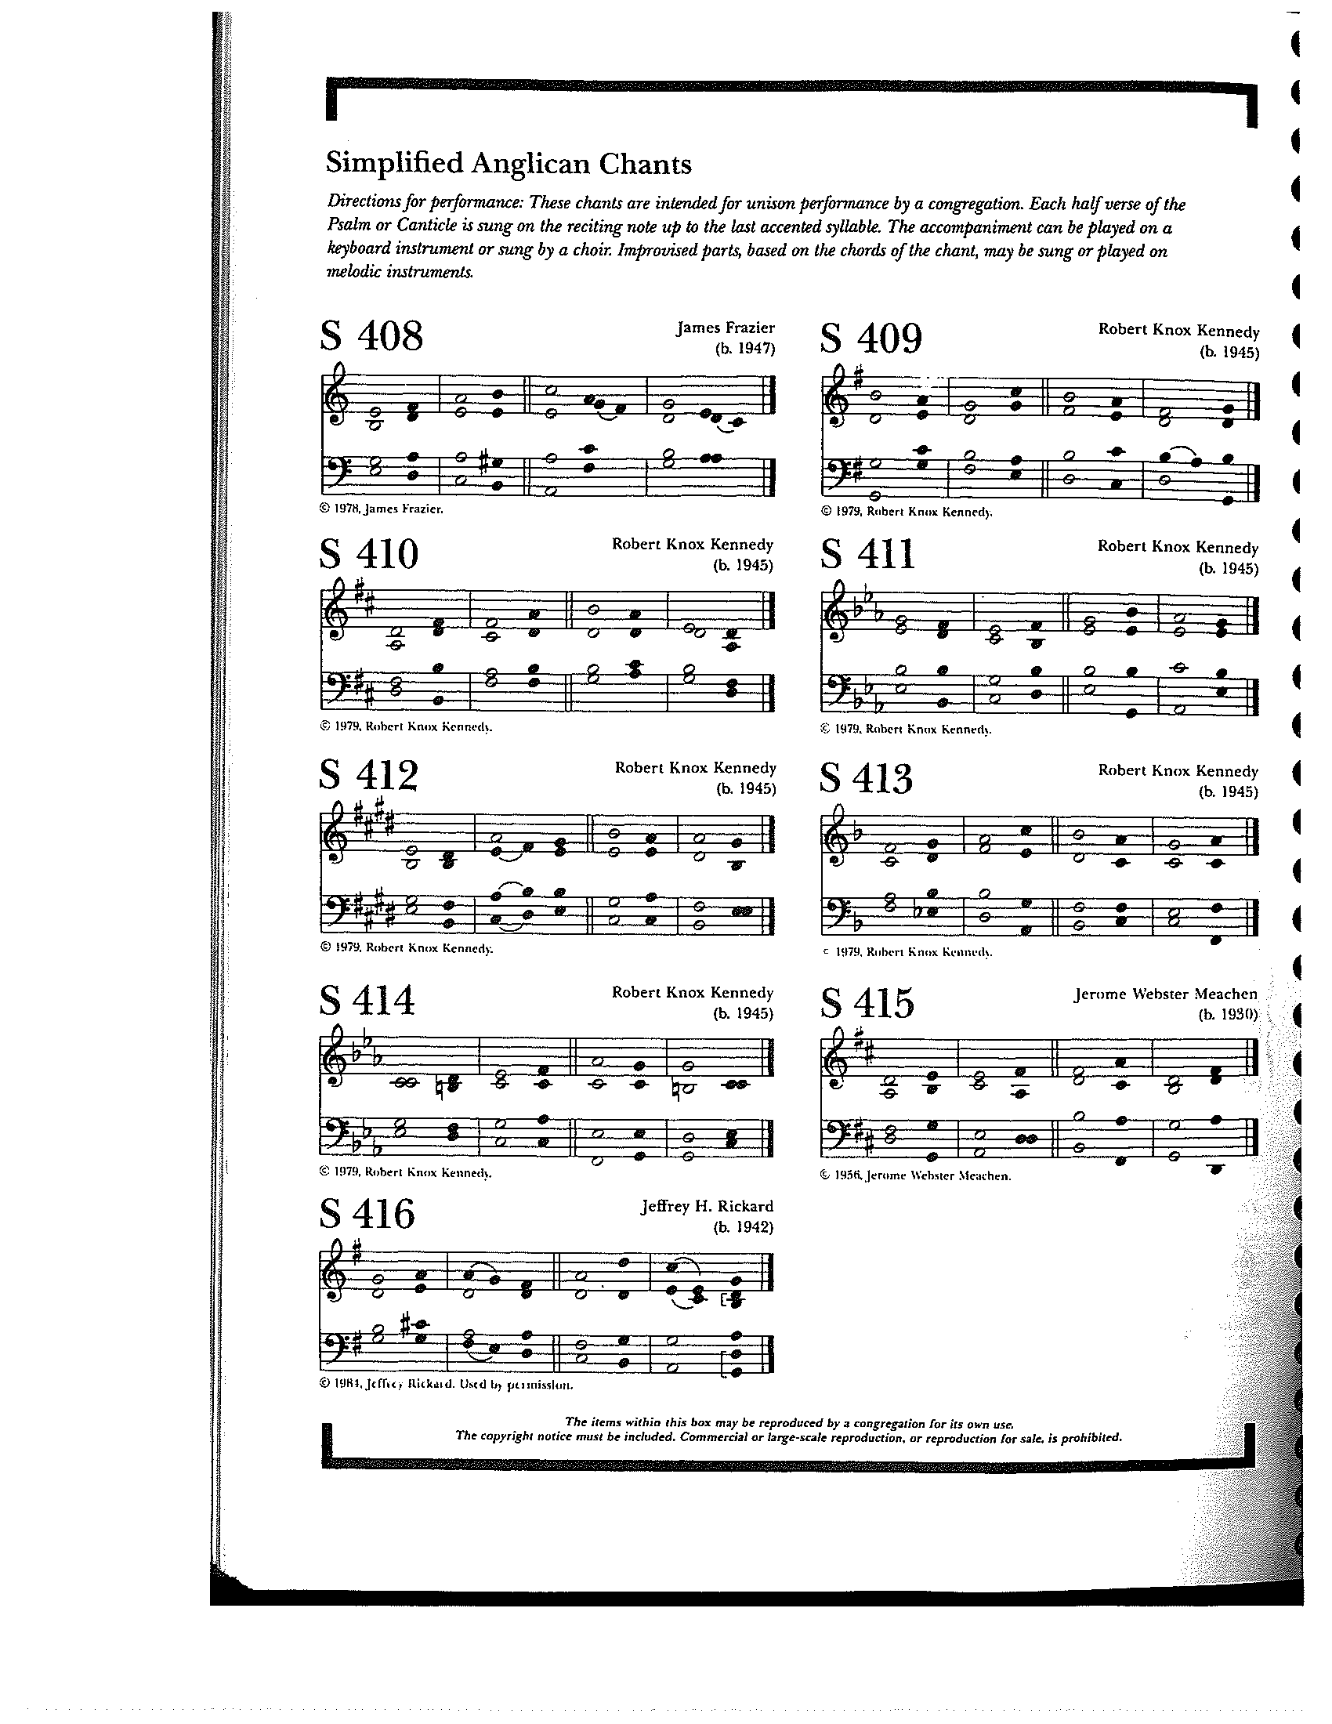

**THE RESPONSE PSALM 105:1-6,23-26, 45c**

1 Give thanks to the Lord and call upon his **Name; \***  
make known his deeds among the **peoples.**

2 Sing to him, sing praises to **him, \***and speak of all his marvelous **works.**

3 Glory in his holy **Name; \***  
let the hearts of those who seek the Lord re**joice.**

4 Search for the Lord and his **strength; \***  
continually seek his **face.**

5 Remember the marvels he has **done, \***his wonders and the judgments of his **mouth,**

6 Offspring of Abraham his **servant, \***O children of Jacob his **chosen.**

23 Israel came into **Egypt, \***  
and Jacob became a sojourner in the land of **Ham.**

24 The Lord made his people exceedingly **fruitful; \***he made them stronger than their **enemies;**

25 Whose heart he turned, so that they hated his **people, \***and dealt unjustly with his **servants.**

26 He sent Moses his **servant, \***and Aaron whom he had **chosen.**

45 Halle**lujah!**

**THE SECOND LESSON Romans 12:9-21**

Let love be genuine; hate what is evil, hold fast to what is good; love one another with mutual affection; outdo one another in showing honor. Do not lag in zeal, be ardent in spirit, serve the Lord. Rejoice in hope, be patient in suffering, persevere in prayer. Contribute to the needs of the saints; extend hospitality to strangers.

Bless those who persecute you; bless and do not curse them. Rejoice with those who rejoice, weep with those who weep. Live in harmony with one another; do not be haughty, but associate with the lowly; do not claim to be wiser than you are. Do not repay anyone evil for evil, but take thought for what is noble in the sight of all. If it is possible, so far as it depends on you, live peaceably with all. Beloved, never avenge yourselves, but leave room for the wrath of God; for it is written, “Vengeance is mine, I will repay, says the Lord.” No, “if your enemies are hungry, feed them; if they are thirsty, give them something to drink; for by doing this you will heap burning coals on their heads.” Do not be overcome by evil, but overcome evil with good.

Lector: The Word of the Lord.

People: **Thanks be to God.**

**SEQUENCE HYMN:** “When Israel was in Egypt’s Land” Hymnal 648

**GOSPEL**

Celebrant: The Holy Gospel of our Lord Jesus Christ according to Matthew (**Matthew 16:21-28**).

People: **Glory to you, Lord Christ.**

Jesus began to show his disciples that he must go to Jerusalem and undergo great suffering at the hands of the elders and chief priests and scribes, and be killed, and on the third day be raised. And Peter took him aside and began to rebuke him, saying, “God forbid it, Lord! This must never happen to you.” But he turned and said to Peter, “Get behind me, Satan! You are a stumbling block to me; for you are setting your mind not on divine things but on human things.”

Then Jesus told his disciples, “If any want to become my followers, let them deny themselves and take up their cross and follow me. For those who want to save their life will lose it, and those who lose their life for my sake will find it. For what will it profit them if they gain the whole world but forfeit their life? Or what will they give in return for their life?

“For the Son of Man is to come with his angels in the glory of his Father, and then he will repay everyone for what has been done. Truly I tell you, there are some standing here who will not taste death before they see the Son of Man coming in his kingdom.”

Celebrant: The Gospel of the Lord.

People: **Praise to you, Lord Christ.**

*Sermon The Rev. Melody Williams*

**THE NICENE CREED SYMBOLE DE NICÉE**

**We believe in one God, the Father, the Almighty,** Nous croyons en un seul Dieu, le Père tout-puissant,

**maker of heaven and earth, of all that is,** Créateur du ciel et de la terre,

**seen and unseen. We believe in one Lord,** De toutes les choses visibles et invisibles.

**Jesus Christ, the only Son of God,** Nous croyons en un seul Seigneur, Jésus Christ,

**eternally begotten of the Father, God from God,** Le Fils unique de Dieu,

**Light from Light, true God from true God,** Endgendré du Père avant tous les siècles,

**begotten, not made, of one Being with the Father.** Dieu né de Dieu, Lumière née de la Lumière,

**Through him all things were made.** Vrai Dieu né du vrai Dieu, Engendré, non pas crée,

**For us and for our salvation he came down** Un seul être avec le Père, Et par lui tout a été fait.

**from heaven, by the power of the Holy Spirit** Pour nous et pour notre salut,

**he became incarnate from the Virgin Mary,** Il est descendu des cieux,

**and was made man. For our sake he was** Il s’est incarné par le saint-Esprit en la Vierge Marie,

**crucified under Pontius Pilate;** Et s’est fait homme. Crucifié pour nous sous Ponce Pilate,

**he suffered death and was buried.** Il a souffert la Passion,

**On the third day he rose again in accordance** Il a été mis au tombeau,

**with the Scriptures; he ascended into heaven** Il est ressuscité le troisième jour, selon les Écritures ;

**and is seated at the right hand of the Father.** Il est monté aux cieux,

**He will come again in glory to judge the living** Il siège à la droite du Père,

**and the dead, and his kingdom will have no end.** Il reviendra dans la gloire pour juger

**We believe in the Holy Spirit, the Lord,** les vivants et les morts,

**the giver of life, who proceeds from the Father,** Et son règne n’aura pas de fin.

**and the Son. With the Father and the Son he** Nous croyons en l’Esprit saint,

**is worshiped and glorified, He has spoken** Qui est Seigneur et qui donne la vie,

**through the Prophets. We believe in one holy** Que procède du Père et du Fils,

**catholic and apostolic Church.** Avec le Père et le Fils, il reçoit même

**We acknowledge one baptism** adoration et même gloire; Il a parlé par les Prophètes.

**for the forgiveness of sins.** Nous croyons en l’Église une, sainte,

**We look for the resurrection of the dead,** catholique et apostolique.

**and the life of the world to come. Amen.** Nous reconnaissons us seul baptême pour

le pardon des péchés.

Nous attendons la résurrection des morts

Et la vie du monde à venir. Amen.

**THE PRAYERS OF THE PEOPLE**

In peace, we pray to you Lord God. (*Congregational responses are in* ***bold****)*

*Silence*

Grant, Almighty God, that all who confess your Name may be united in your truth, live together in your love, and reveal your glory in the world.

Lord, in your mercy  
**Hear our prayer.**

Give grace to church leaders, especially Justin, Archbishop of Canterbury; Michael, our presiding bishop; Wayne, our provisional diocesan bishop; Melody, our supply priest; and all who minister in Christ, that they may be firmly rooted in your truth and love.

Lord, in your mercy  
**Hear our prayer.**

Guide the people of this land, and of all the nations, in the ways of justice and peace; that we may honor one another and serve the common good. In the Ministry Cycle of Prayer, we pray for Clark County Literacy Coalition, Episcopal Community Ministries, Second Harvest Food Bank, Sheltered, Inc., and Springfield Soup Kitchen.

Lord, in your mercy  
**Hear our prayer.**

Give us all a reverence for the earth as your own creation, that we may use its resources rightly in the service of others and to your honor and glory.

Lord, in your mercy  
**Hear our prayer.**

Bless all whose lives are closely linked with ours, and grant that we may serve Christ in them, and love one another as he loves us. We pray for those celebrating their birthdays this week, especially Bonnie Bingman, Angus Randolph, Brian Shelburne, and Joy Bartenstein, and anniversaries this week, especially David and Rose Farrar.

Lord, in your mercy  
**Hear our prayer.**

Comfort and heal all those who suffer in body, mind, or spirit; especially Bill Everingham, Bill Yeazell, Don Rode, Diana DeVoe, Sandi Eyman, Margaret Mattox, Joy Bartenstein, Dodi Holmes, Martha Chaney, Charlene Schreiber, Alice Kelly, Barb Kelly, Traudie Milleck, and any others we may now name, silently or aloud, and

give them courage and hope in their troubles, and bring them the joy of your salvation.

Lord, in your mercy  
**Hear our prayer.**

We commend to your mercy all who have died, that your will for them may be fulfilled; and we pray that we may share with all your saints in your eternal kingdom.

Lord, in your mercy  
**Hear our prayer.**

THE COLLECT FOR THE ELECTION OF A BISHOP  
**Almighty God, giver of every good gift: Look graciously on your Church, and so guide the minds of those who shall choose a bishop for this Diocese, that we may receive a faithful pastor, who will care for your people and equip us for our ministries; through Jesus Christ our Lord. *Amen.***

THE CONFESSION AND ABSOLUTION

Celebrant: Let us confess our sins against God and our neighbor.

**All: God of all mercy, we confess that we have sinned against you, opposing your will in our lives. We have denied your goodness in each other, in ourselves, and in the world you have created. We repent of the evil that enslaves us, the evil we have done, and the evil done on our behalf. Forgive, restore, and strengthen us through our Savior Jesus Christ, that we may abide in your love and serve only your will. *Amen.***

Celebrant: Almighty God have mercy on you, forgive you all your sins through the grace of Jesus Christ, strengthen you in all goodness, and by the power of the Holy Spirit keep you in eternal life. ***Amen.***

THE PEACE

ANNOUNCEMENTS

**OFFERTORY HYMN:** “What Wondrous Love is this” Hymnal 439

PRESENTATION OF THE GIFTSHymnal 380, v. 3

**Praise God from whom all blessings flow;**

**praise him, all creatures here below;**

**praise him above, ye heavenly host:**

**praise Father, Son and Holy Ghost**

**THE HOLY COMMUNION**

THE GREAT THANKSGIVING: EUCHARISTIC PRAYER 1 (from Enriching Our Worship)

Celebrant The Lord be with you.

People **And also with you.**

Celebrant Lift up your hearts.

People **We lift them to the Lord.**

Celebrant Let us give thanks to the Lord our God.

People **It is right to give our thanks and praise**.

It is truly right, and good and joyful, to give you thanks, all-holy God, source of life and fountain of mercy. You have filled us and all creation with your blessing and fed us with your constant love; you have redeemed us in Jesus Christ and knit us into one body. Through your Spirit you replenish us and call us to fullness of life.

Therefore, joining with Angels and Archangels and with the faithful of every generation, we lift our voices with all creation as we sing:

**Holy, holy, holy Lord, God of power and might, Hymnal S129**

**heaven and earth are full of your glory. Hosanna in the highest.**

**Blessed is he who comes in the name of the Lord.**

**Hosanna in the highest.**

Blessed are you, gracious God, Creator of the universe and giver of life. You formed us in your own image and called us to dwell in your infinite love. You gave the world into our care, that we might be your faithful stewards and show forth your bountiful grace. But we failed to honor your image in one another and in ourselves; we would not see your goodness in the world around us; and so we violated your creation, abused one another, and rejected your love. Yet you never ceased to care for us, and prepared the way of salvation for all people.

Through Abraham and Sarah you called us into covenant with you. You delivered us from slavery, sustained us in the wilderness, and raised up prophets to renew your promise of salvation. Then, in the fullness of time, you sent your eternal Word, made mortal flesh in Jesus. Born into the human family, and dwelling among us, he revealed your glory. Giving himself freely to death on the cross, he triumphed over evil, opening the way of freedom and life.

On the night before he died for us, Our Savior Jesus Christ took bread, and when he had given thanks to you, he broke it, and gave it to his friends, and said: “Take, eat: This is my Body which is given for you. Do this for the remembrance of me.”

As supper was ending, Jesus took the cup of wine, and when he had given thanks, he gave it to them, and said: “Drink this, all of you: This is my Blood of the new Covenant, which is poured out for you and for all for the forgiveness of sins. Whenever you drink it, do this for the remembrance of me.”

Therefore we proclaim the mystery of faith:

**Christ has died.**

**Christ is risen.**

**Christ will come again.**

Remembering his death and resurrection, we now present to you from your creation this bread and this wine. By your Holy Spirit may they be for us the Body and Blood of our Savior Jesus Christ. Grant that we who share these gifts may be filled with the Holy Spirit and live as Christ’s Body in the world. Bring us into the everlasting heritage of your daughters and sons, that with Blessed Mother Mary and all your saints, past, present, and yet to come, we may praise your Name for ever.

Through Christ and with Christ and in Christ, in the unity of the Holy Spirit, to you be honor, glory, and praise, forever and ever. Amen.

And now, as our Savior Christ has taught us, we are bold to say,

**Our Father, who art in heaven, Notre Père, qui es aux cieux,**

**hallowed be thy name, Que ton nom soit sanctifé;**

**thy kingdom come, thy will be done, Que ton règne vienne ; que ta volonté soit faite**

**on earth as it is in heaven. Sur la terre comme au ciel.**

**Give us this day our daily bread. Donne-nous aujourd’hui notre pain de ce jour.**

**And forgive us our trespasses, Pardonne-nous nos offenses,**

**as we forgive those who trespass against us. Comme nous pardonnons aussi À ceux qui nous ont offensés.**

**And lead us not into temptation, Et nous laisse pas entrer en tentation,**

**but deliver us from evil. Mais délivre-nous du mal.**

**For thine is the kingdom, Car c’est à toi qu’appartiennent le règne,**

**and the power, and the glory, La puissance et la gloire,**

**forever and ever. Amen. Pour les siècles des siècles. Amen.**

THE BREAKING OF THE BREAD Hymnal S155

**Alleluia, alleluia, alleluia.**

**Christ our Passover is sacrificed for us; therefore let us keep the feast.**

**Alleluia, alleluia, alleluia.**

THE INVITATION TO COMMUNION

**COMMUNION HYMN:** “Will You Come and Follow Me”

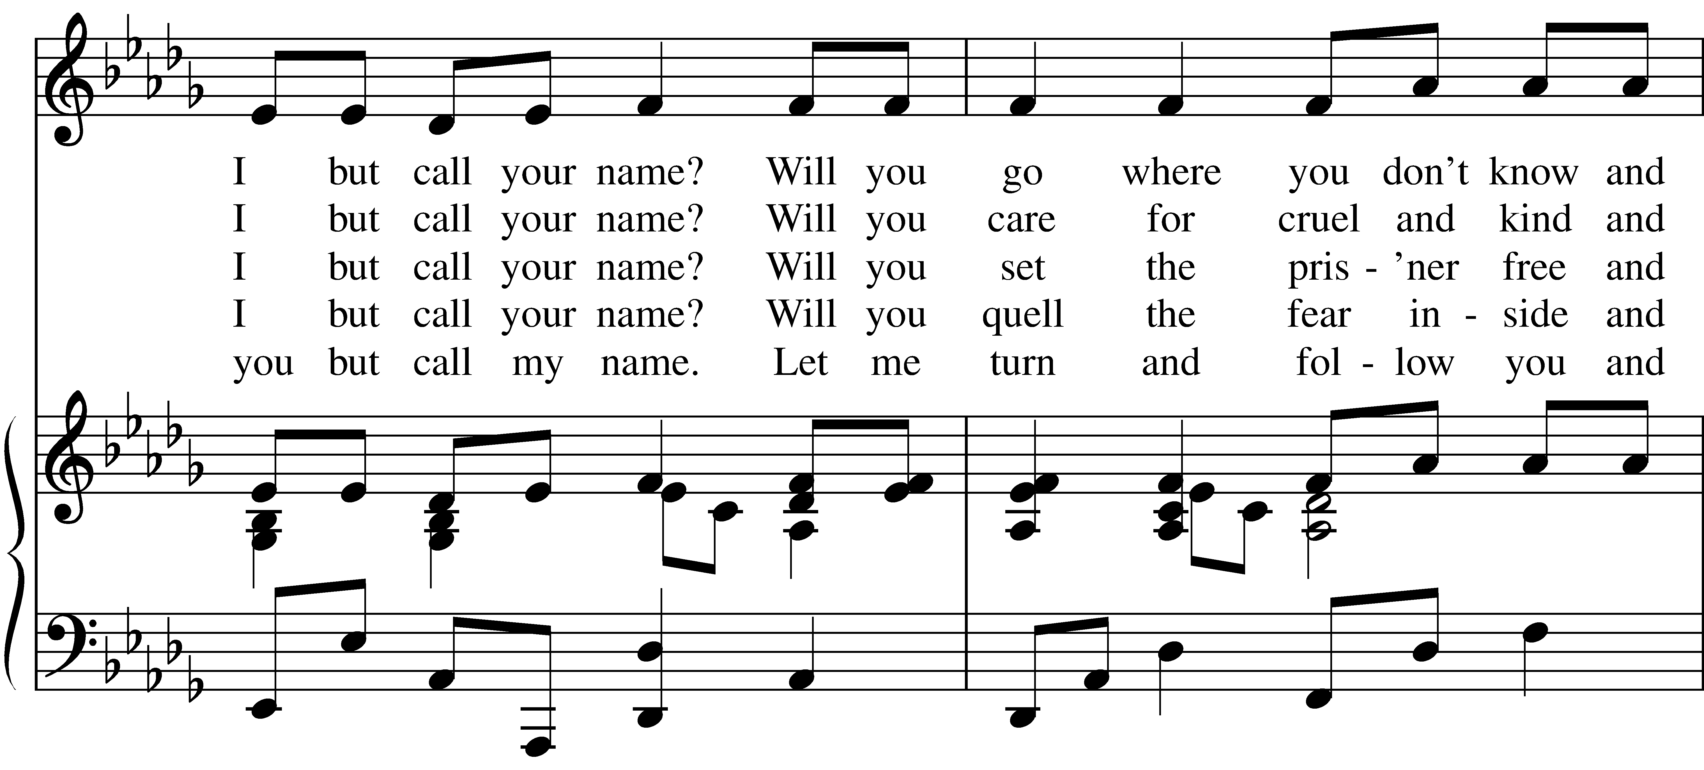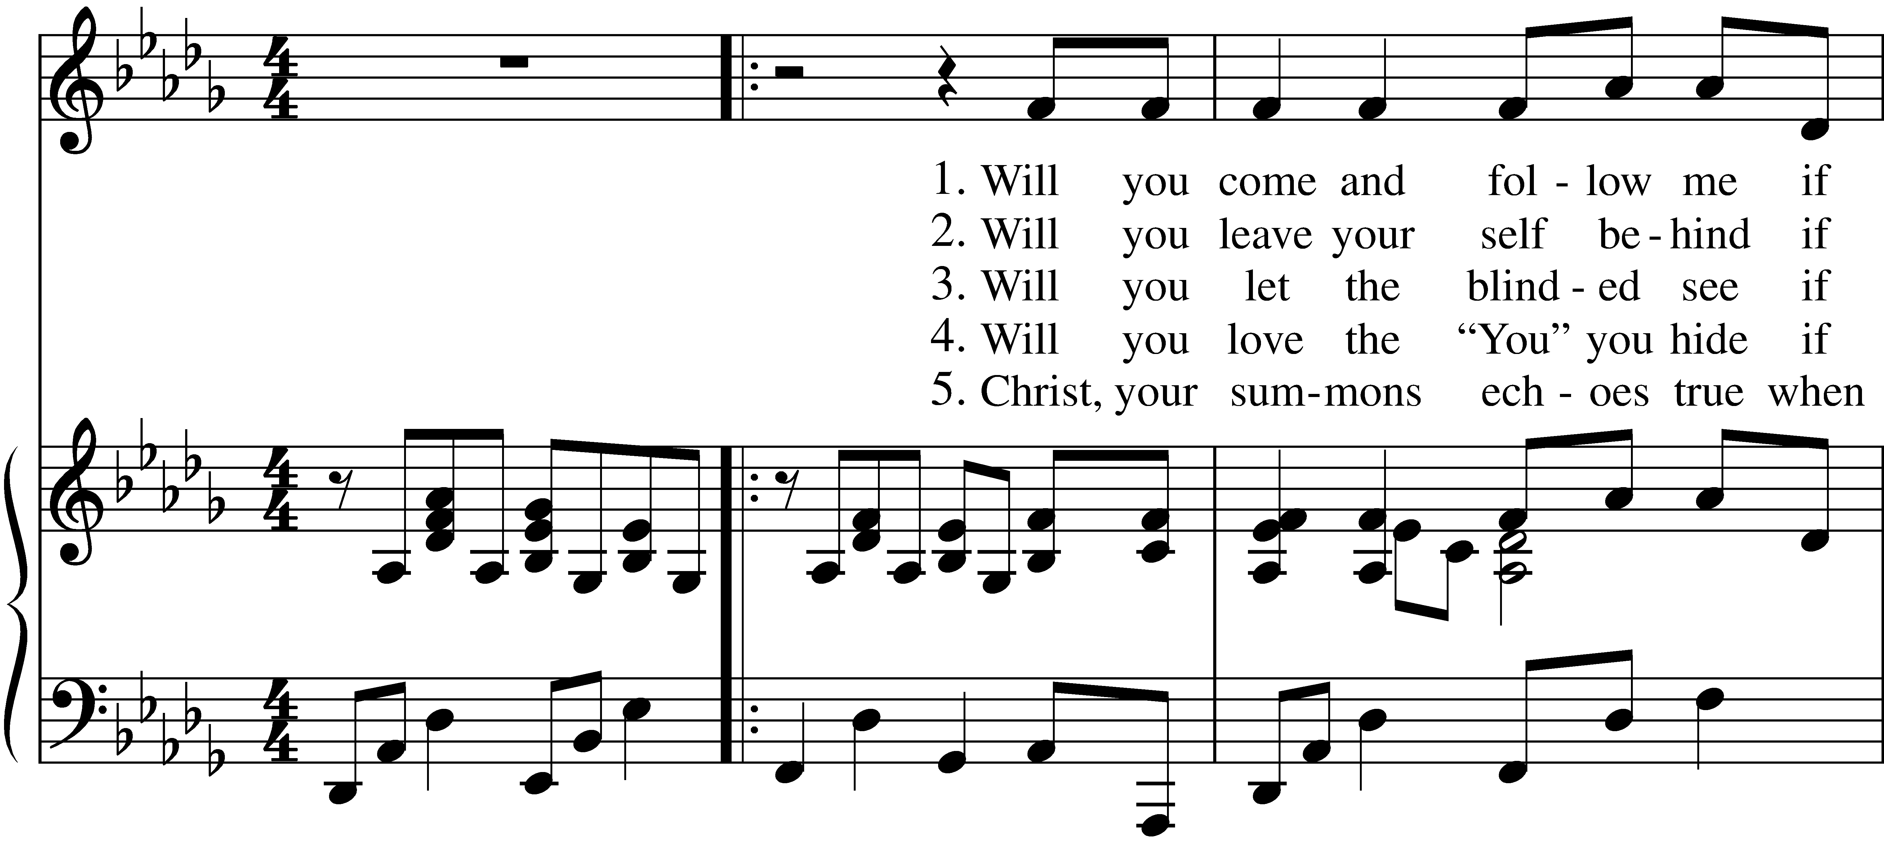

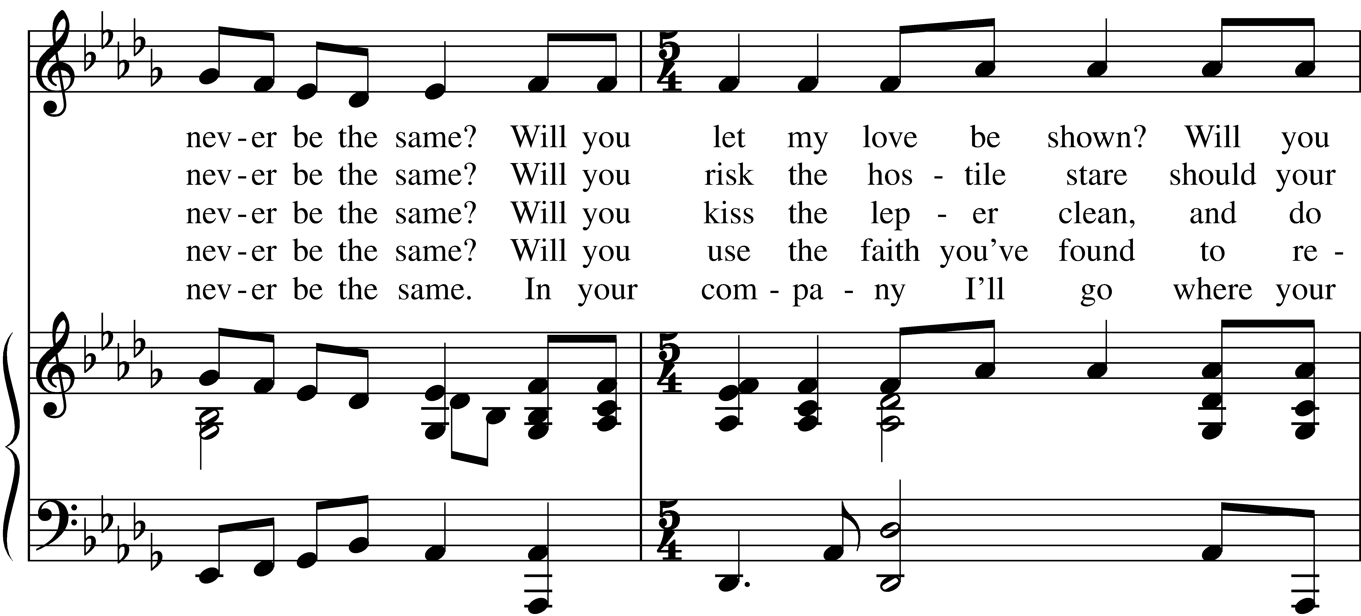

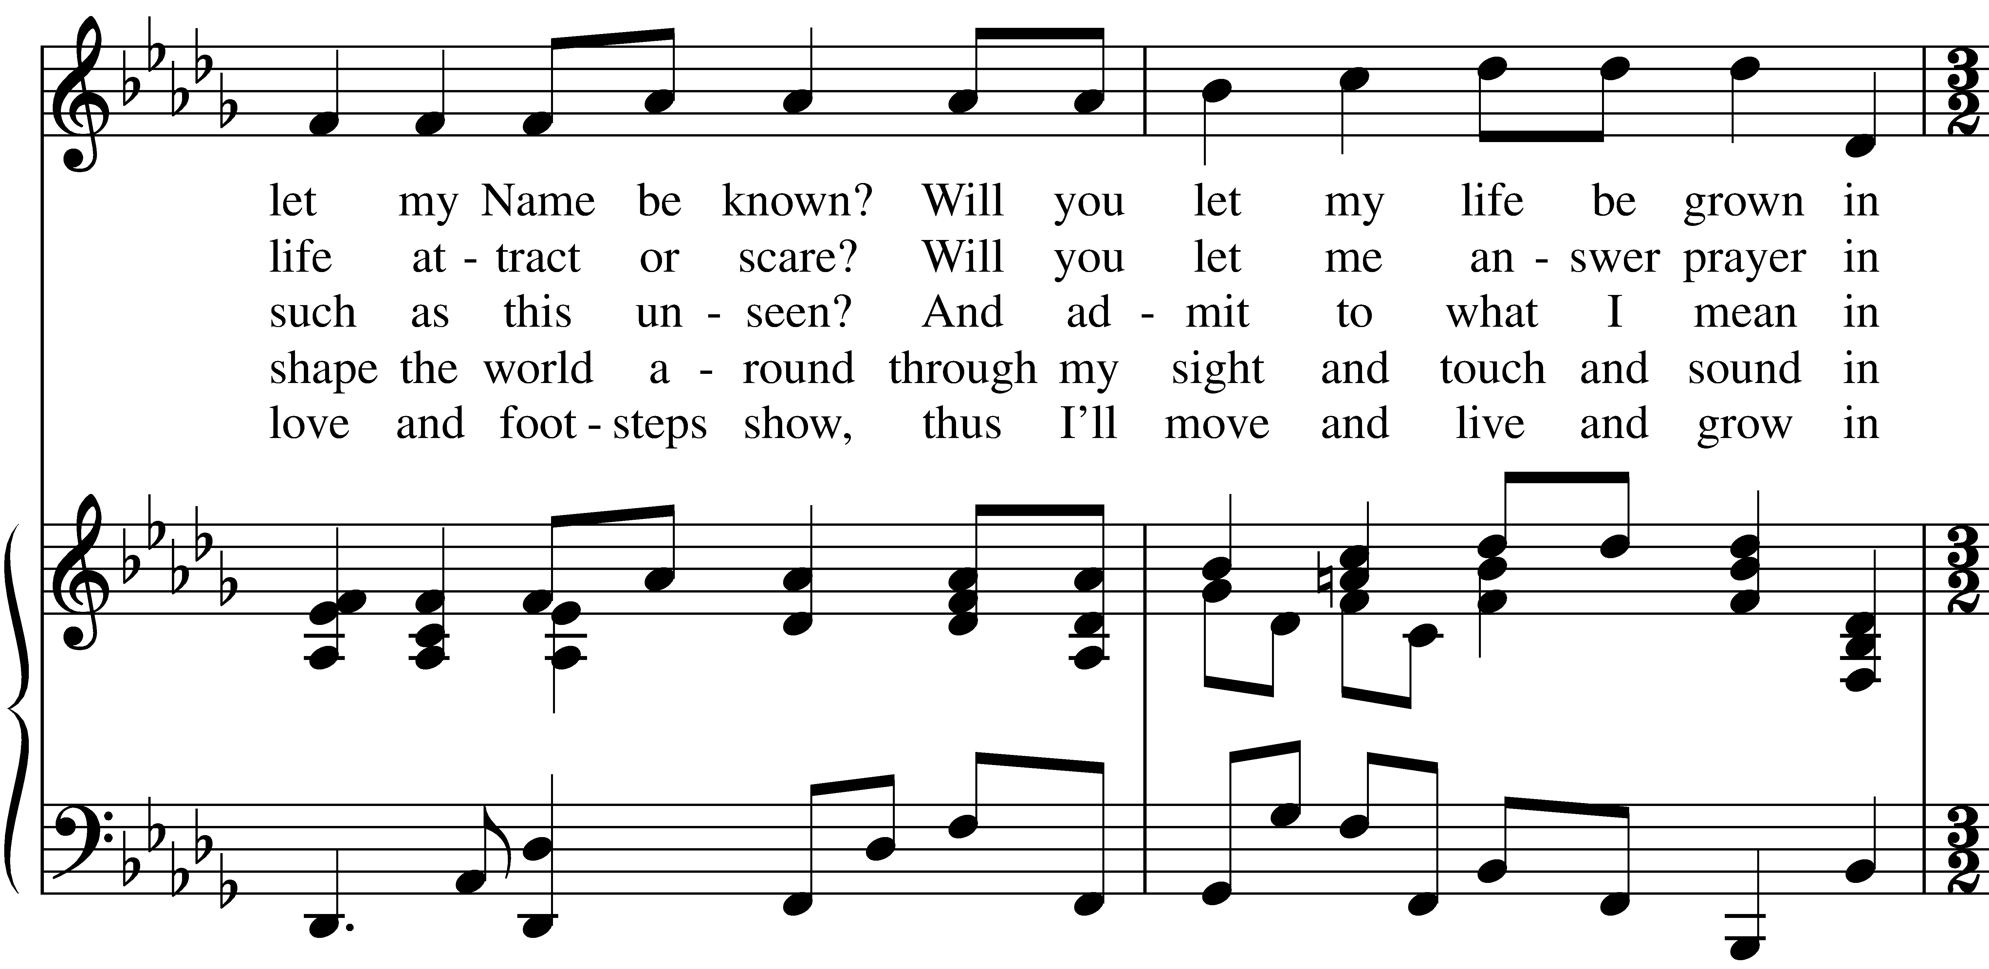

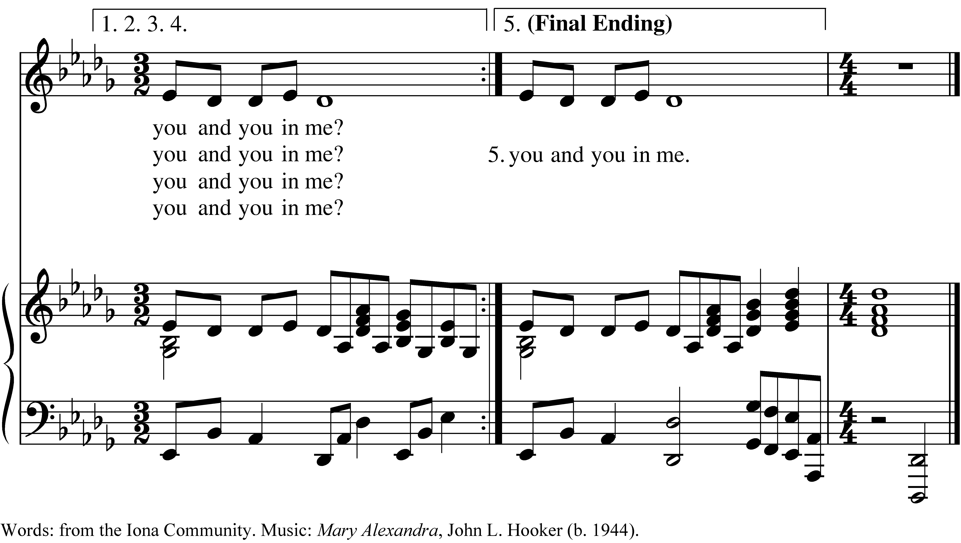

PRAYER AFTER COMMUNION- Celebrant and people together

**Eternal God, heavenly Father, you have graciously accepted us as living members of your Son our Savior Jesus Christ, and you have fed us with spiritual food  in the Sacrament of his Body and Blood. Send us now into the world in peace, and grant us strength and courage to love and serve you with gladness and singleness of heart; through Christ our Lord. Amen.**

THE BLESSING

The peace of God, which passes all understanding, keep your hearts and minds in the knowledge and love of God, and of his Son Jesus Christ our Lord; and the blessing of God Almighty, Father, Son and Holy Spirit, be among you, and remain with you always. ***Amen.***

**CLOSING HYMN:** “I Have Decided to Follow Jesus”

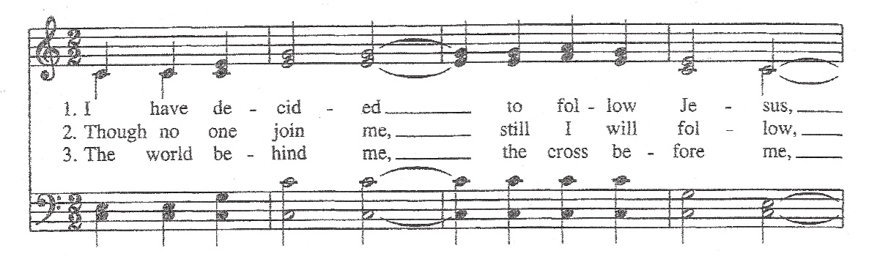

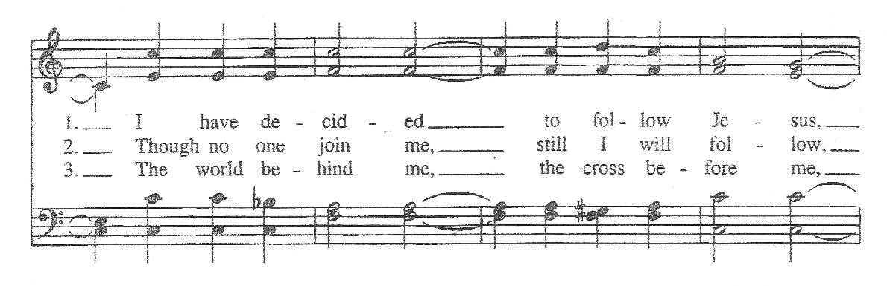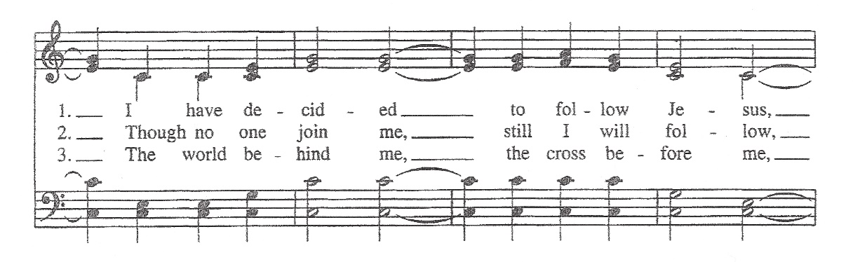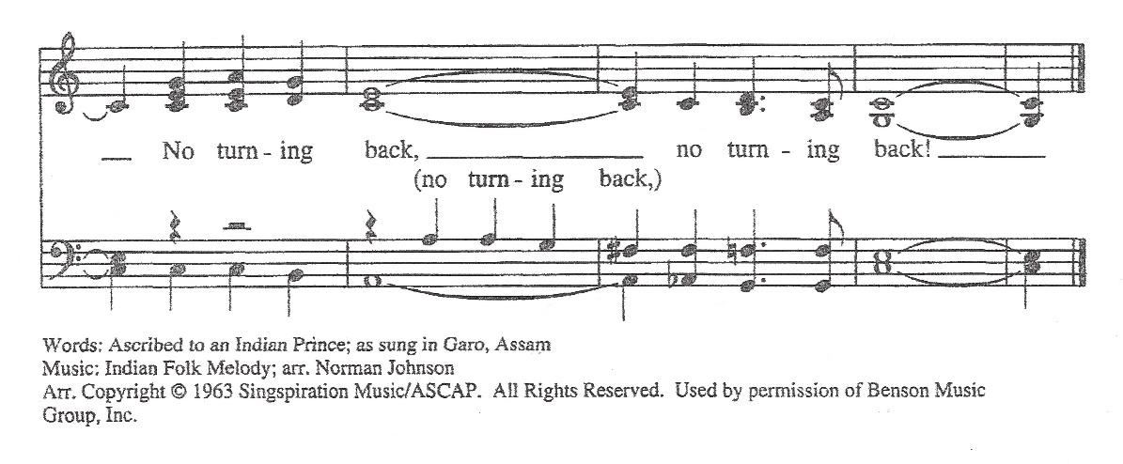

THE DISMISSAL Celebrant: Go in peace to love and serve the Lord.

People: **Thanks be to God.**

**POSTLUDE:** Sonata in G K. 391 - Scarlatti

**Altar Flowers**

The flowers today are given in memory of George and Mary Morrett by Dan and Judy McGregor.

**Announcements from Christ Church**

**Pastoral emergencies**

If you need to reach Rev. Michelle for a pastoral emergency, the number is (937) 505-0141. For

non-emergencies, you can call the office at (937) 323-8651 or email Rev. Michelle at [mboomgaard@christspringfield.org](mailto:mboomgaard@christspringfield.org).

**Wednesday Service of Holy Eucharist~ Every Wednesday!**

### The Rev. Dr. Michelle Boomgaard will offer an in-person Wednesday Service of Holy Eucharist at **noon on September 6th.** The service will be a hybrid model, so please join us in person, but if you can’t, then the service will be live-streamed on Facebook (<https://www.facebook.com/christspringfield.org>/) at noon.

**Food Pantry**

**The September’s Drive-thru Food Pantry will be on September 20th, 2023, starting at 10 am**. *Please consider join us!* Volunteers are needed to help unload food, pack food and help with customer service at approximately 8:15 am. Please contact either Brian Shelburne at [bshelburne@wittenberg.edu](mailto:bshelburne@wittenberg.edu), Kelly Zeller at [zellerk0611@gmail.com](mailto:zellerk0611@gmail.com), or Anne Randolph at [annejrand@aol.com](mailto:annejrand@aol.com) to volunteer.

**Upcoming Food September Pantry opportunities:**

**September 6th, 2023***-* the first food **pick-up** at approximately **8:00 am**

September 13th, 2023 -the second food **pick-up** at approximately**8:00 am**

September 14th, 2023 - grocery bagging day - start time at **9:00 am**

September 20th, 2023 – Food Pantry Day! start time at **8:15 am**

**September’s Lunch Bunch!**

Lunch Bunch will be at 11:30 am at **O Charley’s located at 1830 Bechtle Ave., Springfield, Ohio.** All parishioners that are available during the day are invited to a pleasant luncheon on **Tuesday, September 12th**.  Please let Anita Beardsell, 937 390-6548, know if you plan to come so she can make plans with the restaurant.

**SEPTEMBER’S ADULT FORUMS**

**The Bishop’s Election: What’s at Stake?**

It’s been over fifteen years since Southern Ohio last elected a Bishop. How has the Bishop impacted our lives here at Christ Church and in Springfield? How might the next Bishop help us live out our call? And, what does a Bishop *do*, anyway?

Join us after the **10 AM service** in the Parish Hall on September 10th as we talk about these questions in advance of the “meet and greet” sessions with the candidates. The delegates to the Diocesan convention will be in attendance to hear what qualities we seek in the next Bishop as they prepare to meet and vote. Check out the profiles of the candidates online at  [**https://southernohiobishop.org/candidates/**](https://southernohiobishop.org/candidates/)  or consider participating in one of the “Meet and Greet” sessions:

* Monday, September 11, 7 p.m.: Church of the Redeemer, Cincinnati
* Tuesday, September 12, 7 p.m.: St. Barnabas, Montgomery
* Wednesday, September 13, 4:30 p.m.: All Saints’, Portsmouth
* Thursday, September 14, 7 p.m.: St. Margaret’s, Trotwood
* Friday, September 15, 1 p.m.: St. Patrick’s, Dublin

﻿Or watch them via live stream at [**www.diosohio.org**](http://www.diosohio.org/)

**CELEBRATING OUR PAST, ENVISIONING OUR FUTURE~** **SEPTEMBER 17TH & 24TH**

Whether you’ve been coming here one week or ever since you were baptized as an infant – we need your input as we celebrate our past and envision our future. **Please join us for BOTH Sundays for a combined service at 9:30 am.** Then, we will meet in the **Parish Hall** for fellowship, fun, and food as we celebrate all that God continues to do here at Christ Episcopal Church.

**GAME NIGHT!**

All are welcome to join the We Should Do Something Group! They will meet at different locations once a month to play a variety of board and card games. The next meeting will be **Wednesday, September 20th**, from 6-8 at Rose Goute Creole Restaurant located at 1881 South Limestone St. Springfield, 45506. Feel free to bring a friend or a game to share. If you have questions, contact Rev. Michelle at [mboomgaard@christspringfield.org](mailto:mboomgaard@christspringfield.org).

+++++++++++++++++++++++++++++++++

**Ministers for September 3rd, 2023**

**Altar Guild:** Sally Schwartz

**Chalice:** Beth Deger

**Lector:** Judy Johnson

**Ushers:** Bill Hicks and Sally Schwartz

**Videographer:** David Bingman

**General Information**

**Supply Priest:** The Rev. Melody Williams

**Senior Warden**: Scott Yeazell

**Junior Warden**: Steve Sharp

**Treasurer**: Ken Bladh

**Clerk of Vestry:** Kelly Zeller

**Vestry at Large**: Joy Meyers, Kay Koeninger, Linda Mortensen,

Bill Hicks, Lori Swafford, and Rick Everingham

**Parish Administrator & Program Coordinator**: Kelly Zeller

**Director of Music**: Dr. Christopher Durrenberger

**Facility Manager**: Paul McAfee

**Bookkeeper:** Tina Knox

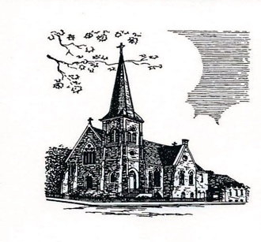

**Christ Episcopal Church**

**409 East High Street**

**Springfield, Ohio 45505**

**937-323-8651**

**www.christspringfield.org**