**The Transfiguration**

**August 6th, 2023 at 10:00 a.m.**

**The Holy Eucharist: Rite II**

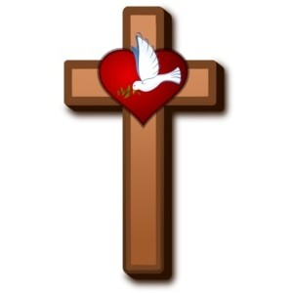

**++++++++++++++++++++++++++++++++++++++++++**

**INFORMATION FOR NEWCOMERS: WELCOME TO CHRIST CHURCH!**



Our motto is true whether you're here for the very first time

or you've been a member for decades –

**There is a place for you at God's Table!**

The worship service has two main parts: the Liturgy of the Word, which includes Scripture readings and a sermon, and the Liturgy of the Table, which is also called Holy Eucharist or Communion. You will notice moments in the service when people stand, kneel, bow, and make the sign of the cross. There is no one “right” way to worship, so do what is comfortable for you at any given time in worship.

All Baptized Christians are welcome at Christ’s Table for Communion. If you do not wish to receive communion, you may come forward and request a blessing. If you wish to receive communion in your pew, please notify the ushers. And if you need a gluten-free wafer, just let Rev. Michelle know.

If you have not been baptized, or if you have questions about Holy Baptism, please talk to The Rev. Dr. Michelle Boomgaard after the service -- the people of Christ Church would love to walk with you to your baptism and beyond!

When you enter a Christ Episcopal Church worship service/event, you will be entering an area where photography, video and audio recording may occur. Finally, if you are a visitor, please fill-out a *Welcome Card* on the back of the pew, so we can add you to our weekly information email the NewsNote.

**The Holy Eucharist Rite II**

**PRELUDE:** “Lento” from 35 Miniatures Op. 55 #15 - Flor Peeters

**OPENING HYMN**: “When Morning Gilds the Skies” Hymnal 427

**THE LITURGY OF THE WORD**

OPENING ACCLAMATION

Celebrant: Blessed be God: Father, Son, and Holy Spirit.

People: **And blessed be his kingdom, now and forever. Amen.**

COLLECT OF PURITY

Almighty God, to you all hearts are open, all desires known, and from you no secrets are hid cleanse the

thoughts of our hearts by the inspiration of your Holy Spirit, that we may perfectly love you, and worthily

magnify your holy Name; through Christ our Lord. **Amen.**

GLORIA HYMNAL S280

**Glory to God in the highest, and peace to his people on earth.**

**Lord God, heavenly King, almighty God and Father,**

**we worship you, we give you thanks, we praise you for your glory.**

**Lord Jesus Christ, only Son of the Father, Lord God, Lamb of God,**

**you take away the sin of the world: have mercy on us;**

**you are seated at the right hand of the Father: receive our prayer.**

**For you alone are the Holy One, you alone are the Lord,**

**you alone are the Most High, Jesus Christ, with the Holy**

**Spirit, in the glory of God the Father. Amen.**

COLLECT OF THE DAY

Celebrant:The Lord be with you.

People: **And also with you.**

Celebrant: Let us pray.

O God, who on the holy mount revealed to chosen witnesses your well-beloved Son, wonderfully transfigured, in raiment white and glistening: Mercifully grant that we, being delivered from the disquietude of this world, may by faith behold the King in his beauty; who with you, O Father, and you, O Holy Spirit, lives and reigns, one God, forever and ever. ***Amen.***

Ô Dieu, sur la sainte montagne, tu as révélé à des témoins choisis ton Fils bien-aimé merveilleusement transfiguré : son visage brillait et ses vêtements étaient devenus d’une blancheur éblouissante ; dans ta miséricorde, daigne nous délivrer des soucis de ce monde afin que nous puissions contempler avec foi le Roi dans sa beauté, lui qui vit et règne avec toi et le Saint-Esprit, un seul Dieu, pour les siècles des siècles. ***Amen.***

**THE LESSONS**

**THE FIRST READING Exodus 34:29-35**

Moses came down from Mount Sinai. As he came down from the mountain with the two tablets of the covenant in his hand, Moses did not know that the skin of his face shone because he had been talking with God. When Aaron and all the Israelites saw Moses, the skin of his face was shining, and they were afraid to come near him. But Moses called to them; and Aaron and all the leaders of the congregation returned to him, and Moses spoke with them. Afterward all the Israelites came near, and he gave them in commandment all that the Lord had spoken with him on Mount Sinai. When Moses had finished speaking with them, he put a veil on his face; but whenever Moses went in before the Lord to speak with him, he would take the veil off, until he came out; and when he came out, and told the Israelites what he had been commanded, the Israelites would see the face of Moses, that the skin of his face was shining; and Moses would put the veil on his face again, until he went in to speak with him.

*Lector:* The Word of the Lord.

***People:* Thanks be to God.**

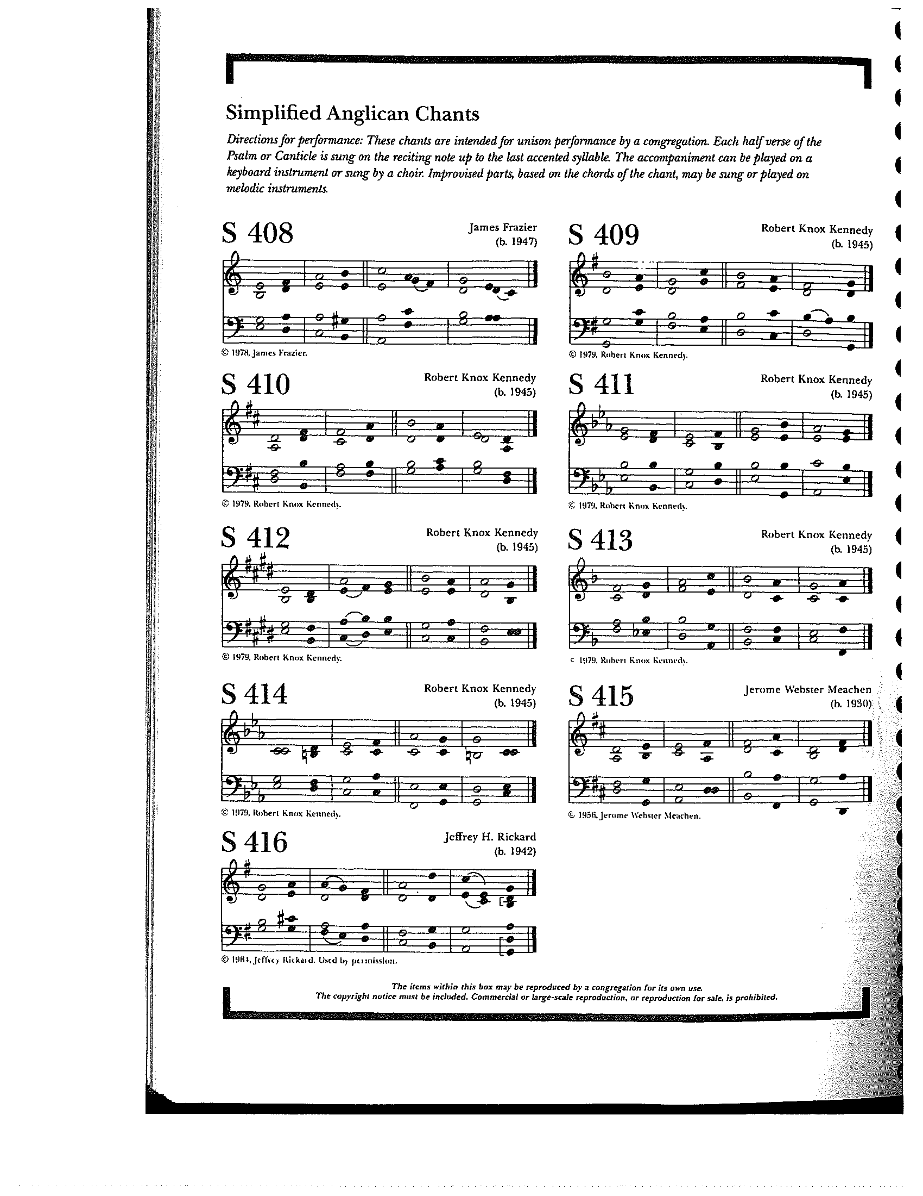

**THE RESPONSE PSALM 99**

1 The Lord is King; let the people **tremble; \***  
he is enthroned upon the cherubim; let the earth **shake.**

2 The Lord is great in **Zion; \***  
he is high above all **peoples.**

3 Let them confess his Name, which is great and **awesome; \***  
he is the Holy **One.**

4 "O mighty King, lover of justice, you have established **equity; \***  
you have executed justice and righteousness in **Jacob."**

5 Proclaim the greatness of the Lord our God and fall down before his **footstool; \***  
he is the Holy **One.**

6 Moses and Aaron among his priests, and Samuel among those who call upon his **Name, \***  
they called upon the Lord, and he answered **them.**

7 He spoke to them out of the pillar of **cloud; \***  
they kept his testimonies and the decree that he gave **them.**

8 O Lord our God, you answered them in**deed; \***  
you were a God who forgave them, yet punished them for their evil **deeds.**

9 Proclaim the greatness of the Lord our God and worship him upon his holy **hill; \***  
for the Lord our God is the Holy **One.**

**THE SECOND LESSON 2 Peter 1:13-21**

I think it right, as long as I am in this body, to refresh your memory, since I know that my death will come soon, as indeed our Lord Jesus Christ has made clear to me. And I will make every effort so that after my departure you may be able at any time to recall these things.

For we did not follow cleverly devised myths when we made known to you the power and coming of our Lord Jesus Christ, but we had been eyewitnesses of his majesty. For he received honor and glory from God the Father when that voice was conveyed to him by the Majestic Glory, saying, “This is my Son, my Beloved, with whom I am well pleased.” We ourselves heard this voice come from heaven, while we were with him on the holy mountain.

So we have the prophetic message more fully confirmed. You will do well to be attentive to this as to a lamp shining in a dark place, until the day dawns and the morning star rises in your hearts. First of all you must understand this, that no prophecy of scripture is a matter of one's own interpretation, because no prophecy ever came by human will, but men and women moved by the Holy Spirit spoke from God.

Lector: The Word of the Lord.

People: **Thanks be to God.**

**SEQUENCE HYMN:** “God is Love, and Where True Love is ” Hymnal 577

**GOSPEL**

Celebrant: The Holy Gospel of our Lord Jesus Christ according to Luke (**Luke 9:28-36**).

People: **Glory to you, Lord Christ.**

Jesus took with him Peter and John and James, and went up on the mountain to pray. And while he was praying, the appearance of his face changed, and his clothes became dazzling white. Suddenly they saw two men, Moses and Elijah, talking to him. They appeared in glory and were speaking of his departure, which he was about to accomplish at Jerusalem. Now Peter and his companions were weighed down with sleep; but since they had stayed awake, they saw his glory and the two men who stood with him. Just as they were leaving him, Peter said to Jesus, “Master, it is good for us to be here; let us make three dwellings, one for you, one for Moses, and one for Elijah” —not knowing what he said. While he was saying this, a cloud came and overshadowed them; and they were terrified as they entered the cloud. Then from the cloud came a voice that said, “This is my Son, my Chosen; listen to him!” When the voice had spoken, Jesus was found alone. And they kept silent and in those days told no one any of the things they had seen.

Celebrant: The Gospel of the Lord.

People: **Praise to you, Lord Christ.**

Saint Évangile de notre Seigneur Jésus Christ selon Matthieu

**Gloire à toi, Christ Seigneur.**

**28**Environ huit jours après qu’il eut dit ces paroles, Jésus prit avec lui Pierre, Jean et Jacques, et il monta sur la montagne pour prier. **29**Pendant qu’il priait, l’aspect de son visage changea, et son vêtement devint d’une éclatante blancheur. **30**Et voici, deux hommes s’entretenaient avec lui: c’étaient Moïse et Elie **31**qui, apparaissant dans la gloire, parlaient de son départ qu’il allait accomplir à Jérusalem. **32**Pierre et ses compagnons étaient appesantis par le sommeil; mais, s’étant tenus éveillés, ils virent la gloire de Jésus et les deux hommes qui étaient avec lui. **33**Au moment où ces hommes se séparaient de Jésus, Pierre lui dit: Maître, il est bon que nous soyons ici; dressons trois tentes, une pour toi, une pour Moïse, et une pour Elie. Il ne savait ce qu’il disait. **34**Comme il parlait ainsi, une nuée vint les couvrir; et les disciples furent saisis de frayeur en les voyant entrer dans la nuée. **35**Et de la nuée sortit une voix, qui dit: Celui-ci est mon Fils élu: écoutez-le! **36**Quand la voix se fit entendre, Jésus se trouva seul. Les disciples gardèrent le silence, et ils ne racontèrent rien à personne, en ce temps-là, de ce qu’ils avaient vu.

L’Évangile de notre Seigneur.

**Louange à toi, Christ Seigneur.**

*Sermon The Rev. Dr. Michelle Boomgaard*

**THE NICENE CREED SYMBOLE DE NICÉE**

**We believe in one God, the Father, the Almighty,** Nous croyons en un seul Dieu, le Père tout-puissant,

**maker of heaven and earth, of all that is,** Créateur du ciel et de la terre,

**seen and unseen. We believe in one Lord,** De toutes les choses visibles et invisibles.

**Jesus Christ, the only Son of God,** Nous croyons en un seul Seigneur, Jésus Christ,

**eternally begotten of the Father, God from God,** Le Fils unique de Dieu,

**Light from Light, true God from true God,** Endgendré du Père avant tous les siècles,

**begotten, not made, of one Being with the Father.** Dieu né de Dieu, Lumière née de la Lumière,

**Through him all things were made.** Vrai Dieu né du vrai Dieu, Engendré, non pas crée,

**For us and for our salvation he came down** Un seul être avec le Père, Et par lui tout a été fait.

**from heaven, by the power of the Holy Spirit** Pour nous et pour notre salut,

**he became incarnate from the Virgin Mary,** Il est descendu des cieux,

**and was made man. For our sake he was** Il s’est incarné par le saint-Esprit en la Vierge Marie,

**crucified under Pontius Pilate;** Et s’est fait homme. Crucifié pour nous sous Ponce Pilate,

**he suffered death and was buried.** Il a souffert la Passion,

**On the third day he rose again in accordance** Il a été mis au tombeau,

**with the Scriptures; he ascended into heaven** Il est ressuscité le troisième jour, selon les Écritures ;

**and is seated at the right hand of the Father.** Il est monté aux cieux,

**He will come again in glory to judge the living** Il siège à la droite du Père,

**and the dead, and his kingdom will have no end.** Il reviendra dans la gloire pour juger

**We believe in the Holy Spirit, the Lord,** les vivants et les morts,

**the giver of life, who proceeds from the Father,** Et son règne n’aura pas de fin.

**and the Son. With the Father and the Son he** Nous croyons en l’Esprit saint,

**is worshiped and glorified, He has spoken** Qui est Seigneur et qui donne la vie,

**through the Prophets. We believe in one holy** Que procède du Père et du Fils,

**catholic and apostolic Church.** Avec le Père et le Fils, il reçoit même

**We acknowledge one baptism** adoration et même gloire; Il a parlé par les Prophètes.

**for the forgiveness of sins.** Nous croyons en l’Église une, sainte,

**We look for the resurrection of the dead,** catholique et apostolique.

**and the life of the world to come. Amen.** Nous reconnaissons us seul baptême pour

le pardon des péchés.

Nous attendons la résurrection des morts

Et la vie du monde à venir. Amen.

**THE PRAYERS OF THE PEOPLE**

In peace, we pray to you Lord God. (*Congregational responses are in* ***bold****)*

*Silence*

Grant, Almighty God, that all who confess your Name may be united in your truth, live together in your love, and reveal your glory in the world.

Lord, in your mercy  
**Hear our prayer.**

Give grace to church leaders, especially Justin, Archbishop of Canterbury; Michael, our presiding bishop; Wayne, our provisional diocesan bishop; Michelle, our rector; and all who minister in Christ, that they may be firmly rooted in your truth and love.

Lord, in your mercy  
**Hear our prayer.**

Guide the people of this land, and of all the nations, in the ways of justice and peace; that we may honor one another and serve the common good. In the Ministry Cycle of Prayer, we pray for Clark County Literacy Coalition, Episcopal Community Ministries, Second Harvest Food Bank, Sheltered, Inc. and Springfield Soup Kitchen.

Lord, in your mercy  
**Hear our prayer.**

Give us all a reverence for the earth as your own creation, that we may use its resources rightly in the service of others and to your honor and glory.

Lord, in your mercy  
**Hear our prayer.**

Bless all whose lives are closely linked with ours, and grant that we may serve Christ in them, and love one another as he loves us. We pray for those celebrating their birthdays this week especially, Dana Waggoner and Marilyn Howat, and anniversaries this week especially, Bonnie and Brian Shelburne.

Lord, in your mercy  
**Hear our prayer.**

Comfort and heal all those who suffer in body, mind, or spirit; especially Bill Everingham, Bill Yeazell, Don Rode, Diana DeVoe, Sandi Eyman, Margaret Mattox, Joy Bartenstein, Dodi Holmes, Martha Chaney, Charlene Schreiber, Alice Kelly, Barb Kelly, and Traudie Milleck, give them courage and hope in their troubles, and bring them the joy of your salvation.

Lord, in your mercy  
**Hear our prayer.**

We commend to your mercy all who have died, that your will for them may be fulfilled; and we pray that we may share with all your saints in your eternal kingdom.

Lord, in your mercy  
**Hear our prayer.**

THE COLLECT FOR THE ELECTION OF A BISHOP  
**Almighty God, giver of every good gift: Look graciously on your Church, and so guide the minds of those who shall choose a bishop for this Diocese, that we may receive a faithful pastor, who will care for your people and equip us for our ministries; through Jesus Christ our Lord. *Amen.***

THE CONFESSION AND ABSOLUTION

Celebrant: Let us confess our sins against God and our neighbor.

**All: God of all mercy, we confess that we have sinned against you, opposing your will in our lives. We have denied your goodness in each other, in ourselves, and in the world you have created. We repent of the evil that enslaves us, the evil we have done, and the evil done on our behalf. Forgive, restore, and strengthen us through our Savior Jesus Christ, that we may abide in your love and serve only your will. *Amen.***

Celebrant: Almighty God have mercy on you, forgive you all your sins through the grace of Jesus Christ, strengthen you in all goodness, and by the power of the Holy Spirit keep you in eternal life. ***Amen.***

THE PEACE

ANNOUNCEMENTS

**OFFERTORY HYMN:** “O Wondrous Type, O Vision Fair” Hymnal 137

PRESENTATION OF THE GIFTSHymnal 380, v. 3

**Praise God from whom all blessings flow;**

**praise him, all creatures here below;**

**praise him above, ye heavenly host:**

**praise Father, Son and Holy Ghost**

**THE HOLY COMMUNION**

THE GREAT THANKSGIVING: EUCHARISTIC PRAYER 1 (from Enriching Our Worship)

Celebrant The Lord be with you.

People **And also with you.**

Celebrant Lift up your hearts.

People **We lift them to the Lord.**

Celebrant Let us give thanks to the Lord our God.

People **It is right to give our thanks and praise**.

It is truly right, and good and joyful, to give you thanks, all-holy God, source of life and fountain of mercy. You have filled us and all creation with your blessing and fed us with your constant love; you have redeemed us in Jesus Christ and knit us into one body. Through your Spirit you replenish us and call us to fullness of life.

Therefore, joining with Angels and Archangels and with the faithful of every generation, we lift our voices with all creation as we sing:

**Holy, holy, holy Lord, God of power and might, Hymnal S129**

**heaven and earth are full of your glory. Hosanna in the highest.**

**Blessed is he who comes in the name of the Lord.**

**Hosanna in the highest.**

Blessed are you, gracious God, Creator of the universe and giver of life. You formed us in your own image and called us to dwell in your infinite love. You gave the world into our care, that we might be your faithful stewards and show forth your bountiful grace. But we failed to honor your image in one another and in ourselves; we would not see your goodness in the world around us; and so we violated your creation, abused one another, and rejected your love. Yet you never ceased to care for us, and prepared the way of salvation for all people.

Through Abraham and Sarah you called us into covenant with you. You delivered us from slavery, sustained us in the wilderness, and raised up prophets to renew your promise of salvation. Then, in the fullness of time, you sent your eternal Word, made mortal flesh in Jesus. Born into the human family, and dwelling among us, he revealed your glory. Giving himself freely to death on the cross, he triumphed over evil, opening the way of freedom and life.

On the night before he died for us, Our Savior Jesus Christ took bread, and when he had given thanks to you, he broke it, and gave it to his friends, and said: “Take, eat: This is my Body which is given for you. Do this for the remembrance of me.”

As supper was ending, Jesus took the cup of wine, and when he had given thanks, he gave it to them, and said: “Drink this, all of you: This is my Blood of the new Covenant, which is poured out for you and for all for the forgiveness of sins. Whenever you drink it, do this for the remembrance of me.”

Therefore we proclaim the mystery of faith:

**Christ has died.**

**Christ is risen.**

**Christ will come again.**

Remembering his death and resurrection, we now present to you from your creation this bread and this wine. By your Holy Spirit may they be for us the Body and Blood of our Savior Jesus Christ. Grant that we who share these gifts may be filled with the Holy Spirit and live as Christ’s Body in the world. Bring us into the everlasting heritage of your daughters and sons, that with Blessed Mother Mary and all your saints, past, present, and yet to come, we may praise your Name for ever.

Through Christ and with Christ and in Christ, in the unity of the Holy Spirit, to you be honor, glory, and praise, forever and ever. Amen.

And now, as our Savior Christ has taught us, we are bold to say,

**Our Father, who art in heaven, Notre Père, qui es aux cieux,**

**hallowed be thy name, Que ton nom soit sanctifé;**

**thy kingdom come, thy will be done, Que ton règne vienne ; que ta volonté soit faite**

**on earth as it is in heaven. Sur la terre comme au ciel.**

**Give us this day our daily bread. Donne-nous aujourd’hui notre pain de ce jour.**

**And forgive us our trespasses, Pardonne-nous nos offenses,**

**as we forgive those who trespass against us. Comme nous pardonnons aussi À ceux qui nous ont offensés.**

**And lead us not into temptation, Et nous laisse pas entrer en tentation,**

**but deliver us from evil. Mais délivre-nous du mal.**

**For thine is the kingdom, Car c’est à toi qu’appartiennent le règne,**

**and the power, and the glory, La puissance et la gloire,**

**forever and ever. Amen. Pour les siècles des siècles. Amen.**

THE BREAKING OF THE BREAD Hymnal S155

**Alleluia, alleluia, alleluia.**

**Christ our Passover is sacrificed for us; therefore let us keep the feast.**

**Alleluia, alleluia, alleluia.**

THE INVITATION TO COMMUNION

**COMMUNION HYMN:** “Humbly I Adore thee” Hymnal 314

PRAYER AFTER COMMUNION- Celebrant and people together

**Eternal God, heavenly Father, you have graciously accepted us as living members of your Son our Savior Jesus Christ, and you have fed us with spiritual food  in the Sacrament of his Body and Blood. Send us now into the world in peace, and grant us strength and courage to love and serve you with gladness and singleness of heart; through Christ our Lord. Amen.**

THE BLESSING

The peace of God, which passes all understanding, keep your hearts and minds in the knowledge and love of God, and of his Son Jesus Christ our Lord; and the blessing of God Almighty, Father, Son and Holy Spirit, be among you, and remain with you always. ***Amen.***

**CLOSING HYMN:** “Christ Whose Glory Fills the Skies” Hymnal 7

THE DISMISSAL Celebrant: Go in peace to love and serve the Lord.

People: **Thanks be to God.**

**POSTLUDE:** "Allegretto" from Sonatina No. 1 in G Major - Beethoven

**Altar Flowers**

The flowers today are given in appreciation for family and friends by Gretchen and Bill Hicks.

**Announcements from Christ Church**

**Pastoral emergencies**

If you need to reach Rev. Michelle for a pastoral emergency, the number is (937) 505-0141. For

non-emergencies, you can call the office at (937) 323-8651 or email Rev. Michelle at [mboomgaard@christspringfield.org](mailto:mboomgaard@christspringfield.org).

**"Walk in Love" Discussion group~ Sundays through August 27th at 9 am in the Parish Hall!**

**The Rev. Dr. Michelle Boomgaard’s Installation**

Please plan to join us this **Wednesday, August 9th**, **at 5 pm** for the celebration of New Ministry and the Installation of The Rev. Michelle Boomgaard as Christ Church’s 33rd rector. A catered reception to follow.

Are you new to the Episcopal Church? Or, have you been a member for years, but still wonder what's going on sometimes?  Rev. Michelle will be hosting a discussion of the book "Walk in Love: Episcopal Beliefs and Practices." The book covers details of what Episcopalians do in worship (and why!), as well as an overview of the Church's history and beliefs. Discussions will take place on **Sunday mornings at 9 am in the Parish Hall** - and will also be on Zoom for those wishing to join in remotely. Here is the Zoom link:

[**https://us02web.zoom.us/j/86506647216pwd=MGVGenVoM2prSS8xN05KVWVTanBWUT09**](https://r20.rs6.net/tn.jsp?f=001yt2DYtzoLT5R0eNRlWhn01STuETlHLOnMpwj6pi2Pu98XrxeaGbV1g_3D0Fm1YvWI3sh9EhJiPlLiAZrrQuum9Wk4L2OGn26ggnmMt_jqpNqwoF7AmbH2j0pr6_30ehp1b7YyfVENFT-6TWaJfwBxSmwCTH2ntFGtJeykBTed20NXBV8JRpxBfwz6DyTwxQhfmibnypzHH5JdsKgiqm0W_Siij605x_p&c=XRMJ9BDRNIhJ0Bthrn9JBe2CRh-OzUy4xPm5LxxDUub0xrnvPVnSAw==&ch=GkgZrtysRCD-lSi2phmvPiLmak-1RyQkuz2iF_48-UJF4MHfrwOLqQ==)

You can join in for all the sessions, or just the ones that interest you. If you would like to participate, please contact Rev. Michelle at [**mboomgaard@christspringfield.org**](mailto:mboomgaard@christspringfield.org).

Tentative schedule (note that in some weeks, the chapters are NOT consecutive):

**August 6** – Church Governance and Vocation (Chapters **18 & 20**)

August 13 – Trinitarian Life (Chapters 21, 22, 23)

August 20 – What Next? Spiritual Practices, Knowing and Telling our Story (Chapters 24, 25, 26)

## **August’s Lunch Bunch**

## Lunch Bunch will be at **11:30 am on August 8th** at The Meadows Restaurant, 4105 East National Road, Springfield, OH 45504. All parishioners that are available during the day are invited to a pleasant luncheon on Tuesday, August 8th. Please let Anita Beardsell, 937 390-6548, know if you plan to come so she can make plans with the restaurant.

**The Food Pantry**

**The August’s Drive-thru Food Pantry will be on August 16th, 2023, starting at 10 am**. *Please consider join us!* Volunteers are needed to help unload food, pack food and help with customer service at approximately 8:15 am. Please contact either Brian Shelburne at [bshelburne@wittenberg.edu](mailto:bshelburne@wittenberg.edu), Kelly Zeller at [zellerk0611@gmail.com](mailto:zellerk0611@gmail.com), or Anne Randolph at [annejrand@aol.com](mailto:annejrand@aol.com) to volunteer.

**Upcoming Food August Pantry opportunities:**

**August 9th, 2023** -the second food **pick-up** at approximately**8:00 am**

August 10th, 2023 - grocery bagging day - start time at **9:00 am**

August 16th, 2023 – Food Pantry Day! start time at **8:15 am**

**Wednesday Service of Holy Eucharist~ Every Wednesday!**

### The Rev. Dr. Michelle Boomgaard will offer an in-person Wednesday Service of Holy Eucharist at **noon on August 9th.** The service will be a hybrid model, so please join us in person, but if you can’t, then the service will be live-streamed on Facebook (<https://www.facebook.com/christspringfield.org>/) at noon.

**Rainbow Table**

In August Christ Church will take its next turn assisting St. John’s Lutheran Church with the Rainbow Table, a weekly free hot meal provided to the community. There are two shifts. The first shift prepares the meal and sets up from 9 AM to 11 AM. The second shift comes in at 11:30 AM to serve and clean up, finishing at 1:30 PM. You may help at just one session or as many as you are able.

**Socks and Underwear!**

Christ Church will collect socks and underwear of all sizes **now through August 27th**. All socks and underwear can be placed in the basket by the elevator or dropped off at the Parish office. In September, the given socks and underwear will be donated to local schools to be handed out to students in need. If you have questions, please contact Kelly Zeller at zellerk0611@gmail.com or 937-323-8651.

**+++++++++++++++++++**

**Ministers for August 6th, 2023**

**Altar Guild:** Sally Schwartz

**Chalice:** Ann Chitkara

**Lector:** Judy Johnson

**Ushers:** Bonnie Bingman and David Bingman

**Videographer:** Kelly Zeller

**General Information**

**Rector:** The Rev. Dr. Michelle Boomgaard

**Senior Warden**: Scott Yeazell

**Junior Warden**: Steve Sharp

**Treasurer**: Ken Bladh

**Clerk of Vestry:** Kelly Zeller

**Vestry at Large**: Joy Meyers, Kay Koeninger, Linda Mortensen,

Bill Hicks, Lori Swafford, and Rick Everingham

**Parish Administrator & Program Coordinator**: Kelly Zeller

**Director of Music**: Dr. Christopher Durrenberger

**Facility Manager**: Paul McAfee

**Bookkeeper:** Tina Knox

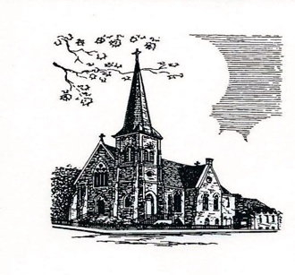

**Christ Episcopal Church**

**409 East High Street**

**Springfield, Ohio 45505**

**937-323-8651**

**www.christspringfield.org**