**Eleventh Sunday after Pentecost**

**August 13th, 2023 at 10:00 a.m.**

**The Holy Eucharist: Rite II**

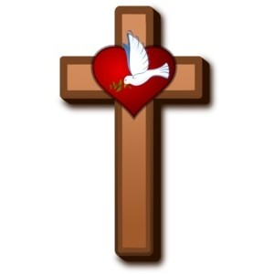

**++++++++++++++++++++++++++++++++++++++++++**

**INFORMATION FOR NEWCOMERS: WELCOME TO CHRIST CHURCH!**

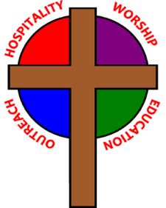

Our motto is true whether you're here for the very first time

or you've been a member for decades –

**There is a place for you at God's Table!**

The worship service has two main parts: the Liturgy of the Word, which includes Scripture readings and a sermon, and the Liturgy of the Table, which is also called Holy Eucharist or Communion. You will notice moments in the service when people stand, kneel, bow, and make the sign of the cross. There is no one “right” way to worship, so do what is comfortable for you at any given time in worship.

All Baptized Christians are welcome at Christ’s Table for Communion. If you do not wish to receive communion, you may come forward and request a blessing. If you wish to receive communion in your pew, please notify the ushers. And if you need a gluten-free wafer, just let Rev. Michelle know.

If you have not been baptized, or if you have questions about Holy Baptism, please talk to The Rev. Dr. Michelle Boomgaard after the service -- the people of Christ Church would love to walk with you to your baptism and beyond!

When you enter a Christ Episcopal Church worship service/event, you will be entering an area where photography, video and audio recording may occur. Finally, if you are a visitor, please fill-out a *Welcome Card* on the back of the pew, so we can add you to our weekly information email the NewsNote.

**The Holy Eucharist Rite II**

**PRELUDE:** “Sostenuto” from 35 Miniatures Op 55 #30 - Peeters

**OPENING HYMN**: “O Worship the King, All Glorious Above” Hymnal 388

**THE LITURGY OF THE WORD**

OPENING ACCLAMATION

Celebrant: Blessed be God: Father, Son, and Holy Spirit.

People: **And blessed be his kingdom, now and forever. Amen.**

COLLECT OF PURITY

Almighty God, to you all hearts are open, all desires known, and from you no secrets are hid cleanse the

thoughts of our hearts by the inspiration of your Holy Spirit, that we may perfectly love you, and worthily

magnify your holy Name; through Christ our Lord. **Amen.**

GLORIA HYMNAL S280

**Glory to God in the highest, and peace to his people on earth.**

**Lord God, heavenly King, almighty God and Father,**

**we worship you, we give you thanks, we praise you for your glory.**

**Lord Jesus Christ, only Son of the Father, Lord God, Lamb of God,**

**you take away the sin of the world: have mercy on us;**

**you are seated at the right hand of the Father: receive our prayer.**

**For you alone are the Holy One, you alone are the Lord,**

**you alone are the Most High, Jesus Christ, with the Holy**

**Spirit, in the glory of God the Father. Amen.**

COLLECT OF THE DAY

Celebrant:The Lord be with you.

People: **And also with you.**

Celebrant: Let us pray.

Grant to us, Lord, we pray, the spirit to think and do always those things that are right, that we, who cannot exist without you, may by you be enabled to live according to your will; through Jesus Christ our Lord, who lives and reigns with you and the Holy Spirit, one God, forever and ever. ***Amen.***

Seigner, nous t’en prions: accorde à nos esprit de toujours penser et faire ce qui est juste, afin que nous recevions de toi, nous qui ne pouvons exister sans toi, la capacité de vivre selon ta volonté: par Jésus Christ, notre Seigner, qui vit et règne avec toi et le Saint-Esprit, un seul Dieu, pour les siècles des siècles. ***Amen.***

**THE LESSONS**

**THE FIRST READING Genesis 37:1-4, 12-28**

Jacob settled in the land where his father had lived as an alien, the land of Canaan. This is the story of the family of Jacob.

Joseph, being seventeen years old, was shepherding the flock with his brothers; he was a helper to the sons of Bilhah and Zilpah, his father’s wives; and Joseph brought a bad report of them to their father. Now Israel loved Joseph more than any other of his children, because he was the son of his old age; and he had made him a long robe with sleeves. But when his brothers saw that their father loved him more than all his brothers, they hated him, and could not speak peaceably to him.

Now his brothers went to pasture their father’s flock near Shechem. And Israel said to Joseph, “Are not your brothers pasturing the flock at Shechem? Come, I will send you to them.” He answered, “Here I am.” So he said to him, “Go now, see if it is well with your brothers and with the flock; and bring word back to me.” So he sent him from the valley of Hebron.

He came to Shechem, and a man found him wandering in the fields; the man asked him, “What are you seeking?” “I am seeking my brothers,” he said; “tell me, please, where they are pasturing the flock.” The man said, “They have gone away, for I heard them say, ‘Let us go to Dothan.’” So Joseph went after his brothers, and found them at Dothan. They saw him from a distance, and before he came near to them, they conspired to kill him. They said to one another, “Here comes this dreamer. Come now, let us kill him and throw him into one of the pits; then we shall say that a wild animal has devoured him, and we shall see what will become of his dreams.” But when Reuben heard it, he delivered him out of their hands, saying, “Let us not take his life.” Reuben said to them, “Shed no blood; throw him into this pit here in the wilderness, but lay no hand on him” —that he might rescue him out of their hand and restore him to his father. So when Joseph came to his brothers, they stripped him of his robe, the long robe with sleeves that he wore; and they took him and threw him into a pit. The pit was empty; there was no water in it.

Then they sat down to eat; and looking up they saw a caravan of Ishmaelites coming from Gilead, with their camels carrying gum, balm, and resin, on their way to carry it down to Egypt. Then Judah said to his brothers, “What profit is it if we kill our brother and conceal his blood? Come, let us sell him to the Ishmaelites, and not lay our hands on him, for he is our brother, our own flesh.” And his brothers agreed. When some Midianite traders passed by, they drew Joseph up, lifting him out of the pit, and sold him to the Ishmaelites for twenty pieces of silver. And they took Joseph to Egypt.

*Lector:* The Word of the Lord.

***People:* Thanks be to God.**

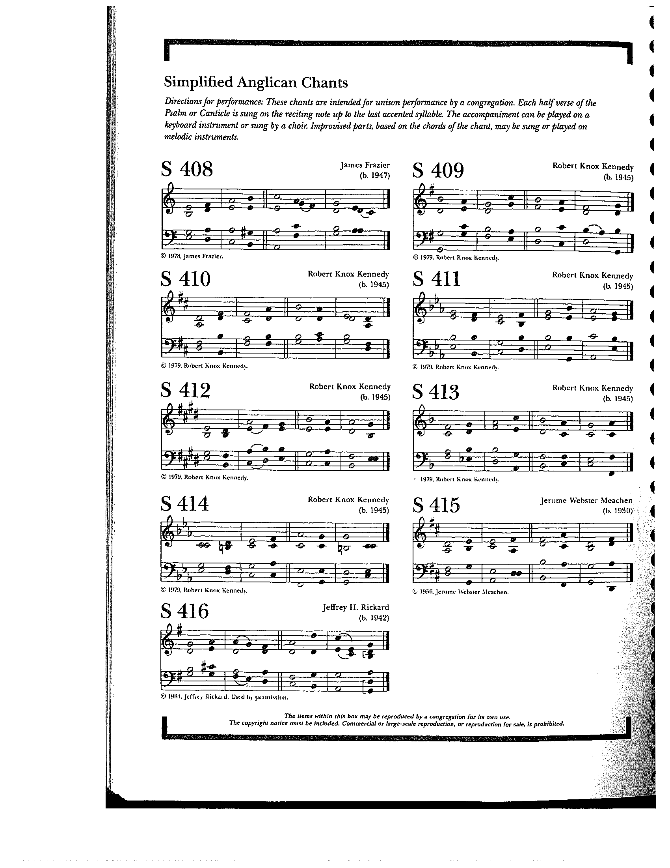

**THE RESPONSE PSALM 105, 1-6, 16-22, 45**

1 Give thanks to the Lord and call upon his **Name; \***make known his deeds among the **peoples.**

2 Sing to him, sing praises to **him, \***  
and speak of all his marvelous **works.**

3 Glory in his holy **Name; \***  
let the hearts of those who seek the Lord re**joice**.

4 Search for the Lord and his **strength; \***continually seek his **face.**

5 Remember the marvels he has **done, \***  
his wonders and the judgments of his **mouth,**

6 O offspring of Abraham his **servant, \***  
O children of Jacob his **chosen.**

16 Then he called for a famine in the **land \***  
and destroyed the supply of **bread.**

17 He sent a man before **them, \***Joseph, who was sold as a **slave.**

18 They bruised his feet in **fetters; \***  
his neck they put in an iron **collar.**

19 Until his prediction came to **pass, \***  
the word of the Lord tested **him.**

20 The king sent and released **him; \***the ruler of the peoples set him **free.**

21 He set him as a master over his **household,**  
as a ruler over all his pos**sessions,**

22 To instruct his princes according to his **will**and to teach his elders **wisdom.**

45 Halle**lujah!**

**THE SECOND LESSON Romans 10:5-15**

Moses writes concerning the righteousness that comes from the law, that “the person who does these things will live by them.” But the righteousness that comes from faith says, “Do not say in your heart, ‘Who will ascend into heaven?’” (that is, to bring Christ down) “or ‘Who will descend into the abyss?’” (that is, to bring Christ up from the dead). But what does it say?

“The word is near you, on your lips and in your heart”

(that is, the word of faith that we proclaim); because if you confess with your lips that Jesus is Lord and believe in your heart that God raised him from the dead, you will be saved. For one believes with the heart and so is justified, and one confesses with the mouth and so is saved. The scripture says, “No one who believes in him will be put to shame.” For there is no distinction between Jew and Greek; the same Lord is Lord of all and is generous to all who call on him. For, “Everyone who calls on the name of the Lord shall be saved.”

But how are they to call on one in whom they have not believed? And how are they to believe in one of whom they have never heard? And how are they to hear without someone to proclaim him? And how are they to proclaim him unless they are sent? As it is written, “How beautiful are the feet of those who bring good news!”

Lector: The Word of the Lord.

People: **Thanks be to God.**

**SEQUENCE HYMN:** “How Firm a Foundation, Ye Saints of the Lord ” Hymnal 637

**GOSPEL**

Celebrant: The Holy Gospel of our Lord Jesus Christ according to Matthew (**Matthew 14:22-33**).

People: **Glory to you, Lord Christ.**

Jesus made the disciples get into the boat and go on ahead to the other side, while he dismissed the crowds. And after he had dismissed the crowds, he went up the mountain by himself to pray. When evening came, he was there alone, but by this time the boat, battered by the waves, was far from the land, for the wind was against them. And early in the morning he came walking toward them on the sea. But when the disciples saw him walking on the sea, they were terrified, saying, “It is a ghost!” And they cried out in fear. But immediately Jesus spoke to them and said, “Take heart, it is I; do not be afraid.”

Peter answered him, “Lord, if it is you, command me to come to you on the water.” He said, “Come.” So Peter got out of the boat, started walking on the water, and came toward Jesus. But when he noticed the strong wind, he became frightened, and beginning to sink, he cried out, “Lord, save me!” Jesus immediately reached out his hand and caught him, saying to him, “You of little faith, why did you doubt?” When they got into the boat, the wind ceased. And those in the boat worshiped him, saying, “Truly you are the Son of God.”

Celebrant: The Gospel of the Lord.

People: **Praise to you, Lord Christ.**

Saint Évangile de notre Seigneur Jésus Christ selon Matthieu

**Gloire à toi, Christ Seigneur.**

**22**Aussitôt après, il obligea les disciples à monter dans la barque et à passer avant lui de l’autre côté, pendant qu’il renverrait la foule. **23**Quand il l’eut renvoyée, il monta sur la montagne, pour prier à l’écart; et, comme le soir était venu, il était là seul.

**24**La barque, déjà au milieu de la mer, était battue par les flots; car le vent était contraire. **25**A la quatrième veille[[a](https://www.biblegateway.com/passage/?search=Matthew+14%3A+22-33&version=NEG1979#ffr-NEG1979-23690a)] de la nuit, Jésus alla vers eux, marchant sur la mer. **26**Quand les disciples le virent marcher sur la mer, ils furent troublés, et dirent: C’est un fantôme! Et, dans leur frayeur, ils poussèrent des cris. **27**Jésus leur dit aussitôt: Rassurez-vous, c’est moi; n’ayez pas peur! **28**Pierre lui répondit: Seigneur, si c’est toi, ordonne que j’aille vers toi sur les eaux. **29**Et il dit: Viens! Pierre sortit de la barque, et marcha sur les eaux, pour aller vers Jésus. **30**Mais, voyant que le vent était fort, il eut peur; et, comme il commençait à enfoncer, il s’écria: Seigneur, sauve-moi! **31**Aussitôt Jésus étendit la main, le saisit, et lui dit: Homme de peu de foi, pourquoi as-tu douté? **32**Et ils montèrent dans la barque, et le vent cessa. **33**Ceux qui étaient dans la barque vinrent adorer Jésus, et dirent: Tu es véritablement le Fils de Dieu.

L’Évangile de notre Seigneur.

**Louange à toi, Christ Seigneur.**

*Sermon The Rev. Dr. Michelle Boomgaard*

**THE NICENE CREED SYMBOLE DE NICÉE**

**We believe in one God, the Father, the Almighty,** Nous croyons en un seul Dieu, le Père tout-puissant,

**maker of heaven and earth, of all that is,** Créateur du ciel et de la terre,

**seen and unseen. We believe in one Lord,** De toutes les choses visibles et invisibles.

**Jesus Christ, the only Son of God,** Nous croyons en un seul Seigneur, Jésus Christ,

**eternally begotten of the Father, God from God,** Le Fils unique de Dieu,

**Light from Light, true God from true God,** Endgendré du Père avant tous les siècles,

**begotten, not made, of one Being with the Father.** Dieu né de Dieu, Lumière née de la Lumière,

**Through him all things were made.** Vrai Dieu né du vrai Dieu, Engendré, non pas crée,

**For us and for our salvation he came down** Un seul être avec le Père, Et par lui tout a été fait.

**from heaven, by the power of the Holy Spirit** Pour nous et pour notre salut,

**he became incarnate from the Virgin Mary,** Il est descendu des cieux,

**and was made man. For our sake he was** Il s’est incarné par le saint-Esprit en la Vierge Marie,

**crucified under Pontius Pilate;** Et s’est fait homme. Crucifié pour nous sous Ponce Pilate,

**he suffered death and was buried.** Il a souffert la Passion,

**On the third day he rose again in accordance** Il a été mis au tombeau,

**with the Scriptures; he ascended into heaven** Il est ressuscité le troisième jour, selon les Écritures ;

**and is seated at the right hand of the Father.** Il est monté aux cieux,

**He will come again in glory to judge the living** Il siège à la droite du Père,

**and the dead, and his kingdom will have no end.** Il reviendra dans la gloire pour juger

**We believe in the Holy Spirit, the Lord,** les vivants et les morts,

**the giver of life, who proceeds from the Father,** Et son règne n’aura pas de fin.

**and the Son. With the Father and the Son he** Nous croyons en l’Esprit saint,

**is worshiped and glorified, He has spoken** Qui est Seigneur et qui donne la vie,

**through the Prophets. We believe in one holy** Que procède du Père et du Fils,

**catholic and apostolic Church.** Avec le Père et le Fils, il reçoit même

**We acknowledge one baptism** adoration et même gloire; Il a parlé par les Prophètes.

**for the forgiveness of sins.** Nous croyons en l’Église une, sainte,

**We look for the resurrection of the dead,** catholique et apostolique.

**and the life of the world to come. Amen.** Nous reconnaissons us seul baptême pour

le pardon des péchés.

Nous attendons la résurrection des morts

Et la vie du monde à venir. Amen.

**THE PRAYERS OF THE PEOPLE**

In peace, we pray to you Lord God. (*Congregational responses are in* ***bold****)*

*Silence*

Grant, Almighty God, that all who confess your Name may be united in your truth, live together in your love, and reveal your glory in the world.

Lord, in your mercy  
**Hear our prayer.**

Give grace to church leaders, especially Justin, Archbishop of Canterbury; Michael, our presiding bishop; Wayne, our provisional diocesan bishop; Michelle, our rector; and all who minister in Christ, that they may be firmly rooted in your truth and love.

Lord, in your mercy  
**Hear our prayer.**

Guide the people of this land, and of all the nations, in the ways of justice and peace; that we may honor one another and serve the common good. In the Ministry Cycle of Prayer, we pray for Springfield Farmer’s Market, Project Woman, Children’s Defense Fund Freedom Schools, The YMCA, and Jefferson St. Oasis Garden.

Lord, in your mercy  
**Hear our prayer.**

Give us all a reverence for the earth as your own creation, that we may use its resources rightly in the service of others and to your honor and glory.

Lord, in your mercy  
**Hear our prayer.**

Bless all whose lives are closely linked with ours, and grant that we may serve Christ in them, and love one another as he loves us. We pray for those celebrating their birthdays this week and anniversaries this week.

Lord, in your mercy  
**Hear our prayer.**

Comfort and heal all those who suffer in body, mind, or spirit; especially Bill Everingham, Bill Yeazell, Don Rode, Diana DeVoe, Sandi Eyman, Margaret Mattox, Joy Bartenstein, Dodi Holmes, Martha Chaney, Charlene Schreiber, Alice Kelly, Barb Kelly, and Traudie Milleck, give them courage and hope in their troubles, and bring them the joy of your salvation.

Lord, in your mercy  
**Hear our prayer.**

We commend to your mercy all who have died, that your will for them may be fulfilled; and we pray that we may share with all your saints in your eternal kingdom.

Lord, in your mercy  
**Hear our prayer.**

THE COLLECT FOR THE ELECTION OF A BISHOP  
**Almighty God, giver of every good gift: Look graciously on your Church, and so guide the minds of those who shall choose a bishop for this Diocese, that we may receive a faithful pastor, who will care for your people and equip us for our ministries; through Jesus Christ our Lord. *Amen.***

THE CONFESSION AND ABSOLUTION

Celebrant: Let us confess our sins against God and our neighbor.

**All: God of all mercy, we confess that we have sinned against you, opposing your will in our lives. We have denied your goodness in each other, in ourselves, and in the world you have created. We repent of the evil that enslaves us, the evil we have done, and the evil done on our behalf. Forgive, restore, and strengthen us through our Savior Jesus Christ, that we may abide in your love and serve only your will. *Amen.***

Celebrant: Almighty God have mercy on you, forgive you all your sins through the grace of Jesus Christ, strengthen you in all goodness, and by the power of the Holy Spirit keep you in eternal life. ***Amen.***

THE PEACE

ANNOUNCEMENTS

**OFFERTORY HYMN:** “At the Name of Jesus” Hymnal 435

PRESENTATION OF THE GIFTSHymnal 380, v. 3

**Praise God from whom all blessings flow;**

**praise him, all creatures here below;**

**praise him above, ye heavenly host:**

**praise Father, Son and Holy Ghost**

**THE HOLY COMMUNION**

THE GREAT THANKSGIVING: EUCHARISTIC PRAYER 1 (from Enriching Our Worship)

Celebrant The Lord be with you.

People **And also with you.**

Celebrant Lift up your hearts.

People **We lift them to the Lord.**

Celebrant Let us give thanks to the Lord our God.

People **It is right to give our thanks and praise**.

It is truly right, and good and joyful, to give you thanks, all-holy God, source of life and fountain of mercy. You have filled us and all creation with your blessing and fed us with your constant love; you have redeemed us in Jesus Christ and knit us into one body. Through your Spirit you replenish us and call us to fullness of life.

Therefore, joining with Angels and Archangels and with the faithful of every generation, we lift our voices with all creation as we sing:

**Holy, holy, holy Lord, God of power and might, Hymnal S129**

**heaven and earth are full of your glory. Hosanna in the highest.**

**Blessed is he who comes in the name of the Lord.**

**Hosanna in the highest.**

Blessed are you, gracious God, Creator of the universe and giver of life. You formed us in your own image and called us to dwell in your infinite love. You gave the world into our care, that we might be your faithful stewards and show forth your bountiful grace. But we failed to honor your image in one another and in ourselves; we would not see your goodness in the world around us; and so we violated your creation, abused one another, and rejected your love. Yet you never ceased to care for us, and prepared the way of salvation for all people.

Through Abraham and Sarah you called us into covenant with you. You delivered us from slavery, sustained us in the wilderness, and raised up prophets to renew your promise of salvation. Then, in the fullness of time, you sent your eternal Word, made mortal flesh in Jesus. Born into the human family, and dwelling among us, he revealed your glory. Giving himself freely to death on the cross, he triumphed over evil, opening the way of freedom and life.

On the night before he died for us, Our Savior Jesus Christ took bread, and when he had given thanks to you, he broke it, and gave it to his friends, and said: “Take, eat: This is my Body which is given for you. Do this for the remembrance of me.”

As supper was ending, Jesus took the cup of wine, and when he had given thanks, he gave it to them, and said: “Drink this, all of you: This is my Blood of the new Covenant, which is poured out for you and for all for the forgiveness of sins. Whenever you drink it, do this for the remembrance of me.”

Therefore we proclaim the mystery of faith:

**Christ has died.**

**Christ is risen.**

**Christ will come again.**

Remembering his death and resurrection, we now present to you from your creation this bread and this wine. By your Holy Spirit may they be for us the Body and Blood of our Savior Jesus Christ. Grant that we who share these gifts may be filled with the Holy Spirit and live as Christ’s Body in the world. Bring us into the everlasting heritage of your daughters and sons, that with Blessed Mother Mary and all your saints, past, present, and yet to come, we may praise your Name for ever.

Through Christ and with Christ and in Christ, in the unity of the Holy Spirit, to you be honor, glory, and praise, forever and ever. Amen.

And now, as our Savior Christ has taught us, we are bold to say,

**Our Father, who art in heaven, Notre Père, qui es aux cieux,**

**hallowed be thy name, Que ton nom soit sanctifé;**

**thy kingdom come, thy will be done, Que ton règne vienne ; que ta volonté soit faite**

**on earth as it is in heaven. Sur la terre comme au ciel.**

**Give us this day our daily bread. Donne-nous aujourd’hui notre pain de ce jour.**

**And forgive us our trespasses, Pardonne-nous nos offenses,**

**as we forgive those who trespass against us. Comme nous pardonnons aussi À ceux qui nous ont offensés.**

**And lead us not into temptation, Et nous laisse pas entrer en tentation,**

**but deliver us from evil. Mais délivre-nous du mal.**

**For thine is the kingdom, Car c’est à toi qu’appartiennent le règne,**

**and the power, and the glory, La puissance et la gloire,**

**forever and ever. Amen. Pour les siècles des siècles. Amen.**

THE BREAKING OF THE BREAD Hymnal S155

**Alleluia, alleluia, alleluia.**

**Christ our Passover is sacrificed for us; therefore let us keep the feast.**

**Alleluia, alleluia, alleluia.**

THE INVITATION TO COMMUNION

**COMMUNION HYMN:** “Precious Lord, Take My Hand”



PRAYER AFTER COMMUNION- Celebrant and people together

**Eternal God, heavenly Father, you have graciously accepted us as living members of your Son our Savior Jesus Christ, and you have fed us with spiritual food  in the Sacrament of his Body and Blood. Send us now into the world in peace, and grant us strength and courage to love and serve you with gladness and singleness of heart; through Christ our Lord. Amen.**

THE BLESSING

The peace of God, which passes all understanding, keep your hearts and minds in the knowledge and love of God, and of his Son Jesus Christ our Lord; and the blessing of God Almighty, Father, Son and Holy Spirit, be among you, and remain with you always. ***Amen.***

**CLOSING HYMN:** “O God, Our Help in Ages Past” Hymnal 680

THE DISMISSAL Celebrant: Go in peace to love and serve the Lord.

People: **Thanks be to God.**

**POSTLUDE:** "Bagatelle in D Major" Op. 33 #6 - Beethoven

**Altar Flowers**

The flowers today are given in memory of Jim Beardsell by Anita Beardsell and Sue Allender.

**Announcements from Christ Church**

**Pastoral emergencies**

If you need to reach Rev. Michelle for a pastoral emergency, the number is (937) 505-0141. For

non-emergencies, you can call the office at (937) 323-8651 or email Rev. Michelle at [mboomgaard@christspringfield.org](mailto:mboomgaard@christspringfield.org).

**"Walk in Love" Discussion group~ Sundays through August 27th at 9 am in the Parish Hall!**

Are you new to the Episcopal Church? Or, have you been a member for years, but still wonder what's going on sometimes?  Rev. Michelle will be hosting a discussion of the book "Walk in Love: Episcopal Beliefs and Practices." The book covers details of what Episcopalians do in worship (and why!), as well as an overview of the Church's history and beliefs. Discussions will take place on **Sunday mornings at 9 am in the Parish Hall** - and will also be on Zoom for those wishing to join in remotely. Here is the Zoom link:

[**https://us02web.zoom.us/j/86506647216pwd=MGVGenVoM2prSS8xN05KVWVTanBWUT09**](https://r20.rs6.net/tn.jsp?f=001yt2DYtzoLT5R0eNRlWhn01STuETlHLOnMpwj6pi2Pu98XrxeaGbV1g_3D0Fm1YvWI3sh9EhJiPlLiAZrrQuum9Wk4L2OGn26ggnmMt_jqpNqwoF7AmbH2j0pr6_30ehp1b7YyfVENFT-6TWaJfwBxSmwCTH2ntFGtJeykBTed20NXBV8JRpxBfwz6DyTwxQhfmibnypzHH5JdsKgiqm0W_Siij605x_p&c=XRMJ9BDRNIhJ0Bthrn9JBe2CRh-OzUy4xPm5LxxDUub0xrnvPVnSAw==&ch=GkgZrtysRCD-lSi2phmvPiLmak-1RyQkuz2iF_48-UJF4MHfrwOLqQ==)

You can join in for all the sessions, or just the ones that interest you. If you would like to participate, please contact Rev. Michelle at [**mboomgaard@christspringfield.org**](mailto:mboomgaard@christspringfield.org).

Tentative schedule (note that in some weeks, the chapters are NOT consecutive):

**August 13** – Trinitarian Life (Chapters 21, 22, 23)

August 20 – What Next? Spiritual Practices, Knowing and Telling our Story (Chapters 24, 25, 26)

**The Food Pantry**

**The August’s Drive-thru Food Pantry will be on August 16th, 2023, starting at 10 am**. *Please consider join us!* Volunteers are needed to help unload food, pack food and help with customer service at approximately 8:15 am. Please contact either Brian Shelburne at [bshelburne@wittenberg.edu](mailto:bshelburne@wittenberg.edu), Kelly Zeller at [zellerk0611@gmail.com](mailto:zellerk0611@gmail.com), or Anne Randolph at [annejrand@aol.com](mailto:annejrand@aol.com) to volunteer.

**Wednesday Service of Holy Eucharist~ Every Wednesday!**

### The Rev. Dr. Michelle Boomgaard will offer an in-person Wednesday Service of Holy Eucharist at **noon on August 16th.** The service will be a hybrid model, so please join us in person, but if you can’t, then the service will be live-streamed on Facebook (<https://www.facebook.com/christspringfield.org>/) at noon.

**Game Night~ Wednesday, August 16th, from 6-8 pm!**

All are welcome to join the We Should Do Something Group! They will meet at different locations once a month to play a variety of board and card games. The next meeting will be **Wednesday, August 16th, from 6-8 pm at COHatch**. Feel free to bring a friend or a game to share. If you have questions, contact Rev. Michelle at [mboomgaard@christspringfield.org](mailto:mboomgaard@christspringfield.org).

**Rainbow Table**

In August Christ Church will take its next turn assisting St. John’s Lutheran Church with the Rainbow Table, a weekly free hot meal provided to the community. There are two shifts. The first shift prepares the meal and sets up from 9 AM to 11 AM. The second shift comes in at 11:30 AM to serve and clean up, finishing at 1:30 PM. You may help at just one session or as many as you are able.

**Socks and Underwear!**

Christ Church will collect socks and underwear of all sizes **now through August 27th**. All socks and underwear can be placed in the basket by the elevator or dropped off at the Parish office. In September, the given socks and underwear will be donated to local schools to be handed out to students in need. If you have questions, please contact Kelly Zeller at zellerk0611@gmail.com or 937-323-8651.

**Ministers for August 13th, 2023**

**Altar Guild:** Joan Hurley

**Chalice:** Diane Rode

**Lector:** Kay Koeninger

**Ushers:** Bill Hicks and Sally Schwartz

**Coffee Hour:** Ann Chitkara

**Videographer:** David Bingman

**General Information**

**Rector:** The Rev. Dr. Michelle Boomgaard

**Senior Warden**: Scott Yeazell

**Junior Warden**: Steve Sharp

**Treasurer**: Ken Bladh

**Clerk of Vestry:** Kelly Zeller

**Vestry at Large**: Joy Meyers, Kay Koeninger, Linda Mortensen,

Bill Hicks, Lori Swafford, and Rick Everingham

**Parish Administrator & Program Coordinator**: Kelly Zeller

**Director of Music**: Dr. Christopher Durrenberger

**Facility Manager**: Paul McAfee

**Bookkeeper:** Tina Knox

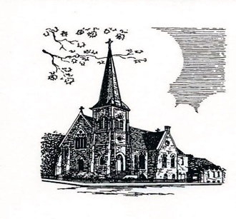

**Christ Episcopal Church**

**409 East High Street**

**Springfield, Ohio 45505**

**937-323-8651**

**www.christspringfield.org**