Good Friday
March 29th, 2024 at 7 pm
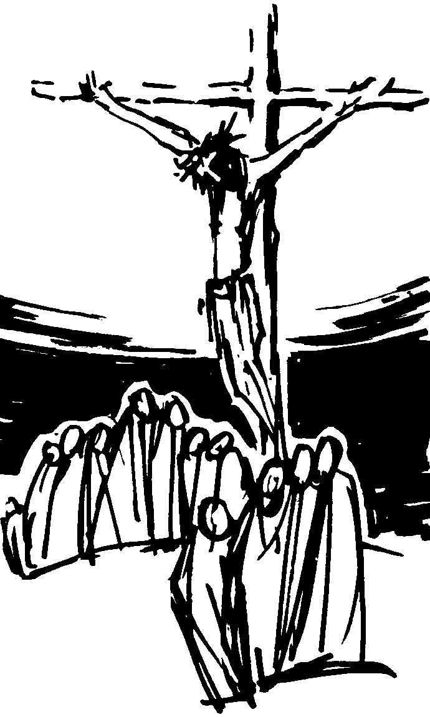

INFORMATION FOR NEWCOMERS: WELCOME TO CHRIST CHURCH!

Our motto is true whether you're here for the very first time
or you've been a member for decades –
There is a place for you at God's Table!

The worship service has two main parts: the Liturgy of the Word, which includes Scripture readings and a sermon, and the Liturgy of the Table, which is also called Holy Eucharist or Communion. You will notice moments in the service when people stand, kneel, bow, and make the sign of the cross. There is no one “right” way to worship, so do what is comfortable for you at any given time in worship.

All Baptized Christians are welcome at Christ’s Table for Communion. If you do not wish to receive communion, you may come forward and request a blessing. If you wish to receive communion in your pew, please notify the ushers. And if you need a gluten-free wafer, just let Rev. Michelle know.

If you have not been baptized, or if you have questions about Holy Baptism, please talk to The Rev. Dr. Michelle Boomgaard after the service -- the people of Christ Church would love to walk with you to your baptism and beyond!

When you enter a Christ Episcopal Church worship service/event, you will be entering an area where photography, video and audio recording may occur. Finally, if you are a visitor, please fill-out a Welcome Card on the back of the pew, so we can add you to our weekly information email the NewsNote.

THE LITURGY OF THE WORD
(The ministers enter in silence)
Celebrant: Blessed be our God,
People: Forever and ever. Amen.
Celebrant: Let us pray.
Almighty God, we pray you graciously to behold this your family, for whom our Lord Jesus Christ was willing to be betrayed, and given into the hands of sinners, and to suffer death upon the cross; who now lives and reigns with you and the Holy Spirit, one God, forever and ever. Amen.

Dieu Tout-Puissant, nous te prions de bien vouloir contempler ta famille, pour qui notre Seigneur Jésus-Christ était prêt à être trahi et livré entre les mains des pécheurs et à souffrir la mort sur la croix ; qui vit et règne maintenant avec vous et le Saint-Esprit, un seul Dieu, pour toujours et à jamais. Amen.

THE FIRST LESSON Isaiah 52:13-53:12
See, my servant shall prosper;
he shall be exalted and lifted up,
and shall be very high.
Just as there were many who were astonished at him
--so marred was his appearance, beyond human semblance,
and his form beyond that of mortals--
so he shall startle many nations;
kings shall shut their mouths because of him;
for that which had not been told them they shall see,
and that which they had not heard they shall contemplate.

Who has believed what we have heard?
And to whom has the arm of the Lord been revealed?
For he grew up before him like a young plant,
and like a root out of dry ground;
he had no form or majesty that we should look at him,
nothing in his appearance that we should desire him.
He was despised and rejected by others;
a man of suffering and acquainted with infirmity;
and as one from whom others hide their faces
he was despised, and we held him of no account.

Surely he has borne our infirmities
and carried our diseases;
yet we accounted him stricken,
struck down by God, and afflicted.
But he was wounded for our transgressions,
crushed for our iniquities;
upon him was the punishment that made us whole,
and by his bruises we are healed.
All we like sheep have gone astray;
we have all turned to our own way,
and the Lord has laid on him the iniquity of us all.
He was oppressed, and he was afflicted,
yet he did not open his mouth;
like a lamb that is led to the slaughter,
and like a sheep that before its shearers is silent,
so he did not open his mouth.
By a perversion of justice he was taken away.
Who could have imagined his future?
For he was cut off from the land of the living,
stricken for the transgression of my people.
They made his grave with the wicked
and his tomb with the rich,
although he had done no violence,
and there was no deceit in his mouth.

Yet it was the will of the Lord to crush him with pain.
When you make his life an offering for sin,
he shall see his offspring, and shall prolong his days;
through him the will of the Lord shall prosper.
Out of his anguish he shall see light;
he shall find satisfaction through his knowledge.
The righteous one, my servant, shall make many righteous,
and he shall bear their iniquities.
Therefore I will allot him a portion with the great,
and he shall divide the spoil with the strong;
because he poured out himself to death,
and was numbered with the transgressors;
yet he bore the sin of many,
and made intercession for the transgressors.
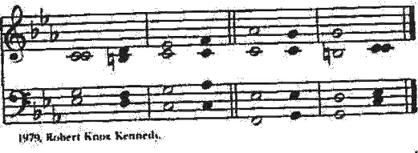
THE RESPONSE PSALM: 22

1 My God, my God, why have you forsaken me? *
and are so far from my cry and from the words of my distress?
2 O my God, I cry in the daytime, but you do not answer; *
by night as well, but I find no rest.
3 Yet you are the Holy One, *
enthroned upon the praises of Israel.
4 Our forefathers put their trust in you; *
they trusted, and you delivered them.
5 They cried out to you and were delivered; *
they trusted in you and were not put to shame.
6 But as for me, I am a worm and no man, *
scorned by all and despised by the people.
7 All who see me laugh me to scorn; *
they curl their lips and wag their heads, saying,
8 "He trusted in the Lord; let him deliver him; *
let him rescue him, if he delights in him."
9 Yet you are he who took me out of the womb, *
and kept me safe upon my mother's breast.
10 I have been entrusted to you ever since I was born; *
you were my God when I was still in my mother's womb.
11 Be not far from me, for trouble is near, *
and there is none to help.
12 Many young bulls encircle me; *
strong bulls of Bashan surround me.
13 They open wide their jaws at me, *
like a ravening and a roaring lion.
14 I am poured out like water; all my bones are out of joint; *
my heart within my breast is melting wax.
15 My mouth is dried out like a pot-sherd; my tongue sticks to the roof of my mouth; *
and you have laid me in the dust of the grave.
16 Packs of dogs close me in, and gangs of evildoers circle around me; *
they pierce my hands and my feet; I can count all my bones.
17 They stare and gloat over me; *
they divide my garments among them; they cast lots for my clothing.
18 Be not far away, O Lord; *
you are my strength; hasten to help me.
19 Save me from the sword, *
my life from the power of the dog.
20 Save me from the lion's mouth, *
my wretched body from the horns of wild bulls.
21 I will declare your Name to my brethren; *
in the midst of the congregation I will praise you.
22 Praise the Lord, you that fear him; *
stand in awe of him, O offspring of Israel; all you of Jacob's line, give glory.
23 For he does not despise nor abhor the poor in their poverty; neither does he hide his face from them;
but when they cry to him he hears them.
24 My praise is of him in the great assembly; *
I will perform my vows in the presence of those who worship him.
25 The poor shall eat and be satisfied, and those who seek the Lord shall praise him: *
"May your heart live forever!"
26 All the ends of the earth shall remember and turn to the Lord, *
and all the families of the nations shall bow before him.
27 For kingship belongs to the Lord; *
he rules over the nations.
28 To him alone all who sleep in the earth bow down in worship; *
all who go down to the dust fall before him.
29 My soul shall live for him; my descendants shall serve him; *
they shall be known as the Lord's forever.
30 They shall come and make known to a people yet unborn *
the saving deeds that he has done.
THE SECOND LESSON Hebrews 4:14-16; 5:7-9
Since, then, we have a great high priest who has passed through the heavens, Jesus, the Son of God, let us hold fast to our confession. For we do not have a high priest who is unable to sympathize with our weaknesses, but we have one who in every respect has been tested as we are, yet without sin. Let us therefore approach the throne of grace with boldness, so that we may receive mercy and find grace to help in time of need.

In the days of his flesh, Jesus offered up prayers and supplications, with loud cries and tears, to the one who was able to save him from death, and he was heard because of his reverent submission. Although he was a Son, he learned obedience through what he suffered; and having been made perfect, he became the source of eternal salvation for all who obey him.
Lector: The Word of the Lord.
People: Thanks be to God.

The Passion of Our Lord Jesus Christ according to John (18:1-19:42)

The congregation may be seated for the first part of the Passion.
At the verse which mentions the arrival at Golgotha all stand (as able).

Jesus went out with his disciples across the Kidron valley to a place where there was a garden, which he and his disciples entered. Now Judas, who betrayed him, also knew the place, because Jesus often met there with his disciples. So Judas brought a detachment of soldiers together with police from the chief priests and the Pharisees, and they came there with lanterns and torches and weapons.
Then Jesus, knowing all that was to happen to him, came forward and asked them, ‘For whom are you looking?’ They answered, ‘Jesus of Nazareth.’ Jesus replied, ‘I am he.’ Judas, who betrayed him, was standing with them. When Jesus said to them, ‘I am he,’ they stepped back and fell to the ground.
Again he asked them, ‘For whom are you looking?’ And they said, ‘Jesus of Nazareth.’ Jesus answered, ‘I told you that I am he. So if you are looking for me, let these men go.’ This was to fulfill the word that he had spoken, ‘I did not lose a single one of those whom you gave me.’
Then Simon Peter, who had a sword, drew it, struck the high priest’s slave, and cut off his right ear. The slave’s name was Malchus. Jesus said to Peter, ‘Put your sword back into its sheath. Am I not to drink the cup that the Father has given me?’
So the soldiers, their officer, and the Jewish police arrested Jesus and bound him. First they took him to Annas, who was the father-in-law of Caiaphas, the high priest that year. Caiaphas was the one who had advised them that it was better to have one person die for the people.
Simon Peter and another disciple followed Jesus. Since that disciple was known to the high priest, he went with Jesus into the courtyard of the high priest, but Peter was standing outside at the gate. So the other disciple, who was known to the high priest, went out, spoke to the woman who guarded the gate, and brought Peter in. The woman said to Peter, ‘You are not also one of this man’s disciples, are you?’ He said, ‘I am not.’
Now the slaves and the police had made a charcoal fire because it was cold, and they were standing around it and warming themselves. Peter also was standing with them and warming himself.
Then the high priest questioned Jesus about his disciples and about his teaching. Jesus answered, ‘I have spoken openly to the world; I have always taught in synagogues and in the temple, where all the people come together. I have said nothing in secret. Why do you ask me? Ask those who heard what I said to them; they know what I said.’
When he had said this, one of the police standing nearby struck Jesus on the face, saying, ‘Is that how you answer the high priest?’ Jesus answered, ‘If I have spoken wrongly, testify to the wrong. But if I have spoken rightly, why do you strike me?’ Then Annas sent him bound to Caiaphas the high priest.
Now Simon Peter was standing and warming himself. They asked him, ‘You are not also one of his disciples, are you?’ He denied it and said, ‘I am not.’ One of the slaves of the high priest, a relative of the man whose ear Peter had cut off, asked, ‘Did I not see you in the garden with him?’ Again Peter denied it, and at that moment the cock crowed.
Then they took Jesus from Caiaphas to Pilate’s headquarters. It was early in the morning. They themselves did not enter the headquarters, so as to avoid ritual defilement and to be able to eat the Passover. So Pilate went out to them and said, ‘What accusation do you bring against this man?’
They answered, ‘If this man were not a criminal, we would not have handed him over to you.’ Pilate said to them, ‘Take him yourselves and judge him according to your law.’ The people replied, ‘We are not permitted to put anyone to death.’ (This was to fulfill what Jesus had said when he indicated the kind of death he was to die.) Then Pilate entered the headquarters again, summoned Jesus, and asked him, ‘Are you the King of the Jews?’
Jesus answered, ‘Do you ask this on your own, or did others tell you about me?’
Pilate replied, ‘I am not a Jew, am I? Your own chief priests have handed you over to me. What have you done?’
Jesus answered, ‘My kingdom is not from this world. If my kingdom were from this world, my followers would be fighting to keep me from being handed over to death. But as it is, my kingdom is not from here.’
Pilate asked him, ‘So you are a king?’
Jesus answered, ‘You say that I am a king. For this I was born, and for this I came into the world, to testify to the truth. Everyone who belongs to the truth listens to my voice.’
Pilate asked him, ‘What is truth?’
After he had said this, he went out to the people again and told them, ‘I find no case against him. But you have a custom that I release someone for you at the Passover. Do you want me to release for you the King of the Jews?’ They shouted in reply, ‘Not this man, but Barabbas!’ Now Barabbas was a bandit.
Then Pilate took Jesus and had him flogged. And the soldiers wove a crown of thorns and put it on his head, and they dressed him in a purple robe. They kept coming up to him, saying, ‘Hail, King of the Jews!’ and striking him on the face.
Pilate went out again and said to them, ‘Look, I am bringing him out to you to let you know that I find no case against him.’ So Jesus came out, wearing the crown of thorns and the purple robe. Pilate said to them, ‘Here is the man!’ When the chief priests and the police saw him, they shouted, ‘Crucify him! Crucify him!’

Pilate said to them, ‘Take him yourselves and crucify him; I find no case against him.’ The people answered him, ‘We have a law, and according to that law he ought to die because he has claimed to be the Son of God.’

Now when Pilate heard this, he was more afraid than ever. He entered his headquarters again and asked Jesus, ‘Where are you from?’ But Jesus gave him no answer. Pilate therefore said to him, ‘Do you refuse to speak to me? Do you not know that I have power to release you, and power to crucify you?’
Jesus answered him, ‘You would have no power over me unless it had been given you from above; therefore the one who handed me over to you is guilty of a greater sin.’ From then on Pilate tried to release him, but the crowds cried out, ‘If you release this man, you are no friend of the emperor. Everyone who claims to be a king sets himself against the emperor.’
When Pilate heard these words, he brought Jesus outside and sat on the judge’s bench at a place called The Stone Pavement, or in Hebrew Gabbatha. Now it was the day of Preparation for the Passover; and it was about noon. He said to the people, ‘Here is your King!’ They cried out, ‘Away with him! Away with him! Crucify him!’ Pilate asked them, ‘Shall I crucify your King?’ The chief priests answered, ‘We have no king but the emperor.’ Then he handed him over to them to be crucified.
So they took Jesus; and carrying the cross by himself, he went out to what is called The Place of the Skull, which in Hebrew is called Golgotha. There they crucified him, and with him two others, one on either side, with Jesus between them. Pilate also had an inscription written and put on the cross. It read, ‘Jesus of Nazareth, the King of the Jews.’ Many people read this inscription, because the place where Jesus was crucified was near the city; and it was written in Hebrew, in Latin, and in Greek.
Then the chief priests said to Pilate, 'Do not write, “The King of the Jews”, but, “This man said, I am King of the Jews.”' Pilate answered, ‘What I have written I have written.’
When the soldiers had crucified Jesus, they took his clothes and divided them into four parts, one for each soldier. They also took his tunic; now the tunic was seamless, woven in one piece from the top. So they said to one another, ‘Let us not tear it, but cast lots for it to see who will get it.’ This was to fulfill what the scripture says,
‘They divided my clothes among themselves,
and for my clothing they cast lots.’
And that is what the soldiers did.
Meanwhile, standing near the cross of Jesus were his mother, and his mother’s sister, Mary the wife of Clopas, and Mary Magdalene. When Jesus saw his mother and the disciple whom he loved standing beside her, he said to his mother, ‘Woman, here is your son.’ Then he said to the disciple, ‘Here is your mother.’ And from that hour the disciple took her into his own home.
After this, when Jesus knew that all was now finished, he said (in order to fulfill the scripture), ‘I am thirsty.’ A jar full of sour wine was standing there. So they put a sponge full of the wine on a branch of hyssop and held it to his mouth. When Jesus had received the wine, he said, ‘It is finished.’ Then he bowed his head and gave up his spirit.
Since it was the day of Preparation, the chief priests did not want the bodies left on the cross during the sabbath, especially because that sabbath was a day of great solemnity. So they asked Pilate to have the legs of the crucified men broken and the bodies removed. Then the soldiers came and broke the legs of the first and of the other who had been crucified with him. But when they came to Jesus and saw that he was already dead, they did not break his legs.
Instead, one of the soldiers pierced his side with a spear, and at once blood and water came out. (He who saw this has testified so that you also may believe. His testimony is true, and he knows that he tells the truth.) These things occurred so that the scripture might be fulfilled, ‘None of his bones shall be broken.’ And again another passage of scripture says, ‘They will look on the one whom they have pierced.’
Sermon The Rev. Dr. Michelle Boomgaard
CHOIR ANTHEM: "See How He Dies!" - Lau

THE SOLEMN COLLECTS

Dear People of God: Our heavenly Father sent his Son into the world, not to condemn the world, but that the world through him might be saved; that all who believe in him might be delivered from the power of sin and death, and become heirs with him of everlasting life.

We pray, therefore, for people everywhere according to their needs.

Let us pray for the holy Catholic church of Christ throughout the world;
For its unity in witness and service
For all bishops and other ministers and the people whom they serve
For all Christians in Springfield and the surrounding communities
For all who seek God, or a greater knowledge of him
That God will confirm the Church in faith, increase it in love, and preserve it in peace.

[Silence]

Almighty and everlasting God, by whose Spirit the whole body of your faithful people is governed and sanctified: Receive our supplications and prayers which we offer before you for all members of your holy Church, that in their vocation and ministry they may truly and devoutly serve you; through our Lord and Savior Jesus Christ. Amen.

Let us pray for all nations and peoples of the earth, and for those in authority among them;
For the President of the United States
For the Congress and the Supreme Court
For the Members and Representatives of the United Nations
For all who serve the common good
That by God's help they may seek justice and truth, and live in peace and concord.

[Silence]

Almighty God, kindle, we pray, in every heart the true love of peace, and guide with your wisdom those who take counsel for the nations of the earth and especially for Ukraine; that in tranquility your dominion may increase, until the earth is filled with the knowledge of your love; through Jesus Christ our Lord. Amen.

Let us pray for all who suffer and are afflicted in body or in mind;
For the hungry and the homeless, the poor and the oppressed
For the sick, the wounded, and the disabled
For those in loneliness, fear, and anguish
For those who face temptation, addiction, doubt, and despair
For the sorrowful and bereaved
For prisoners and captives, and those in mortal danger
That God in his mercy will comfort and relieve them, and grant them the knowledge of his love, and stir up in us the will and patience to minister to their needs.

[Silence]

Gracious God, the comfort of all who sorrow, the strength of all who suffer: Let the cry of those in misery and need come to you, that they may find your mercy present with them in all their afflictions; and give us, we pray, the strength to serve them for the sake of him who suffered for us, your Son Jesus Christ our Lord. Amen.

Let us pray for all who have not received the Gospel of Christ;
For those who have never heard the word of salvation
For those who have lost their faith
For those hardened by sin, indifference
For the contemptuous and the scornful
For those who are enemies of the Cross of Christ and
persecutors of his disciples
For those who in the name of Christ have persecuted others
That God will open their hearts to the truth, and lead them to faith, obedience.

[Silence]

Merciful God, Creator of all the peoples of the earth and lover of souls: Have compassion on all who do not know you as you are revealed in your Son Jesus Christ; let your Gospel be preached with grace and power to those who have not heard it; turn the hearts of those who resist it; and bring home to your fold those who have gone astray; that there may be one flock under one shepherd, Jesus Christ our Lord. Amen.

Let us commit ourselves to our God, and pray for the grace of a holy life, that, with all who have departed this world and have died in the peace of Christ, and those whose faith is known to God alone, we may be accounted worthy to enter into the fullness of the joy of our Lord, and receive the crown of life in the day of resurrection.

[Silence]

O God of unchangeable power and eternal light: Look favorably on your whole Church, that wonderful and sacred mystery; by the effectual working of your providence, carry out in tranquility the plan of salvation; let the whole world see and know that things which were cast down are being raised up, and things which had grown old are being made new, and that all things are being brought to their perfection by him through whom all things were made, your Son Jesus Christ our Lord; who lives and reigns with you, in the unity of the Holy Spirit, one God, for ever and ever. Amen.

THE VENERATION OF THE CROSS
We glory in your cross, O Lord,
and praise and glorify your holy resurrection;
for by virtue of your cross
joy has come to the whole world.

May God be merciful to us and bless us,
show us the light of his countenance, and come to us.
Let your ways be known upon earth,
your saving health among all nations.

Let the peoples praise you, O God;
let all the peoples praise you.
We glory in your cross, O Lord,
and praise and glorify your holy resurrection;
for by virtue of your cross joy has come to the whole world.

We adore you, O Christ, and we bless you,
because by your holy cross you have redeemed the world.
If we have died with him, we shall also live with him;
if we endure, we shall also reign with him.
We adore you, O Christ, and we bless you,
because by your holy cross you have redeemed the world.
O Savior of the world, who by thy cross and precious blood hast redeemed us:
Save us and help us, we humbly beseech thee, O Lord.

HYMN: “Were You there when they crucified my Lord?” Hymnal 172

THE LORD'S PRAYER
And now, as our Savior Christ has taught us, we are bold to say,
Our Father, who art in heaven, Notre Père, qui es aux cieux,
hallowed be thy name, Que ton nom soit sanctifé;
thy kingdom come, thy will be done, Que ton règne vienne ; que ta volonté soit faite
on earth as it is in heaven. Sur la terre comme au ciel.
Give us this day our daily bread. Donne-nous aujourd’hui notre pain de ce jour.
And forgive us our trespasses, Pardonne-nous nos offenses,
as we forgive those who trespass against us. Comme nous pardonnons aussi À ceux qui nous ont offensés.
And lead us not into temptation, Et nous laisse pas entrer en tentation,
but deliver us from evil. Mais délivre-nous du mal.
For thine is the kingdom, Car c’est à toi qu’appartiennent le règne,
and the power, and the glory, La puissance et la gloire,
forever and ever. Amen. Pour les siècles des siècles. Amen.

THE CLOSING PRAYER
Lord Jesus Christ, Son of the living God, we pray you to set your passion, cross, and death between your judgment and our souls, now and in the hour of our death. Give mercy and grace to the living; pardon and rest to the dead; to your holy Church peace and concord; and to us sinners everlasting life and glory; for with the Father and Holy Spirit you live and reign, one God, now and forever. Amen.

The congregation departs in silence.

Please join Christ Church for The Feast of the Resurrection-March 31st ~ at 10 am for a Festive Rite II Service with the Choir and Brass on this holiest day of the Christian year, we rejoice at Christ's victory over the powers of death.

Ministers for March 29th, 2024
Altar Guild: Joan Hurley
Lectors: Anne Strothman and Fred Bartenstein
Usher: Angus Randolph

General Information
Rector: The Rev. Dr. Michelle Boomgaard
Senior Warden: Scott Yeazell
Junior Warden: Steve Sharp
Treasurer: Ken Bladh
Clerk of Vestry: Kelly Zeller
Vestry at Large: Joy Meyers, Marjory Wentworth, Anne Strothman,
Bill Hicks, Lori Swafford, and Rick Everingham
Parish Administrator & Program Coordinator: Kelly Zeller
Director of Music: Dr. Christopher Durrenberger
Facility Manager: Paul McAfee
Bookkeeper: Tina Knox

Christ Church has an option for online giving through the church’s website.
- Go to christspringfield.org or use the QR code
- Go to the tab in the upper right-hand corner marked “Online Giving”
- Click on the online giving link in blue
- Fill in the amount you would like to give
- Next, use the drop box Pledged Giving for a Pledge or Miscellaneous Giving for other giving
- If you choose Miscellaneous Giving, there is another memo drop box for the type of giving-choose one
- Fill out the rest of the form
- Press Continue
- On the next page, press continue
- Then enter your billing information
- Thank you!- If you have questions or concerns, please contact Kelly Zeller at zellerk0611@gmail.com.

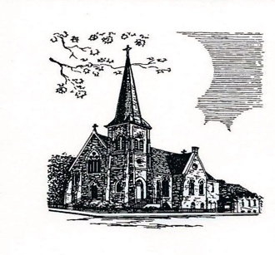

Christ Episcopal Church
409 East High Street
Springfield, Ohio 45505
937-323-8651
www.christspringfield.org

