**Twenty-Second Sunday after Pentecost**

**October 20th, 2024 at 10 am**

**The Holy Eucharist**



**++++++++++++++++++++++++++++++++++++++++++**

**INFORMATION FOR NEWCOMERS: WELCOME TO CHRIST CHURCH!**



Our motto is true whether you're here for the very first time

or you've been a member for decades –

**There is a place for you at God's Table!**

The worship service has two main parts: the Liturgy of the Word, which includes Scripture readings and a sermon, and the Liturgy of the Table, which is also called Holy Eucharist or Communion. You will notice moments in the service when people stand, kneel, bow, and make the sign of the cross. There is no one “right” way to worship, so do what is comfortable for you at any given time in worship.

All Baptized Christians are welcome at Christ’s Table for Communion. If you do not wish to receive communion, you may come forward and request a blessing. If you wish to receive communion in your pew, please notify the ushers. And if you need a gluten-free wafer, just let Rev. Michelle know.

If you have not been baptized, or if you have questions about Holy Baptism, please talk to The Rev. Dr. Michelle Boomgaard after the service -- the people of Christ Church would love to walk with you to your baptism and beyond!

When you enter a Christ Episcopal Church worship service/event, you will be entering an area where photography, video and audio recording may occur. Finally, if you are a visitor, please fill-out a *Welcome Card* on the back of the pew, so we can add you to our weekly information email the NewsNote.

**The Holy Eucharist: Rite II**

**PRELUDE:** “Jerusalem, My Happy Home” - *Land of Rest/*arr. Callahan

**OPENING HYMN**: “God is love, let heaven adore Him” Hymnal 379

**THE LITURGY OF THE WORD**

OPENING ACCLAMATION

Celebrant: Blessed be God: Father, Son, and Holy Spirit.

People: **And blessed be his kingdom, now and forever. Amen.**

COLLECT FOR PURITY

Almighty God, to you all hearts are open, all desires known, and from you no secrets are hid. Cleanse the

thoughts of our hearts by the inspiration of your Holy Spirit, that we may perfectly love you, and worthily

magnify your holy Name; through Christ our Lord. **Amen.**

GLORIA Hymnal S236

**Glory to you, Lord God of our fathers;**

**you are worthy of praise; glory to you.**

**Glory to you for the radiance of your holy Name;**

**we will praise you and highly exalt you forever.**

**Glory to you in the splendor of your temple;**

**on the throne of your majesty, glory to you.**

**Glory to you, seated between the Cherubim;**

**we will praise you and highly exalt you forever.**

**Glory to you, beholding the depths;**

**in the high vault of heaven, glory to you.**

**Glory to you, Father, Son, and Holy Spirit;  
we will praise you and highly exalt you forever.**

COLLECT OF THE DAY

Celebrant:The Lord be with you.

**People: And also with you.**

Celebrant: Let us pray.

Almighty and everlasting God, in Christ you have revealed your glory among the nations: Preserve the works of your mercy, that your Church throughout the world may persevere with steadfast faith in the confession of your Name; through Jesus Christ our Lord, who lives and reigns with you and the Holy Spirit, one God, forever and ever**. Amen.**

Dieu éternel et tout-puissant, en Christ tu as révélé ta gloire aux nations : préserve l’œuvre de ta miséricorde, afin que ton Église persévère dans le monde entier avec une foi inébranlable dans la confession de ton Nom ; par Jésus Christ, notre Seigneur, qui vit et règne avec toi et le Saint-Esprit, un seul Dieu, pour les siècles des siècles. ***Amen.***

**THE LESSONS**

**THE FIRST READING Job 38:1-7**

The Lord answered Job out of the whirlwind:

"Who is this that darkens counsel by words without knowledge?

Gird up your loins like a man,  
I will question you, and you shall declare to me.

"Where were you when I laid the foundation of the earth?  
Tell me, if you have understanding.

Who determined its measurements—surely you know!  
Or who stretched the line upon it?

On what were its bases sunk,  
or who laid its cornerstone

when the morning stars sang together  
and all the heavenly beings shouted for joy?

*Lector:* The Word of the Lord.

***People:* Thanks be to God**

THE RESPONSE~PSALM 104:1-9, 25, 37b

1 Bless the Lord, O my **soul; \***O Lord my God, how excellent is your greatness! you are clothed with majesty and **splendor.**

2 You wrap yourself with light as with a **cloak \***  
and spread out the heavens like a **curtain.**

3 You lay the beams of your chambers in the waters a**bove; \***  
you make the clouds your chariot; you ride on the wings of the **wind.**

4 You make the winds your **messengers \***  
and flames of fire your **servants.**

5 You have set the earth upon its foun**dations, \***  
so that it never shall move at any **time.**

6 You covered it with the Deep as with a **mantle; \***  
the waters stood higher than the **mountains**.

7 At your rebuke they **fled; \***  
at the voice of your thunder they hastened a**way.**

8 They went up into the hills and down to the valleys be**neath, \***  
to the places you had appointed for **them.**

9 You set the limits that they should not **pass; \***  
they shall not again cover the **earth.**

25 O Lord, how manifold are your **works! \***  
in wisdom you have made them all; the earth is full of your **creatures**.

37b Halle**lujah!**

**THE SECOND LESSON**  **Hebrews 5:1-10**

Every high priest chosen from among mortals is put in charge of things pertaining to God on their behalf, to offer gifts and sacrifices for sins. He is able to deal gently with the ignorant and wayward, since he himself is subject to weakness; and because of this he must offer sacrifice for his own sins as well as for those of the people. And one does not presume to take this honor, but takes it only when called by God, just as Aaron was.

So also Christ did not glorify himself in becoming a high priest, but was appointed by the one who said to him,

“You are my Son,   
today I have begotten you”;

as he says also in another place,

“You are a priest forever,   
according to the order of Melchizedek.”

In the days of his flesh, Jesus offered up prayers and supplications, with loud cries and tears, to the one who was able to save him from death, and he was heard because of his reverent submission. Although he was a Son, he learned obedience through what he suffered; and having been made perfect, he became the source of eternal salvation for all who obey him, having been designated by God a high priest according to the order of Melchizedek.

Lector: The Word of the Lord.

**People:** **Thanks be to God.**

**SEQUENCE HYMN:** “O Love of God, how strong and true” Hymnal 455

**GOSPEL**

Celebrant: The Holy Gospel of our Lord Jesus Christ according to Mark (**Mark 10:35-45**).

People: **Glory to you, Lord Christ.**

James and John, the sons of Zebedee, came forward to Jesus and said to him, “Teacher, we want you to do for us whatever we ask of you.” And he said to them, “What is it you want me to do for you?” And they said to him, “Grant us to sit, one at your right hand and one at your left, in your glory.” But Jesus said to them, “You do not know what you are asking. Are you able to drink the cup that I drink, or be baptized with the baptism that I am baptized with?” They replied, “We are able.” Then Jesus said to them, “The cup that I drink you will drink; and with the baptism with which I am baptized, you will be baptized; but to sit at my right hand or at my left is not mine to grant, but it is for those for whom it has been prepared.”

When the ten heard this, they began to be angry with James and John. So Jesus called them and said to them, “You know that among the Gentiles those whom they recognize as their rulers lord it over them, and their great ones are tyrants over them. But it is not so among you; but whoever wishes to become great among you must be your servant, and whoever wishes to be first among you must be slave of all. For the Son of Man came not to be served but to serve, and to give his life a ransom for many.”

Celebrant: The Gospel of the Lord.

**People: Praise to you, Lord Christ.**

*Sermon The Rev. Dr. Michelle Boomgaard*

**THE NICENE CREED SYMBOLE DE NICÉE**

**We believe in one God, the Father, the Almighty,** Nous croyons en un seul Dieu, le Père tout-puissant,

**maker of heaven and earth, of all that is,** Créateur du ciel et de la terre,

**seen and unseen. We believe in one Lord,** De toutes les choses visibles et invisibles.

**Jesus Christ, the only Son of God,** Nous croyons en un seul Seigneur, Jésus Christ,

**eternally begotten of the Father, God from God,** Le Fils unique de Dieu,

**Light from Light, true God from true God,** Endgendré du Père avant tous les siècles,

**begotten, not made, of one Being with the Father.** Dieu né de Dieu, Lumière née de la Lumière,

**Through him all things were made.** Vrai Dieu né du vrai Dieu, Engendré, non pas crée,

**For us and for our salvation he came down** Un seul être avec le Père, Et par lui tout a été fait.

**from heaven, by the power of the Holy Spirit** Pour nous et pour notre salut,

**he became incarnate from the Virgin Mary,** Il est descendu des cieux,

**and was made man. For our sake he was** Il s’est incarné par le saint-Esprit en la Vierge Marie,

**crucified under Pontius Pilate;** Et s’est fait homme. Crucifié pour nous sous Ponce Pilate,

**he suffered death and was buried.** Il a souffert la Passion,

**On the third day he rose again in accordance** Il a été mis au tombeau,

**with the Scriptures; he ascended into heaven** Il est ressuscité le troisième jour, selon les Écritures ;

**and is seated at the right hand of the Father.** Il est monté aux cieux,

**He will come again in glory to judge the living** Il siège à la droite du Père,

**and the dead, and his kingdom will have no end.** Il reviendra dans la gloire pour juger

**We believe in the Holy Spirit, the Lord,** les vivants et les morts,

**the giver of life, who proceeds from the Father,** Et son règne n’aura pas de fin.

**and the Son. With the Father and the Son he** Nous croyons en l’Esprit saint,

**is worshiped and glorified, He has spoken** Qui est Seigneur et qui donne la vie,

**through the Prophets. We believe in one holy** Que procède du Père et du Fils,

**catholic and apostolic Church.** Avec le Père et le Fils, il reçoit même

**We acknowledge one baptism** adoration et même gloire; Il a parlé par les Prophètes.

**for the forgiveness of sins.** Nous croyons en l’Église une, sainte,

**We look for the resurrection of the dead,** catholique et apostolique.

**and the life of the world to come. Amen.** Nous reconnaissons us seul baptême pour

le pardon des péchés. Nous attendons la résurrection des morts

Et la vie du monde à venir. Amen.

**THE PRAYERS OF THE PEOPLE**

In peace, we pray to you Lord God. (*Congregational responses are in* ***bold****)*

*Silence*

Blessed are you eternal God,  
**to be praised and glorified forever.**

Hear us as we pray for the unity of the Church.  
**May we all be one, that the world may come to know you.**

Grant that every member of the Church may truly and humbly serve you, especially in the Northwest Region cycle of prayer, we pray St. Mark’s, Dayton; St. George’s, Washington Township; St Mary’s Waynesville, and Christ Church, Springfield.

**That the life of Christ may be revealed in us.**

We remember those who have died.  
**Into your hands we commend them.**

We praise you for all your saints who have entered eternal glory.

**May we also come to share your heavenly kingdom.**

Have compassion on those who suffer from sickness, grief or trouble, especially Sharon B., Beth Harbaugh, Mary Allardyce, Marj Vasileff, Pat Duncan, Marilyn Howat, Jeanie Everingham, Bonnie Bingman, Anita Beardsell, Don Rode, Diana DeVoe, Sandi Eyman, Margaret Mattox, Joy Bartenstein, Dodi Holmes, Alice Kelly, Barb Kelly, and Traudie Milleck.  
**In your presence may they find strength.**

Look with kindness on our homes and families, and all who celebrate birthdays especially, Joan Hurley and Ann Chitkara, and anniversaries this week.

**Grant that your love may grow in our hearts.**

Make us alive to the needs of our community, and bless the holy work of Children’s Rescue Center/ The Ark, Christ Church Food Pantry, Habitat for Humanity, and Her Story.

**Help us to share one another’s joys and burdens.**

Inspire and lead those who hold authority in the nations of the world.  
**Guide us and all people in the way of justice and peace.**

For Justin, Archbishop of Canterbury; Michael, our Presiding Bishop; Sean, our Presiding Bishop-elect; Kristin, our Bishop, and Michelle, our Priest; all bishops and other ministers.  
**Inspire us and give us courage to proclaim your Gospel of Resurrection.**

*The celebrant adds a concluding collect.*

THE CONFESSION AND ABSOLUTION

Celebrant: Let us confess our sins against God and our neighbor.

**All: Most merciful God, we confess that we have sinned against you in thought, word, and deed, by what we have done, and by what we have left undone. We have not loved you with our whole heart; we have not loved our neighbors as ourselves. We are truly sorry and we humbly repent. For the sake of your Son Jesus Christ, have mercy on us and forgive us; that we may delight in your will, and walk in your ways, to the glory of your Name. Amen.**

Celebrant: Almighty God have mercy on you, forgive you all your sins through our Lord Jesus Christ, strengthen you in all goodness, and by the power of the Holy Spirit keep you in eternal life. ***Amen.***

THE PEACE

ANNOUNCEMENTS

OFFERTORY: “Morning Has Broken” - arr. Larson

PRESENTATION OF THE GIFTSHymnal 380, v. 3

**Praise God from whom all blessings flow;**

**praise him, all creatures here below;**

**praise him above, ye heavenly host:**

**praise Father, Son and Holy Ghost**

THE GREAT THANKSGIVING: EUCHARISTIC PRAYER A

The Lord be with you.

*People* **And****also with you.**

*Celebrant* Lift up your hearts.

*People* **We lift them to the Lord.**

*Celebrant* Let us give thanks to the Lord our God.

*People* **It is right to give him thanks and praise.**

It is right, and a good and joyful thing, always and everywhere to give thanks to you, Father Almighty, Creator of heaven and earth. For you are the source of light and life, you made us in your image, and called us to new life in Jesus Christ our Lord.

Therefore we praise you, joining our voices with Angels and Archangels and with all the company of heaven, who forever sing this hymn to proclaim the glory of your Name:

**Holy, Holy, Holy Lord, God of power and might,** Hymnal S130 **heaven and earth are full of your glory.  
Hosanna in the highest. Hosanna in the highest.**

**Blessed is he who comes in the name of the Lord.  
Hosanna in the highest. Hosanna in the highest.**

Holy and gracious Father: In your infinite love you made us for yourself; and, when we had fallen into sin and become subject to evil and death, you, in your mercy, sent Jesus Christ, your only and eternal Son, to share our human nature, to live and die as one of us, to reconcile us to you, the God and Father of all.

He stretched out his arms upon the cross, and offered himself in obedience to your will, a perfect sacrifice for the whole world.

On the night he was handed over to suffering and death, our Lord Jesus Christ took bread; and when he had given thanks to you, he broke it, and gave it to his disciples, and said, “Take, eat: This is my Body, which is given for you. Do this for the remembrance of me.”

After supper he took the cup of wine; and when he had given thanks, he gave it to them, and said, “Drink this, all of you: This is my Blood of the new Covenant, which is shed for you and for many for the forgiveness of sins. Whenever you drink it, do this for the remembrance of me.”

Therefore we proclaim the mystery of faith:

**Christ has died.**

**Christ is risen.**

**Christ will come again.**

We celebrate the memorial of our redemption, O Father, in this sacrifice of praise and thanksgiving. Recalling his death, resurrection, and ascension, we offer you these gifts.

Sanctify them by your Holy Spirit to be for your people the Body and Blood of your Son, the holy food and drink of new and unending life in him. Sanctify us also that we may faithfully receive this holy Sacrament, and serve you in unity, constancy, and peace; and at the last day bring us with all your saints into the joy of your eternal kingdom.

### All this we ask through your Son Jesus Christ. By him, and with him, and in him, in the unity of the Holy Spirit all honor and glory is yours, Almighty Father, now and forever. **Amen.**

And now, as our Savior Christ has taught us, we are bold to say,

**Our Father, who art in heaven, Notre Père, qui es aux cieux,**

**hallowed be thy name, Que ton nom soit sanctifé;**

**thy kingdom come, thy will be done, Que ton règne vienne ; que ta volonté soit faite**

**on earth as it is in heaven. Sur la terre comme au ciel.**

**Give us this day our daily bread. Donne-nous aujourd’hui notre pain de ce jour.**

**And forgive us our trespasses, Pardonne-nous nos offenses,**

**as we forgive those who trespass against us. Comme nous pardonnons aussi À ceux qui nous ont offensés.**

**And lead us not into temptation, Et nous laisse pas entrer en tentation,**

**but deliver us from evil. Mais délivre-nous du mal.**

**For thine is the kingdom, Car c’est à toi qu’appartiennent le règne,**

**and the power, and the glory, La puissance et la gloire,**

**forever and ever. Amen. Pour les siècles des siècles. Amen.**

THE BREAKING OF THE BREAD Hymnal S164

**Jesus, Lamb of God, have mercy on us.**

**Jesus, bearer of our sins, have mercy on us.**

**Jesus, redeemer, redeemer of the world,**

**Give us your peace. Give us your peace.**

THE INVITATION TO COMMUNION

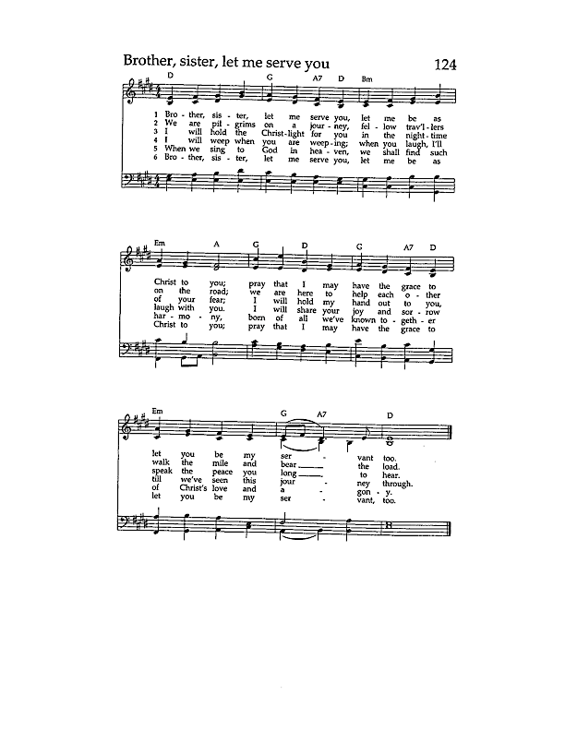**COMMUNION HYMN:** “Brother, Sister, let me serve you”

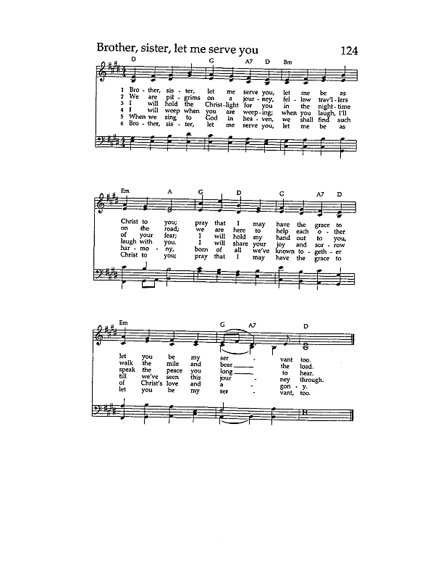



PRAYER AFTER COMMUNION- Celebrant and people together

**Eternal God, heavenly Father, you have graciously accepted us as living members of your Son our Savior Jesus Christ, and you have fed us with spiritual food  in the Sacrament of his Body and Blood. Send us now into the world in peace, and grant us strength and courage to love and serve you with gladness and singleness of heart; through Christ our Lord. Amen.**

THE BLESSING

The peace of God, which passes all understanding, keep your hearts and minds in the knowledge and love of God, and of his Son Jesus Christ our Lord; and the blessing of God Almighty, Father, Son and Holy Spirit, be among you, and remain with you always.  ***Amen.***

**CLOSING HYMN:** “Alleluia! Sing to Jesus” Hymnal 460

THE DISMISSAL Celebrant: Go in peace to love and serve the Lord.

People: **Thanks be to God.**

**POSTLUDE:** “Prelude III’ - from *Three Preludes* - Gershwin

**Altar Flowers**

In memory of Joseph Strothman by Anne Strothman.

**Announcements from Christ Church**

**Pastoral emergencies**

If you need to reach Rev. Michelle for a pastoral emergency, the number is (937) 505-0141. For non-emergencies, you can call the office at (937) 323-8651 or email Rev. Michelle at [mboomgaard@christspringfield.org](mailto:mboomgaard@christspringfield.org).

**Thank you to all the Food Pantry Volunteers!**

At the October Food Pantry, we served 149 households representing 479 individuals! The clients were offered chicken, chicken chunks, ham, soup, fish, ground beef, roasts, cheese, fresh produce, can goods, and a few treats~ chips, cookies, and the extras of toilet paper, cleaning supplies, pet food, and toiletries. The clients are always grateful, and volunteers have a good time! Please consider joining us if you have an hour or two!

**Toilet Paper, Pet Food, And Laundry Detergent!**

What do these items have in common? These are the three items most requested by Food Pantry clients, and none of the three can be purchased with the SNAP card. We are the only Food Pantry that offers toilet paper, and the clients often ask when they first arrive if we have it that day. The rising costs of Pet food are hurting some of our senior clients on a fixed income. One client comes with his dog at 4:30 am and hopes we have dog food on the miscellaneous table. Laundry detergent and cleaning supplies are expensive items; client are very grateful when we have these items on distribution day. Your contributions are greatly appreciated and really make a difference!! Thank you!

**Taize Service**

**Sunday, October 27, 5:00 p.m., Christ Episcopal Church**. Experience worship in a candle-lit sanctuary with peaceful music, contemplative prayer, scripture readings, and silent reflection. People of all expressions of faith are welcome. There will be a potluck after the service. For more information, contact Rev. Michelle at mboomgaard@christspringfield.org.

**All Saints’ Day November 3rd, 2024~ Last day to get your loved ones names to Kelly Zeller!**

Please submit any names of family, friends, and loved ones that are deceased that you would like included in our Prayers of the People on All Saints’ Day **by October 20th.** You can submit names of your saints by emailing Kelly Zeller at zellerk0611@gmail.com, by dropping the names in the giving plate, or by mailing them to the Parish office at 409 East High Street, Springfield, Ohio 45505. Please include the information shown on the form below.

Your name: ___________________________________________________________

Name of loved one(s): ___________________________________________________ _____________________________________________________________________ _____________________________________________________________________ _____________________________________________________________________

**Ministers for October 20th, 2024**

**Altar Guild:** Joan Hurley

**Chalice:** Mary Allardyce

**Lector:** Liz Wheeler

**Ushers:** Dan McGregor, Angus Randolph, and Brian Drew

**Videographer:** Truss, Inc.

**Children’s Chapel:** Kelly Zeller

**Coffee Hour Host:** Jillian and Brian Drew

**General Information**

**Priest:** The Rev. Dr. Michelle Boomgaard

**Senior Warden**: Scott Yeazell

**Junior Warden**: Steve Sharp

**Treasurer**: Ken Bladh

**Clerk of Vestry:** Kelly Zeller

**Vestry at Large**: Joy Meyers, Marjory Wentworth, Anne Strothman,

Bill Hicks, Lori Swafford, and Rick Everingham

**Parish Administrator & Program Coordinator**: Kelly Zeller

**Director of Music**: Dr. Christopher Durrenberger

**Nursery Attendant:** Madison Smith

**Facility Manager**: Paul McAfee

**Bookkeeper:** Tina Knox

**Christ Church has an option for online giving through the church’s website.**

* Go to christspringfield.org or use the QR code
* Go to the tab in the upper right-hand corner marked “Online Giving”
* Click on the online giving link in blue
* Fill in the amount you would like to give
* Next, use the drop box Pledged Giving for a Pledge or Miscellaneous Giving for other giving
* If you choose Miscellaneous Giving, there is another memo drop box for the type of giving-choose one
* Fill out the rest of the form
* Press Continue
* On the next page, press **continue**
* Then enter your billing information
* Thank you!- If you have questions or concerns, please contact Kelly Zeller at [zellerk0611@gmail.com](mailto:zellerk0611@gmail.com)

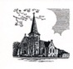

**Christ Episcopal Church**

**409 East High Street**

**Springfield, Ohio 45505**

**937-323-8651**

**www.christspringfield.org**