**The Day of Pentecost**

**June 8th, 2025 at 10 am**

**The Holy Eucharist: Rite II and Holy Baptism**

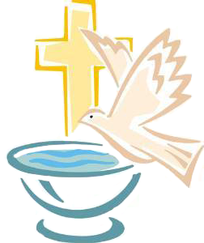

**++++++++++++++++++++++++++++++++++++++++++**

**INFORMATION FOR NEWCOMERS: WELCOME TO CHRIST CHURCH!**

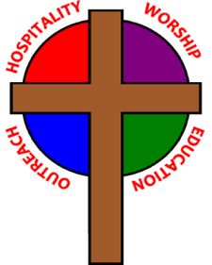

Our motto is true whether you're here for the very first time

or you've been a member for decades –

**There is a place for you at God's Table!**

The worship service has two main parts: the Liturgy of the Word, which includes Scripture readings and a sermon, and the Liturgy of the Table, which is also called Holy Eucharist or Communion. You will notice moments in the service when people stand, kneel, bow, and make the sign of the cross. There is no one “right” way to worship, so do what is comfortable for you at any given time in worship.

All Baptized Christians are welcome at Christ’s Table for Communion. If you do not wish to receive communion, you may come forward and request a blessing. If you wish to receive communion in your pew, please notify the ushers. And if you need a gluten-free wafer, just let Rev. Michelle know.

If you have not been baptized, or if you have questions about Holy Baptism, please talk to The Rev. Dr. Michelle Boomgaard after the service -- the people of Christ Church would love to walk with you to your baptism and beyond!

When you enter a Christ Episcopal Church worship service/event, you will be entering an area where photography, video and audio recording may occur. Finally, if you are a visitor, please fill-out a *Welcome Card* on the back of the pew, so we can add you to our weekly information email the NewsNote.

**The Holy Eucharist Rite II**

**PRELUDE:**  "Sonata in D minor" K. 9 - Scarlatti

**OPENING HYMN**: “Hail thee, festival day!” Hymnal 225

**THE LITURGY OF THE WORD**

Celebrant Alleluia! Christ is risen

People The lord is risen indeed. Alleluia!

Celebrant There is one Body and one Spirit;

People There is one hope in God's call to us;

Celebrant One Lord, one Faith, one Baptism;

People One God and Father of all.

Celebrant The Lord be with you.

People And also with you.

Celebrant Let us pray.

Almighty God, on this day you opened the way of eternal life to every race and nation by the promised gift of your Holy Spirit: Shed abroad this gift throughout the world by the preaching of the Gospel, that it may reach to the ends of the earth; through Jesus Christ our Lord, who lives and reigns with you, in the unity of the Holy Spirit, one God, for ever and ever. ***Amen****.*

Dieu tout-poussant, tu as ouvert en ce jour le chemin de la vie éternelle à toutes les races et nations par le don announcé de ton Esprit saint : répands ce don dans le monde entier par la prédication de l’Évangile, afin qu’il atteigne les extrémités de la terre ; par Jésus Christ, notre Seigneur, qui vit et règne avec toi, dans l’unité du Saint-Esprit, un seul Dieu, pour les siècles des siècles. ***Amen.***

**THE LESSON** (*read in multiple languages)*

**THE FIRST READING Acts 2:1-21**

When the day of Pentecost had come, the disciples were all together in one place. And suddenly from heaven there came a sound like the rush of a violent wind, and it filled the entire house where they were sitting. Divided tongues, as of fire, appeared among them, and a tongue rested on each of them. All of them were filled with the Holy Spirit and began to speak in other languages, as the Spirit gave them ability.

Now there were devout Jews from every nation under heaven living in Jerusalem. And at this sound the crowd gathered and was bewildered, because each one heard them speaking in the native language of each. Amazed and astonished, they asked, "Are not all these who are speaking Galileans? And how is it that we hear, each of us, in our own native language? Parthians, Medes, Elamites, and residents of Mesopotamia, Judea and Cappadocia, Pontus and Asia, Phrygia and Pamphylia, Egypt and the parts of Libya belonging to Cyrene, and visitors from Rome, both Jews and proselytes, Cretans and Arabs-- in our own languages we hear them speaking about God's deeds of power." All were amazed and perplexed, saying to one another, "What does this mean?" But others sneered and said, "They are filled with new wine."

But Peter, standing with the eleven, raised his voice and addressed them, "Men of Judea and all who live in Jerusalem, let this be known to you, and listen to what I say. Indeed, these are not drunk, as you suppose, for it is only nine o'clock in the morning. No, this is what was spoken through the prophet Joel:

`In the last days it will be, God declares,

that I will pour out my Spirit upon all flesh,  
and your sons and your daughters shall prophesy,

and your young men shall see visions,  
and your old men shall dream dreams.

Even upon my slaves, both men and women,  
in those days I will pour out my Spirit;  
and they shall prophesy.

And I will show portents in the heaven above  
and signs on the earth below, blood, and fire, and smoky mist.

The sun shall be turned to darkness and the moon to blood,  
before the coming of the Lord's great and glorious day.

Then everyone who calls on the name of the Lord shall be saved.' "

Lector: The Word of the Lord.

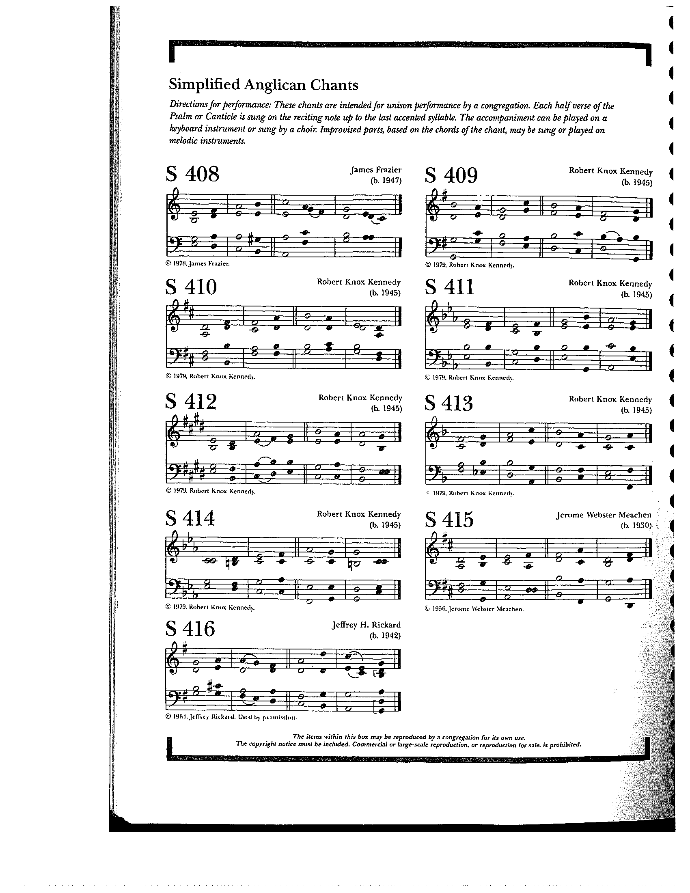**People: Thanks be to God**

THE RESPONSE PSALM 104:25-35, 37

25 O Lord, how manifold are your **works! \***  
in wisdom you have made them all; the earth is full of your **creatures.**

26 Yonder is the great and wide sea with its living things too many to **number, \***  
creatures both small and **great.**

27 There move the ships, and there is that Le**viathan, \***  
which you have made for the sport of **it.**

28 All of them look to **you \***  
to give them their food in due **season.**

29 You give it to them; they gather **it; \***  
you open your hand, and they are filled with good **things.**

30 You hide your face, and they are **terrified;** *  
you take away their breath, and they die and return to their **dust.**

31 You send forth your Spirit, and they are **created; \***  
and so you renew the face of the **earth.**

32 May the glory of the Lord endure for**ever; \***  
may the Lord rejoice in all his **works.**

33 He looks at the earth and it **trembles; \***  
he touches the mountains and they **smoke.**

34 I will sing to the Lord as long as I **live; \***  
I will praise my God while I have my **being.**

35 May these words of mine please **him; \***  
I will rejoice in the **Lord.**

37 Bless the Lord, O my **soul. \***  
Hal**lelujah!**

**GOSPEL**

Celebrant: The Holy Gospel of our Lord Jesus Christ according to John (**John 14:8-17, 25-27**).

People: **Glory to you, Lord Christ.**

Philip said to Jesus, "Lord, show us the Father, and we will be satisfied." Jesus said to him, "Have I been with you all this time, Philip, and you still do not know me? Whoever has seen me has seen the Father. How can you say, `Show us the Father'? Do you not believe that I am in the Father and the Father is in me? The words that I say to you I do not speak on my own; but the Father who dwells in me does his works. Believe me that I am in the Father and the Father is in me; but if you do not, then believe me because of the works themselves. Very truly, I tell you, the one who believes in me will also do the works that I do and, in fact, will do greater works than these, because I am going to the Father. I will do whatever you ask in my name, so that the Father may be glorified in the Son. If in my name you ask me for anything, I will do it.

"If you love me, you will keep my commandments. And I will ask the Father, and he will give you another Advocate, to be with you forever. This is the Spirit of truth, whom the world cannot receive, because it neither sees him nor knows him. You know him, because he abides with you, and he will be in you."

"I have said these things to you while I am still with you. But the Advocate, the Holy Spirit, whom the Father will send in my name, will teach you everything, and remind you of all that I have said to you. Peace I leave with you; my peace I give to you. I do not give to you as the world gives. Do not let your hearts be troubled, and do not let them be afraid."

Celebrant: The Gospel of the Lord.

***People:* Praise to you, Lord Christ.**

*Sermon The Rev. Dr. Michelle Boomgaard*

**+ + +**

**THE BAPTISM OF TATUM JEANNE DREW AND THOMAS GATES DREW**

**PRESENTATION AND EXAMINATION OF THE CANDIDATE**

Celebrant The Candidates for Holy Baptism will now be presented.

Parents and Godparents **I present Tatum and Gates to receive the Sacrament of Baptism.**

Celebrant Will you be responsible for seeing that these children you present

are brought up in the Christian faith and life?

Parents and Godparents **I will, with God's help.**

Celebrant Will you by your prayers and witness help these children to grow

into the full stature of Christ?

Parents and Godparents **I will, with God's help.**

Question Do you renounce Satan and all the spiritual forces

of wickedness that rebel against God?

Parents **I renounce them.**

Question Do you renounce the evil powers of this world

which corrupt and destroy the creatures of God?

Parents **I renounce them.**

Question Do you renounce all sinful desires that draw you

from the love of God?

Parents **I renounce them.**

Question Do you turn to Jesus Christ and accept him as your

Savior?

Parents **I do.**

Question Do you put your whole trust in his grace and love?

Parents **I do.**

Question Do you promise to follow and obey him as your Lord?

Parents **I do.**

Question Will you who witness these vows do all in your power to support these people in

their lives in Christ?

People **We will.**

Let us join with these children who are committing themselves to Christ and renew our own baptismal covenant.

**THE BAPTISMAL COVENANT**

Celebrant:Do you believe in God the Father?

*(Croyez-vous en Dieu le Père ?)*People: **I believe in God, the Father almighty, creator of heaven and earth.**

Celebrant: Do you believe in Jesus Christ, the Son of God?

*(Croyez-vous en Jésus Christ, le Fils de Dieu ?)*People: **I believe in Jesus Christ, his only Son, our Lord.**

**He was conceived by the power of the Holy Spirit and born of the Virgin Mary.  
 He suffered under Pontius Pilate, was crucified, died, and was buried.**

**He descended to the dead. On the third day he rose again.  
 He ascended into heaven, and is seated at the right hand of the Father.  
 He will come again to judge the living and the dead.**

Celebrant: Do you believe in God the Holy Spirit?

*(Croyez-vous en Dieu le Saint-Esprit ?)*

People: **I believe in the Holy Spirit, the holy catholic Church,  
 the communion of saints, the forgiveness of sins,  
 the resurrection of the body, and the life everlasting.**

Celebrant: Will you continue in the apostles’ teaching and fellowship, in the breaking of bread, and in the prayers?

*(Vous appliquerez-vous fidèlement à écouter l’enseignement que donnaient les apôtres, à vivre dans la*

*communion fraternelle, à partager ensemble le pain et à participer aux prières ?)*

People: **I will, with God’s help.**

Celebrant:Will you persevere in resisting evil, and, whenever you fall into sin, repent and return to the Lord?

*(Continuerez-vous à résister au mal et, quand vous pécherez, vous repentirez-vous et reviendrezvous vers le Seigneur ?)*

People: **I will, with God’s help.**

Celebrant: Will you proclaim by word and example the Good News of God in Christ?

*(Proclamerez-vous par la parole et par l’exemple la bonne nouvelle de Dieu en Christ ?)*

People: **I will, with God’s help.**

Celebrant: Will you seek and serve Christ in all persons, loving your neighbor as yourself?

*(Chercherez-vous à servir le Christ dans chaque personne, en aimant votre prochain comme vous-mêmes ?)*

People: **I will, with God’s help.**

Celebrant: Will you strive for justice and peace among all people, and respect the dignity of the Earth, and every human being?

*(Ferez-vous grandir la justice et la paix entre tous les êtres humains, et respecterez-vous la dignité la Terre, et de chaque personne ?)*

People: **I will, with God’s help.**

**THE PRAYERS FOR THE CANDIDATES**

Celebrant: Let us now pray for Tatum and Gates, who are to receive the Sacrament of new birth.

Celebrant: Deliver them, O Lord, from the way of sin and death.

People: **Lord, hear our prayer**.

Celebrant: Open their hearts to your grace and truth.

People: **Lord, hear our prayer**.

Celebrant: Fill them with your holy and life-giving Spirit.

People: **Lord, hear our prayer**.

Celebrant: Keep them in the faith and communion of your holy Church.

People: **Lord, hear our prayer**.

Celebrant: Teach them to love others in the power of the Spirit.

People: **Lord, hear our prayer.**

Celebrant: Send them into the world in witness to your love.

People: **Lord, hear our prayer.**

Celebrant: Bring them to the fullness of your peace and glory.

People: **Lord, hear our prayer.**

Celebrant: Grant, O Lord, that all who are baptized into the death of Jesus Christ your Son may live in the power of his resurrection and look for him to come again in glory; who lives and reigns now and forever. **Amen**.

**THE THANKSGIVING OVER THE WATER**

Celebrant: The Lord be with you.

People: **And also with you.**

Celebrant: Let us give thanks to the Lord our God.

People: **It is right to give him thanks and praise.**

We thank you, Almighty God, for the gift of water. Over it the Holy Spirit moved in the beginning of creation.  
Through it you led the children of Israel out of their bondage in Egypt into the land of promise. In it your Son Jesus received the baptism of John and was anointed by the Holy Spirit as the Messiah, the Christ, to lead us, through his death and resurrection, from the bondage of sin into everlasting life.

We thank you, Father, for the water of Baptism. In it we are buried with Christ in his death. By it we share in his resurrection. Through it we are reborn by the Holy Spirit. Therefore in joyful obedience to your Son, we bring into his fellowship those who come to him in faith, baptizing them in the Name of the Father, and of the Son, and of the Holy Spirit.

Now sanctify this water, we pray you, by the power of your Holy Spirit, that those who here are cleansed from sin and born again may continue forever in the risen life of Jesus Christ our Savior. To him, to you, and to the Holy Spirit, be all honor and glory, now and forever. **Amen.**

**THE BAPTISM AND ANOINTING**

Tatum, I baptize you in the Name of the Father, and of the Son, and of the Holy Spirit. **Amen.**

Gates, I baptize you in the Name of the Father, and of the Son, and of the Holy Spirit. **Amen.**

Let us pray.

Heavenly Father, we thank you that by water and the Holy Spirit you have bestowed upon your servants the forgiveness of sin, and have raised them to the new life of grace. Sustain them, O Lord, in your Holy Spirit. Give them an inquiring and discerning hearts, the courage to will and to persevere, a spirit to know and to love you, and the gift of joy and wonder in all your works. **Amen.**

Tatum, you are sealed by the Holy Spirit in Baptism and marked as Christ’s own forever. **Amen.**

Gates, you are sealed by the Holy Spirit in Baptism and marked as Christ’s own forever. **Amen.**

Celebrant: Let us welcome the newly baptized.

People: **We receive you into the household of God. Confess the faith of Christ crucified, proclaim his resurrection, and share with us in his eternal priesthood.**

THE PEACE

ANNOUNCEMENTS

OFFERTORY:  "Spirit, Sing" - Martin

PRESENTATION OF THE GIFTSHymnal 380, v. 3

**Praise God from whom all blessings flow;**

**praise him, all creatures here below;**

**praise him above, ye heavenly host:**

**praise Father, Son and Holy Ghost**

**THE HOLY COMMUNION**

THE GREAT THANKSGIVING: EUCHARISTIC PRAYER A

The Lord be with you.

*People* **And****also with you.**

*Celebrant* Lift up your hearts.

*People* **We lift them to the Lord.**

*Celebrant* Let us give thanks to the Lord our God.

*People* **It is right to give him thanks and praise.**

It is right, and a good and joyful thing, always and everywhere to give thanks to you, Father Almighty, Creator of heaven and earth. Through Jesus Christ our Lord. In fulfillment of his true promise, the Holy Spirit came down from heaven, lighting upon the disciples, to teach them and to lead them into all truth; uniting peoples of many tongues in the confession of one faith, and giving to your Church the power to serve you as a royal priesthood, and to preach the Gospel to all nations.

Therefore we praise you, joining our voices with Angels and Archangels and with all the company of heaven, who forever sing this hymn to proclaim the glory of your Name:

**Holy, holy, holy Lord, God of power and might,** Hymnal S129

**heaven and earth are full of your glory.**

**Hosanna in the highest.**

**Blessed is he who comes in the name of the Lord.**

**Hosanna in the highest.**

Holy and gracious Father: In your infinite love you made us for yourself; and, when we had fallen into sin and become subject to evil and death, you, in your mercy, sent Jesus Christ, your only and eternal Son, to share our human nature, to live and die as one of us, to reconcile us to you, the God and Father of all.

He stretched out his arms upon the cross, and offered himself in obedience to your will, a perfect sacrifice for the whole world.

On the night he was handed over to suffering and death, our Lord Jesus Christ took bread; and when he had given thanks to you, he broke it, and gave it to his disciples, and said, “Take, eat: This is my Body, which is given for you. Do this for the remembrance of me.”

After supper he took the cup of wine; and when he had given thanks, he gave it to them, and said, “Drink this, all of you: This is my Blood of the new Covenant, which is shed for you and for many for the forgiveness of sins. Whenever you drink it, do this for the remembrance of me.”

Therefore we proclaim the mystery of faith:

**Christ has died.**

**Christ is risen.**

**Christ will come again.**

We celebrate the memorial of our redemption, O Father, in this sacrifice of praise and thanksgiving. Recalling his death, resurrection, and ascension, we offer you these gifts.

Sanctify them by your Holy Spirit to be for your people the Body and Blood of your Son, the holy food and drink of new and unending life in him. Sanctify us also that we may faithfully receive this holy Sacrament, and serve you in unity, constancy, and peace; and at the last day bring us with all your saints into the joy of your eternal kingdom.

All this we ask through your Son Jesus Christ. By him, and with him, and in him, in the unity of the Holy Spirit all honor and glory is yours, Almighty Father, now and forever. **Amen.**

And now, as our Savior Christ has taught us, we are bold to say,

**Our Father, who art in heaven, Notre Père, qui es aux cieux,**

**hallowed be thy name, Que ton nom soit sanctifé;**

**thy kingdom come, thy will be done, Que ton règne vienne ; que ta volonté soit faite**

**on earth as it is in heaven. Sur la terre comme au ciel.**

**Give us this day our daily bread. Donne-nous aujourd’hui notre pain de ce jour.**

**And forgive us our trespasses, Pardonne-nous nos offenses,**

**as we forgive those who trespass against us. Comme nous pardonnons aussi À ceux qui nous ont offensés.**

**And lead us not into temptation, Et nous laisse pas entrer en tentation,**

**but deliver us from evil. Mais délivre-nous du mal.**

**For thine is the kingdom, Car c’est à toi qu’appartiennent le règne,**

**and the power, and the glory, La puissance et la gloire,**

**forever and ever. Amen. Pour les siècles des siècles. Amen.**

THE BREAKING OF THE BREAD Hymnal S155

**Alleluia, alleluia, alleluia.**

**Christ our Passover is sacrificed for us;**

**therefore let us keep the feast.**

**Alleluia, alleluia, alleluia.**

THE INVITATION TO COMMUNION

**COMMUNION HYMN:** "Baptized in Water"

1.Baptized in water, sealed by the Spirit,

Cleansed by the blood of Christ our King:

Heirs of salvation, trusting his promise,

Faithfully now God's praise we sing.

2.Baptized in water, sealed by the Spirit,

Dead in the tomb with Christ our King:

One with his rising, freed and forgiven,

Thankfully now God's praise we sing.

3.Baptized in water, sealed by the Spirit,

Marked with the sign of Christ our King:

Born of one Father, we are his children,

Joyfully now God's praise we sing.

PRAYER AFTER COMMUNION- Celebrant and people together

**Eternal God, heavenly Father, you have graciously accepted us as living members of your Son our Savior Jesus Christ, and you have fed us with spiritual food  in the Sacrament of his Body and Blood. Send us now into the world in peace, and grant us strength and courage to love and serve you with gladness and singleness of heart; through Christ our Lord. Amen.**

THE BLESSING

The God of peace, who brought again from the dead our Lord Jesus Christ, the great Shepherd of the sheep, through the blood of the everlasting covenant, make you perfect in every good work to do his will, working in you that which is well-pleasing in his sight; and the blessing of God Almighty, the Father, the Son, and the Holy Spirit, be among you, and remain with you always. ***Amen.***

**CLOSING HYMN:** “We are marching in the light of God”

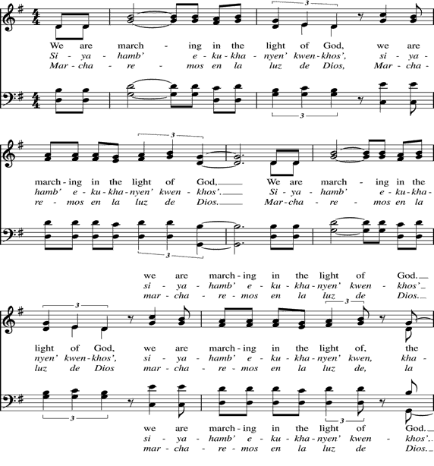







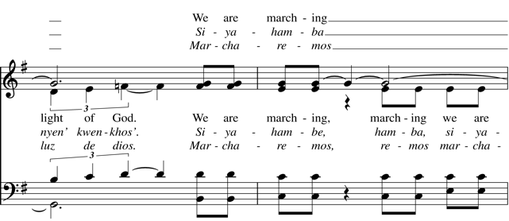

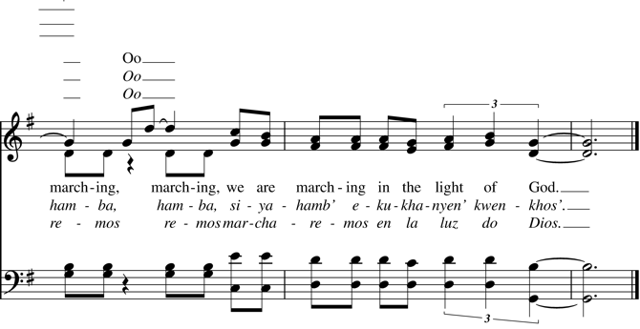

THE DISMISSAL Celebrant: Go in peace to love and serve the Lord. Alleluia, alleluia!

People: **Thanks be to God. Alleluia, alleluia!**

**POSTLUDE:** "Holy Spirit, Ever Dwelling" - *In Babilone*/arr. Langlois

**Altar Flowers**

In celebration of Wes Sharp's birthday by Steve and Denise Sharp.

**++++++++++++++**

**Announcements from Christ Church**

**Pastoral emergencies**

If you need to reach Rev. Michelle for a pastoral emergency, the number is (937) 505-0141. For

non-emergencies, you can call the office at (937) 323-8651 or email Rev. Michelle at [mboomgaard@christspringfield.org](mailto:mboomgaard@christspringfield.org).

**Calling All Gardeners!**

Join us at CEC for monthly gardening **today** after the 10 am coffee hour all members and friends welcome! We will meet in the parking lot.

**Welcome to the Pews!**

Next Sunday, we welcome the choir to the congregation pews for the summer. Today is their last Sunday up front until the fall—many thanks to the choir for their dedication and musical gifts they offer during our worship.

**Springfield Pride Fest**

Springfield Pride Fest will be on **Saturday, June 28th** from noon to 4 PM on City Hall Plaza. If you would be willing to serve on a team of folks representing Christ Church at this year's Pride Fest, please contact

Rev. Michelle at [mboomgaard@christspringfield.org](mailto:mboomgaard@christspringfield.org) by no later than **June 13th**.

**Christ Church Food Pantry**

The June Drive-thru Food Pantry will be on **June 18th, 2025.** Volunteers are needed to help unload food, pack food and help with customer service at approximately 8:15 am. Please contact either Brian Shelburne at [bshelburne@wittenberg.edu](mailto:bshelburne@wittenberg.edu), Kelly Zeller at [zellerk0611@gmail.com](mailto:zellerk0611@gmail.com), or Anne Randolph at [annejrand@aol.com](mailto:annejrand@aol.com) to volunteer.

**Upcoming Food Pantry opportunities:**

**June 11th, 2025***-* **the first food delivery at 8:30 am**

**June 12th, 2025**- grocery bagging day - start time at **9:00 am**

**June 18th, 2025**– Food Pantry Day! start time at **8:15 am**

**GAME NIGHT!**

All are welcome to join the We Should Do Something Group! They will meet at different locations once a month to play a variety of board and card games. The next meeting will be **Thursday, June 19th,** from 6-8 pm. at Cohatch /Myers Market101 S Fountain Ave, Springfield, OH 45502. Feel free to bring a friend or a game to share. If you have questions, contact Rev. Michelle at [mboomgaard@christspringfield.org](mailto:mboomgaard@christspringfield.org).

**Name Tags**

Please remember to make a name tag prior to each Sunday service in the East Entrance. As the number of guests increases in the summer months we would like members of Christ Church to wear nametags to make our guests feel welcome and show our approachability!

**Dinner Church at Christ Church ~Save the Date-Saturday, June 28th at 6 pm**

Join us in the Guild Room at 6 PM on the last Saturday of each month. After an opening prayer and song, we will light candles to remind us of the Light of Christ, pass consecrated bread and juice, and sit down for a vegan or vegetarian meal. We’ll have the chance to have a conversation and possibly meet someone new. And, as dinner is winding down, we’ll read and discuss Scripture together. We’ll pray, and everyone will share in the work of cleaning up.If you’d like to know more, please contact Rev. Michelle at [mboomgaard@christspringfield.org](mailto:mboomgaard@christspringfield.org)

**Ministers for June 8th, 2025**

**Altar Guild:** Sally Schwartz

**Chalice:** Beth Deger

**Lectors:** Keith Doubt and Fred Bartenstein

**Ushers:** Sally Schwartz and Judy Roby

**Videographer:** Truss, Inc.

**Coffee Hour Host:** Isabella Mendes

**General Information**

**Rector:** The Rev. Dr. Michelle Boomgaard

**Senior Warden**: Joyce Spangler

**Junior Warden**: Dan McGregor

**Treasurer**: Ken Bladh

**Clerk of Vestry:** Kelly Zeller

**Vestry at Large**: Kay Koeninger, Marjory Wentworth,

David Bingman, Beth Deger, and Rick Everingham

**Parish Director & Parish Administrator**: Kelly Zeller

**Director of Music**: Dr. Christopher Durrenberger

**Facility Manager**: Paul McAfee

**Bookkeeper:** Tina Knox

**Christ Church has an option for online giving through the church’s website.**

* Go to christspringfield.org or use the QR code
* Go to the tab in the upper right-hand corner marked “Online Giving”
* Click on the online giving link in blue
* Fill in the amount you would like to give
* Next, use the drop box Pledged Giving for a Pledge or Miscellaneous Giving for other giving
* If you choose Miscellaneous Giving, there is another memo drop box for the type of giving-choose one
* Fill out the rest of the form
* Press Continue
* On the next page, press **continue**
* Then enter your billing information
* Thank you!- If you have questions or concerns, please contact Kelly Zeller at [zellerk0611@gmail.com](mailto:zellerk0611@gmail.com)

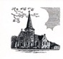

**Christ Episcopal Church**

**409 East High Street**

**Springfield, Ohio 45505**

**937-323-8651**

**www.christspringfield.org**