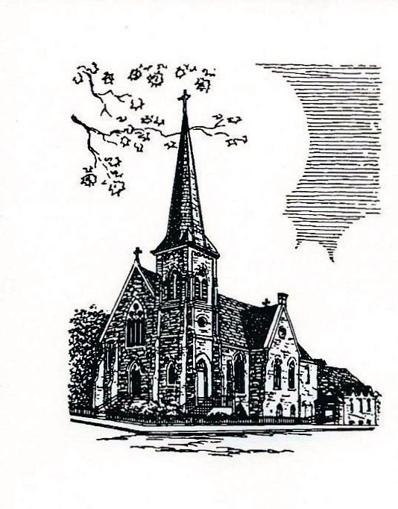

Christ Episcopal Church
409 East High Street
Springfield, OH 45505-1007
Phone: 937-323-8651
Website: www.christspringfield.org

The Rev. Michelle Boomgaard
Rector

Joyce Spangler
The Senior Warden

Dan McGregor
Junior Warden

Ken Bladh
Treasurer

Kelly Zeller
Parishofficecec@gmail.com
Program Director/Parish Administrator

Dr. Christopher Durrenberger
Director of Choir and Organist

Version: 1-22-26

CHRIST EPISCOPAL CHURCH
Outreach Grantee Final Report Form (optional; you may prefer to send a narrative email or letter addressing these prompts) due by January 31 of the year following your grant or as specified in your grant award letter

Name of organization:
________________________________________________

Address of organization, including city and zip code:
________________________________________________

Contact person’s name, title, cell, and email:
________________________________________________

Please address how the CEC funding benefited our community (e.g., success stories, partnerships):

Describe participants and number of unduplicated individuals served:

Provide evaluation, feedback, and/or evidence of outcomes, results, impacts, or changed behaviors:

Please explain any parts of the project you were unable to complete:

What lessons did you learn that you will apply to your organization’s future work?

Thanks for your ministry’s impact. Please return final report to: outreach@christspringfield.org or by snail mail.

