The Sixteenth Sunday after Pentecost
September 13th, 2026 at 10 am
The Holy Eucharist



+++++++++++++++++++++++++++++++++++++++++

INFORMATION FOR NEWCOMERS: WELCOME TO CHRIST CHURCH!

Our motto is true whether you're here for the very first time
or you've been a member for decades –
There is a place for you at God's Table!

The worship service has two main parts: the Liturgy of the Word, which includes Scripture readings and a sermon, and the Liturgy of the Table, which is also called Holy Eucharist or Communion. You will notice moments in the service when people stand, kneel, bow, and make the sign of the cross. There is no one “right” way to worship, so do what is comfortable for you at any given time in worship.

All Baptized Christians are welcome at Christ’s Table for Communion. If you do not wish to receive communion, you may come forward and request a blessing. If you wish to receive communion in your pew, please notify the ushers. And if you need a gluten-free wafer, just let Rev. Michelle know.

If you have not been baptized, or if you have questions about Holy Baptism, please talk to The Rev. Dr. Michelle Boomgaard after the service -- the people of Christ Church would love to walk with you to your baptism and beyond!

When you enter a Christ Episcopal Church worship service/event, you will be entering an area where photography, video and audio recording may occur. Finally, if you are a visitor, please fill-out a Welcome Card on the back of the pew, so we can add you to our weekly information email the NewsNote.
The Holy Eucharist

PRELUDE: "Prelude in C Major" WTC Book I - J.S. Bach

OPENING HYMN: “All creatures of our God and King” Hymnal 400 vs. 1, 4, 5, &7

THE LITURGY OF THE WORD

OPENING ACCLAMATION
Celebrant: This is the day the Creator has made.
People: Let us rejoice and be glad in it. Amen.

COLLECT FOR PURITY
Almighty God, to you all hearts are open, all desires known, and from you no secrets are hid. Cleanse the
thoughts of our hearts by the inspiration of your Holy Spirit, that we may perfectly love you, and worthily
magnify your holy Name; through Christ our Lord. Amen.

FOR THE BEAUTY OF THE EARTH
For the beauty of the earth, for the beauty of the skies, Hymnal 416
for the love which form our birth over and around us lies,
Christ our God, to thee we raise this our hymn of grateful praise.

COLLECT OF THE DAY
Celebrant: God be with you
People: And also with you.
Celebrant: Let us pray.
O God, because without you we are not able to please you, mercifully grant that your Holy Spirit may in all things direct and rule our hearts; through Jesus Christ our Lord, who lives and reigns with you and the Holy Spirit, one God, now and forever. Amen.

Ô Dieu, puisque sans toi il nous est impossible de te plaire, accepte, dans ta bonté, que ton Esprit saint dirige et gouverne nos cœurs en toutes choses ; par Jésus Christ, notre Seigneur, qui vit et règne avec toi et le Saint-Esprit, un seul Dieu, pour les siècles des siècles. Amen.

THE LESSONS

THE FIRST READING Genesis 50:15-21
Realizing that their father was dead, Joseph’s brothers said, “What if Joseph still bears a grudge against us and pays us back in full for all the wrong that we did to him?” So they approached Joseph, saying, “Your father gave this instruction before he died, ‘Say to Joseph: I beg you, forgive the crime of your brothers and the wrong they did in harming you.’ Now therefore please forgive the crime of the servants of the God of your father.” Joseph wept when they spoke to him. Then his brothers also wept, fell down before him, and said, “We are here as your slaves.” But Joseph said to them, “Do not be afraid! Am I in the place of God? Even though you intended to do harm to me, God intended it for good, in order to preserve a numerous people, as he is doing today. So have no fear; I myself will provide for you and your little ones.” In this way he reassured them, speaking kindly to them.
Lector: The Word of the Lord.
People: Thanks be to God.

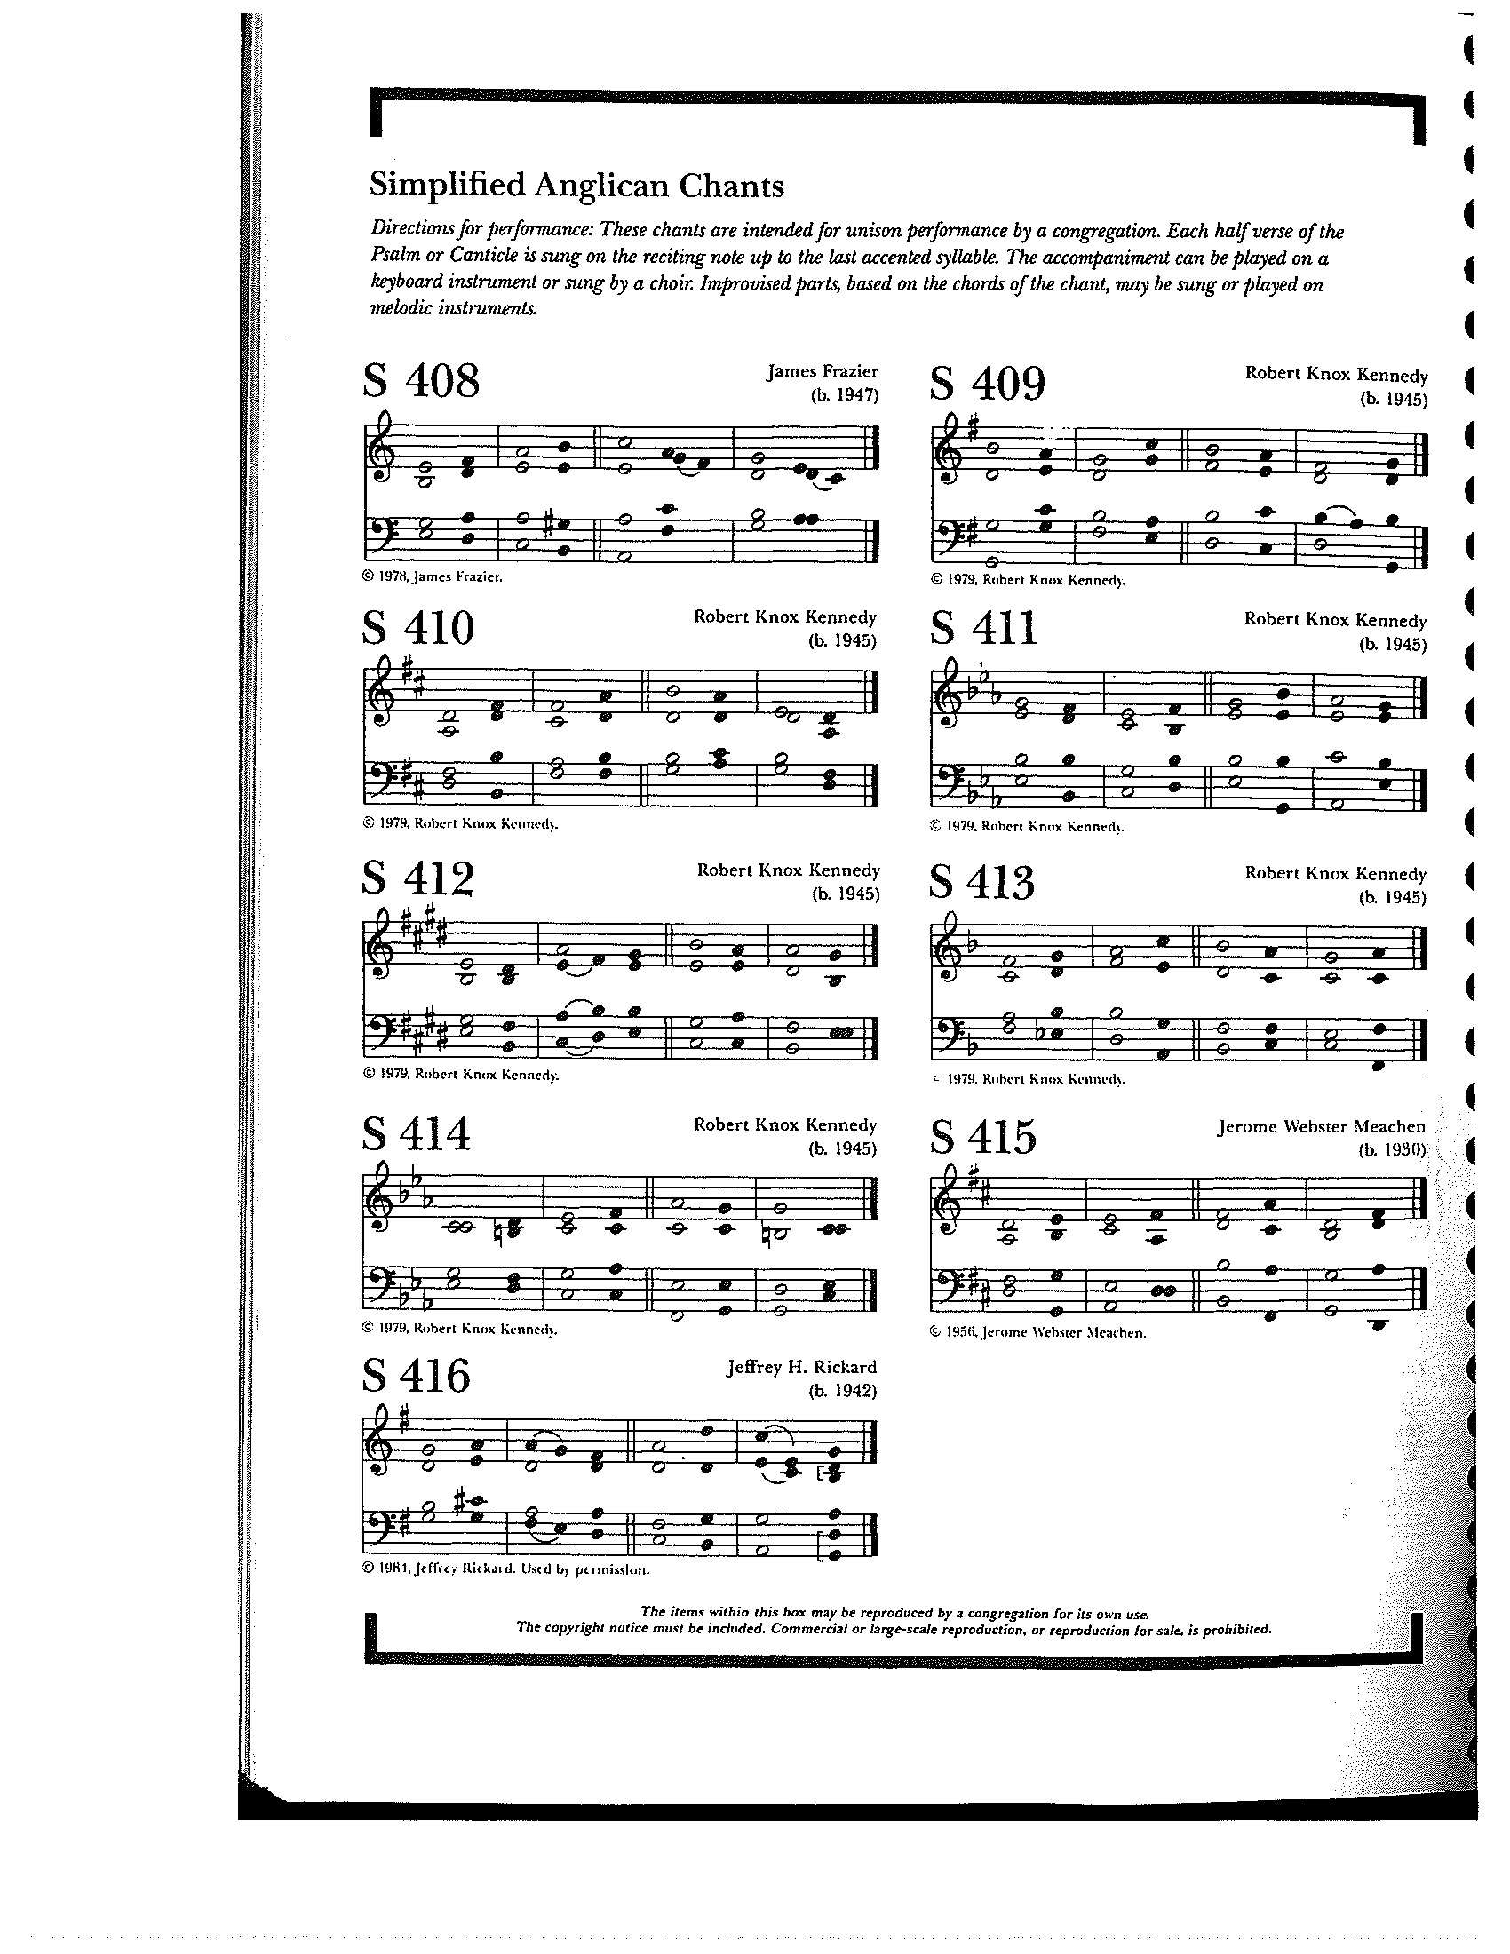

THE RESPONSE PSALM 103:1-13

1 Bless the Lord, O my soul, *
and all that is within me, bless his holy Name.
2 Bless the Lord, O my soul, *
and forget not all his benefits.
3 He forgives all your sins *
and heals all your infirmities;
4 He redeems your life from the grave *
and crowns you with mercy and loving-kindness;
5 He satisfies you with good things, *
and your youth is renewed like an eagle's.
6 The Lord executes righteousness *
and judgment for all who are oppressed.
7 He made his ways known to Moses *
and his works to the children of Israel.
8 The Lord is full of compassion and mercy, *
slow to anger and of great kindness.
9 He will not always accuse us, *
nor will he keep his anger forever.
10 He has not dealt with us according to our sins, *
nor rewarded us according to our wickedness.
11 For as the heavens are high above the earth, *
so is his mercy great upon those who fear him.
12 As far as the east is from the west, *
so far has he removed our sins from us.
13 As a father cares for his children, *
so does the Lord care for those who fear him.

THE SECOND LESSON Romans 14:1-12
Welcome those who are weak in faith, but not for the purpose of quarreling over opinions. Some believe in eating anything, while the weak eat only vegetables. Those who eat must not despise those who abstain, and those who abstain must not pass judgment on those who eat; for God has welcomed them. Who are you to pass judgment on servants of another? It is before their own lord that they stand or fall. And they will be upheld, for the Lord is able to make them stand.

Some judge one day to be better than another, while others judge all days to be alike. Let all be fully convinced in their own minds. Those who observe the day, observe it in honor of the Lord. Also those who eat, eat in honor of the Lord, since they give thanks to God; while those who abstain, abstain in honor of the Lord and give thanks to God.

We do not live to ourselves, and we do not die to ourselves. If we live, we live to the Lord, and if we die, we die to the Lord; so then, whether we live or whether we die, we are the Lord's. For to this end Christ died and lived again, so that he might be Lord of both the dead and the living.
Why do you pass judgment on your brother or sister? Or you, why do you despise your brother or sister? For we will all stand before the judgment seat of God. For it is written,

"As I live, says the Lord, every knee shall bow to me, and every tongue shall give praise to God."

So then, each of us will be accountable to God.
Lector: The Word of the Lord.
People: Thanks be to God.

SEQUENCE HYMN: “Creator of the stars of night” Hymnal 60 vs. 1-4

GOSPEL
Celebrant: The Holy Gospel of our Lord Jesus Christ according to Matthew (Matthew 18:21-35).
People: Glory to you, Lord Christ.
Peter came and said to Jesus, “Lord, if another member of the church sins against me, how often should I forgive? As many as seven times?” Jesus said to him, “Not seven times, but, I tell you, seventy-seven times.

“For this reason the kingdom of heaven may be compared to a king who wished to settle accounts with his slaves. When he began the reckoning, one who owed him ten thousand talents was brought to him; and, as he could not pay, his lord ordered him to be sold, together with his wife and children and all his possessions, and payment to be made. So the slave fell on his knees before him, saying, ‘Have patience with me, and I will pay you everything.’ And out of pity for him, the lord of that slave released him and forgave him the debt. But that same slave, as he went out, came upon one of his fellow slaves who owed him a hundred denarii; and seizing him by the throat, he said, ‘Pay what you owe.’ Then his fellow slave fell down and pleaded with him, ‘Have patience with me, and I will pay you.’ But he refused; then he went and threw him into prison until he would pay the debt. When his fellow slaves saw what had happened, they were greatly distressed, and they went and reported to their lord all that had taken place. Then his lord summoned him and said to him, ‘You wicked slave! I forgave you all that debt because you pleaded with me. Should you not have had mercy on your fellow slave, as I had mercy on you?’ And in anger his lord handed him over to be tortured until he would pay his entire debt. So my heavenly Father will also do to every one of you, if you do not forgive your brother or sister from your heart.”
Celebrant: The Gospel of the Lord.
People: Praise to you, Lord Christ.

Sermon The Rev. Dr. Michelle Boomgaard

THE NICENE CREED SYMBOLE DE NICÉE
We believe in one God, the Father, the Almighty, Nous croyons en un seul Dieu, le Père tout-puissant,
maker of heaven and earth, of all that is, Créateur du ciel et de la terre,
seen and unseen. We believe in one Lord, De toutes les choses visibles et invisibles.
Jesus Christ, the only Son of God, Nous croyons en un seul Seigneur, Jésus Christ,
eternally begotten of the Father, God from God, Le Fils unique de Dieu,
Light from Light, true God from true God, Endgendré du Père avant tous les siècles,
begotten, not made, of one Being with the Father. Dieu né de Dieu, Lumière née de la Lumière,
Through him all things were made. Vrai Dieu né du vrai Dieu, Engendré, non pas crée,
For us and for our salvation he came down Un seul être avec le Père, Et par lui tout a été fait.
from heaven, by the power of the Holy Spirit Pour nous et pour notre salut,
he became incarnate from the Virgin Mary, Il est descendu des cieux,
and was made man. For our sake he was Il s’est incarné par le saint-Esprit en la Vierge Marie,
crucified under Pontius Pilate; Et s’est fait homme. Crucifié pour nous sous Ponce Pilate,
he suffered death and was buried. Il a souffert la Passion,
On the third day he rose again in accordance Il a été mis au tombeau,
with the Scriptures; he ascended into heaven Il est ressuscité le troisième jour, selon les Écritures ;
and is seated at the right hand of the Father. Il est monté aux cieux,
He will come again in glory to judge the living Il siège à la droite du Père,
and the dead, and his kingdom will have no end. Il reviendra dans la gloire pour juger
We believe in the Holy Spirit, the Lord, les vivants et les morts,
the giver of life, who proceeds from the Father. Et son règne n’aura pas de fin.
With the Father and the Son he Nous croyons en l’Esprit saint,
is worshiped and glorified, He has spoken Qui est Seigneur et qui donne la vie,
through the Prophets. We believe in one holy Que procède du Père.
catholic and apostolic Church. Avec le Père et le Fils, il reçoit même
We acknowledge one baptism adoration et même gloire; Il a parlé par les Prophètes.
for the forgiveness of sins. Nous croyons en l’Église une, sainte,
We look for the resurrection of the dead, catholique et apostolique.
and the life of the world to come. Amen. Nous reconnaissons us seul baptême pour
le pardon des péchés. Nous attendons la résurrection des morts
Et la vie du monde à venir. Amen.
THE PRAYERS OF THE PEOPLE

The people respond with “hear our prayer”

Eternal God: We thank you for the beauty of the World: for the teeming life of the seas, the flight of birds, and the diversity of animal life.

Grant us grace to treat Creation with respect and care; to protect endangered species, to preserve the variety of habitats, and to honor the delicate balance of nature.

God of life:
hear our prayer.

We thank you for the wealth of blessings from land and sea; for the power of wind, and the warmth of sun.
We thank you for the gift of life, and for family and friends. We thank you for those celebrating birthdays this week, especially Madison Smith and Dawn Ivy, and for those celebrating anniversaries this week, especially Dana & Cathy Waggoner, and Brian & Jillian Drew.

God of abundance:
hear our prayer.

We pray for the nations of the earth. Give us the will to cherish this planet and, and grant our leaders the wisdom and will to use its resources sustainably for the welfare of all.

God of justice:
hear our prayer.

We pray for the faithful witness of the Church, called to reconcile and heal: For Sarah, Archbishop of Canterbury; Sean, our Presiding Bishop; Kristin, our Bishop, and Michelle, our Rector; for the people of parish and all parishes. In the Diocese of Southern Ohio cycle of prayer, we pray for Calvary, Clifton and
St. Andrew’s, Pickerington.

God of grace:
hear our prayer.

We pray for the human family.
We exult in our diversity and giftedness, we repent of our sins, divisions and violence. By the power of your Spirit, restore your image within us. As every human being is known and loved by you, may we care for one another with love and respect. We pray for those doing this work in our own community, especially Partners in Ministry in Liberia, Greater Springfield Assn Fundraising Professionals, and Clark County Literacy Center.

God of hope:
Hear our prayer.

We pray for those you have commended to our care: Robert Heine, Linda Butler, Ann Collier, Chris Durrenberger, Cindy Mellott Bayley, Melissa Dillon, Craig Lorimer, Linda Hupp, Amy Zook, Faye Richardson, Beth Harbaugh, Marilyn Howat, Jeanie Everingham, Bonnie Bingman, Anita Beardsell, Sandi Eyman, Margaret Mattox, Alice Kelly, Barb Kelly, and Steve Hall.

God of compassion:
hear our prayer.

We pray for those who have died whom we entrust to your eternal love; may we support and comfort those who mourn.
God of peace:
hear our prayer.

Celebrant: O merciful Creator, your hand is open wide to satisfy the needs of every living creature: Make us always thankful for your loving providence; and remembering the account that we must give one day, grant that we may be faithful stewards of your good gifts; through Jesus Christ our Savior, who with you and the Holy Spirit lives and reigns, one God, forever and ever. Amen

THE CONFESSION AND ABSOLUTION
Celebrant: Let us confess our sins against God and our neighbor.
All: God of compassion, have mercy upon us. Heal our relationship with all creation. Forgive us for our mistreatment and neglect of the creatures who share the earth with us. We are truly sorry and we humbly repent for what we have done to harm them, and for what we have not done to help them. Fill us with your Spirit, that we may care for one another and for all creatures, according to your will and in the fullness of your love; through Jesus Christ our Redeemer. Amen.

Celebrant: Almighty God have mercy on you, forgive you all your sins through our Lord Jesus Christ, strengthen you in all goodness, and by the power of the Holy Spirit keep you in eternal life. Amen.

THE PEACE

OFFERTORY: "For the fruit of all creation" - East Acklam/arr. Jackson (Hymn 424)

PRESENTATION OF THE GIFTS Hymnal 380, v. 3
Praise God from whom all blessings flow;
praise him, all creatures here below;
praise him above, ye heavenly host:
praise Father, Son and Holy Ghost

THE HOLY COMMUNION

THE GREAT THANKSGIVING: HOLY EUCHARIST COMMUNION WITH CREATION
Celebrant: The Creator be with you.
People: And also with you.
Celebrant: Lift up your hearts.
People: We lift them to the Creator.
Celebrant: Let us give thanks to our loving God.
People: It is right to give God thanks and praise
Praise and thanks are yours, our Creating God. From the dust of the earth you shaped human beings in your own image, and you filled the earth and seas and skies with a myriad of wonders. Yet we consistently turn your generosity into our scarcity, your elegance into our meanness, and your simplicity into our corruption. Though we poison and destroy your good Creation, you continue to offer us your abundance. In your mercy, you have redeemed us through your Son, Jesus, transforming death into life. Through the Spirit you continue to call us into covenant with you—for the restoration of Creation and the reconciliation of all people. And so we give you thanks, rejoicing with all of Creation, as we join the saints and angels in their unending hymn:
Holy, holy, holy Lord, God of power and might, Hymnal S129
heaven and earth are full of your glory.
Hosanna in the highest. Hosanna in the highest.
Blessed is he who comes in the name of the Lord.
Hosanna in the highest.

In the night that Jesus was betrayed, he took bread, and gave thanks to God. He broke the bread, gave it to his friends and said: “Take and eat, for this is my body, given for you. Do this in remembrance of me.” He took the wine, and gave thanks to God, Creator. He gave it to his friends saying: “This is my blood of the new covenant, shed for you and for all creation for the forgiveness of sins. Every time you drink of the wine, do this in remembrance of me.”

So we proclaim the mystery of faith:
Christ has died.
Christ is risen.
Christ will come again.

Merciful God, we come to this table seeking reconciliation: with you, with one another, and with all creation. Through these mysteries reconcile us to our world and empower us to restore your Creation and fulfill your will. Send your life-giving Spirit upon us, and upon this bread and wine. Stir in us the creative and redeem the destructive. Heal your stricken world, that the soil, the skies, and the seas may be filled with your life anew. Fill every heart with the sure and certain hope that we shall enter into the fullness of your joy, when your whole Creation is justified by faith and sanctified by love, and you are all in all. Through Christ and with Christ and in Christ, in the unity of the Spirit, all honor and glory is yours, everlasting God, now and forever. Amen

And now, as our Savior Christ has taught us, we are bold to say,
Our Father in heaven, Notre Père, qui es aux cieux,
hallowed be your Name, Que ton nom soit sanctifé;
your kingdom come, your will be done, Que ton règne vienne ; que ta volonté soit faite
on earth as in heaven. Sur la terre comme au ciel.
Give us this day our daily bread. Donne-nous aujourd’hui notre pain de ce jour.
Forgive us our sins, Pardonne-nous nos offenses,
as we forgive those who sin against us. Comme nous pardonnons aussi À ceux qui nous ont offensés.
Save us from the time of trial, Et nous laisse pas entrer en tentation,
and deliver us from evil. Mais délivre-nous du mal.
For the kingdom, the power, Car c’est à toi qu’appartiennent le règne,
and the glory are yours, La puissance et la gloire,
now and forever. Amen. Pour les siècles des siècles. Amen.

THE BREAKING OF THE BREAD Hymnal S155
Alleluia, alleluia, alleluia.
Christ our Passover is sacrificed for us;
therefore let us keep the feast.
Alleluia, alleluia, alleluia.

THE INVITATION TO COMMUNION

COMMUNION HYMN: “Forgive our sins, as we forgive” Hymnal 674

THE SENDING FORTH OF THE LAY EUCHARISTIC VISITOR
Celebrant: In the name of this congregation, I send you forth bearing these holy gifts, that those to whom you go may share with us in the communion of Christ’s body and blood.
People: We who are many are one body, for we all share in the one cup.

PRAYER AFTER COMMUNION- Celebrant and people together
Faithful God in the wonder of your wisdom and love you fed your people in the wilderness with the bread of angels, and you sent Jesus to be the bread of life. We thank you for feeding us with this bread. May it strengthen us that by the power of the Holy Spirit we may embody your desire and be renewed for your service through Jesus Christ our Savior. Amen.

THE BLESSING
May God who established the dance of creation, who marveled at the lilies of the field, who transforms chaos to order, lead us to transform our lives and the church to listen to the voice of all creatures that reflect God’s glory in creation. Amen.

ANNOUNCEMENTS

CLOSING HYMN: “Praise to the Lord, the Almighty, the King of Creation” Hymnal 390

THE DISMISSAL
Celebrant: Let us go forth into all Creation, rejoicing in the power of the Spirit.
People: Thanks be to God.

POSTLUDE: "Let All things Now Living" - The Ash Grove/arr. Robert Hobby

Altar Flowers
To the glory of God and in memory of Dirk Boomgaard.
Announcements from Christ Church

Pastoral emergencies

If you need to reach Rev. Michelle for a pastoral emergency, the number is (937) 505-0141. For

non-emergencies, you can call the office at (937) 323-8651 or email Rev. Michelle at mboomgaard@christspringfield.org.

Adult Forum in September:
9/13 - An overview of Pope Francis's perspective (or, "why was this controversial?")
9/20 - The threat, in Pope Francis's view
9/27 - An alternative approach and action for the future

Lectio Divina Bible Study
This fall, we are changing the meeting time for African Bible study to Tuesdays at 1 PM, beginning September 8th. We hope people consider joining us for this empowering study of Scripture. Each week, we select the Lectionary reading for the forthcoming Sunday in preparation for Sunday's worship. We adapt a meditative, structured approach, taking turns to listen and to speak. The discipline encourages listening and self-reflection and discourages cross-talk. We meet online and can send you the link before the gathering.
If you have questions, contact Keith at keithdoubt@123mail.org or talk with him at church. We hope you consider joining us.

Christ Church Food Pantry
The September Drive-thru Food Pantry will be on September 16th, 2026. Volunteers are needed to help unload food, pack food, and help with customer service at approximately 8:15 am. Please contact either Brian Shelburne at bshelburne@wittenberg.edu, Kelly Zeller at zellerk0611@gmail.com, or Anne Randolph at annejrand@aol.com to volunteer.

Dinner Church Saturday, September 26th at 6 pm
Join us in the Guild Room at 6 PM on Saturday, September 26th. We’ll start the evening with prayers and song. We’ll have a conversation about Scripture and finish with Evening Prayer or Compline. Afterward, everyone will share in the work of cleaning up. If you’d like to know more, please contact Rev. Michelle at mboomgaard@christspringfield.org

Making community connections!
Interested in connecting with Wittenberg or other colleges in the area? Let's talk! Province V is offering a series of webinars on how to better engage with college students. This is our chance to learn more and be intentional about connecting with some great young adults in town! Talk to Rev. Michelle to learn more.

Ministers for September 13th, 2026
Altar Guild: Cathy Yeazell and Gretchen Hicks
Chalice: Brian Shelburne
Lector: Judy Johnson
Ushers: Dan McGregor and Brian Drew
Children’s Chapel: Kelly Zeller and Madison Smith
Greeter: David Bingman
Coffee hour: Brian and Jillian Drew
Videographer: Truss, Inc.

General Information
Priest: The Rev. Dr. Michelle Boomgaard
Senior Warden: Joyce Spangler
Junior Warden: Steve Sharp
Treasurer: Ken Bladh
Clerk of Vestry: Kelly Zeller
Vestry at Large: Kay Koeninger, David Bingman, Beth Deger, Diane Rode,
John Richardson, and Fred Bartenstein
Parish Director & Parish Administrator: Kelly Zeller
Director of Music: Dr. Christopher Durrenberger
Facility Manager: Paul McAfee
Bookkeeper: Tina Knox
Christ Church’s Wi-Fi password is: Christchurch (all lower cased)

Christ Church has an option for online giving through the church’s website.
- Go to christspringfield.org or use the QR code
- Go to the tab in the upper right-hand corner marked “Online Giving”
- Click on the online giving link in blue
- Fill in the amount you would like to give
- Next, choose either Pledged Giving for a Pledge or Miscellaneous Giving for other giving
- Fill out the rest of the form
- Press Continue
- Then enter your billing information
- Thank you!- If you have questions or concerns, please contact Kelly Zeller at zellerk0611@gmail.com

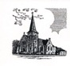

Christ Episcopal Church
409 East High Street
Springfield, Ohio 45505
937-323-8651
www.christspringfield.org

