The Fifteenth Sunday after Pentecost
September 6th, 2026 at 10 am
The Holy Eucharist



+++++++++++++++++++++++++++++++++++++++++

INFORMATION FOR NEWCOMERS: WELCOME TO CHRIST CHURCH!

Our motto is true whether you're here for the very first time
or you've been a member for decades –
There is a place for you at God's Table!

The worship service has two main parts: the Liturgy of the Word, which includes Scripture readings and a sermon, and the Liturgy of the Table, which is also called Holy Eucharist or Communion. You will notice moments in the service when people stand, kneel, bow, and make the sign of the cross. There is no one “right” way to worship, so do what is comfortable for you at any given time in worship.

All Baptized Christians are welcome at Christ’s Table for Communion. If you do not wish to receive communion, you may come forward and request a blessing. If you wish to receive communion in your pew, please notify the ushers. And if you need a gluten-free wafer, just let Rev. Michelle know.

If you have not been baptized, or if you have questions about Holy Baptism, please talk to The Rev. Dr. Michelle Boomgaard after the service -- the people of Christ Church would love to walk with you to your baptism and beyond!

When you enter a Christ Episcopal Church worship service/event, you will be entering an area where photography, video and audio recording may occur. Finally, if you are a visitor, please fill-out a Welcome Card on the back of the pew, so we can add you to our weekly information email the NewsNote.
The Holy Eucharist

PRELUDE: Carol on " 'Tis the Gift to be Simple" - Simple Gifts/arr. Callahan

OPENING HYMN: “When morning gilds the skies” Hymnal 427

THE LITURGY OF THE WORD

OPENING ACCLAMATION
Celebrant: This is the day the Creator has made.
People: Let us rejoice and be glad in it. Amen.

COLLECT FOR PURITY
Almighty God, to you all hearts are open, all desires known, and from you no secrets are hid. Cleanse the
thoughts of our hearts by the inspiration of your Holy Spirit, that we may perfectly love you, and worthily
magnify your holy Name; through Christ our Lord. Amen.

FOR THE BEAUTY OF THE EARTH
For the beauty of the earth, for the beauty of the skies, Hymnal 416
for the love which form our birth over and around us lies,
Christ our God, to thee we raise this our hymn of grateful praise.

COLLECT OF THE DAY
Celebrant: God be with you
People: And also with you.
Celebrant: Let us pray.
Grant us, O Lord, to trust in you with all our hearts; for, as you always resist the proud who confide in their own strength, so you never forsake those who make their boast of your mercy; through Jesus Christ our Lord, who lives and reigns with you and the Holy Spirit, one God, now and forever. Amen.

Seigneur, accorde-nous d’espérer en toi de tout notre cœur; car, si tu résistes toujours aux êtres orgueilleux qui se fient à leurs propres forces, tu n’abandonnes jamais celles et ceux qui se glorifient de ta miséricorde; par Jésus Christ, notre Seigneur, qui vit et règne avec toi et le Saint-Esprit, un seul Dieu, pour les siècles des siècles. Amen.

THE LESSONS

THE FIRST READING Ezekiel 33:7-11
You, mortal, I have made a sentinel for the house of Israel; whenever you hear a word from my mouth, you shall give them warning from me. If I say to the wicked, “O wicked ones, you shall surely die,” and you do not speak to warn the wicked to turn from their ways, the wicked shall die in their iniquity, but their blood I will require at your hand. But if you warn the wicked to turn from their ways, and they do not turn from their ways, the wicked shall die in their iniquity, but you will have saved your life.

Now you, mortal, say to the house of Israel, Thus you have said: “Our transgressions and our sins weigh upon us, and we waste away because of them; how then can we live?” Say to them, As I live, says the Lord God, I have no pleasure in the death of the wicked, but that the wicked turn from their ways and live; turn back, turn back from your evil ways; for why will you die, O house of Israel?
Lector: The Word of the Lord.
People: Thanks be to God.

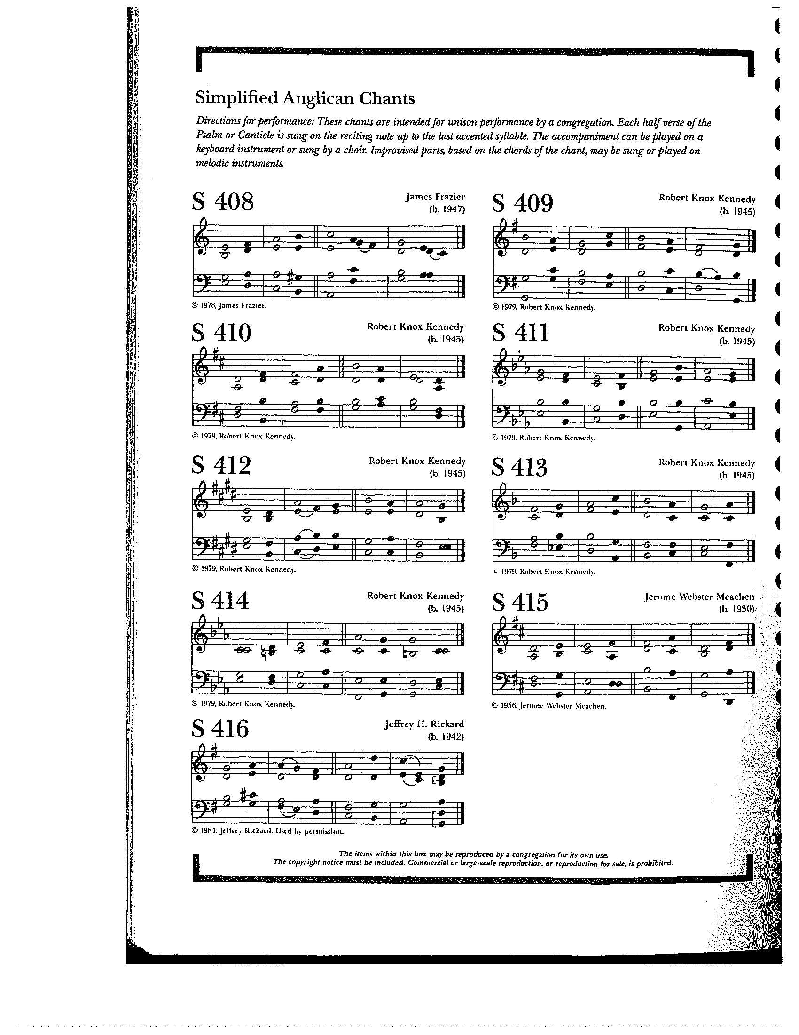

THE RESPONSE PSALM 119:33-40

33 Teach me, O Lord, the way of your statutes, *
and I shall keep it to the end.
34 Give me understanding, and I shall keep your law; *
I shall keep it with all my heart.
35 Make me go in the path of your commandments, *
for that is my desire.
36 Incline my heart to your decrees *
and not to unjust gain.
37 Turn my eyes from watching what is worthless; *
give me life in your ways.
38 Fulfill your promise to your servant, *
which you make to those who fear you.
39 Turn away the reproach which I dread, *
because your judgments are good.
40 Behold, I long for your commandments; *
in your righteousness preserve my life.

THE SECOND LESSON Romans 13:8-14
Owe no one anything, except to love one another; for the one who loves another has fulfilled the law. The commandments, “You shall not commit adultery; You shall not murder; You shall not steal; You shall not covet”; and any other commandment, are summed up in this word, “Love your neighbor as yourself.” Love does no wrong to a neighbor; therefore, love is the fulfilling of the law.

Besides this, you know what time it is, how it is now the moment for you to wake from sleep. For salvation is nearer to us now than when we became believers; the night is far gone, the day is near. Let us then lay aside the works of darkness and put on the armor of light; let us live honorably as in the day, not in reveling and drunkenness, not in debauchery and licentiousness, not in quarreling and jealousy. Instead, put on the Lord Jesus Christ, and make no provision for the flesh, to gratify its desires.
Lector: The Word of the Lord.
People: Thanks be to God.

SEQUENCE HYMN: “Awake my soul, stretch every nerve” Hymnal 546

GOSPEL
Celebrant: The Holy Gospel of our Lord Jesus Christ according to Matthew (Matthew 18:15-20).
People: Glory to you, Lord Christ.
Jesus said, “If another member of the church sins against you, go and point out the fault when the two of you are alone. If the member listens to you, you have regained that one. But if you are not listened to, take one or two others along with you, so that every word may be confirmed by the evidence of two or three witnesses. If the member refuses to listen to them, tell it to the church; and if the offender refuses to listen even to the church, let such a one be to you as a Gentile and a tax collector. Truly I tell you, whatever you bind on earth will be bound in heaven, and whatever you loose on earth will be loosed in heaven. Again, truly I tell you, if two of you agree on earth about anything you ask, it will be done for you by my Father in heaven. For where two or three are gathered in my name, I am there among them.”
Celebrant: The Gospel of the Lord.
People: Praise to you, Lord Christ.

Sermon The Rev. Dr. Michelle Boomgaard

THE NICENE CREED SYMBOLE DE NICÉE
We believe in one God, the Father, the Almighty, Nous croyons en un seul Dieu, le Père tout-puissant,
maker of heaven and earth, of all that is, Créateur du ciel et de la terre,
seen and unseen. We believe in one Lord, De toutes les choses visibles et invisibles.
Jesus Christ, the only Son of God, Nous croyons en un seul Seigneur, Jésus Christ,
eternally begotten of the Father, God from God, Le Fils unique de Dieu,
Light from Light, true God from true God, Endgendré du Père avant tous les siècles,
begotten, not made, of one Being with the Father. Dieu né de Dieu, Lumière née de la Lumière,
Through him all things were made. Vrai Dieu né du vrai Dieu, Engendré, non pas crée,
For us and for our salvation he came down Un seul être avec le Père, Et par lui tout a été fait.
from heaven, by the power of the Holy Spirit Pour nous et pour notre salut,
he became incarnate from the Virgin Mary, Il est descendu des cieux,
and was made man. For our sake he was Il s’est incarné par le saint-Esprit en la Vierge Marie,
crucified under Pontius Pilate; Et s’est fait homme. Crucifié pour nous sous Ponce Pilate,
he suffered death and was buried. Il a souffert la Passion,
On the third day he rose again in accordance Il a été mis au tombeau,
with the Scriptures; he ascended into heaven Il est ressuscité le troisième jour, selon les Écritures ;
and is seated at the right hand of the Father. Il est monté aux cieux,
He will come again in glory to judge the living Il siège à la droite du Père,
and the dead, and his kingdom will have no end. Il reviendra dans la gloire pour juger
We believe in the Holy Spirit, the Lord, les vivants et les morts,
the giver of life, who proceeds from the Father. Et son règne n’aura pas de fin.
With the Father and the Son he Nous croyons en l’Esprit saint,
is worshiped and glorified, He has spoken Qui est Seigneur et qui donne la vie,
through the Prophets. We believe in one holy Que procède du Père.
catholic and apostolic Church. Avec le Père et le Fils, il reçoit même
We acknowledge one baptism adoration et même gloire; Il a parlé par les Prophètes.
for the forgiveness of sins. Nous croyons en l’Église une, sainte,
We look for the resurrection of the dead, catholique et apostolique.
and the life of the world to come. Amen. Nous reconnaissons us seul baptême pour
le pardon des péchés. Nous attendons la résurrection des morts
Et la vie du monde à venir. Amen.
THE PRAYERS OF THE PEOPLE

The people respond with “hear our prayer”

Eternal God: We thank you for the beauty of the World: for the teeming life of the seas, the flight of birds, and the diversity of animal life.

Grant us grace to treat Creation with respect and care; to protect endangered species, to preserve the variety of habitats, and to honor the delicate balance of nature.

God of life:
hear our prayer.
We thank you for the wealth of blessings from land and sea; for the power of wind, and the warmth of sun.
We thank you for the gift of life, and for family and friends. We thank you for those celebrating birthdays this week, especially Brian Shelburne and Dee Washington, and for those celebrating anniversaries this week.
God of abundance:
hear our prayer.

We pray for the nations of the earth. Give us the will to cherish this planet and, and grant our leaders the wisdom and will to use its resources sustainably for the welfare of all.

God of justice:
hear our prayer.

We pray for the faithful witness of the Church, called to reconcile and heal: For Sarah, Archbishop of Canterbury; Sean, our Presiding Bishop; Kristin, our Bishop, and Michelle, our Rector; for the people of parish and all parishes. In the Diocese of Southern Ohio cycle of prayer, we pray for St. Mary’s, Waynesville and for Episcopal Seminaries.
God of grace:
hear our prayer.

We pray for the human family.
We exult in our diversity and giftedness, we repent of our sins, divisions and violence. By the power of your Spirit, restore your image within us. As every human being is known and loved by you, may we care for one another with love and respect. We pray for those doing this work in our own community, especially Covenant CDC Freedom School-Summer program, Jefferson St. Oasis Garden, and Springfield Promise Neighborhood.
God of hope:
Hear our prayer.

We pray for those you have commended to our care: Robert Heine, Linda Butler, Ann Collier, Chris Durrenberger, Cindy Mellott Bayley, Melissa Dillon, Craig Lorimer, Linda Hupp, Amy Zook, Faye Richardson, Beth Harbaugh, Marilyn Howat, Jeanie Everingham, Bonnie Bingman, Anita Beardsell, Sandi Eyman, Margaret Mattox, Alice Kelly, Barb Kelly, and Steve Hall.
God of compassion:
hear our prayer.

We pray for those who have died whom we entrust to your eternal love; may we support and comfort those who mourn.
God of peace:
hear our prayer.

Celebrant: O merciful Creator, your hand is open wide to satisfy the needs of every living creature: Make us always thankful for your loving providence; and remembering the account that we must give one day, grant that we may be faithful stewards of your good gifts; through Jesus Christ our Savior, who with you and the Holy Spirit lives and reigns, one God, forever and ever. Amen

THE CONFESSION AND ABSOLUTION
Celebrant: Let us confess our sins against God and our neighbor.
All: God of compassion, have mercy upon us. Heal our relationship with all creation. Forgive us for our mistreatment and neglect of the creatures who share the earth with us. We are truly sorry and we humbly repent for what we have done to harm them, and for what we have not done to help them. Fill us with your Spirit, that we may care for one another and for all creatures, according to your will and in the fullness of your love; through Jesus Christ our Redeemer. Amen.

Celebrant: Almighty God have mercy on you, forgive you all your sins through our Lord Jesus Christ, strengthen you in all goodness, and by the power of the Holy Spirit keep you in eternal life. Amen.

THE PEACE

OFFERTORY: “We all are one in mission”

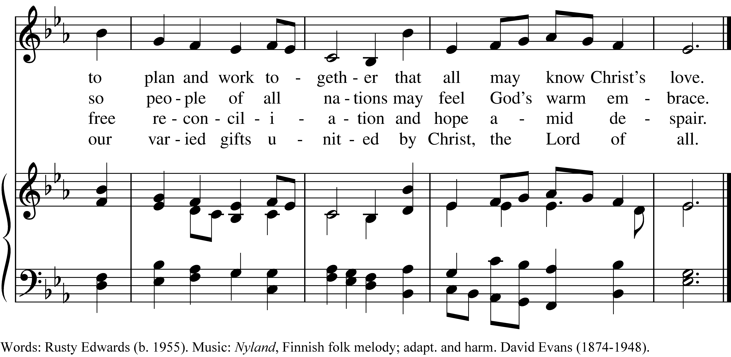

PRESENTATION OF THE GIFTS Hymnal 380, v. 3
Praise God from whom all blessings flow;
praise him, all creatures here below;
praise him above, ye heavenly host:
praise Father, Son and Holy Ghost

THE HOLY COMMUNION

THE GREAT THANKSGIVING: HOLY EUCHARIST COMMUNION WITH CREATION
Celebrant: The Creator be with you.
People: And also with you.
Celebrant: Lift up your hearts.
People: We lift them to the Creator.
Celebrant: Let us give thanks to our loving God.
People: It is right to give God thanks and praise
Praise and thanks are yours, our Creating God. From the dust of the earth you shaped human beings in your own image, and you filled the earth and seas and skies with a myriad of wonders. Yet we consistently turn your generosity into our scarcity, your elegance into our meanness, and your simplicity into our corruption. Though we poison and destroy your good Creation, you continue to offer us your abundance. In your mercy, you have redeemed us through your Son, Jesus, transforming death into life. Through the Spirit you continue to call us into covenant with you—for the restoration of Creation and the reconciliation of all people. And so we give you thanks, rejoicing with all of Creation, as we join the saints and angels in their unending hymn:
Holy, holy, holy Lord, God of power and might, Hymnal S129
heaven and earth are full of your glory.
Hosanna in the highest. Hosanna in the highest.
Blessed is he who comes in the name of the Lord.
Hosanna in the highest.

In the night that Jesus was betrayed, he took bread, and gave thanks to God. He broke the bread, gave it to his friends and said: “Take and eat, for this is my body, given for you. Do this in remembrance of me.” He took the wine, and gave thanks to God, Creator. He gave it to his friends saying: “This is my blood of the new covenant, shed for you and for all creation for the forgiveness of sins. Every time you drink of the wine, do this in remembrance of me.”

So we proclaim the mystery of faith:
Christ has died.
Christ is risen.
Christ will come again.
Merciful God, we come to this table seeking reconciliation: with you, with one another, and with all creation. Through these mysteries reconcile us to our world and empower us to restore your Creation and fulfill your will. Send your life-giving Spirit upon us, and upon this bread and wine. Stir in us the creative and redeem the destructive. Heal your stricken world, that the soil, the skies, and the seas may be filled with your life anew. Fill every heart with the sure and certain hope that we shall enter into the fullness of your joy, when your whole Creation is justified by faith and sanctified by love, and you are all in all. Through Christ and with Christ and in Christ, in the unity of the Spirit, all honor and glory is yours, everlasting God, now and forever. Amen

And now, as our Savior Christ has taught us, we are bold to say,
Our Father in heaven, Notre Père, qui es aux cieux,
hallowed be your Name, Que ton nom soit sanctifé;
your kingdom come, your will be done, Que ton règne vienne ; que ta volonté soit faite
on earth as in heaven. Sur la terre comme au ciel.
Give us this day our daily bread. Donne-nous aujourd’hui notre pain de ce jour.
Forgive us our sins, Pardonne-nous nos offenses,
as we forgive those who sin against us. Comme nous pardonnons aussi À ceux qui nous ont offensés.
Save us from the time of trial, Et nous laisse pas entrer en tentation,
and deliver us from evil. Mais délivre-nous du mal.
For the kingdom, the power, Car c’est à toi qu’appartiennent le règne,
and the glory are yours, La puissance et la gloire,
now and forever. Amen. Pour les siècles des siècles. Amen.

THE BREAKING OF THE BREAD Hymnal S155
Alleluia, alleluia, alleluia.
Christ our Passover is sacrificed for us;
therefore let us keep the feast.
Alleluia, alleluia, alleluia.

THE INVITATION TO COMMUNION

COMMUNION HYMN: “Lord make us servants of your peace” Hymnal 593

PRAYER AFTER COMMUNION- Celebrant and people together
Faithful God in the wonder of your wisdom and love you fed your people in the wilderness with the bread of angels, and you sent Jesus to be the bread of life. We thank you for feeding us with this bread. May it strengthen us that by the power of the Holy Spirit we may embody your desire and be renewed for your service through Jesus Christ our Savior. Amen.

THE BLESSING
May God who established the dance of creation, who marveled at the lilies of the field, who transforms chaos to order, lead us to transform our lives and the church to listen to the voice of all creatures that reflect God’s glory in creation. Amen.

ANNOUNCEMENTS

CLOSING HYMN: “Singing songs of expectation” Hymnal 527

THE DISMISSAL
Celebrant: Let us go forth into all Creation, rejoicing in the power of the Spirit.
People: Thanks be to God.

POSTLUDE: "Rondo alla Turca" from Sonata in A minor K.331 - Mozart

Altar Flowers
In memory of Joy Christine Bartenstein by Fred Bartenstein.
++++++++++++++

Announcements from Christ Church

Pastoral emergencies

If you need to reach Rev. Michelle for a pastoral emergency, the number is (937) 505-0141. For

non-emergencies, you can call the office at (937) 323-8651 or email Rev. Michelle at mboomgaard@christspringfield.org.

Lectio Divina Bible Study
This fall, we are changing the meeting time for African Bible study to Tuesdays at 1 PM, beginning September 8th. We hope people consider joining us for this empowering study of Scripture. Each week, we select the Lectionary reading for the forthcoming Sunday in preparation for Sunday's worship. We adapt a meditative, structured approach, taking turns to listen and to speak. The discipline encourages listening and self-reflection and discourages cross-talk. We meet online and can send you the link before the gathering.
If you have questions, contact Keith at keithdoubt@123mail.org or talk with him at church. We hope you consider joining us.

Christ Church Food Pantry
The September Drive-thru Food Pantry will be on September 16th, 2026. Volunteers are needed to help unload food, pack food, and help with customer service at approximately 8:15 am. Please contact either Brian Shelburne at bshelburne@wittenberg.edu, Kelly Zeller at zellerk0611@gmail.com, or Anne Randolph at annejrand@aol.com to volunteer.

Upcoming Food Pantry opportunities:
September 10th, 2026- grocery bagging day - start time at 9:00 am
September 16th , 2026 – Food Pantry Day! start time at 8:15 am

Children's Chapel Services for ages 2 through 6 will start September 13th and meet twice a month through May. We will meet in the Chapel on the church's lower level at the start of the 10 am service, down the aisle from the nursery. This year, we're all about hands-on learning from the former Atrium. Your children will have loads of opportunities to explore and learn through play. After the sermon upstairs wraps up, an usher will come to gather the kids (and me!) to bring their gifts up to the Altar. Then, they can either head back to the nursery or stay upstairs—totally your choice! Madison will be there as the second adult, ensuring everything stays safe and fun under the Safe Church guidelines. Each month will have its own exciting theme, and September's theme is all about Creation.

Adult Forum in September:
9/13 - An overview of Pope Francis's perspective (or, "why was this controversial?")
9/20 - The threat, in Pope Francis's view
9/27 - An alternative approach and action for the future

Making community connections!
Interested in connecting with Wittenberg or other colleges in the area? Let's talk! Province V is offering a series of webinars on how to better engage with college students. This is our chance to learn more and be intentional about connecting with some great young adults in town! Talk to Rev. Michelle to learn more.
Ministers for September 6th, 2026
Altar Guild: Cathy Yeazell and Gretchen Hicks
Chalice: Diane Rode
Lector: Fred Bartenstein
Ushers: David Bingman and Judy Roby
Greeter: John Richardson
Coffee Hour Host: Rick Everingham
Videographer: Truss, Inc.

General Information
Priest: The Rev. Dr. Michelle Boomgaard
Senior Warden: Joyce Spangler
Junior Warden: Steve Sharp
Treasurer: Ken Bladh
Clerk of Vestry: Kelly Zeller
Vestry at Large: Kay Koeninger, David Bingman, Beth Deger, Diane Rode,
John Richardson, and Fred Bartenstein
Parish Director & Parish Administrator: Kelly Zeller
Director of Music: Dr. Christopher Durrenberger
Facility Manager: Paul McAfee
Bookkeeper: Tina Knox

Christ Church has an option for online giving through the church’s website.
- Go to christspringfield.org or use the QR code
- Go to the tab in the upper right-hand corner marked “Online Giving”
- Click on the online giving link in blue
- Fill in the amount you would like to give
- Next, choose either Pledged Giving for a Pledge or Miscellaneous Giving for other giving
- Fill out the rest of the form
- Press Continue
- Then enter your billing information
- Thank you!- If you have questions or concerns, please contact Kelly Zeller at zellerk0611@gmail.com

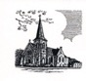

Christ Episcopal Church
409 East High Street
Springfield, Ohio 45505
937-323-8651
www.christspringfield.org

