All Saints Day
November 1st, 2026 at 10:00 a.m.
Holy Eucharist: Rite II



+++++++++++++++++++++++++++++++++++++++++

INFORMATION FOR NEWCOMERS: WELCOME TO CHRIST CHURCH!

Our motto is true whether you're here for the very first time
or you've been a member for decades –
There is a place for you at God's Table!

The worship service has two main parts: the Liturgy of the Word, which includes Scripture readings and a sermon, and the Liturgy of the Table, which is also called Holy Eucharist or Communion. You will notice moments in the service when people stand, kneel, bow, and make the sign of the cross. There is no one “right” way to worship, so do what is comfortable for you at any given time in worship.

All Baptized Christians are welcome at Christ’s Table for Communion. If you do not wish to receive communion, you may come forward and request a blessing. If you wish to receive communion in your pew, please notify the ushers. And if you need a gluten-free wafer, just let Rev. Michelle know.

If you have not been baptized, or if you have questions about Holy Baptism, please talk to The Rev. Dr. Michelle Boomgaard after the service -- the people of Christ Church would love to walk with you to your baptism and beyond!

When you enter a Christ Episcopal Church worship service/event, you will be entering an area where photography, video and audio recording may occur. Finally, if you are a visitor, please fill-out a Welcome Card on the back of the pew, so we can add you to our weekly information email the NewsNote.
The Holy Eucharist

PRELUDE: "Amazing Grace" - Keith Doubt, saxophone

OPENING HYMN: “For all the saints, who from their labors rest” Hymnal 287

THE LITURGY OF THE WORD

OPENING ACCLAMATION
Celebrant: Blessed be God: Father, Son, and Holy Spirit.
People: And blessed be his kingdom, now and forever. Amen.

COLLECT FOR PURITY
Almighty God, to you all hearts are open, all desires known, and from you no secrets are hid. Cleanse the
thoughts of our hearts by the inspiration of your Holy Spirit, that we may perfectly love you, and worthily
magnify your holy Name; through Christ our Lord. Amen.

GLORIA Hymnal S236
Glory to you, Lord God of our fathers;
you are worthy of praise; glory to you.
Glory to you for the radiance of your holy Name;
we will praise you and highly exalt you forever.
Glory to you in the splendor of your temple; on the throne of your majesty, glory to you.
Glory to you, seated between the Cherubim;
we will praise you and highly exalt you forever.
Glory to you, beholding the depths; in the high vault of heaven, glory to you.
Glory to you, Father, Son, and Holy Spirit;
we will praise you and highly exalt you forever.

COLLECT OF THE DAY
Celebrant: The Lord be with you.
People: And also with you.
Celebrant: Let us pray.
Almighty God, you have knit together your elect in one communion and fellowship in the mystical body of your Son Christ our Lord: Give us grace so to follow your blessed saints in all virtuous and godly living, that we may come to those ineffable joys that you have prepared for those who truly love you; through Jesus Christ our Lord, who with you and the Holy Spirit lives and reigns, one God, in glory everlasting. Amen.

Dieu tout-puissant, tu as lié ensemble tes élus dans une même communion au corps mystique du Christ, ton Fils, notre Seigneur: accorde-nous la grâce de suivre tes bienheureux saints et saintes dans toutes leurs vertus et leur sainteté de vie, afin que nous puissions atteindre les joies ineffables que tu as préparées pour les personnes qui t’aiment sincèrement; par Jésus Christ, notre Seigneur, qui vit et règne avec toi et le Saint-Esprit, un seul Dieu, dans la gloire éternelle. Amen.

THE LESSONS
THE FIRST READING Revelation 7:9-17
After this I, John, looked, and there was a great multitude that no one could count, from every nation, from all tribes and peoples and languages, standing before the throne and before the Lamb, robed in white, with palm branches in their hands. They cried out in a loud voice, saying,
"Salvation belongs to our God who is seated on the throne, and to the Lamb!" And all the angels stood around the throne and around the elders and the four living creatures, and they fell on their faces before the throne and worshiped God, singing,

"Amen! Blessing and glory and wisdom and thanksgiving and honor and power and might
be to our God forever and ever! Amen."

Then one of the elders addressed me, saying, "Who are these, robed in white, and where have they come from?" I said to him, "Sir, you are the one that knows." Then he said to me, "These are they who have come out of the great ordeal; they have washed their robes and made them white in the blood of the Lamb.

"For this reason they are before the throne of God,
and worship him day and night within his temple,
and the one who is seated on the throne will shelter them.
They will hunger no more, and thirst no more;
the sun will not strike them, nor any scorching heat;
for the Lamb at the center of the throne will be their shepherd,
and he will guide them to springs of the water of life,
and God will wipe away every tear from their eyes."
Lector: The Word of the Lord.
People: Thanks be to God.

THE RESPONSE PSALM 34:1-10, 22

1 I will bless the Lord at all times; *
his praise shall ever be in my mouth.
2 I will glory in the Lord; *
let the humble hear and rejoice.
3 Proclaim with me the greatness of the Lord; *
let us exalt his Name together.
4 I sought the Lord, and he answered me *
and delivered me out of all my terror.
5 Look upon him and be radiant, *
and let not your faces be ashamed.
6 I called in my affliction and the Lord heard me *
and saved me from all my troubles.
7 The angel of the Lord encompasses those who fear him, *
and he will deliver them.
8 Taste and see that the Lord is good; *
happy are they who trust in him!
9 Fear the Lord, you that are his saints, *
for those who fear him lack nothing.
10 The young lions lack and suffer hunger, *
but those who seek the Lord lack nothing that is good.
22 The Lord ransoms the life of his servants, *
and none will be punished who trust in him.

THE SECOND LESSON 1 John 3:1-3
See what love the Father has given us, that we should be called children of God; and that is what we are. The reason the world does not know us is that it did not know him. Beloved, we are God's children now; what we will be has not yet been revealed. What we do know is this: when he is revealed, we will be like him, for we will see him as he is. And all who have this hope in him purify themselves, just as he is pure.
Lector: The Word of the Lord.
People: Thanks be to God.

SEQUENCE HYMN: “Blessed Jesus, at thy word” Hymnal 440

GOSPEL
Celebrant: The Holy Gospel of our Lord Jesus Christ according to Matthew (Matthew 5:1-12).
People: Glory to you, Lord Christ.
When Jesus saw the crowds, he went up the mountain; and after he sat down, his disciples came to him. Then he began to speak, and taught them, saying:
"Blessed are the poor in spirit, for theirs is the kingdom of heaven.
"Blessed are those who mourn, for they will be comforted.
"Blessed are the meek, for they will inherit the earth.
"Blessed are those who hunger and thirst for righteousness, for they will be filled.
"Blessed are the merciful, for they will receive mercy.
"Blessed are the pure in heart, for they will see God.
"Blessed are the peacemakers, for they will be called children of God.
"Blessed are those who are persecuted for righteousness' sake, for theirs is the kingdom of heaven.
"Blessed are you when people revile you and persecute you and utter all kinds of evil against you falsely on my account. Rejoice and be glad, for your reward is great in heaven, for in the same way they persecuted the prophets who were before you."
Celebrant: The Gospel of the Lord.
People: Praise to you, Lord Christ.

Sermon The Rev. Dr. Michelle Boomgaard

THE RENEWAL OF BAPTISMAL VOWS

Celebrant: Do you reaffirm your renunciation of evil and renew your commitment to Jesus Christ?
(Réaffirmez-vous que vous renoncez au mal, et renouvelez-vous votre engagement à la suite de Jésus Christ ?)
People: I do

Celebrant: Do you believe in God the Father?
(Croyez-vous en Dieu le Père ?)
People: I believe in God, the Father almighty, creator of heaven and earth.

Celebrant: Do you believe in Jesus Christ, the Son of God?
(Croyez-vous en Jésus Christ, le Fils de Dieu ?)

People: I believe in Jesus Christ, his only Son, our Lord.
He was conceived by the power of the Holy Spirit and born of the Virgin Mary. He suffered under Pontius Pilate, was crucified, died, and was buried. He descended to the dead.
On the third day he rose again. He ascended into heaven, and is seated at the right hand of the Father. He will come again to judge the living and the dead.

Celebrant: Do you believe in God the Holy Spirit?
(Croyez-vous en Dieu le Saint-Esprit ?)
People: I believe in the Holy Spirit, the holy catholic Church, the communion of saints, the forgiveness of sins, the resurrection of the body, and the life everlasting.

Celebrant: Will you continue in the apostles’ teaching and fellowship, in the breaking of bread, and in the prayers? (Vous appliquerez-vous fidèlement à écouter l’enseignement que donnaient les apôtres, à vivre dans la
communion fraternelle, à partager ensemble le pain et à participer aux prières ?)
People: I will, with God’s help.

Celebrant: Will you persevere in resisting evil, and, whenever you fall into sin, repent and return to the Lord?
(Continuerez-vous à résister au mal et, quand vous pécherez, vous repentirez-vous et reviendrezvous vers le Seigneur ?)
People: I will, with God’s help.

Celebrant: Will you proclaim by word and example the Good News of God in Christ?
(Proclamerez-vous par la parole et par l’exemple la bonne nouvelle de Dieu en Christ ?)
People: I will, with God’s help.

Celebrant: Will you seek and serve Christ in all persons, loving your neighbor as yourself?
(Chercherez-vous à servir le Christ dans chaque personne, en aimant votre prochain comme vous-mêmes ?)
People: I will, with God’s help.

Celebrant: Will you strive for justice and peace among all people, and respect the dignity of every human being?
(Ferez-vous grandir la justice et la paix entre tous les êtres humains, et respecterez-vous la dignité de chaque personne ?)
People: I will, with God’s help.

Celebrant: May Almighty God, the Father of our Lord Jesus Christ, who has given us a new birth by water and the Holy Spirit, and bestowed upon us the forgiveness of sins, keep us in eternal life by his grace, in Christ Jesus our Lord. Amen.

THE PRAYERS OF THE PEOPLE
In peace, we pray to you Lord God. (Congregational responses are in bold)

Silence

Grant, Almighty God, that all who confess your Name may be united in your truth, live together in your love, and reveal your glory in the world.
Lord, in your mercy
Hear our prayer.

Give grace to church leaders, especially for Sarah, Archbishop of Canterbury; Sean, our Presiding Bishop; Kristin, our Bishop, and Michelle, our Rector; and all who minister in Christ, that they may be firmly rooted in your truth and love.
Lord, in your mercy
Hear our prayer.

Guide the people of this land, and of all the nations, in the ways of justice and peace; that we may honor one another and serve the common good. In the Ministry Cycle of Prayer, we pray for Covenant CDC Freedom School-Summer program, Jefferson St. Oasis Garden, and Springfield Promise Neighborhood. In the Diocese of Southern Ohio cycle of prayer, we pray for we pray for St. Stephen’s, Columbus and the Finance Committee.
Lord, in your mercy
Hear our prayer.

Give us all a reverence for the earth as your own creation, that we may use its resources rightly in the service of others and to your honor and glory.
Lord, in your mercy
Hear our prayer.

Bless all whose lives are closely linked with ours, and grant that we may serve Christ in them, and love one another as he loves us. We pray for those celebrating their birthdays this week especially, Reilly Smith and anniversaries this week.
Lord, in your mercy
Hear our prayer.

Comfort and heal all those who suffer in body, mind, or spirit; especially Judy Tracy, Robert Heine, Linda Butler, Ann Collier, Chris Durrenberger, Melissa Dillon, Craig Lorimer, Linda Hupp, Amy Zook, Faye Richardson, Beth Harbaugh, Marilyn Howat, Jeanie Everingham, Bonnie Bingman, Anita Beardsell, Sandi Eyman, Margaret Mattox, Alice Kelly, Barb Kelly, and Steve Hall. Lord, in your mercy
Hear our prayer.

We commend to your mercy all who have died, that your will for them may be fulfilled; and we pray that we may share with all your saints in your eternal kingdom.
Lord, in your mercy
Hear our prayer.

LIGHTING OF THE ALL SAINTS' CANDLES/READING OF THE NAMES

THE PEACE

OFFERTORY: "Through the Eyes of Faith" - Craig Courtney

PRESENTATION OF THE GIFTS Hymnal 380, v. 3

Praise God from whom all blessings flow;
praise him, all creatures here below;
praise him above, ye heavenly host:
praise Father, Son and Holy Ghost

THE HOLY COMMUNION
THE GREAT THANKSGIVING: EUCHARISTIC PRAYER A

The Lord be with you.
People And also with you.
Celebrant Lift up your hearts.
People We lift them to the Lord.
Celebrant Let us give thanks to the Lord our God.
People It is right to give him thanks and praise.
It is right, and a good and joyful thing, always and everywhere to give thanks to you, Father Almighty, Creator of heaven and earth. For in the multitude of your saints you have surrounded us with a great cloud of witnesses, that we might rejoice in their fellowship, and run with endurance the race that is set before us; and, together with them, receive the crown of glory that never fades away.

Therefore we praise you, joining our voices with Angels and Archangels and with all the company of heaven, who forever sing this hymn to proclaim the glory of your Name:

Holy, Holy, Holy Lord, God of power and might, Hymnal S130
heaven and earth are full of your glory.
Hosanna in the highest. Hosanna in the highest.
Blessed is he who comes in the name of the Lord.
Hosanna in the highest. Hosanna in the highest.

Holy and gracious Father: In your infinite love you made us for yourself; and, when we had fallen into sin and become subject to evil and death, you, in your mercy, sent Jesus Christ, your only and eternal Son, to share our human nature, to live and die as one of us, to reconcile us to you, the God and Father of all.

He stretched out his arms upon the cross, and offered himself in obedience to your will, a perfect sacrifice for the whole world.

On the night he was handed over to suffering and death, our Lord Jesus Christ took bread; and when he had given thanks to you, he broke it, and gave it to his disciples, and said, “Take, eat: This is my Body, which is given for you. Do this for the remembrance of me.”

After supper he took the cup of wine; and when he had given thanks, he gave it to them, and said, “Drink this, all of you: This is my Blood of the new Covenant, which is shed for you and for many for the forgiveness of sins. Whenever you drink it, do this for the remembrance of me.”

Therefore we proclaim the mystery of faith:
Christ has died.
Christ is risen.
Christ will come again.

We celebrate the memorial of our redemption, O Father, in this sacrifice of praise and thanksgiving. Recalling his death, resurrection, and ascension, we offer you these gifts.

Sanctify them by your Holy Spirit to be for your people the Body and Blood of your Son, the holy food and drink of new and unending life in him. Sanctify us also that we may faithfully receive this holy Sacrament, and serve you in unity, constancy, and peace; and at the last day bring us with all your saints into the joy of your eternal kingdom.

All this we ask through your Son Jesus Christ. By him, and with him, and in him, in the unity of the Holy Spirit all honor and glory is yours, Almighty Father, now and forever. Amen.

And now, as our Savior Christ has taught us, we are bold to say,
Our Father, who art in heaven, Notre Père, qui es aux cieux,
hallowed be thy name, Que ton nom soit sanctifé;
thy kingdom come, thy will be done, Que ton règne vienne ; que ta volonté soit faite
on earth as it is in heaven. Sur la terre comme au ciel.
Give us this day our daily bread. Donne-nous aujourd’hui notre pain de ce jour.
And forgive us our trespasses, Pardonne-nous nos offenses,
as we forgive those who trespass against us. Comme nous pardonnons aussi À ceux qui nous ont offensés.
And lead us not into temptation, Et nous laisse pas entrer en tentation,
but deliver us from evil. Mais délivre-nous du mal.
For thine is the kingdom, Car c’est à toi qu’appartiennent le règne,
and the power, and the glory, La puissance et la gloire,
forever and ever. Amen. Pour les siècles des siècles. Amen.

THE BREAKING OF THE BREAD Hymnal S164
Jesus, Lamb of God, have mercy on us.
Jesus, bearer of our sins, have mercy on us.
Jesus, redeemer, redeemer of the world,
Give us your peace. Give us your peace.

THE INVITATION TO COMMUNION

COMMUNION HYMN: “Blest are the pure in heart” Hymnal 656

PRAYER AFTER COMMUNION- Celebrant and people together
Eternal God, heavenly Father, you have graciously accepted us as living members of your Son our Savior Jesus Christ, and you have fed us with spiritual food in the Sacrament of his Body and Blood. Send us now into the world in peace, and grant us strength and courage to love and serve you with gladness and singleness of heart; through Christ our Lord. Amen.

THE BLESSING
God’s Blessing be with you, Christ’s peace be with you, and the Spirit’s outpouring be with you. Now and always. Amen.

ANNOUNCEMENTS

CLOSING HYMN: “Ye watchers and ye holy ones” Hymnal 618

THE DISMISSAL Celebrant: Go in peace to love and serve the Lord.
People: Thanks be to God.

POSTLUDE: "Jerusalem, My Happy Home" - Land of Rest/arr. Callahan

Altar Flowers
In loving memory of Harold & Kathleen McGregor and George & Mary Morrett by Dan and Judy McGregor.

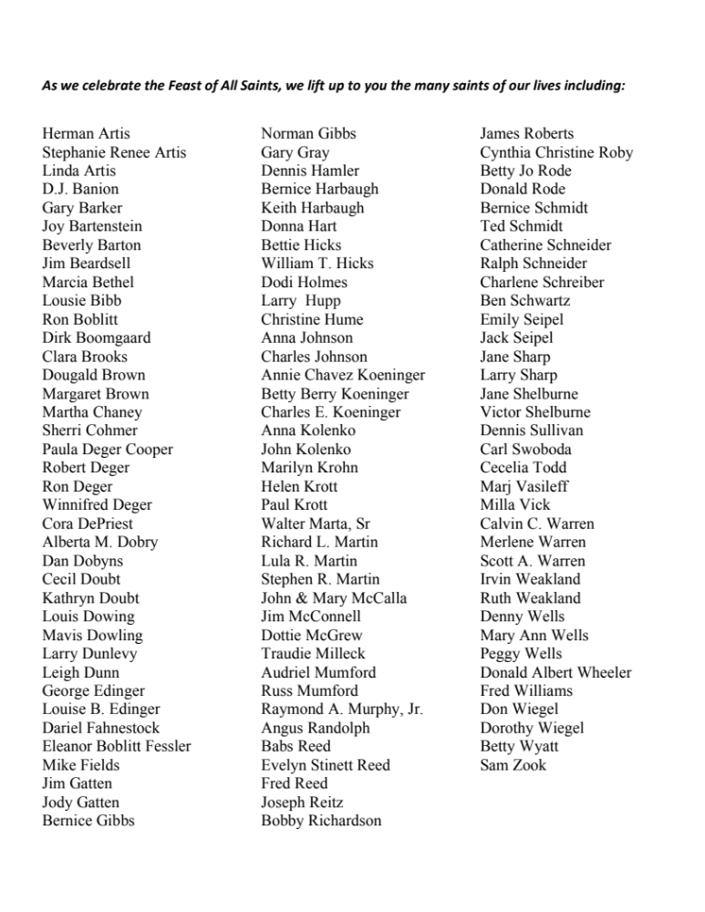

Announcements from Christ Church

Pastoral emergencies

If you need to reach Rev. Michelle for a pastoral emergency, the number is (937) 505-0141. For

non-emergencies, you can call the office at (937) 323-8651 or email Rev. Michelle at mboomgaard@christspringfield.org.

Please join in the Parish Hall today after the service for the Adult Forum on "The Saints Around Us" quiz game in honor of All Saints' Day. Compete individually or in teams, or just come cheer on participants.

Pledges
If you would like an update of what you have given thus far in fulfillment of your pledge for 2026, please email Kelly Zeller at zellerk0611@gmail.com for a statement.

Christ Church Food Pantry
The November Drive-thru Food Pantry will be on November 18th, 2026. Volunteers are needed to help unload food, pack food, and help with customer service at approximately 8:15 am. Please contact either Brian Shelburne at bshelburne@wittenberg.edu, Kelly Zeller at zellerk0611@gmail.com, or Anne Randolph at annejrand@aol.com to volunteer.

Upcoming Food Pantry opportunities:
November 4th 2026- the food delivery at approximately 8:15 am
November 12th, 2026 - grocery bagging day - start time at 9:00 am
November 18th, 2026 – Food Pantry Day! start time at 8:15 am

Adult Forum in November
Get ready for an exciting month of adult forums ahead! Join us in the Parish Hall right after the 10 am service for a variety of inspiring guest speakers. We can't wait to see you there and share in the experience together!

November 8: Jerusalem Greer will speak on "Is Episcopal Evangelism an oxymoron?" and discuss the importance of belonging in ministry.

November 15: The Rev. Dr. Christian Brady, President of Wittenberg University, will discuss vocation and creating personal mission statements. Join us for an inspiring morning as part of our "Deeper Dive into Invite-Welcome-Connect."

November 22: Hear news from the Diocesan Convention with updates from delegates.

SAVE THE DATE
Concerts at Christ Church Series 2 starts on Sunday, November 22, 2026 at 3:00 pm. Callisto Quartet from Columbus collaborates with our own Christopher Durrenberger on a pair of Piano Quartets by Brahms and Mozart. For more information about Callisto Quartet, visit www.callistoquartet.com.

Ministers for November 1st, 2026
Altar Guild: Cathy Yeazell and Gretchen Hicks
Chalice: Brian Shelburne
Lector: Liz Wheeler
Ushers: Bill Hicks and David Bingman
Children’s Chapel: Kelly Zeller and Madison Smith
Coffee Hour Host: Rick Everingham
Greeter: Joyce Spangler
Videographer: Truss, Inc.
Guest Musician: Keith Doubt

General Information
Priest: The Rev. Dr. Michelle Boomgaard
Senior Warden: Joyce Spangler
Junior Warden: Steve Sharp
Treasurer: Ken Bladh
Clerk of Vestry: Kelly Zeller
Vestry at Large: Kay Koeninger, David Bingman, Beth Deger, Diane Rode,
John Richardson, and Fred Bartenstein
Parish Director & Parish Administrator: Kelly Zeller
Director of Music: Dr. Christopher Durrenberger
Facility Manager: Paul McAfee
Bookkeeper: Tina Knox
Christ Church’s Wi-Fi password is: Christchurch (all lower cased)

Christ Church has an option for online giving through the church’s website.
- Go to christspringfield.org or use the QR code
- Go to the tab in the upper right-hand corner marked “Online Giving”
- Click on the online giving link in blue
- Fill in the amount you would like to give
- Next, choose either Pledged Giving for a Pledge or Miscellaneous Giving for other giving
- Fill out the rest of the form
- Press Continue
- Then enter your billing information
- Thank you!- If you have questions or concerns, please contact Kelly Zeller at zellerk0611@gmail.com

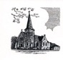

Christ Episcopal Church
409 East High Street
Springfield, Ohio 45505
937-323-8651
www.christspringfield.org

